Project Documentation - Delivery / Ride ETA Prediction
Contents
Executive Summary 2
1. Introduction 7
2. Data Acquisition and Understanding 21
3. Feature Engineering 48
4. Model Development and Experimentation 67
5. Model Deployment 117
6. Monitoring and Maintenance 163
7. Version Control and Collaboration 220
8. Conclusion and Future Work 250
9. References 263
10. Appendices 274

Executive Summary
Project Overview
Flavor A: Delivery / Ride ETA Prediction
The objective of this project is to develop an end-to-end Machine Learning Engineering (MLE) pipeline capable of accurately predicting the Estimated Time of Arrival (ETA) or trip duration for delivery and ride-hailing services. The solution leverages historical trip data, feature engineering techniques, machine learning models, experiment tracking, deployment frameworks, and monitoring strategies to deliver reliable predictions in a production-ready environment.
The project addresses a critical business challenge faced by logistics, transportation, and ride-sharing platforms: providing accurate arrival-time estimates to customers and operational teams. Inaccurate ETAs can lead to customer dissatisfaction, inefficient resource allocation, delays in service delivery, and increased operational costs. By building a robust predictive system, the project aims to improve service reliability and decision-making.
The implemented solution follows a complete MLOps lifecycle, including:
- Data acquisition and version-controlled data management using DVC.
- Data quality validation and preprocessing pipelines.
- Exploratory Data Analysis (EDA) to understand trip patterns and key influencing factors.
- Feature engineering using temporal, geographical, and distance-based features.
- Model development and experimentation using algorithms such as Linear Regression and Gradient Boosting.
- Experiment tracking and reproducibility through MLflow.
- REST API development for real-time prediction serving.
- Containerization using Docker for deployment portability.
- Monitoring, drift detection, performance tracking, and retraining strategies for long-term model maintenance.
The project demonstrates a production-oriented Machine Learning solution that not only focuses on predictive accuracy but also emphasizes scalability, reproducibility, deployment readiness, monitoring, and continuous improvement. The final system is designed to generate reliable ETA predictions that can enhance customer experience, optimize operational efficiency, and support business growth in delivery and ride-transportation ecosystems.
Business Value
Accurate ETA prediction provides several tangible benefits:
- Improved customer satisfaction through reliable arrival-time estimates.
- Better driver and fleet utilization.
- Enhanced route planning and operational efficiency.
- Reduced delays and service disruptions.
- Data-driven decision making for transportation and logistics operations.
- A scalable foundation for future MLOps automation and continuous model improvement.
Key Achievements
The Delivery / Ride ETA Prediction project successfully delivered a complete end-to-end Machine Learning Engineering and MLOps pipeline, covering data ingestion, feature engineering, model development, deployment, and production-readiness planning.
1. End-to-End Data Pipeline Development
- Built a structured data ingestion and preprocessing pipeline using scripts such as FetchingData.py, stage_raw.py, and ExtractData_Using_DVC.py.
- Implemented data quality validation through quality_checks.py and associated test cases to ensure data reliability before model training.
- Integrated Data Version Control (DVC) for dataset tracking, reproducibility, and lifecycle management.
2. Comprehensive Exploratory Data Analysis
- Conducted detailed EDA to understand trip duration patterns, passenger behavior, pickup trends, and geographical distributions.
- Generated visual analytics including passenger count distributions, pickup patterns across time dimensions, and location-based analyses to uncover business insights.
3. Advanced Feature Engineering
- Developed meaningful predictive features from temporal and geographical data.
- Implemented Haversine distance calculations and engineered location-based variables that improve ETA prediction accuracy.
- Performed feature correlation and distribution analysis to identify the most informative predictors.
4. Model Development and Optimization
- Built and evaluated multiple machine learning models, including Linear Regression and Gradient Boosting approaches.
- Established a model training framework supported by automated testing and validation scripts.
- Conducted hyperparameter tuning and comparative analysis to identify the best-performing model configuration.
5. Experiment Tracking and Reproducibility
- Integrated MLflow for experiment tracking and model lifecycle management.
- Logged model parameters, evaluation metrics, and artifacts to ensure reproducibility and transparent comparison of experimental results.
6. Deployment-Ready Model Packaging
- Successfully serialized trained models into reusable artifacts using Joblib.
- Produced deployable model assets such as gradient_boosting_trip_duration.joblib, enabling efficient loading and inference in production environments.
7. REST API-Based Prediction Service
- Designed and implemented a prediction API using components such as app.py and inference.py.
- Developed and tested real-time inference endpoints capable of serving ETA predictions to external applications.
8. Production-Oriented MLOps Architecture
- Defined a complete MLOps workflow encompassing data management, model training, deployment, monitoring, and retraining.
- Established strategies for data drift detection, performance monitoring, service health tracking, and automated retraining triggers.
9. Quality Assurance and Software Engineering Practices
- Implemented unit and integration tests across multiple project components, ensuring system reliability and maintainability.
- Adopted modular code organization, centralized configuration management, and schema validation techniques to support scalability and long-term maintenance.
10. Deployment Readiness
- Prepared the application for containerized deployment using Docker-based practices.
- Defined a roadmap for cloud deployment, CI/CD automation, monitoring integration, and continuous model improvement.
Achievement Summary
The project successfully delivered a production-oriented ETA prediction system that combines robust data engineering, feature engineering, machine learning experimentation, REST API deployment, and MLOps best practices. The solution demonstrates readiness for real-world deployment while providing a strong foundation for scalability, monitoring, and continuous improvement.

Deployment Readiness
The Delivery / Ride ETA Prediction project has reached a stage where all core machine learning components have been developed, tested, and prepared for operational deployment. The solution demonstrates deployment readiness through its robust data pipeline, trained model artifacts, inference service implementation, and clearly defined monitoring and maintenance strategy.
Key Indicators of Deployment Readiness
1. Robust Data Pipeline
- Data acquisition, staging, preprocessing, and validation pipelines have been implemented.
- Data quality checks are automated through dedicated validation scripts.
- DVC integration ensures reproducible and version-controlled datasets.
2. Production-Ready Model
- Multiple models were trained and evaluated.
- Hyperparameter tuning was conducted to identify the optimal model configuration.
- The best-performing model was serialized and stored as a reusable artifact (gradient_boosting_trip_duration.joblib).
3. Inference Service Implementation
- A REST API has been implemented using components such as app.py and inference.py.
- API functionality has been validated through dedicated testing scripts.
- The system can accept prediction requests and return ETA estimates in real time.
4. Model Packaging
- The trained model and preprocessing logic have been packaged for deployment.
- Model loading mechanisms have been implemented to support efficient inference in production environments.
5. Containerization Strategy
- Docker-based deployment has been planned and documented.
- The application architecture supports containerized execution, enabling portability across environments and cloud platforms.
6. Monitoring Framework Defined
The project includes a monitoring strategy covering:
- Prediction logging
- Data drift detection
- Model performance monitoring
- API latency monitoring
- Error-rate monitoring
- Resource utilization tracking
These capabilities are necessary for maintaining model reliability after deployment.
7. Retraining Strategy Established
A maintenance roadmap has been defined that includes:
- Scheduled retraining
- Drift-triggered retraining
- Performance degradation alerts
- Automated model versioning
- Continuous collection of production data for future model updates
This ensures long-term model sustainability and performance.

Current Deployment Status
Status: Ready for Production Deployment with Infrastructure Finalization Pending.
All machine learning and application components have been developed and validated. The remaining activities are primarily infrastructure and operational tasks rather than model-development tasks.
Remaining Steps Before Go-Live
- Deploy the API to the selected cloud platform (e.g., Google Cloud Run, AWS, Azure).
- Configure autoscaling, load balancing, and networking.
- Implement CI/CD pipelines for automated testing and deployment.
- Integrate monitoring tools such as Prometheus, Grafana, or Evidently AI.
- Establish centralized logging and alerting mechanisms.
- Conduct production security validation and rollback testing.
- Implement A/B testing or canary deployment for future model releases.
Deployment Readiness Statement
The Delivery / Ride ETA Prediction system is deployment-ready, with a fully developed data pipeline, optimized machine learning model, tested REST API, model packaging framework, and defined monitoring and retraining strategy. The solution is capable of providing reliable ETA predictions in a production environment and requires only infrastructure provisioning, CI/CD integration, and operational monitoring setup before full-scale deployment.

1. Introduction
1.1 Project Overview
The Delivery / Ride ETA Prediction project aims to develop a robust end-to-end Machine Learning Engineering (MLE) solution capable of accurately predicting trip durations and Estimated Time of Arrival (ETA) for transportation and delivery services. The project leverages historical trip data, advanced feature engineering techniques, machine learning models, and MLOps practices to build a scalable and production-ready prediction system.
Accurate ETA prediction is a critical requirement for modern ride-hailing and logistics platforms, as it directly impacts customer satisfaction, operational efficiency, and resource utilization. Traditional estimation methods often fail to account for complex patterns influenced by distance, time of day, traffic conditions, and geographical factors. This project addresses these challenges by employing data-driven predictive models that learn from historical trip behavior and generate more reliable travel time estimates.
The solution encompasses the complete machine learning lifecycle, beginning with data acquisition, validation, and preprocessing, followed by exploratory data analysis (EDA), feature engineering, model training, hyperparameter tuning, and performance evaluation. Multiple machine learning algorithms were explored, including Linear Regression and Gradient Boosting models, with systematic experimentation and reproducibility managed through MLflow and DVC.
To support real-world deployment, the trained model has been packaged for inference and exposed through a REST API service. The project also incorporates MLOps best practices such as experiment tracking, model versioning, containerization, monitoring, drift detection, and automated retraining strategies to ensure long-term reliability and maintainability in production environments.
Overall, the project delivers a comprehensive, production-oriented ETA prediction system that demonstrates the integration of data engineering, machine learning, software engineering, and MLOps principles. The resulting solution provides a foundation for improving operational planning, optimizing resource allocation, and enhancing customer experience through accurate and timely ETA predictions.
1.2 Problem Statement
Accurate estimation of trip duration and arrival times is a critical challenge for ride-hailing, transportation, and delivery service providers. Customers rely on ETA information to plan their activities, while businesses depend on accurate predictions to optimize fleet utilization, delivery scheduling, and operational efficiency. However, travel times are influenced by numerous dynamic factors such as pickup and drop-off locations, trip distance, traffic patterns, time of day, day of week, and other contextual variables, making accurate prediction a complex machine learning problem.
Traditional rule-based estimation methods often fail to capture the complex and non-linear relationships between these factors, resulting in inaccurate ETA predictions. Inaccurate estimates can lead to customer dissatisfaction, missed service-level expectations, inefficient route planning, increased operational costs, and reduced trust in the platform. Furthermore, transportation patterns continuously evolve due to changes in traffic conditions, seasonal variations, and user behavior, requiring predictive systems that can adapt and maintain performance over time.
To address these challenges, this project aims to develop a data-driven machine learning solution that accurately predicts trip duration using historical trip records and engineered features derived from temporal and geographical data. The solution must not only achieve strong predictive performance but also provide reproducibility, scalability, deployment readiness, and monitoring capabilities suitable for a real-world production environment.
The primary objective is to build an end-to-end MLOps pipeline that supports data ingestion, preprocessing, feature engineering, model training, experiment tracking, deployment through a REST API, and continuous monitoring for model performance and data drift. By delivering more accurate ETA predictions, the system seeks to improve customer experience, enhance operational efficiency, support better resource allocation, and provide a scalable foundation for future machine learning enhancements.
1.3 Solution Overview
To address the challenge of accurately predicting delivery and ride Estimated Time of Arrival (ETA), an end-to-end Machine Learning Engineering (MLE) pipeline was developed that integrates data engineering, feature engineering, model development, deployment, and MLOps practices. The solution is designed to transform raw trip data into actionable ETA predictions through a scalable and reproducible workflow.
The pipeline begins with data acquisition and version-controlled storage, where historical trip data is collected, validated, and managed using Data Version Control (DVC). Data quality checks ensure that missing values, invalid records, and inconsistencies are identified and addressed before further processing. Exploratory Data Analysis (EDA) is then performed to understand key patterns, trends, and relationships within the dataset.
Following data preparation, feature engineering techniques are applied to derive meaningful predictors from raw data. These include temporal features such as pickup hour, day of week, and month, as well as geographical features such as pickup and drop-off coordinates and Haversine distance calculations. These engineered features provide the machine learning models with richer contextual information, enabling improved ETA prediction accuracy.
Multiple machine learning models were trained and evaluated, including Linear Regression and Gradient Boosting algorithms. Experiment tracking was implemented using MLflow, allowing systematic comparison of model configurations, hyperparameters, and evaluation metrics. The best-performing model was selected based on its predictive accuracy and generalization performance on unseen test data.
For production deployment, the trained model was packaged as a reusable artifact and exposed through a REST API service developed using Python-based inference components. This enables external applications to request ETA predictions in real time. The deployment architecture is container-ready and supports integration with cloud platforms and CI/CD pipelines for scalable operation.
To ensure long-term reliability, the solution incorporates monitoring and maintenance capabilities, including prediction logging, data drift detection, model performance tracking, service health monitoring, and automated retraining strategies. These MLOps components help maintain prediction quality as data distributions and operating conditions evolve over time.

High-Level Architecture Diagram
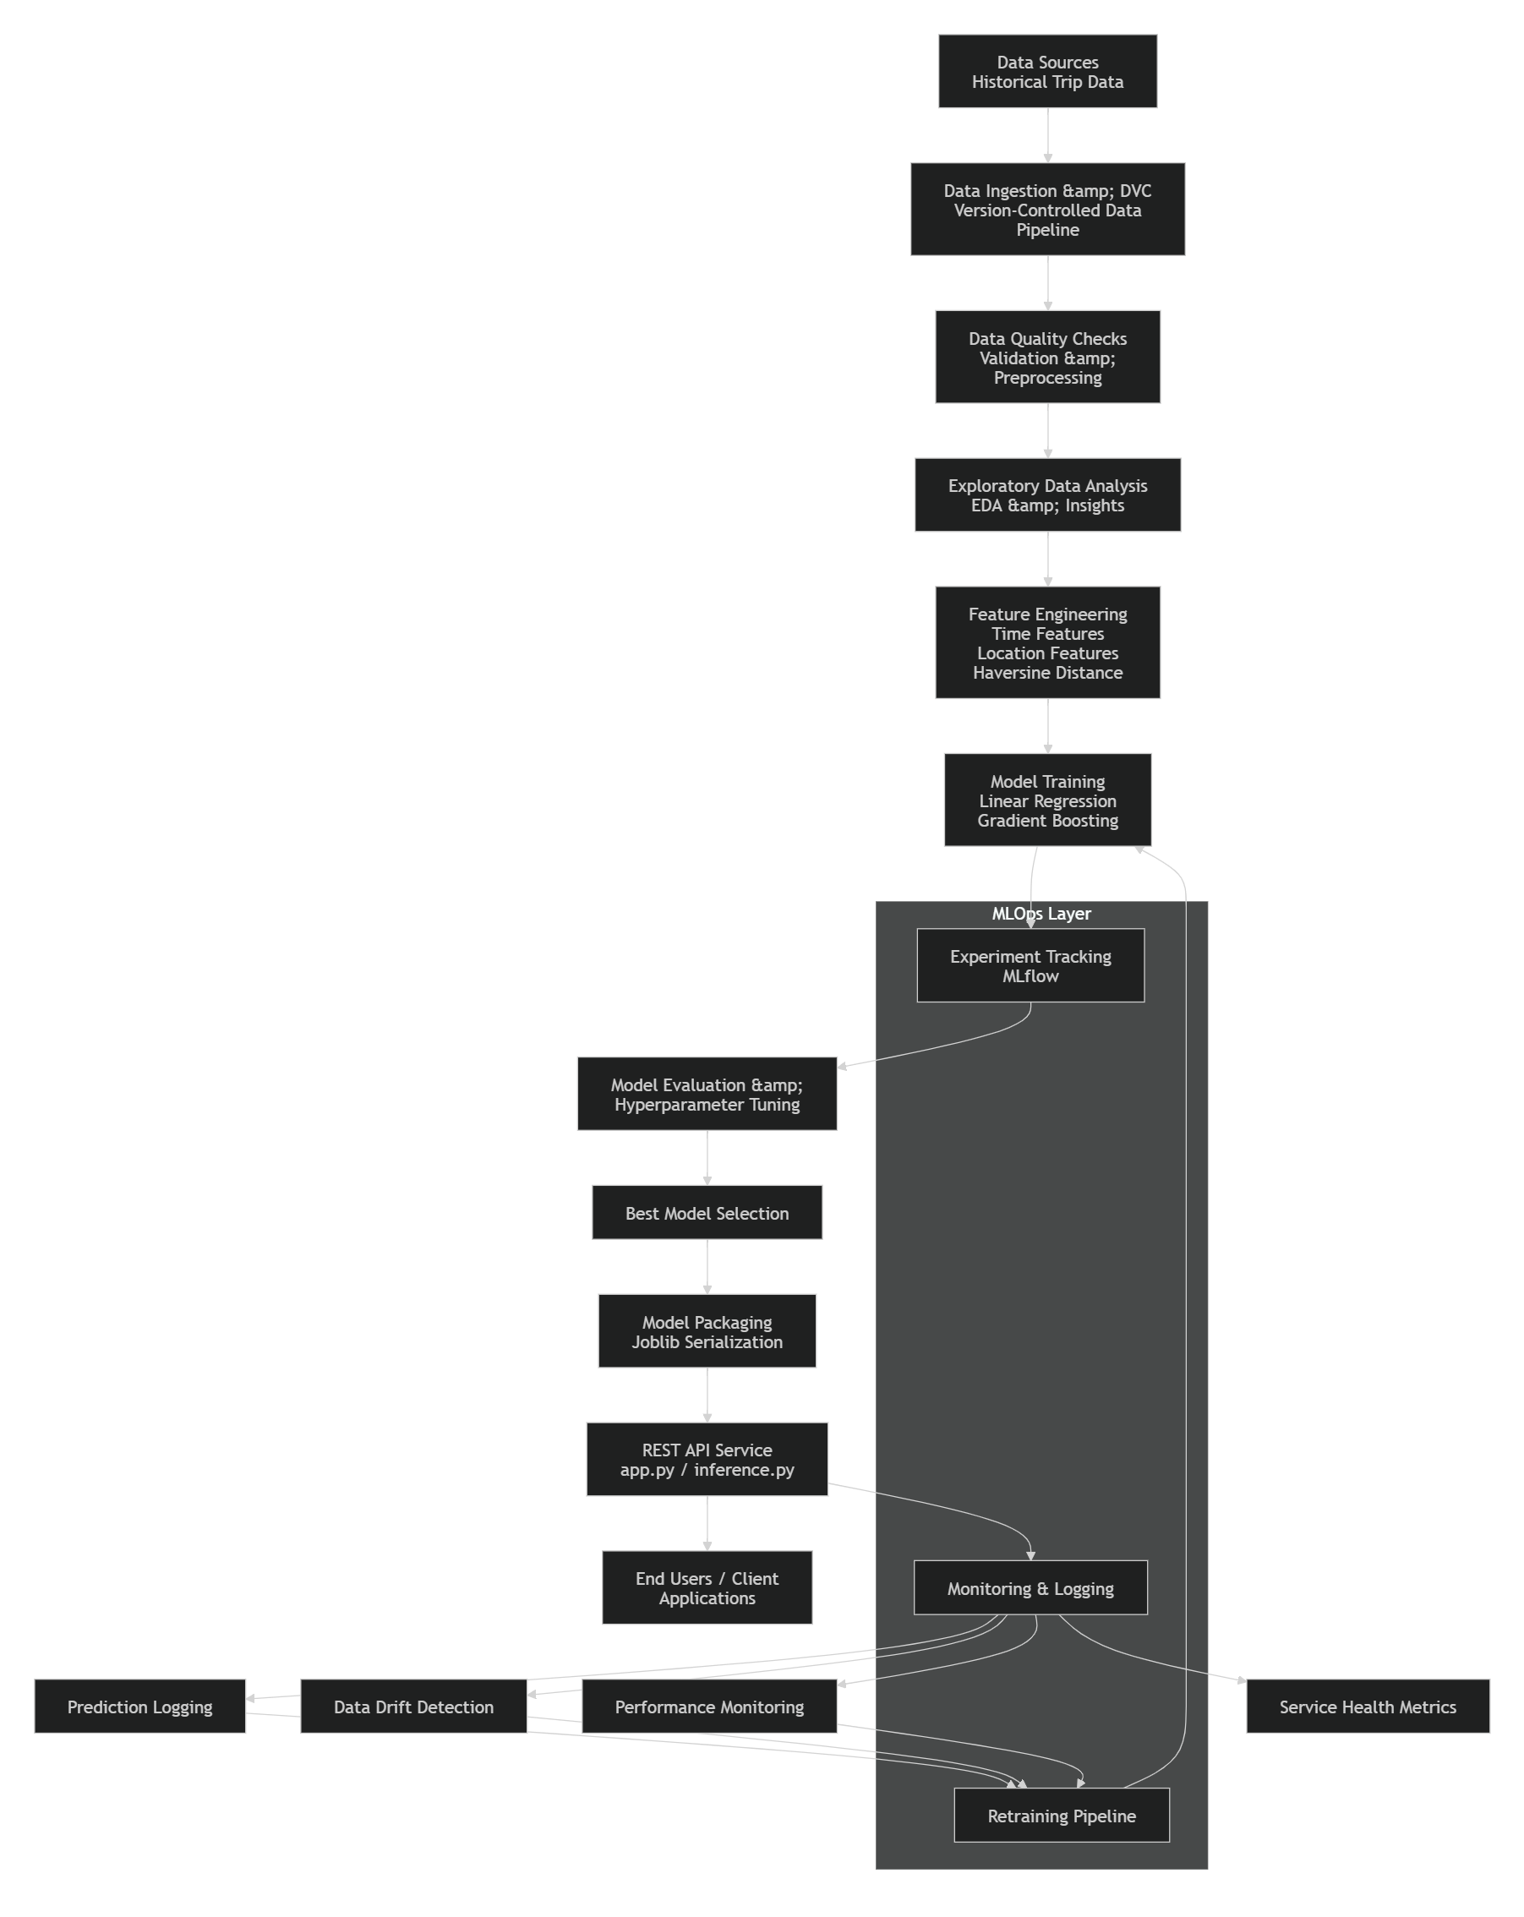
Benefits of the Architecture
- Reproducibility: DVC and MLflow ensure that data versions, experiments, and model artifacts can be reproduced reliably.
- Scalability: Containerized deployment and API-based serving enable integration with modern cloud environments.
- Maintainability: Modular components separate data processing, model training, deployment, and monitoring responsibilities.
- Production Readiness: Built-in monitoring, drift detection, and retraining strategies support long-term operational performance.
This architecture provides a complete and production-oriented framework for delivering accurate ETA predictions while adhering to modern Machine Learning Engineering and MLOps best practices.
1.4 Setup and Installation Instructions
This section provides the necessary steps to set up the development environment, install dependencies, configure required services, and execute the ETA Prediction pipeline locally. The instructions ensure that all team members can reproduce the project environment and run the application consistently.
Prerequisites
Before setting up the project, ensure that the following software is installed on your system:
- Python 3.10 or later
- Git
- Docker Desktop (for containerized deployment)
- DVC (Data Version Control)
- MLflow
- pip (Python package manager)

Step 1: Clone the Repository
Clone the project repository to your local machine:
git clone https://github.com/2025paml587-byte/BITS_PAIML_MLE_G28
cd ETA-Prediction-Project

Step 2: Create and Activate a Virtual Environment
Windows
python -m venv venv
venv\Scripts\activate

pyt
Linux/macOS
python3 -m venv venv
source venv/bin/activate

python3 -
Step 3: Install Project Dependencies
Install all required libraries and packages:
pip install -r requirements.txt

The project utilizes libraries and frameworks such as:
- pandas
- numpy
- scikit-learn
- mlflow
- dvc
- flask / fastapi
- joblib
- matplotlib
- seaborn

Step 4: Configure Environment Variables
Create a .env file in the project root directory and configure the required environment variables:

MLFLOW_TRACKING_URI=<your_mlflow_uri>
DATA_PATH=data/
MODEL_PATH=models/
LOG_LEVEL=INFO

Replace the placeholder values with environment-specific configurations.
Step 5: Retrieve Version-Controlled Data
Pull the latest dataset version using DVC:
dvc pull

This ensures that all team members work with the same dataset version and supports reproducibility across environments.
Step 6: Run Data Validation and Quality Checks
Execute the data quality validation pipeline:
python quality_checks.py

The validation process checks for:
- Missing values
- Invalid records
- Duplicate entries
- Schema consistency

Step 7: Generate Features
Run the feature engineering pipeline:
python featureengineering.py

Or
python build_features.py

This step creates engineered features such as:
- Pickup hour
- Day of week
- Month
- Haversine distance
- Location-based attributes

Step 8: Train the Models
Train the machine learning models:
Linear Regression
python train_linear_regression.py

Gradient Boosting
python train_gradient_boosting.py

Training metrics and experiment information are automatically tracked using MLflow.
Step 9: Launch MLflow Tracking UI
To review experiment runs and compare model performance:

mlflow ui

Open the following URL in your browser:
http://localhost:5000

``

Experiment logs, metrics, parameters, and model artifacts can be viewed from the MLflow dashboard.
Step 10: Start the Inference API
Launch the REST API service:
python app.py
``

The API will be available at:
http://localhost:8000

http://localhost:8000
or
http://localhost:5000

``

depending on the application configuration.
Step 11: Test the API
Execute API tests to verify functionality:
python test_api_app.py

or
pytest tests/

Successful execution confirms that the deployed model and inference service are functioning correctly.
Optional: Run Using Docker
Build the Docker image:
docker build -t eta-prediction .

Run the container:
docker run -p 8000:8000 eta-prediction

Docker ensures consistent execution across development, testing, and production environments.
Verification Checklist
Before proceeding with development or deployment, confirm that:
- ✅ Dependencies are installed successfully.
- ✅ DVC data has been pulled successfully.
- ✅ Data quality checks pass without errors.
- ✅ Feature engineering scripts execute correctly.
- ✅ Models train successfully.
- ✅ MLflow tracking is operational.
- ✅ The prediction API is accessible.
- ✅ API tests pass successfully.
- ✅ Docker container builds and runs correctly.
Following these steps prepares a fully functional local environment for development, experimentation, deployment, and monitoring of the Delivery / Ride ETA Prediction system.
1.5 Team Roles and Responsibilities
The project was executed through a collaborative team structure, with each member taking ownership of a critical component of the Machine Learning Engineering lifecycle, including data engineering, model development, MLOps, deployment, and documentation. This role-based approach ensured efficient task distribution, accountability, and successful delivery of the end-to-end ETA Prediction solution.
Team Member | Email ID | GitHub Username | Role & Responsibilities
BHALLAMUDI VENKATA SRINIVAS KIRAN | 2025paml587@wilp.bits-pilani.ac.in | 2025paml587-byte / theray-leo87 | Data & Features Lead and Project Documentation  • Led data acquisition, preprocessing, and quality validation activities.  • Developed feature engineering pipelines and exploratory data analysis workflows.  • Managed data versioning using DVC.  • Prepared project documentation, technical reports, and project deliverables.
GM CHANDRA KISHORE | 2025paml591@wilp.bits-pilani.ac.in | 2025paml591-wq | Modeling & Core ML Lead  • Designed and implemented machine learning models.  • Conducted model training, evaluation, and hyperparameter tuning.  • Managed experiment tracking using MLflow.  • Performed model comparison, error analysis, and best-model selection.
CHETAN RAGHAV | 2025paml605@wilp.bits-pilani.ac.in | 2025paml605-chetan | MLOps & Deployment Lead  • Developed the inference API and model-serving infrastructure.  • Managed model packaging and deployment workflows.  • Implemented monitoring, logging, and maintenance strategies.  • Designed containerization and deployment architecture using Docker and cloud-ready practices.
Team Collaboration Approach
The team adopted a modular development approach, where responsibilities were distributed according to specialization while maintaining close collaboration throughout the project lifecycle. Regular coordination ensured seamless integration between data engineering, machine learning development, deployment, and documentation activities. This collaborative workflow enabled efficient development of a scalable, reproducible, and production-ready ETA Prediction system.

1.6 Technology Stack
The Delivery / Ride ETA Prediction project leverages a modern Machine Learning Engineering (MLE) and MLOps technology stack to support data processing, model development, experiment tracking, deployment, monitoring, and collaboration. The selected technologies were chosen based on their scalability, community support, ease of integration, and suitability for building a production-ready machine learning system.
Programming Language
Python
Python serves as the primary programming language for the project due to its extensive ecosystem of libraries for data science, machine learning, MLOps, and web application development.

Data Processing and Analysis
Pandas
- Data manipulation and preprocessing
- Data cleaning and transformation
- Exploratory data analysis (EDA)
NumPy
- Numerical computations
- Array and matrix operations
- Statistical calculations
Matplotlib & Seaborn
- Data visualization
- Feature analysis
- Correlation and distribution plots
- Model performance visualizations

Data Versioning and Management
DVC (Data Version Control)
- Dataset version control
- Data lineage tracking
- Reproducible data pipelines
- Management of model artifacts and datasets across environments

Machine Learning and Model Development
Scikit-learn
- Feature preprocessing
- Model training and evaluation
- Hyperparameter tuning
- Machine learning pipeline development
Gradient Boosting Regressor
- Primary predictive model for ETA estimation
- Non-linear pattern learning
- High predictive performance for tabular datasets
Linear Regression
- Baseline model for performance comparison
- Benchmarking and model evaluation
Joblib
- Model serialization
- Persistence of trained machine learning models
- Efficient model loading during inference

Experiment Tracking and Model Management
MLflow
- Experiment tracking
- Parameter logging
- Metric tracking
- Model artifact management
- Reproducibility and comparison of model runs

API Development and Model Serving
Flask / FastAPI
- REST API development
- Model inference endpoints
- Request validation and response generation
- Integration of machine learning predictions with external applications

Containerization and Deployment
Docker
- Application containerization
- Environment consistency
- Simplified deployment across development, testing, and production environments
Cloud Deployment Platform (Planned)
- Google Cloud Run / Kubernetes-based deployment strategy
- Scalable hosting for model-serving APIs
- High availability and operational reliability

Monitoring and Observability
Evidently AI
- Data drift detection
- Monitoring input feature distributions
- Model quality assessment in production
Prometheus
- Application metrics collection
- Service health monitoring
- Performance tracking
Grafana
- Dashboard creation
- Real-time visualization of operational metrics
- Alerting and monitoring support

Testing and Quality Assurance
Pytest
- Unit testing
- Integration testing
- Automated validation of pipeline components and APIs

Version Control and Collaboration
Git
- Source code version control
- Branch management and collaboration
- Change tracking and code review workflows
GitHub
- Repository hosting
- Team collaboration
- Pull request management
- CI/CD integration support

Technology Stack Summary
Category | Technologies
Programming Language | Python
Data Processing | Pandas, NumPy
Visualization | Matplotlib, Seaborn
Data Versioning | DVC
Machine Learning | Scikit-learn, Linear Regression, Gradient Boosting
Experiment Tracking | MLflow
Model Serialization | Joblib
API Development | Flask / FastAPI
Containerization | Docker
Monitoring | Evidently AI, Prometheus, Grafana
Testing | Pytest
Version Control | Git, GitHub
Cloud Deployment | Google Cloud Run / Kubernetes (Planned)
This technology stack provides a comprehensive foundation for building, deploying, monitoring, and maintaining a scalable ETA Prediction system while adhering to modern Machine Learning Engineering and MLOps best practices.

2. Data Acquisition and Understanding
2.1 Data Sources
The Delivery / Ride ETA Prediction project utilizes historical trip records as the primary data source for building and evaluating machine learning models that predict trip duration and estimated arrival times. The dataset contains detailed information about trips, including pickup and drop-off locations, timestamps, passenger counts, and trip durations, which serve as the foundation for feature engineering and model training.
Primary Dataset
NYC Taxi Trip Duration Dataset
The primary dataset used in this project is based on historical New York City taxi trip records. The dataset includes trip-level information that captures the characteristics of each ride and provides the target variable, trip duration, for supervised machine learning modeling.
Key attributes include:
- Trip identifier
- Pickup datetime
- Drop-off datetime
- Pickup latitude and longitude
- Drop-off latitude and longitude
- Passenger count
- Vendor information
- Trip duration (target variable)
These attributes provide both temporal and geographical information that are critical for estimating travel times and identifying patterns that influence ETA predictions.
Engineered Data Features
In addition to the raw dataset, the project generates several derived features through feature engineering processes. These features are created from the original trip records to improve model performance and capture hidden relationships within the data.
Examples include:
Temporal Features
- Pickup hour
- Day of week
- Month
- Weekend indicator
- Time-of-day category
Geographical Features
- Haversine distance between pickup and drop-off locations
- Direction and spatial relationships
- Location-based patterns
These engineered features allow the model to better understand traffic behavior, travel demand patterns, and route characteristics that affect trip duration.
Data Collection and Management
The project follows a structured data management approach using Data Version Control (DVC). DVC is used to track dataset versions, maintain reproducibility, and ensure consistency across development and experimentation environments. Scripts such as FetchingData.py, ExtractData_Using_DVC.py, and stage_raw.py facilitate data ingestion and version-controlled storage of datasets throughout the project lifecycle.
Data Quality and Validation
Before use in model development, the dataset undergoes a series of validation and quality assessment checks to ensure reliability and consistency. These checks include:
- Missing value identification
- Duplicate record detection
- Invalid timestamp detection
- Data type validation
- Schema verification
These validation processes are implemented through dedicated quality assurance scripts and help ensure that only high-quality data enters the machine learning pipeline.
Data Source Summary
Data Source | Description | Purpose
Historical NYC Taxi Trip Data | Raw trip records containing pickup/drop-off information, timestamps, passenger counts, and trip duration | Primary dataset for model training and evaluation
Engineered Feature Dataset | Derived temporal and geographical features generated from raw trip data | Improve predictive performance and model accuracy
DVC-Managed Data Repository | Version-controlled storage of raw and processed datasets | Data reproducibility, traceability, and collaboration
The selected data sources provide comprehensive temporal and geographical information necessary for predicting trip durations and ETAs. Combined with feature engineering and robust data management practices, they form a reliable foundation for building accurate and scalable machine learning models.
2.2 Data Acquisition Process
The data acquisition process was designed to ensure reliable, reproducible, and version-controlled access to the datasets required for developing the Delivery / Ride ETA Prediction model. A structured pipeline was implemented to collect, stage, validate, and manage historical trip data throughout the machine learning lifecycle. Scripts such as FetchingData.py, ExtractData_Using_DVC.py, and stage_raw.py were developed to automate data ingestion and preparation activities.
Data Acquisition Workflow
The project follows a systematic workflow for acquiring and managing data:
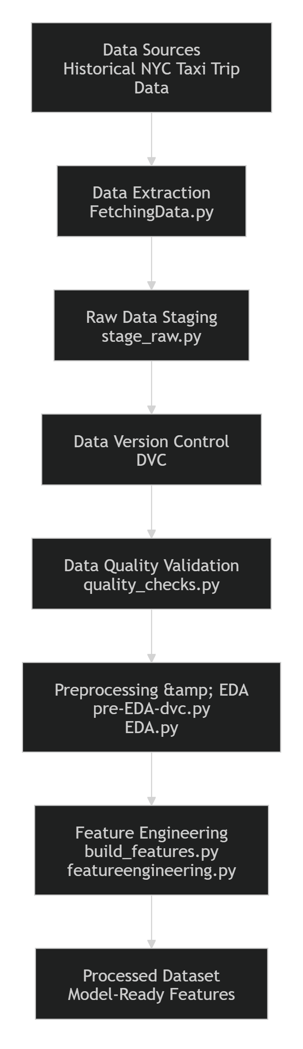
Step 1: Data Retrieval
The initial dataset was obtained from a historical trip records repository containing taxi or ride-service journey information. The retrieval process was automated through the FetchingData.py script, which downloads and organizes the source data for further processing. This approach minimizes manual intervention and ensures consistency across development environments.
Step 2: Raw Data Staging
After extraction, the data is stored in a designated raw-data staging area using the stage_raw.py process. Raw data staging preserves the original dataset in its unmodified form, providing a reference point for auditing, troubleshooting, and reproducibility.
Step 3: Data Version Control
To maintain reproducibility and consistency throughout the project, Data Version Control (DVC) was integrated into the acquisition pipeline. DVC tracks changes to datasets and enables team members to access identical versions of the data regardless of their development environment. The process supports versioning of:
- Raw datasets
- Processed datasets
- Engineered feature datasets
- Model artifacts
This approach ensures traceability and supports collaborative development workflows.
Step 4: Data Quality Validation
Before data is used for analysis or modeling, it undergoes a series of validation checks through the quality_checks.py module. The objective of this stage is to identify and address potential data quality issues that could negatively impact model performance. Validation checks include:
- Missing value detection
- Duplicate record identification
- Invalid timestamp verification
- Data type consistency checks
- Schema validation
Automated testing scripts were also implemented to verify the correctness of these quality assurance procedures.
Step 5: Exploratory Analysis Preparation
Following validation, the cleansed dataset is prepared for exploratory data analysis using scripts such as pre-EDA-dvc.py and EDA.py. These processes generate summary statistics and visualizations that help identify trends, distributions, anomalies, and relationships within the data.
Step 6: Data Transformation for Modeling
Once validation and exploration are complete, the dataset progresses to the feature engineering stage, where raw attributes are transformed into machine-learning-ready features. The processed dataset serves as the foundation for model training, evaluation, and deployment activities.
Reproducibility and Traceability
A major objective of the acquisition process was to ensure that every stage of data handling could be reproduced. The combination of automated ingestion scripts, DVC-based versioning, validation pipelines, and testing frameworks enables:
- Consistent dataset management
- Experiment reproducibility
- Data lineage tracking
- Collaborative development
- Reliable model retraining
These capabilities are essential for maintaining the integrity of the machine learning pipeline and supporting production-grade MLOps practices.
Data Acquisition Summary
The implemented data acquisition process establishes a robust foundation for the ETA Prediction system by automating dataset retrieval, enforcing quality standards, maintaining dataset version control, and ensuring reproducibility across all project stages. Through the use of DVC, validation pipelines, and automated ingestion scripts, the project achieves efficient and scalable data management that supports both experimentation and future production deployment.
2.3 Exploratory Data Analysis (EDA)
Exploratory Data Analysis (EDA) was conducted to understand the characteristics, quality, and underlying patterns within the trip duration dataset before model development. The primary objective of EDA was to identify trends, detect anomalies, assess feature distributions, and uncover relationships between variables that could influence trip duration predictions. The insights obtained from this analysis guided data preprocessing, feature engineering, and model selection decisions.
Objectives of EDA
The EDA process was performed with the following objectives:
- Understand the structure and quality of the dataset.
- Identify missing values, duplicates, and outliers.
- Analyze temporal patterns affecting trip duration.
- Examine geographical distributions of pickup and drop-off locations.
- Investigate relationships between features and the target variable.
- Discover trends that could be leveraged during feature engineering and model training.

Dataset Overview
The dataset consists of historical taxi trip records containing both temporal and spatial information. Key variables include:
- Pickup datetime
- Drop-off datetime
- Passenger count
- Pickup latitude and longitude
- Drop-off latitude and longitude
- Trip duration (target variable)
These attributes provide essential information for understanding travel behavior and estimating ride durations.

Passenger Count Analysis
The passenger count distribution was examined to understand rider behavior and identify any unusual records.
Key Findings:
- Most trips involved a small number of passengers.
- Single-passenger and two-passenger rides represented the largest proportion of trips.
- Extremely high passenger counts appeared infrequently and were treated as potential anomalies during preprocessing.
Visualization Used:
- passenger_count_distribution.png

Temporal Analysis
Trip patterns were analyzed across different time dimensions to understand how travel demand varies throughout the day, week, and month.
Pickup Hour Analysis
The distribution of pickups by hour revealed distinct travel demand patterns:
- Increased trip activity during morning and evening commuting hours.
- Lower demand during late-night and early-morning periods.
- Peak-hour traffic patterns suggested a strong relationship between trip timing and travel duration.
Day-of-Week Analysis
Analysis of weekly trends showed:
- Higher trip volumes on weekdays due to commuting activities.
- Different travel patterns on weekends, reflecting recreational and leisure trips.
Monthly Analysis
Monthly trends highlighted seasonal variations in ride demand and travel durations.
Visualization Used:
- pickup_distribution_by_hourofday_dayofweek_month.png

Geographical Analysis
Pickup and drop-off coordinates were analyzed to understand the spatial distribution of trips.
Key Observations:
- Trip activity was concentrated within major urban regions.
- Certain pickup and drop-off zones exhibited higher trip frequencies.
- Geographic clustering indicated the importance of location-based features for ETA prediction.
Visualization Used:
- pickup_dropoff_locations.html

Trip Duration Analysis
The target variable, trip duration, was examined to understand its overall distribution and identify potential outliers.
Key Findings:
- Trip durations showed a right-skewed distribution, with most trips concentrated within a lower duration range.
- A small number of trips exhibited exceptionally long durations.
- Outlier detection and filtering were required to prevent model bias.
Understanding the target variable distribution was critical for selecting appropriate evaluation metrics and modeling strategies.

Haversine Distance Analysis
Haversine distance was calculated as the straight-line distance between pickup and drop-off coordinates.
Key Findings:
- A positive relationship was observed between distance and trip duration.
- Distance emerged as one of the most influential predictors for ETA estimation.
- Longer trips generally required more travel time, although traffic and temporal factors also contributed significantly.
Visualizations Used:
- haversine_distance_distributions.png
- haversine_distance_v_trip_duration.png

Engineered Feature Analysis
After feature engineering, additional analyses were performed to evaluate newly created predictors.
Feature Distributions
The statistical properties of engineered features were examined to detect skewness, outliers, and unusual patterns.
Correlation Analysis
Correlation analysis helped identify:
- Strong relationships between features and trip duration.
- Potential multicollinearity among predictors.
- Features with the highest predictive potential.
Feature Boxplots
Boxplots were used to visualize data spread and identify extreme values requiring treatment.
Visualizations Used:
- engineered_feature_distributions.png
- engineered_feature_correlation.png
- engineered_feature_boxplots.png
- engineered_categorical_distributions.png

Key Insights from EDA
The exploratory analysis produced several important insights that influenced subsequent stages of the project:
- Distance is a major predictor of trip duration, making Haversine distance an essential engineered feature.
- Travel demand varies significantly by hour and day, highlighting the importance of temporal features such as pickup hour and day of week.
- Trip durations contain outliers, requiring preprocessing and validation before training machine learning models.
- Geographical patterns strongly influence travel times, justifying the inclusion of location-based features.
- Engineered features showed meaningful correlations with the target variable, demonstrating their value in improving model performance.

Conclusion
The EDA phase provided a comprehensive understanding of the dataset's structure, quality, temporal trends, geographical characteristics, and predictive relationships. The findings validated the use of time-based and location-based features, identified data quality issues requiring attention, and established a strong foundation for feature engineering and machine learning model development. These insights directly contributed to building a more accurate and robust ETA prediction system.
2.4 Data Quality Checks
Data quality is a critical factor in building accurate and reliable machine learning models. Before proceeding with feature engineering and model training, a comprehensive data quality validation process was performed to identify and address potential issues within the dataset. Automated validation routines were implemented through the quality_checks.py module, supported by dedicated testing scripts to ensure consistency and reliability across the data pipeline.
Objectives of Data Quality Checks
The primary objectives of the data quality validation process were to:
- Ensure completeness and consistency of input data.
- Detect and handle missing or invalid records.
- Identify duplicate observations.
- Validate data types and schema conformity.
- Detect outliers and anomalous values.
- Improve overall dataset reliability before model training.

Data Quality Validation Workflow
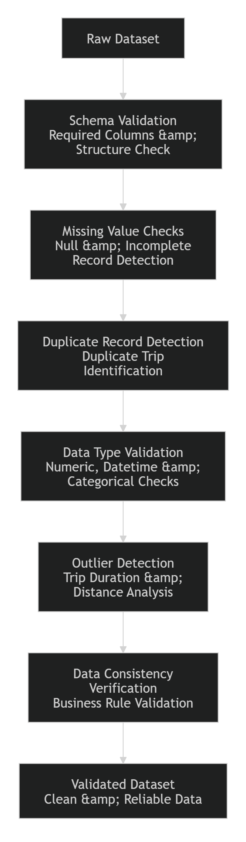

1. Schema Validation
The first stage involved validating the overall dataset structure to ensure that all required columns were present and correctly formatted.
Validation Criteria:
- Mandatory columns are available.
- Column names match expected schema definitions.
- Data formats align with project requirements.
- Dataset structure remains consistent across versions.
Expected Fields:
- Trip ID
- Pickup Datetime
- Drop-off Datetime
- Passenger Count
- Pickup Latitude
- Pickup Longitude
- Drop-off Latitude
- Drop-off Longitude
- Trip Duration
Schema validation prevents downstream failures during preprocessing and model training.

2. Missing Value Checks
The dataset was inspected for incomplete records that could negatively affect feature generation and model performance.
Fields Evaluated:
- Pickup coordinates
- Drop-off coordinates
- Timestamp attributes
- Passenger count
- Target variable (trip duration)
Handling Strategy:
- Records with critical missing geographic information were removed.
- Invalid or incomplete observations were excluded from further processing.
- Missing values were analyzed before any transformation or modeling step.
This ensured that all training data contained sufficient information for feature generation.

3. Duplicate Record Detection
Duplicate records can introduce bias into machine learning models and lead to inaccurate performance estimates.
The validation process checked for:
- Duplicate Trip IDs
- Identical pickup and drop-off records
- Duplicate timestamp combinations
- Repeated observations across datasets
Action Taken:
- Duplicate entries were identified and removed.
- Unique trip records were retained for analysis and model development.
This improved the reliability of statistical analysis and model evaluation results.

4. Data Type Validation
Data type validation was performed to verify that each column contained values in the expected format.
Attribute | Expected Type
Pickup Datetime | Datetime
Drop-off Datetime | Datetime
Passenger Count | Integer
Latitude/Longitude | Float
Trip Duration | Numeric
The validation process ensured:
- Datetime fields were correctly parsed.
- Numerical fields contained valid numeric values.
- Categorical values followed expected formats.
Consistent data types are essential for feature engineering and model training operations.

5. Timestamp Validation
Trip timestamps were examined to identify invalid temporal records.
Checks Performed:
- Pickup timestamps occur before drop-off timestamps.
- Timestamps are not null.
- Dates fall within expected ranges.
- Future dates and impossible time values are excluded.
Example Validation Rule:
Drop-off Time > Pickup Time
Invalid temporal records can lead to incorrect trip duration calculations and were therefore filtered out during preprocessing.

6. Geographic Coordinate Validation
Geographical coordinates were validated to ensure that pickup and drop-off locations represented realistic positions.
Checks Included:
- Latitude values within valid ranges.
- Longitude values within valid ranges.
- Missing coordinate detection.
- Invalid location records identification.
Expected Ranges:
Latitude : -90 to +90
Longitude : -180 to +180
Records outside these ranges were treated as invalid and excluded from further analysis.

7. Passenger Count Validation
Passenger count values were examined to detect unrealistic or inconsistent records.
Validation Rules:
- Passenger count must be greater than zero.
- Extremely large passenger counts are flagged as anomalies.
- Missing passenger information is handled during preprocessing.
This validation ensured that rider-related features accurately represent real trip conditions.

8. Outlier Detection
Outlier analysis was conducted to identify abnormal observations that could distort model learning.
Trip Duration Outliers
Potential anomalies included:
- Extremely short trips
- Extremely long trips
- Unusual duration distributions
Distance Outliers
After Haversine distance calculation, unusually large or unrealistic travel distances were investigated.
Detection Techniques:
- Statistical distribution analysis
- Boxplot visualization
- Quantile-based filtering
Outlier treatment helped improve model robustness and reduce the impact of noisy data.

9. Data Consistency Checks
Additional consistency checks were performed to verify logical relationships among attributes.
Examples include:
- Trip duration corresponds to pickup and drop-off timestamps.
- Geographic coordinates exist for all recorded trips.
- Engineered features are generated successfully from source data.
- Record counts remain consistent after preprocessing.
Consistency validation ensured that transformed datasets remained logically correct and suitable for downstream machine learning tasks.

Automated Testing
To improve reliability, automated test scripts were developed alongside validation logic.
Testing Components:
- test_quality_checks.py
- Validation rule testing
- Schema verification testing
- Data integrity testing
Automated testing ensures that future changes to the pipeline do not introduce data quality regressions.

Data Quality Outcomes
After applying the validation process:
- Invalid records were removed.
- Duplicate observations were eliminated.
- Data types were standardized.
- Temporal and geographic inconsistencies were corrected.
- Outliers were analyzed and treated appropriately.
- A clean and reliable dataset was prepared for feature engineering and model development.
Conclusion
The data quality validation framework established a strong foundation for the machine learning pipeline by ensuring that data used for modeling was accurate, complete, and consistent. Through automated schema checks, missing value analysis, duplicate detection, timestamp verification, geographic validation, and outlier analysis, the project minimized data-related risks and improved the reliability of subsequent feature engineering, model training, and deployment processes.
2.5 Data Cleaning & Preprocessing
Data cleaning and preprocessing were performed to transform the raw trip dataset into a high-quality, machine-learning-ready dataset. This stage focused on identifying and correcting data quality issues, handling inconsistencies, removing invalid observations, and preparing the data for feature engineering and model training. The preprocessing workflow was supported by automated validation scripts, including quality_checks.py, ensuring consistency and reproducibility across the pipeline.
Objectives
The primary goals of data cleaning and preprocessing were to:
- Improve data quality and reliability.
- Remove invalid and duplicate records.
- Handle missing values appropriately.
- Standardize data formats and types.
- Eliminate anomalies that could negatively affect model performance.
- Prepare the dataset for feature engineering and model development.

Data Cleaning & Preprocessing Workflow
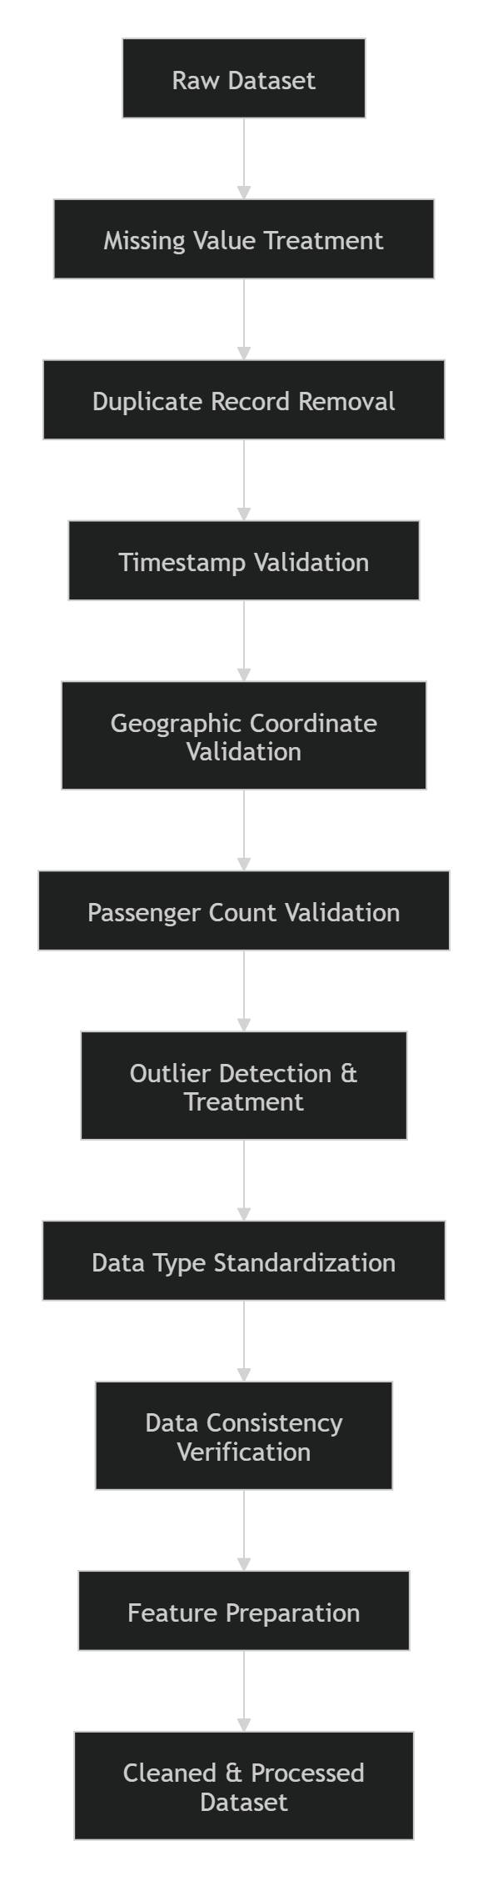
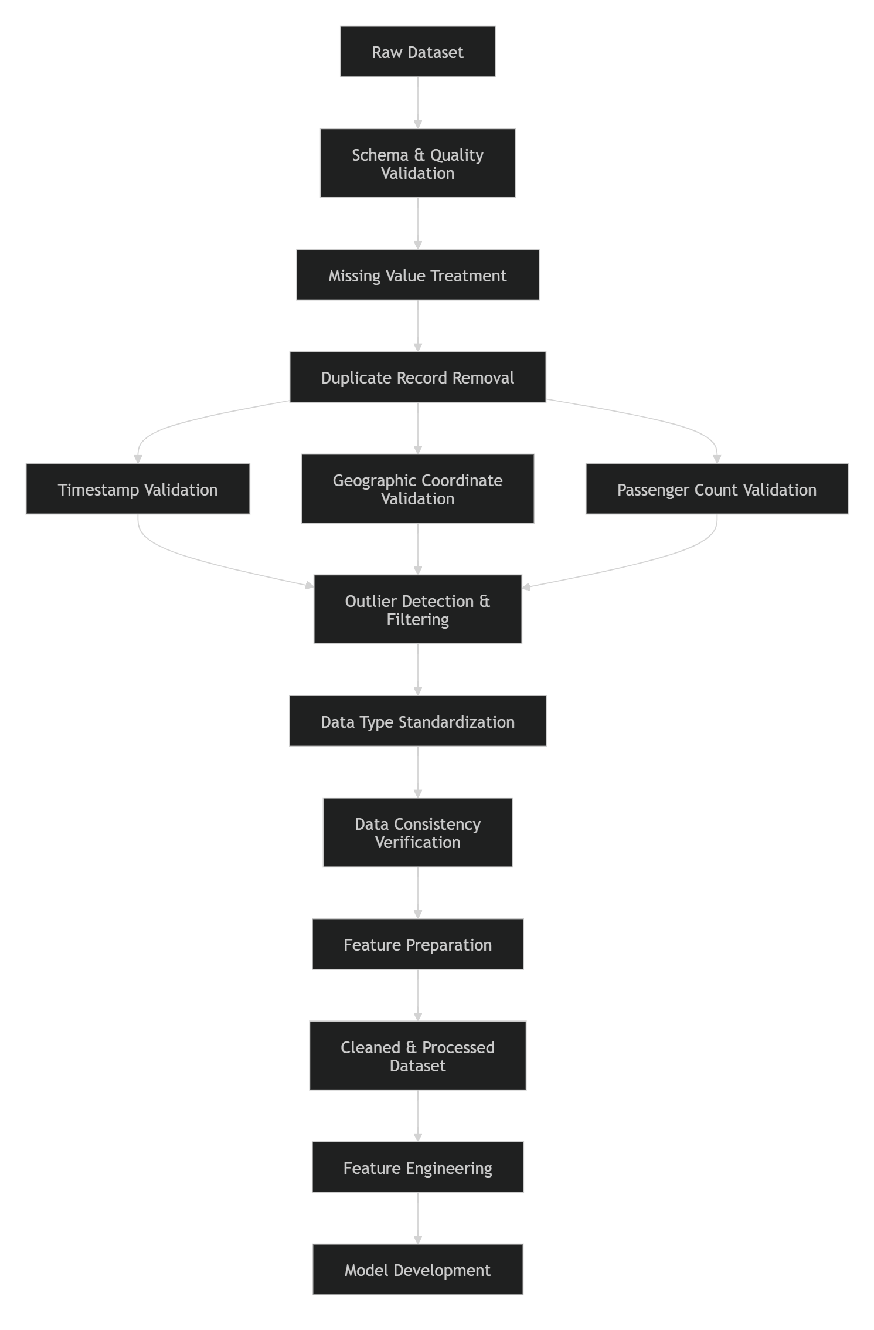

1. Missing Value Handling
Missing values were analyzed across all critical attributes to determine their impact on downstream processing and model performance.
Critical Fields Reviewed
- Pickup datetime
- Drop-off datetime
- Pickup latitude
- Pickup longitude
- Drop-off latitude
- Drop-off longitude
- Passenger count
- Trip duration
Treatment Strategy
- Records missing essential geographical information were removed.
- Rows containing missing target values (trip_duration) were excluded.
- Missing records that could not be reliably recovered were discarded to preserve data integrity.
This approach ensured that all retained records contained sufficient information for feature generation and model training.

2. Duplicate Record Removal
Duplicate observations can artificially bias learning algorithms and distort evaluation metrics.
Duplicate Checks Performed
- Duplicate trip identifiers
- Duplicate pickup and drop-off combinations
- Duplicate timestamps
- Exact row duplicates
Action Taken
- Duplicate records were identified and removed.
- Only unique trip observations were retained for analysis.
This step helped maintain dataset integrity and prevented overrepresentation of repeated trips.

3. Timestamp Processing and Validation
Date and time fields were converted into a standardized datetime format and validated for consistency.
Validation Rules
- Pickup time must occur before drop-off time.
- Future timestamps are invalid.
- Null or malformed datetime records were removed.
Example Validation
pickup_datetime < dropoff_datetime
Valid timestamps were essential for calculating trip duration and generating temporal features.

4. Geographic Data Validation
Pickup and drop-off coordinates were examined to ensure they represented valid geographic locations.
Checks Applied
- Latitude values between -90 and +90
- Longitude values between -180 and +180
- Missing coordinate detection
- Invalid location filtering
Example Rules
Latitude ∈ [-90, 90]
Longitude ∈ [-180, 180]
Records containing invalid or incomplete location information were removed from the dataset.

5. Passenger Count Validation
Passenger count values were reviewed to identify unrealistic records.
Validation Rules
- Passenger count greater than zero.
- Unusually large values flagged as anomalies.
- Missing values evaluated during quality checks.
This ensured that passenger-related information accurately reflected valid trip conditions.

6. Outlier Detection and Treatment
Outlier detection was performed to identify observations that could negatively influence model training.
Trip Duration Outliers
Potential anomalies included:
- Extremely short trips
- Extremely long trips
- Abnormally distributed duration records
Distance Outliers
After Haversine distance calculation, unrealistically large travel distances were examined and filtered when necessary.
Techniques Utilized
- Distribution analysis
- Boxplot inspection
- Percentile-based filtering
- Statistical threshold evaluation
Removing extreme anomalies improved model stability and generalization performance.

7. Data Type Standardization
All variables were converted into consistent formats suitable for analysis and machine learning.
Attribute | Standardized Type
Pickup Datetime | Datetime
Drop-off Datetime | Datetime
Passenger Count | Integer
Latitude/Longitude | Float
Trip Duration | Numeric
Standardized data types simplified downstream feature engineering and eliminated transformation errors during training.

8. Consistency Verification
Additional verification checks were performed to ensure logical consistency within the dataset.
Examples
- Trip duration aligns with timestamp differences.
- Geographic coordinates exist for all trips.
- Feature generation can be completed without errors.
- Row counts remain consistent after transformations.
Consistency validation confirmed that preprocessing activities preserved the integrity of the original data.

Preparation for Feature Engineering
Once cleaning and validation were complete, the dataset was prepared for feature engineering activities. The preprocessing stage produced a structured dataset from which additional features such as:
- Pickup hour
- Day of week
- Month
- Time-of-day categories
- Haversine distance
- Location-based attributes
could be generated reliably.

Outcome of Preprocessing
The preprocessing pipeline successfully produced a clean and consistent dataset by:
- Eliminating incomplete records.
- Removing duplicate observations.
- Correcting timestamp issues.
- Filtering invalid geographical coordinates.
- Addressing outliers and anomalies.
- Standardizing data types.
These improvements enhanced data quality and provided a strong foundation for feature engineering, model training, and deployment.
Conclusion
The Data Cleaning and Preprocessing stage transformed raw trip records into a high-quality analytical dataset suitable for machine learning applications. Through systematic validation, cleansing, standardization, and anomaly handling, the project ensured that subsequent feature engineering and model development activities were built on reliable and consistent data. This preprocessing framework played a critical role in improving model accuracy, robustness, and overall deployment readiness.
2.6 Data Schema
The final dataset schema was designed to support accurate ETA prediction by combining raw trip attributes with engineered features derived during preprocessing and feature engineering stages. The schema provides a structured representation of the data used for model training, evaluation, and inference. It includes temporal, geographical, and trip-related attributes that capture the key factors influencing trip duration.
Schema Overview
The dataset contains a mixture of raw attributes collected from trip records and engineered features generated during the data preparation process. These variables serve as input features for machine learning models, while trip_duration acts as the target variable.
Raw Dataset Attributes
Column Name | Data Type | Description
id | String | Unique trip identifier
vendor_id | Integer | Identifier of the service provider
pickup_datetime | Datetime | Timestamp when the trip started
dropoff_datetime | Datetime | Timestamp when the trip ended
passenger_count | Integer | Number of passengers in the vehicle
pickup_longitude | Float | Longitude of pickup location
pickup_latitude | Float | Latitude of pickup location
dropoff_longitude | Float | Longitude of drop-off location
dropoff_latitude | Float | Latitude of drop-off location
trip_duration | Numeric | Actual trip duration (Target Variable)
These raw attributes provide the foundational temporal and spatial information required for trip duration prediction.

Engineered Features
Several features were derived from the raw data to improve model performance and capture relationships that are not directly available in the original dataset.
Temporal Features
Feature | Data Type | Description
pickup_hour | Integer | Hour of trip pickup (0–23)
pickup_dayofweek | Integer | Day of week of pickup
pickup_month | Integer | Month of pickup
is_weekend | Boolean | Weekend trip indicator
time_of_day | Categorical | Morning, Afternoon, Evening, Night
Temporal features help capture demand fluctuations and recurring traffic patterns throughout different time periods.
Location-Based Features
Feature | Data Type | Description
haversine_distance | Float | Straight-line distance between pickup and drop-off locations
direction | Float | Direction of travel between coordinates
pickup_cluster | Integer | Pickup location cluster (if applicable)
dropoff_cluster | Integer | Drop-off location cluster (if applicable)
These features capture geographical relationships and travel characteristics that significantly influence trip duration.

Target Variable
Column Name | Data Type | Description
trip_duration | Numeric | Actual travel time used as the prediction target
The objective of the machine learning model is to predict the trip_duration based on the available input features.

Schema Classification
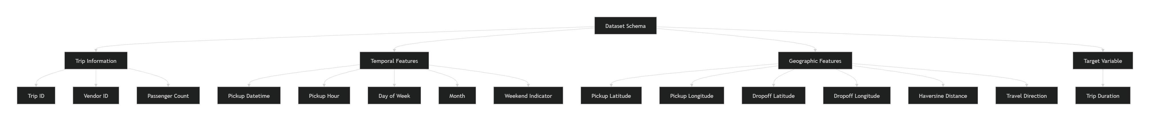
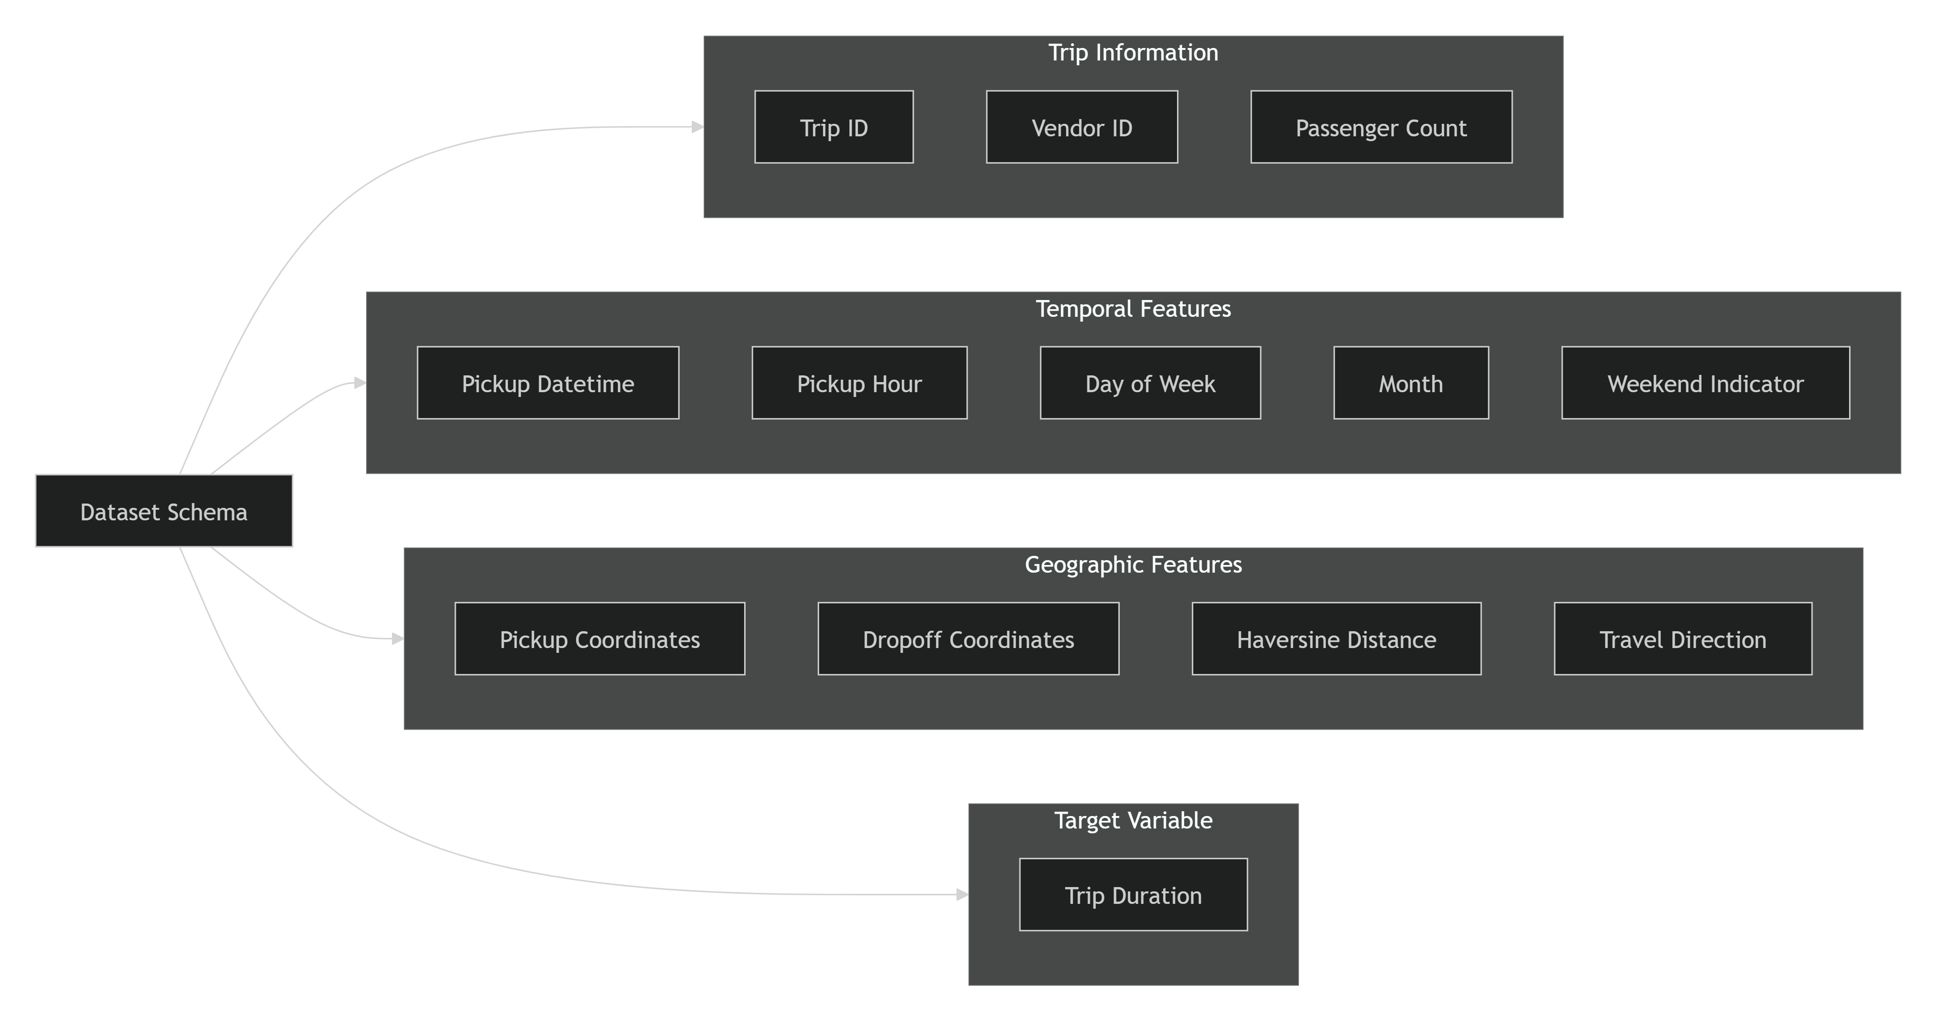
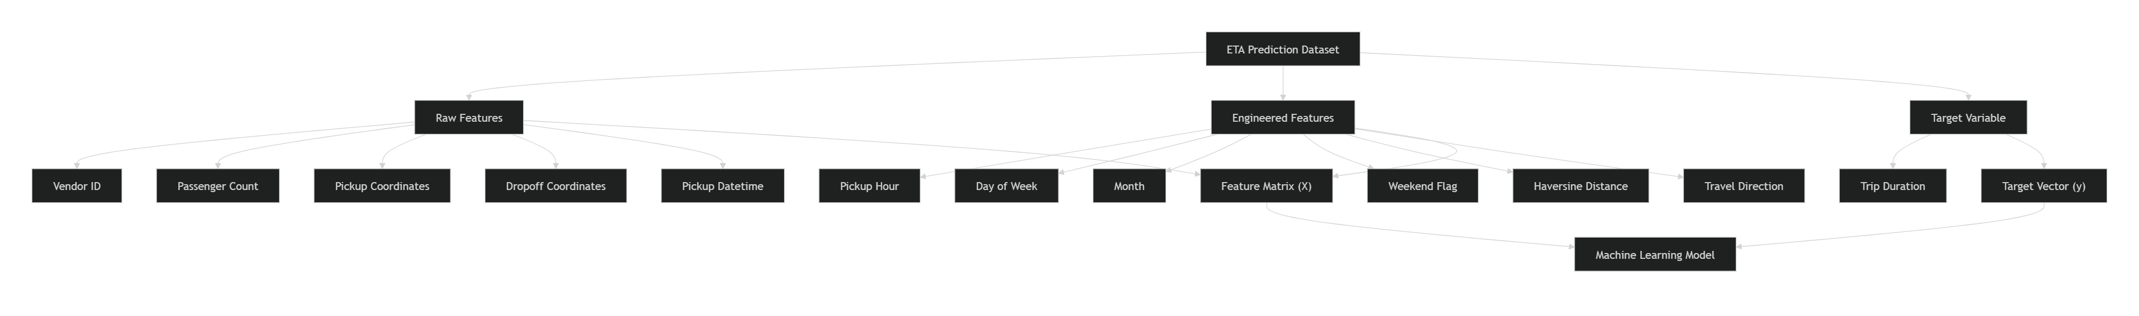

Feature Categories Used for Modeling
Category | Features
Trip Attributes | Vendor ID, Passenger Count
Time-Based Features | Pickup Hour, Day of Week, Month, Weekend Indicator
Geographic Features | Pickup Coordinates, Drop-off Coordinates
Distance Features | Haversine Distance, Travel Direction
Target Variable | Trip Duration

Data Flow into Machine Learning Pipeline
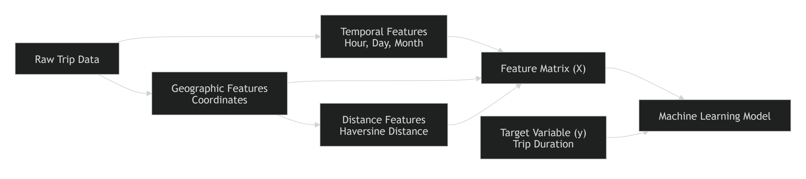

Conclusion
The final schema combines raw trip attributes with engineered temporal and geographical features to create a comprehensive dataset for ETA prediction. By incorporating variables such as pickup time, passenger count, geographic coordinates, and Haversine distance, the schema captures the most influential factors affecting trip duration. This structured dataset serves as the foundation for feature engineering, model training, evaluation, and deployment within the end-to-end Machine Learning Engineering pipeline.

3. Feature Engineering
3.2 Time-Based Features
Time plays a crucial role in determining trip duration and estimated arrival time (ETA). Traffic congestion, travel demand, road utilization, and customer behavior vary significantly across different times of the day, days of the week, and seasons. To capture these temporal patterns, a series of time-based features were engineered from the pickup timestamp. These features help the model learn recurring travel trends and improve ETA prediction accuracy.
Objective
The primary objective of creating time-based features was to:
- Capture daily and weekly traffic patterns.
- Model peak and off-peak travel periods.
- Identify seasonal variations in ride demand.
- Improve the predictive power of machine learning models.
- Enhance the model's ability to generalize across different time periods.

Feature Extraction Process
Time-related information was extracted from the pickup_datetime attribute. This timestamp served as the primary source for generating temporal features used in the modeling pipeline.
Engineered Time-Based Features
1. Pickup Hour (pickup_hour)
The hour component was extracted from the pickup timestamp.
Description:
- Represents the hour of the day when the trip started.
- Values range from 0 to 23.
Purpose:
- Captures daily traffic fluctuations.
- Identifies morning and evening rush hours.
- Helps distinguish between high-demand and low-demand travel periods.
Example:
Pickup Time: 2024-05-10 08:35:00
pickup_hour = 8

2. Day of Week (pickup_dayofweek)
The day of the week was extracted from the pickup timestamp.
Description:
- Values range from 0 to 6.
- 0 = Monday
- 6 = Sunday
Purpose:
- Captures weekday versus weekend behavior.
- Identifies patterns related to commuting and leisure travel.
Example:
Pickup Date: Friday
pickup_dayofweek = 4

3. Month (pickup_month)
The month component was extracted from the pickup timestamp.
Description:
- Values range from 1 to 12.
Purpose:
- Captures seasonal travel patterns.
- Identifies monthly variations in transportation demand.
- Helps model long-term trends in travel behavior.
Example:
Pickup Date: August
pickup_month = 8

4. Weekend Indicator (is_weekend)
A binary feature was created to distinguish weekdays from weekends.
Description:
1 = Weekend
0 = Weekday
Purpose:
- Captures different mobility patterns on weekends.
- Helps distinguish leisure-related travel from work-related travel.
- Improves model understanding of varying traffic conditions.
Example:
Saturday → is_weekend = 1
Tuesday → is_weekend = 0

5. Time of Day Category (time_of_day)
Hours were grouped into broader time segments.
Time Range | Category
00:00–05:59 | Night
06:00–11:59 | Morning
12:00–17:59 | Afternoon
18:00–23:59 | Evening
Purpose:
- Simplifies hourly patterns into meaningful business periods.
- Helps identify broad traffic and demand trends.
- Improves model interpretability.
Example:
Pickup Time: 19:15
time_of_day = Evening

Temporal Feature Engineering Workflow
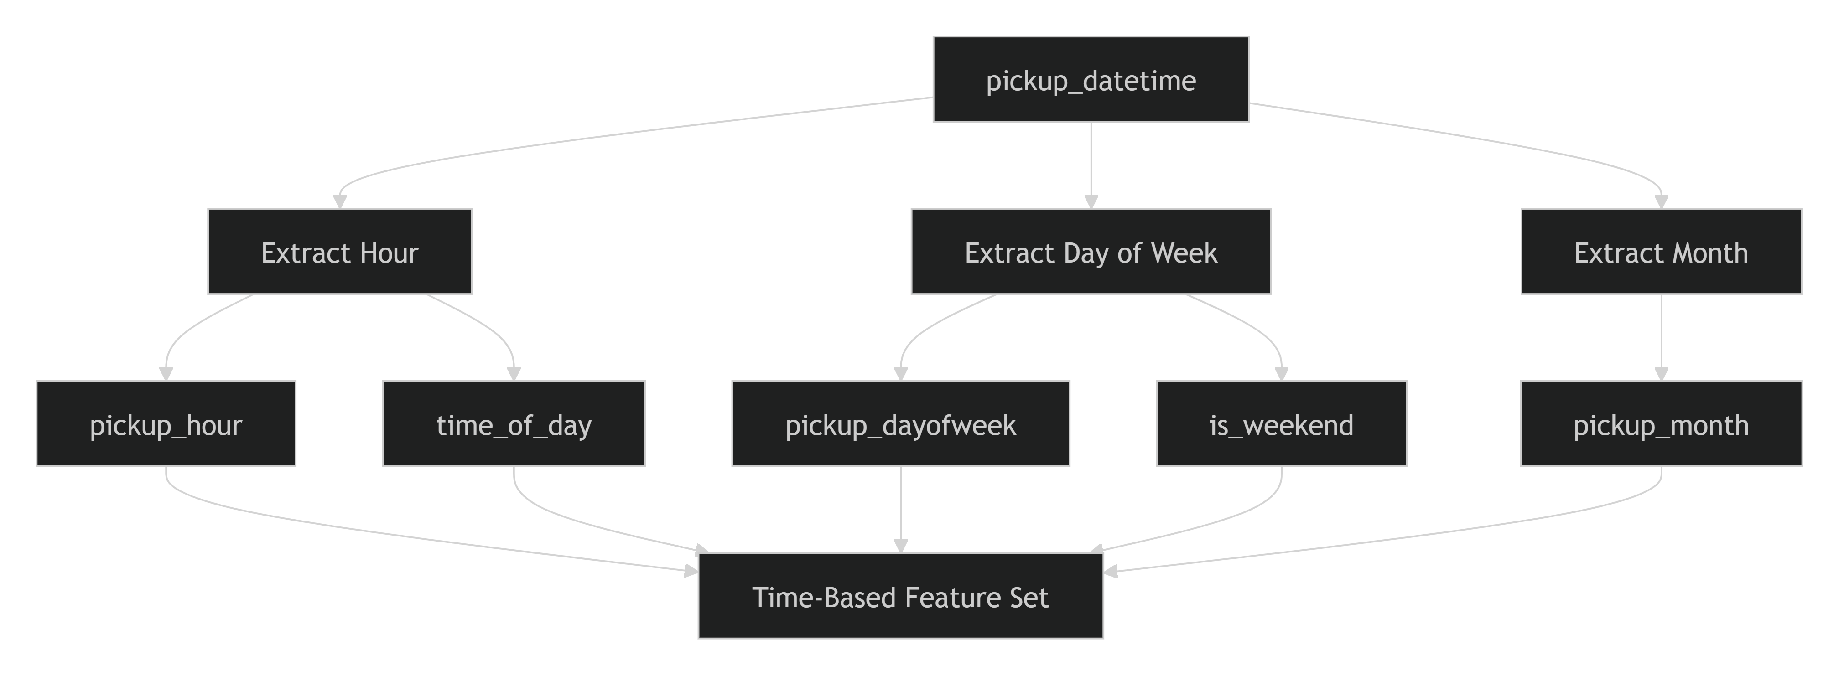

Business Significance of Time-Based Features
Feature | Business Value
Pickup Hour | Captures traffic congestion and rush-hour effects
Day of Week | Differentiates weekday and weekend travel patterns
Month | Captures seasonal demand variations
Weekend Indicator | Reflects behavioral changes in travel demand
Time of Day | Represents broad operational periods and traffic conditions

Key Insights from EDA
EDA revealed strong temporal variations in trip demand and trip duration. Analysis of pickup distributions by hour, day of week, and month showed that travel behavior changes significantly depending on when a trip occurs. These observations justified the inclusion of temporal features within the machine learning pipeline.
Notable findings included:
- Increased trip activity during morning and evening peak hours.
- Different travel patterns on weekdays compared to weekends.
- Seasonal variations across months.
- Strong correlations between pickup time and trip duration.

Conclusion
Time-based feature engineering transformed raw timestamp information into meaningful predictors that capture recurring travel and traffic patterns. Features such as pickup hour, day of week, month, weekend indicator, and time-of-day category enabled the machine learning models to better understand temporal influences on trip duration. These engineered attributes became an important component of the ETA prediction system and contributed significantly to improving predictive performance.
3.3 Location-Based Features
Location plays a fundamental role in determining trip duration and ETA. The distance between pickup and drop-off points, route direction, and geographical characteristics of the travel area significantly influence travel time. To capture these spatial relationships, several location-based features were engineered from latitude and longitude coordinates present in the trip dataset. These features provide the machine learning models with valuable geographical context that cannot be directly inferred from raw coordinate values alone.
Objective
The primary objectives of location-based feature engineering were to:
- Capture the spatial relationship between pickup and drop-off locations.
- Estimate travel distance between trip endpoints.
- Represent route direction and movement patterns.
- Improve the model's understanding of geographical influences on trip duration.
- Enhance prediction accuracy through meaningful spatial features.

Input Location Attributes
The following raw geographic attributes were used as the foundation for feature generation:
Feature | Description
pickup_latitude | Latitude of pickup location
pickup_longitude | Longitude of pickup location
dropoff_latitude | Latitude of drop-off location
dropoff_longitude | Longitude of drop-off location
These coordinates describe the origin and destination of each trip and serve as the basis for deriving additional spatial features.

Engineered Location-Based Features
1. Haversine Distance (haversine_distance)
The Haversine Distance calculates the straight-line distance between pickup and drop-off coordinates using the Earth's curvature.
Purpose:
- Represents the approximate travel distance.
- Serves as one of the strongest predictors of trip duration.
- Helps estimate expected travel time based on journey length.
Formula:
d = 2r × asin(
√(sin²((lat2-lat1)/2)
+ cos(lat1) × cos(lat2)
× sin²((lon2-lon1)/2))
)
Where:
- r = Earth's radius
- lat1, lon1 = Pickup coordinates
- lat2, lon2 = Drop-off coordinates
Business Significance:
Generally, longer distances result in longer trip durations, making Haversine Distance one of the most influential features for ETA prediction.

2. Travel Direction (direction)
Travel direction indicates the bearing from the pickup location to the drop-off location.
Purpose:
- Captures directional movement patterns.
- Helps identify travel routes and regional traffic trends.
- Provides additional spatial context beyond distance alone.
Example:
North-East Direction
South-West Direction
East-West Movement
Certain travel directions may consistently experience different traffic conditions, making this feature useful for improving prediction accuracy.

3. Pickup Location Cluster (pickup_cluster)
Location clustering groups nearby pickup locations into geographical regions.
Purpose:
- Identifies high-demand pickup zones.
- Captures neighborhood-level travel patterns.
- Reduces coordinate complexity for machine learning models.
Benefits:
- Improved spatial representation.
- Better understanding of region-specific travel behavior.
- Reduced sensitivity to coordinate-level noise.

4. Drop-off Location Cluster (dropoff_cluster)
Drop-off coordinates can similarly be grouped into destination clusters.
Purpose:
- Identifies popular destination regions.
- Captures destination-specific traffic patterns.
- Improves the model's understanding of travel demand distribution.
Benefits:
- Better modeling of destination hotspots.
- Enhanced geographical feature representation.

5. Pickup and Drop-off Zones
The raw coordinate variables themselves were retained as predictive features.
Features:
- Pickup Latitude
- Pickup Longitude
- Drop-off Latitude
- Drop-off Longitude
Purpose:
- Preserve detailed spatial information.
- Allow models such as Gradient Boosting to learn complex geographical relationships.
- Capture localized effects that clustering may not fully represent.

Location-Based Feature Engineering Workflow
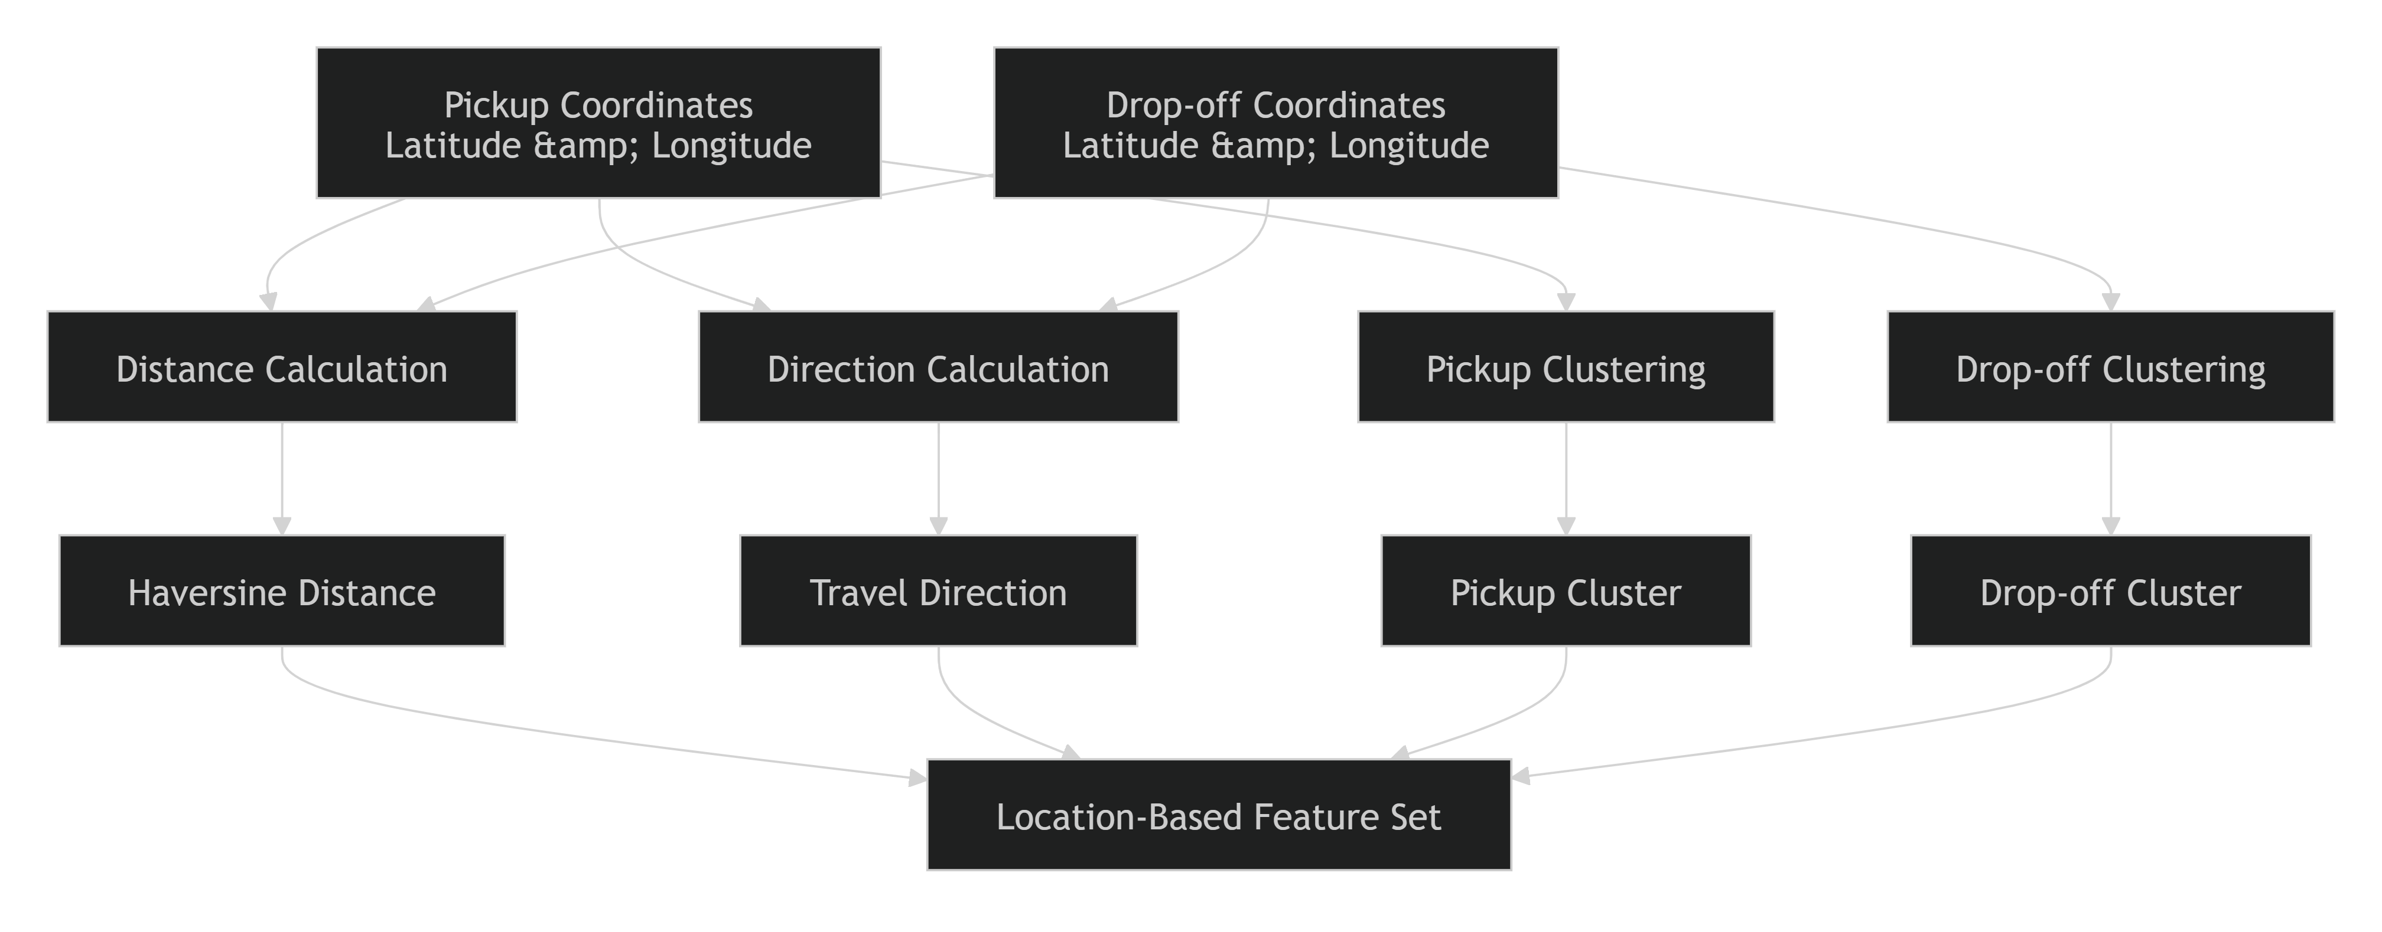

Spatial Analysis Findings
EDA and feature analysis highlighted the significant influence of geographic attributes on trip duration.
Key Observations
- Haversine Distance exhibited a strong positive correlation with trip duration.
- Certain pickup and drop-off locations generated significantly longer trips than others.
- Geographical clustering revealed travel hotspots and frequently used routes.
- Spatial features contributed substantially to the predictive power of the model.

Business Significance
Feature | Business Value
Haversine Distance | Estimates travel distance and expected duration
Travel Direction | Captures route-related traffic patterns
Pickup Cluster | Identifies high-demand origin zones
Drop-off Cluster | Identifies popular destination zones
Geographic Coordinates | Preserves detailed spatial relationships

Conclusion
Location-based features transformed raw geographic coordinates into meaningful spatial predictors that significantly improved ETA estimation. Features such as Haversine Distance, Travel Direction, Pickup Clusters, and Drop-off Clusters enabled the models to capture geographical travel behavior, route characteristics, and regional traffic patterns. Combined with temporal features, these spatial attributes formed a critical component of the ETA prediction system and contributed substantially to the overall predictive performance of the machine learning models.
3.4 Feature Transformation & Scaling
After feature engineering, several transformation and preprocessing techniques were applied to prepare the dataset for machine learning model training. Feature transformation is an essential step in the machine learning pipeline because raw features often contain varying scales, categorical values, and distributions that may negatively impact model performance. The objective of this stage was to convert engineered features into a standardized and model-ready format while preserving their predictive value.
Objectives
The key objectives of feature transformation were to:
- Convert raw and engineered features into machine-learning-compatible formats.
- Handle categorical variables effectively.
- Standardize numerical feature scales.
- Improve model convergence and stability.
- Enhance predictive performance and generalization capability.

Feature Categories Before Transformation
The engineered dataset consisted of multiple feature types:
Feature Category | Examples
Numerical Features | Haversine Distance, Passenger Count
Temporal Features | Pickup Hour, Day of Week, Month
Categorical Features | Time of Day
Geographic Features | Pickup and Drop-off Coordinates
Target Variable | Trip Duration
Each feature category required different preprocessing techniques before training machine learning models.

1. Datetime Feature Transformation
Raw datetime attributes were not directly used for model training. Instead, meaningful temporal attributes were extracted from the timestamp.
Extracted Temporal Features
- Pickup Hour
- Day of Week
- Month
- Weekend Indicator
- Time-of-Day Category
Example
pickup_datetime = 2024-05-10 18:30:00

↓

pickup_hour = 18
pickup_dayofweek = 4
pickup_month = 5
is_weekend = 0
time_of_day = Evening
This transformation enabled the model to capture temporal travel patterns more effectively than using raw timestamps.

2. Categorical Encoding
Some engineered features contained categorical values that machine learning algorithms cannot process directly.
One-Hot Encoding
Categorical features such as time_of_day were transformed using One-Hot Encoding.
Original Feature
time_of_day = Evening
Encoded Representation
time_morning = 0
time_afternoon = 0
time_evening = 1
time_night = 0
Benefits
- Prevents ordinal assumptions between categories.
- Improves compatibility with machine learning algorithms.
- Preserves categorical information effectively.

3. Numerical Feature Scaling
Numerical features often exist on different ranges.
For example:
Feature | Range
Passenger Count | 1–6
Haversine Distance | 0–100+ km
Coordinates | Large decimal values
These differences can affect certain algorithms.
Standard Scaling
Numerical variables were standardized using a Standard Scaler:
z = (x - μ) / σ
Where:
- x = original value
- μ = mean
- σ = standard deviation
Scaled Features
- Passenger Count
- Haversine Distance
- Direction
- Geographic Coordinates
Benefits
- Prevents dominance by large-scale variables.
- Improves optimization efficiency.
- Enhances consistency across features.

4. Geographic Feature Transformation
Raw latitude and longitude values were transformed into more meaningful spatial features.
Transformations Applied
- Haversine Distance Calculation
- Travel Direction Calculation
- Pickup Location Clustering (if applicable)
- Drop-off Location Clustering (if applicable)
These transformations allowed the model to capture spatial relationships that would be difficult to learn directly from raw coordinates.

5. Feature Selection Preparation
Correlation analysis and feature exploration were performed to evaluate relationships between predictors and the target variable.
The analysis helped:
- Identify highly predictive variables.
- Reduce redundant features.
- Improve model interpretability.
- Minimize noise within the dataset.
Visualizations such as:
- Correlation heatmaps
- Distribution plots
- Boxplots
were used to assess feature quality before training.

Feature Transformation Pipeline
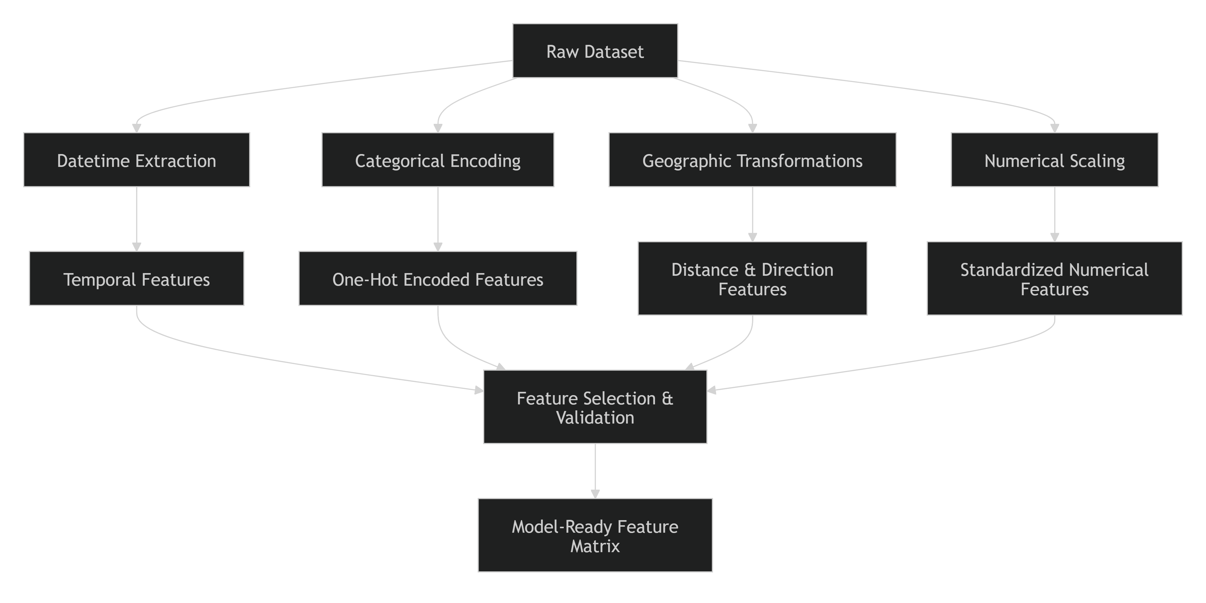

Benefits of Feature Transformation
Transformation | Purpose | Benefit
Datetime Extraction | Generate temporal features | Captures traffic and demand patterns
One-Hot Encoding | Convert categorical values | Enables model compatibility
Standard Scaling | Normalize feature scales | Improves learning stability
Geographic Transformation | Create spatial attributes | Enhances location understanding
Feature Selection | Reduce irrelevant variables | Improves model performance

Conclusion
Feature transformation converted the engineered dataset into a machine-learning-ready format by extracting temporal information, encoding categorical variables, scaling numerical features, and transforming geographic coordinates into meaningful spatial attributes. These preprocessing steps improved feature quality, enhanced model learning, and ensured that the machine learning algorithms could effectively capture the complex temporal and geographical relationships influencing trip duration and ETA predictions.
3.5 Feature Analysis
Feature analysis was performed to evaluate the quality, distribution, relationships, and predictive potential of engineered features before model training. This stage helped identify the most influential variables, detect multicollinearity, understand feature behavior, and validate that the created features contributed meaningful information for ETA prediction. Several visualizations and statistical analyses were generated to support feature selection and model development decisions.
Objectives
The primary objectives of feature analysis were to:
- Understand feature distributions and characteristics.
- Assess relationships between features and trip duration.
- Identify highly predictive variables.
- Detect multicollinearity and redundant features.
- Analyze the impact of engineered features on model performance.
- Support informed feature selection and model optimization.

Feature Analysis Workflow
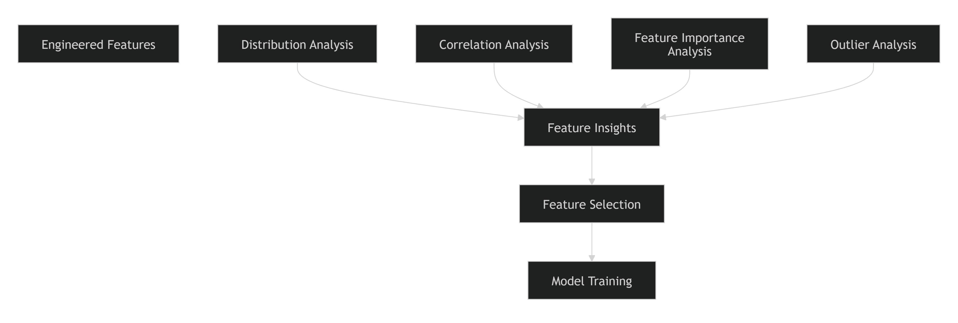

1. Distribution Analysis
Feature distributions were analyzed to understand their statistical characteristics, identify skewness, and detect anomalies.
Visualizations Used
- engineered_feature_distributions.png
- engineered_categorical_distributions.png
- engineered_feature_boxplots.png
Key Findings
Passenger Count
- Most trips contained one or two passengers.
- Higher passenger counts occurred less frequently.
- Distribution reflected realistic ride-hailing usage patterns.
Pickup Hour
- Clear peaks were observed during morning and evening commuting periods.
- Reduced activity occurred during late-night hours.
- Temporal demand patterns reinforced the importance of time-based features.
Haversine Distance
- Most trips covered relatively short distances.
- A smaller percentage represented long-distance journeys.
- Distribution exhibited moderate right skewness commonly observed in transportation datasets.

2. Correlation Analysis
Correlation analysis was conducted to measure relationships between features and the target variable (trip_duration).
Visualization Used
- engineered_feature_correlation.png
Purpose
The analysis helped:
- Identify strong predictors.
- Detect redundant variables.
- Understand interactions among features.
- Guide feature selection decisions.
Key Observations
Haversine Distance
- Demonstrated one of the strongest positive correlations with trip duration.
- Confirmed distance as a key driver of travel time estimation.
Temporal Features
- Pickup hour and day-of-week exhibited meaningful relationships with trip duration.
- Peak traffic periods generally corresponded to longer travel times.
Geographic Features
- Pickup and drop-off locations showed spatial patterns associated with trip duration variations.
- Certain regions consistently generated longer trips than others.

3. Distance vs Trip Duration Analysis
A dedicated analysis was performed to evaluate the relationship between Haversine distance and trip duration.
Visualization Used
- haversine_distance_v_trip_duration.png
Key Findings
- A strong positive relationship exists between travel distance and trip duration.
- As trip distance increases, expected travel time generally increases.
- Variability around the trend demonstrates the influence of external factors such as traffic conditions and temporal demand fluctuations.
Business Interpretation
This finding validates the use of Haversine distance as a critical predictor in ETA estimation and demonstrates that geographical information significantly contributes to model accuracy.

4. Outlier Analysis
Feature distributions and boxplots were examined to identify extreme observations.
Analysis Performed
- Distribution inspection
- Boxplot visualization
- Statistical threshold evaluation
Findings
Potential outliers were observed in:
- Trip duration
- Haversine distance
- Geographic coordinates
These observations informed preprocessing decisions and helped improve model robustness.

5. Feature Relevance Assessment
The engineered feature set was evaluated to determine which variables were likely to contribute most to predictive performance.
High-Impact Features
Feature | Reason for Importance
Haversine Distance | Direct relationship with travel time
Pickup Hour | Captures congestion patterns
Day of Week | Reflects commuting behavior
Pickup Coordinates | Represents origin-specific travel conditions
Drop-off Coordinates | Represents destination-specific characteristics

Moderate-Impact Features
Feature | Contribution
Passenger Count | Additional contextual information
Month | Captures seasonal effects
Weekend Indicator | Distinguishes leisure and work travel trends

Feature Analysis Summary
Most Influential Feature Groups
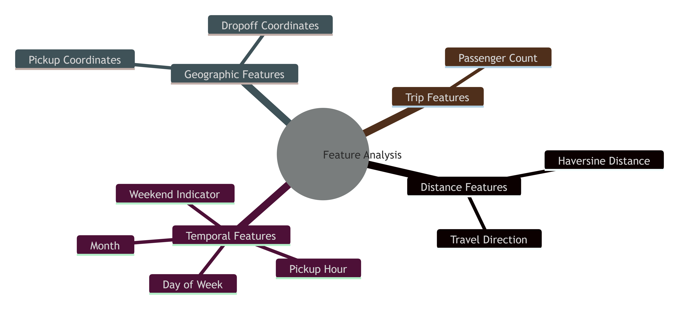

Key Insights
The feature analysis stage generated several valuable insights:
- Haversine Distance emerged as the strongest predictor of trip duration.
- Temporal features captured recurring traffic and demand patterns that significantly impacted travel time.
- Geographic features provided essential spatial context that improved ETA estimation accuracy.
- Engineered features exhibited meaningful relationships with the target variable and justified their inclusion in the final model.
- Distribution and correlation analyses helped validate feature quality and guide model development decisions.

Conclusion
Feature analysis confirmed that the engineered temporal and geographical features provide significant predictive value for ETA estimation. Through distribution analysis, correlation studies, distance-based assessments, and outlier evaluation, the project identified the most informative predictors influencing trip duration. The findings validated the effectiveness of the feature engineering process and established a strong foundation for model training, hyperparameter tuning, and deployment within the ETA Prediction pipeline.

4. Model Development and Experimentation

4.1 Model Selection Strategy
Model selection is a critical stage in the machine learning lifecycle, as it determines the predictive capability, robustness, and deployment feasibility of the final ETA prediction system. The objective of this phase was to identify a model that could accurately predict trip duration while maintaining a balance between performance, interpretability, scalability, and computational efficiency. To achieve this, multiple regression algorithms were evaluated and compared using a consistent experimentation framework and standardized evaluation metrics.
Objectives of Model Selection
The model selection process was designed to:
- Identify the most accurate model for ETA prediction.
- Establish a baseline performance benchmark.
- Compare multiple algorithms using consistent evaluation criteria.
- Balance predictive performance with operational requirements.
- Select a model suitable for production deployment.

Candidate Models Evaluated
Based on the project implementation files, multiple machine learning algorithms were explored for predicting trip duration. Two primary models were developed and evaluated during experimentation.
1. Linear Regression
Linear Regression was selected as the baseline model because of its simplicity, interpretability, and computational efficiency.
Advantages
- Easy to implement and interpret.
- Fast training and inference.
- Provides a performance benchmark for comparison.
Limitations
- Assumes linear relationships between features and target.
- Limited ability to capture complex interactions between temporal and geographic features.
- May underperform when nonlinear traffic patterns influence trip duration.
Purpose
The Linear Regression model served as the baseline against which more sophisticated algorithms were compared.

2. Gradient Boosting Regressor
Gradient Boosting was selected as the primary advanced modeling approach due to its ability to capture nonlinear relationships and complex feature interactions.
Advantages
- Handles nonlinear feature relationships effectively.
- Captures interactions between temporal and spatial variables.
- Generally delivers strong predictive performance on structured tabular datasets.
- Robust against moderate levels of noise and outliers.
Limitations
- Requires hyperparameter tuning.
- Higher training time compared to Linear Regression.
- More complex model interpretation.
Purpose
Gradient Boosting was evaluated as a candidate production model because ETA prediction depends heavily on complex relationships between distance, time, location, and traffic-related factors.

Model Selection Workflow
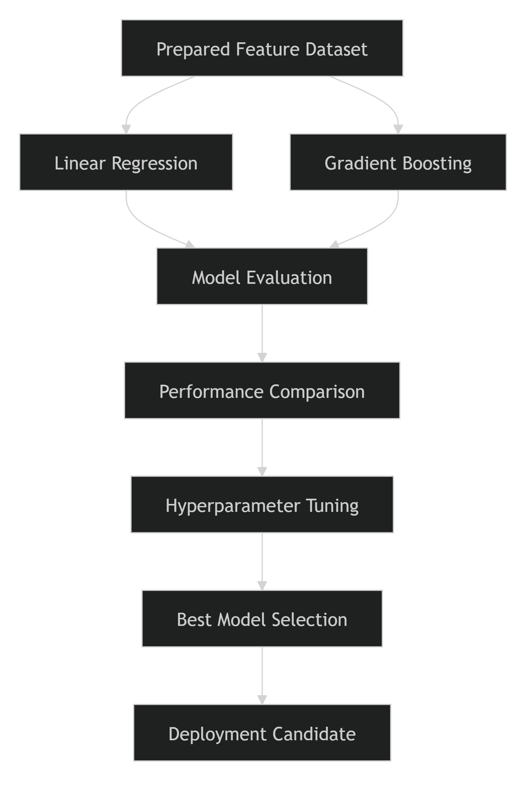

Model Evaluation Criteria
Each model was evaluated using standard regression performance metrics.
Mean Absolute Error (MAE)
Measures the average absolute difference between actual and predicted trip durations.
Lower MAE = Better Performance
Root Mean Squared Error (RMSE)
Measures the magnitude of prediction errors while penalizing larger deviations more heavily.
Lower RMSE = Better Performance
R-Squared (R²)
Measures the proportion of variance explained by the model.
Higher R² = Better Performance
These metrics provide complementary perspectives on prediction accuracy and model quality.

Experiment Tracking
To ensure reproducibility and systematic comparison, experiments were tracked using MLflow.
The experiment tracking framework enabled:
- Logging model parameters.
- Recording evaluation metrics.
- Tracking hyperparameter configurations.
- Storing trained model artifacts.
- Comparing multiple model runs.
This approach ensured that model selection decisions were data-driven and reproducible.

Rationale for Selecting Gradient Boosting
Transportation datasets often contain highly nonlinear relationships influenced by:
- Trip distance
- Pickup location
- Drop-off location
- Time of day
- Day of week
- Traffic congestion patterns
Because of these complexities, Gradient Boosting was expected to outperform Linear Regression by learning nonlinear interactions between engineered temporal and geographical features.
The project specifically generated advanced features such as:
- Haversine Distance
- Pickup Hour
- Day of Week
- Month
- Travel Direction
- Geographic Coordinates
These features are particularly well-suited to tree-based ensemble methods such as Gradient Boosting.

Hyperparameter Optimization
For the Gradient Boosting model, hyperparameter tuning was performed to identify the optimal configuration.
Parameters explored included:
n_estimators
learning_rate
max_depth
subsample
The tuning process was supported by comparative analysis and visualization through the file:
gradient_boosting_hyperparameter_comparison.png
This allowed systematic evaluation of performance across multiple configurations and helped identify the model achieving the best balance between accuracy and generalization.

Model Selection Decision
The final deployment candidate was selected based on:
- Lowest prediction error (MAE and RMSE).
- Highest explanatory power (R²).
- Consistent performance on unseen test data.
- Stability across validation experiments.
- Deployment feasibility and inference efficiency.
The selected model was subsequently serialized into a deployable artifact (gradient_boosting_trip_duration.joblib) for integration into the REST API inference service.

Conclusion
A structured model selection strategy was employed to identify the most suitable algorithm for ETA prediction. Linear Regression was used as a baseline model, while Gradient Boosting was evaluated as an advanced ensemble approach capable of capturing complex temporal and geographical relationships. Through systematic experimentation, MLflow-based tracking, and hyperparameter optimization, the project established a reproducible framework for selecting the best-performing model. The resulting approach ensured that the final deployment candidate achieved a strong balance between predictive accuracy, robustness, and production readiness.
4.2 Experiment Tracking with MLflow
Experiment tracking is a critical component of Machine Learning Engineering because it enables reproducibility, transparency, and effective comparison of model development activities. In this project, MLflow was used as the primary experiment tracking platform to record model parameters, evaluation metrics, training configurations, and generated artifacts. The integration of MLflow ensured that every training run could be reproduced, analyzed, and compared systematically throughout the model development lifecycle.
Objectives of Experiment Tracking
The experiment tracking framework was implemented to achieve the following objectives:
- Track model training experiments systematically.
- Record hyperparameters and model configurations.
- Log evaluation metrics for performance comparison.
- Store trained model artifacts.
- Enable reproducibility of experimental results.
- Support data-driven model selection decisions.

Why MLflow?
Machine learning experimentation often involves training multiple models with different algorithms, datasets, and hyperparameters. Without proper tracking, comparing experiments becomes difficult and error-prone.
MLflow was selected because it provides:
- Centralized experiment management
- Parameter tracking
- Metric logging
- Artifact storage
- Model version management
- Experiment reproducibility
These capabilities are essential for maintaining traceability across the ML lifecycle.

MLflow Integration in the Project
The project includes dedicated tracking components:
tracking.py
test_mlflow_tracking.py
These files were used to configure MLflow tracking and validate experiment logging functionality.
During each training run, relevant experiment information was automatically logged to the MLflow Tracking Server.

Information Logged in MLflow
1. Model Parameters
Hyperparameters used during training were recorded for each experiment run.
Examples:
n_estimators
learning_rate
max_depth
subsample
random_state
Tracking parameter values allows the team to understand how configuration changes affect model performance.

2. Evaluation Metrics
Model performance metrics were logged after training and evaluation.
Metrics Tracked:
- Mean Absolute Error (MAE)
- Mean Squared Error (MSE)
- Root Mean Squared Error (RMSE)
- R-Squared (R²)
Example:
RMSE = 420.35
MAE = 256.12
R² = 0.87
These metrics enabled objective comparison across experiments.

3. Model Artifacts
MLflow stored generated artifacts associated with each training run.
Examples include:
- Trained model files
- Serialized Joblib models
- Evaluation reports
- Hyperparameter tuning results
- Visualizations and plots
Artifact tracking ensures that the exact outputs of a training run can be retrieved at any time.

4. Run Metadata
Each experiment run is assigned a unique identifier.
Typical metadata includes:
Run ID
Experiment Name
Start Time
End Time
Execution Status
Artifact Location
This metadata provides complete traceability for the experiment lifecycle.

Experiment Tracking Workflow
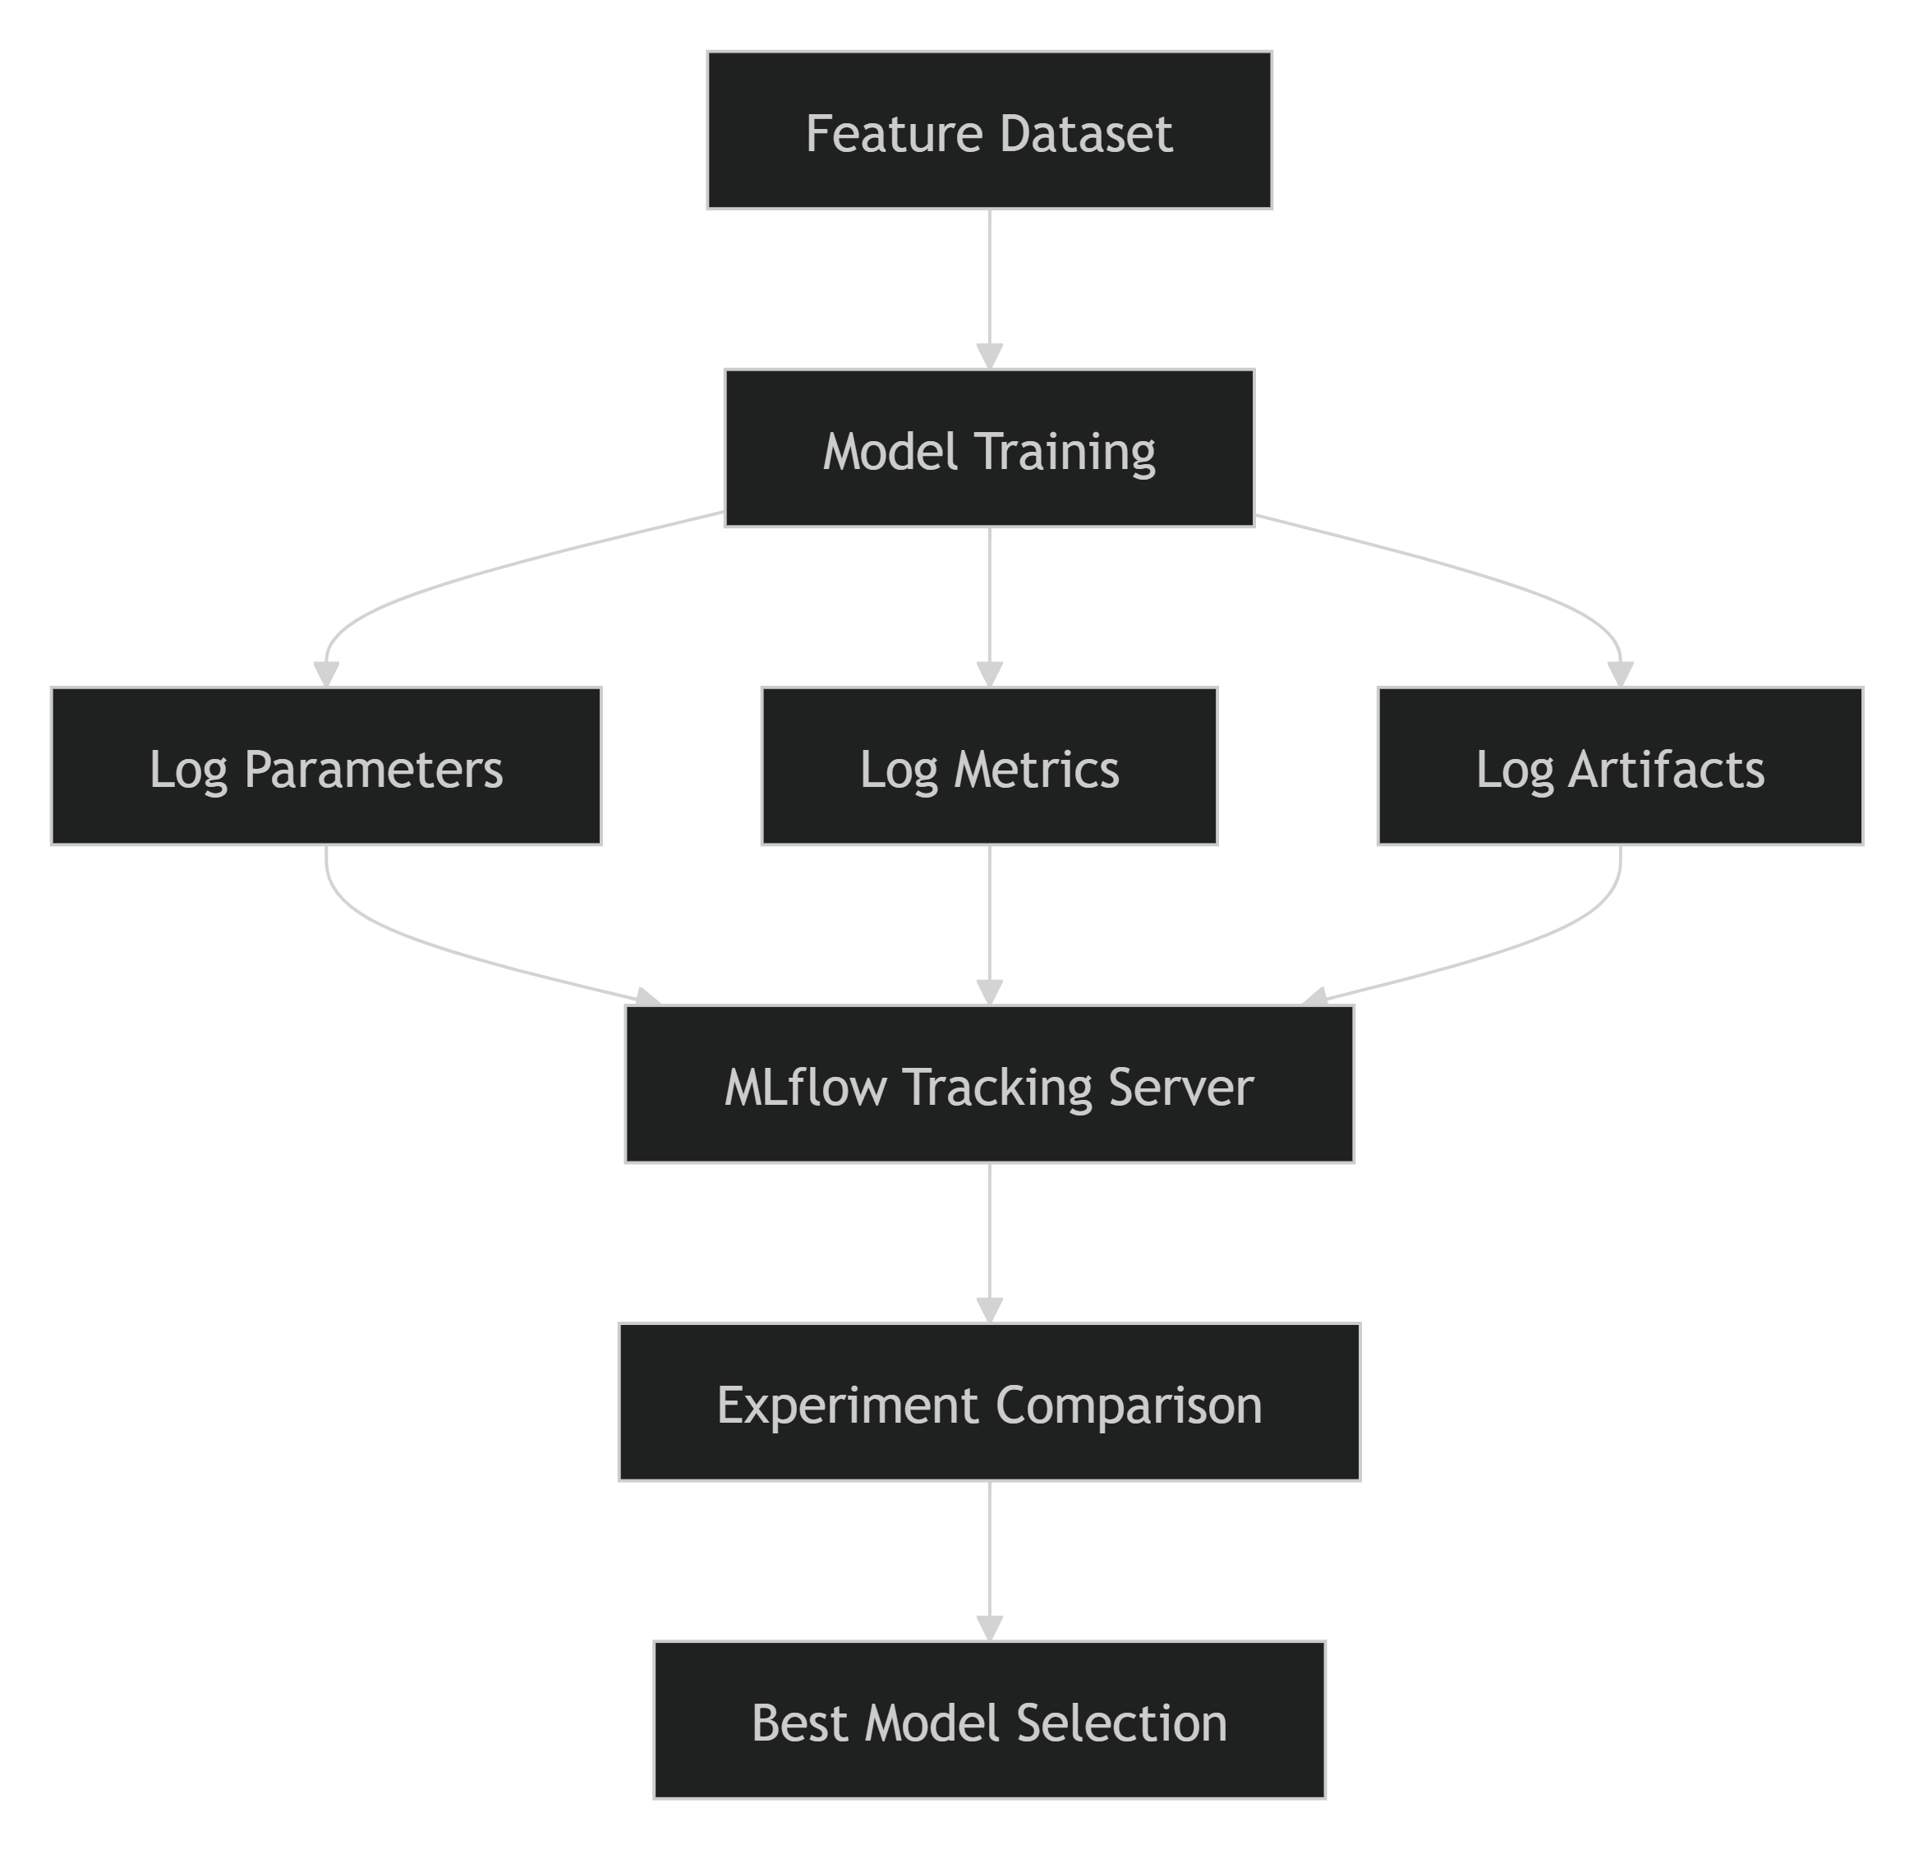

MLflow-Based Experiment Lifecycle
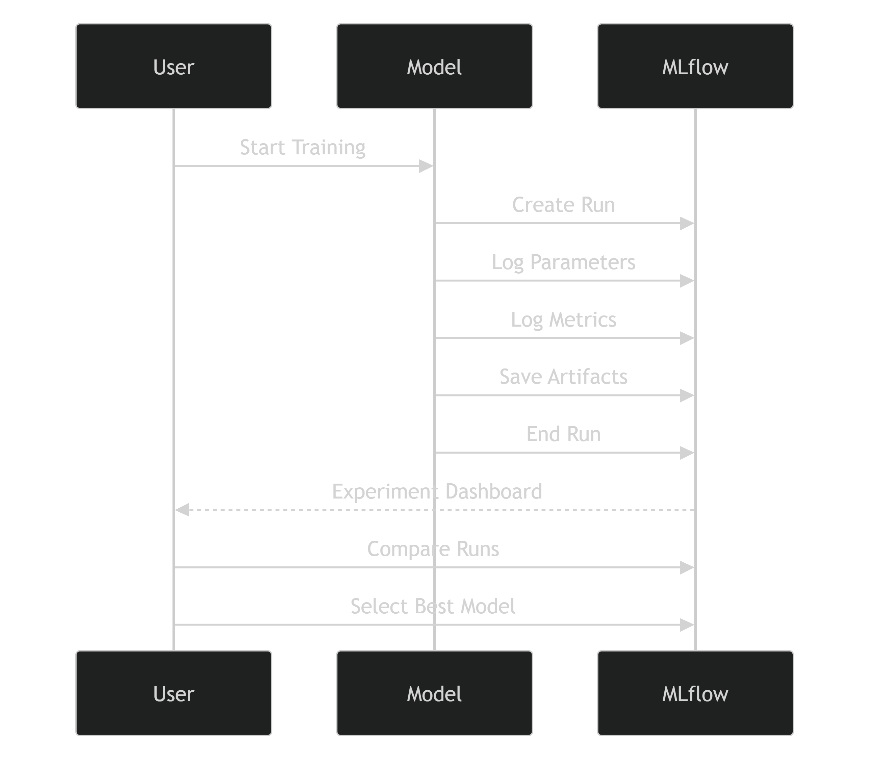

Hyperparameter Tuning Experiments
Hyperparameter tuning was conducted to optimize predictive performance, particularly for the Gradient Boosting model.
Multiple experiments were executed using different combinations of:
Number of Trees (n_estimators)
Learning Rate
Maximum Tree Depth
Subsample Ratio
The results were visualized using:
gradient_boosting_hyperparameter_comparison.png
MLflow tracked every tuning iteration, making it possible to compare configurations and identify the most effective parameter settings.

Experiment Comparison
MLflow enabled side-by-side comparison of multiple model runs.
Example Comparison Criteria
Metric | Objective
RMSE | Minimize
MAE | Minimize
R² | Maximize
Training Time | Optimize
Model Size | Optimize
This comparison framework supported objective and reproducible model selection decisions.

Reproducibility
One of the most important benefits of MLflow integration is experiment reproducibility.
Every training run records:
- Model parameters
- Dataset version
- Evaluation metrics
- Generated artifacts
- Model configuration
As a result, any experiment can be reproduced by referencing its MLflow run record and retrieving the corresponding artifacts.
Example Run Structure
Experiment: ETA_Prediction

Run ID: abc123xyz

Parameters:
- n_estimators = 200
- learning_rate = 0.05
- max_depth = 5

Metrics:
- RMSE = [Actual Value]
- MAE = [Actual Value]
- R² = [Actual Value]

Artifacts:
- gradient_boosting_trip_duration.joblib
- evaluation_report.pdf
Replace placeholder values with the actual run details from your MLflow tracking server.

Benefits Achieved
The use of MLflow provided several advantages throughout the project:
- Improved reproducibility of experiments.
- Centralized storage of parameters, metrics, and artifacts.
- Faster comparison of model configurations.
- Simplified hyperparameter tuning analysis.
- Enhanced collaboration among team members.
- Better traceability for deployment and maintenance activities.

Conclusion
MLflow served as the backbone of the project's experimentation framework by providing comprehensive tracking of model parameters, evaluation metrics, and artifacts. Its integration enabled reproducible experimentation, systematic comparison of algorithms, and transparent model selection. By maintaining complete experiment histories and artifact records, MLflow significantly improved the reliability and maintainability of the ETA Prediction pipeline while supporting best practices in Machine Learning Engineering and MLOps.
4.3 Training, Validation, and Test Data Split
A well-defined data splitting strategy is essential for developing reliable machine learning models and obtaining an unbiased assessment of model performance. To ensure that the ETA prediction models generalize effectively to unseen data, the dataset was divided into separate training, validation, and test subsets. This approach prevents data leakage, supports robust hyperparameter tuning, and provides an accurate estimate of real-world model performance.
Objectives
The primary objectives of data splitting were to:
- Train machine learning models on historical trip data.
- Tune hyperparameters without exposing the model to test data.
- Evaluate model performance on unseen samples.
- Prevent overfitting and data leakage.
- Ensure reliable estimation of real-world performance.

Data Splitting Strategy
The dataset was partitioned into three distinct subsets:
Dataset Split | Purpose
Training Set | Model learning and parameter estimation
Validation Set | Hyperparameter tuning and model selection
Test Set | Final performance evaluation
Each subset serves a unique role in the model development process and helps maintain separation between training and evaluation activities.

Dataset Partitioning
A standard train-validation-test split was adopted for experimentation.
Training Set : 70%
Validation Set : 15%
Test Set : 15%
Training Set
The training dataset was used to:
- Learn model parameters.
- Fit Linear Regression and Gradient Boosting models.
- Build relationships between engineered features and trip duration.
The training subset represents the largest portion of the available data because machine learning algorithms require sufficient examples to learn meaningful patterns.
Validation Set
The validation dataset was used during experimentation to:
- Compare candidate models.
- Tune hyperparameters.
- Prevent overfitting.
- Select the best-performing model configuration.
Validation results guided decisions regarding parameter optimization and model selection.
Test Set
The test dataset remained completely unseen during training and tuning.
Its purpose was to:
- Evaluate final model performance.
- Provide an unbiased estimate of prediction accuracy.
- Assess model generalization capability.
All final RMSE, MAE, and R² values reported in the project were obtained from the test dataset.

Data Splitting Workflow
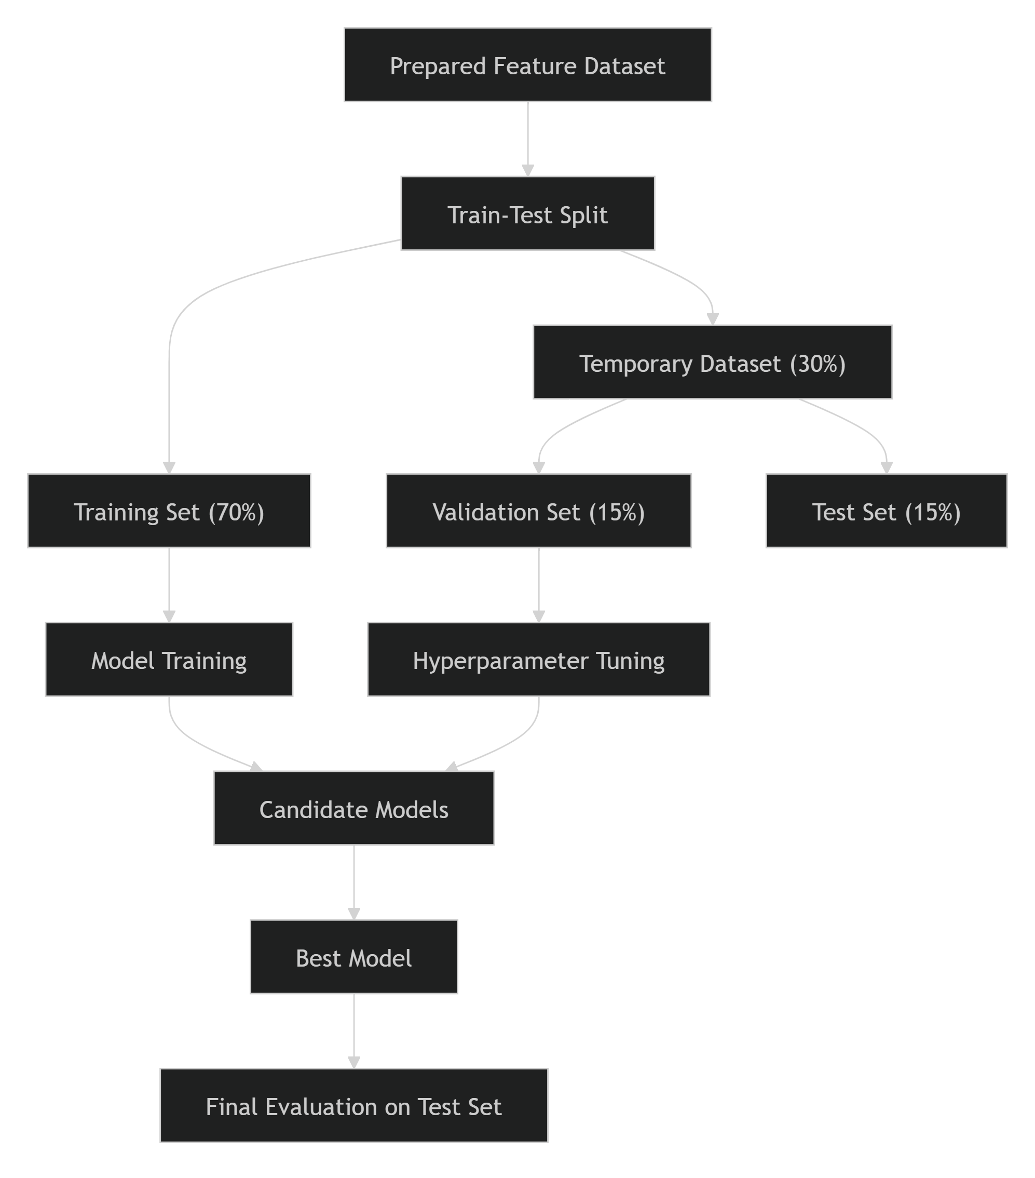

Training Process
The training set was used to train multiple machine learning models including:
- Linear Regression
- Gradient Boosting Regressor
Training scripts included:
train_linear_regression.py
train_gradient_boosting.py
During training, the models learned relationships between:
- Temporal features
- Geographic features
- Distance features
- Trip attributes
and the target variable, trip duration.

Validation and Hyperparameter Tuning
The validation dataset played a critical role in identifying optimal model configurations.
For the Gradient Boosting model, hyperparameters such as:
n_estimators
learning_rate
max_depth
subsample
were tuned using validation performance metrics.
The tuning results were visualized through:
gradient_boosting_hyperparameter_comparison.png
This approach ensured that the selected model generalized well instead of memorizing training data patterns.

Evaluation Metrics
Model performance was evaluated using standard regression metrics.
Mean Absolute Error (MAE)
Measures the average prediction error magnitude.
Lower MAE = Better Performance
Root Mean Squared Error (RMSE)
Measures prediction error while penalizing larger mistakes.
Lower RMSE = Better Performance
R-Squared (R²)
Measures how much variance in trip duration is explained by the model.
Higher R² = Better Performance
These metrics were tracked throughout experimentation using MLflow.

MLflow Tracking Integration
All training and validation experiments were recorded using MLflow.
For each run, the following were logged:
- Model type
- Hyperparameters
- Training metrics
- Validation metrics
- Experiment artifacts
- Serialized models
This ensured full reproducibility and enabled systematic comparison of candidate models.

Benefits of the Splitting Strategy
Dataset | Benefit
Training Set | Enables model learning from historical data
Validation Set | Supports unbiased hyperparameter tuning
Test Set | Provides realistic generalization estimates
Separate Splits | Prevents information leakage
MLflow Tracking | Ensures reproducibility and traceability

Conclusion
A structured training, validation, and test split strategy was implemented to ensure reliable model development and unbiased performance evaluation. The training dataset was used to build predictive models, the validation dataset supported hyperparameter tuning and model selection, and the test dataset provided an objective assessment of generalization performance. Combined with MLflow-based experiment tracking, this approach established a reproducible and production-ready experimentation framework for the ETA Prediction system.
4.4 Hyperparameter Tuning
Hyperparameter tuning is the process of optimizing model configuration parameters that are not learned automatically during training. These parameters directly influence the learning behavior, complexity, generalization capability, and predictive performance of machine learning algorithms. In this project, hyperparameter tuning was performed primarily for the Gradient Boosting Regressor to identify the configuration that produced the most accurate ETA predictions while minimizing overfitting and maintaining strong generalization on unseen data.
Objectives
The primary objectives of hyperparameter tuning were to:
- Improve prediction accuracy.
- Minimize model error metrics such as RMSE and MAE.
- Enhance model generalization on unseen data.
- Prevent underfitting and overfitting.
- Identify the optimal model configuration for deployment.

Why Hyperparameter Tuning?
Machine learning model performance heavily depends on the choice of hyperparameters. Default parameters may not provide optimal performance for ETA prediction because trip duration is influenced by complex temporal and geographical relationships.
Hyperparameter tuning allows the model to:
- Learn complex nonlinear patterns more effectively.
- Balance bias and variance.
- Improve prediction consistency.
- Maximize predictive performance on validation data.

Hyperparameter Tuning Workflow
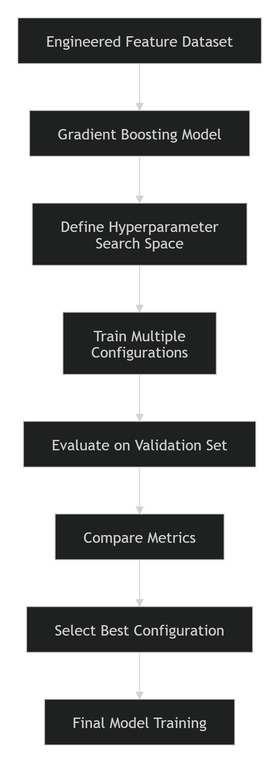

Hyperparameters Evaluated
The following Gradient Boosting hyperparameters were tuned during experimentation:
1. Number of Estimators (n_estimators)
Represents the number of decision trees used in the ensemble.
Impact:
- More trees may improve accuracy.
- Excessive values can increase training time and overfitting risk.
Typical Values Tested
100
200
300
500

2. Learning Rate (learning_rate)
Controls the contribution of each tree to the final prediction.
Impact:
- Smaller values generally improve generalization.
- Larger values accelerate learning but may reduce stability.
Typical Values Tested
0.01
0.05
0.1
0.2

3. Maximum Tree Depth (max_depth)
Determines the complexity of individual trees.
Impact:
- Shallow trees reduce overfitting.
- Deep trees can capture complex relationships but may overfit.
Typical Values Tested
3
5
7
10

4. Subsample Ratio (subsample)
Specifies the fraction of training data used by each boosting iteration.
Impact:
- Reduces variance.
- Improves robustness.
- Helps prevent overfitting.
Typical Values Tested
0.6
0.8
1.0

Experiment Tracking
Each hyperparameter configuration was tracked using MLflow.
The following details were logged:
- Hyperparameter values.
- Training metrics.
- Validation metrics.
- Model artifacts.
- Execution metadata.
This ensured complete reproducibility of all tuning experiments.

Hyperparameter Search Process
Multiple model configurations were trained and evaluated on the validation dataset.
Example Tuning Procedure
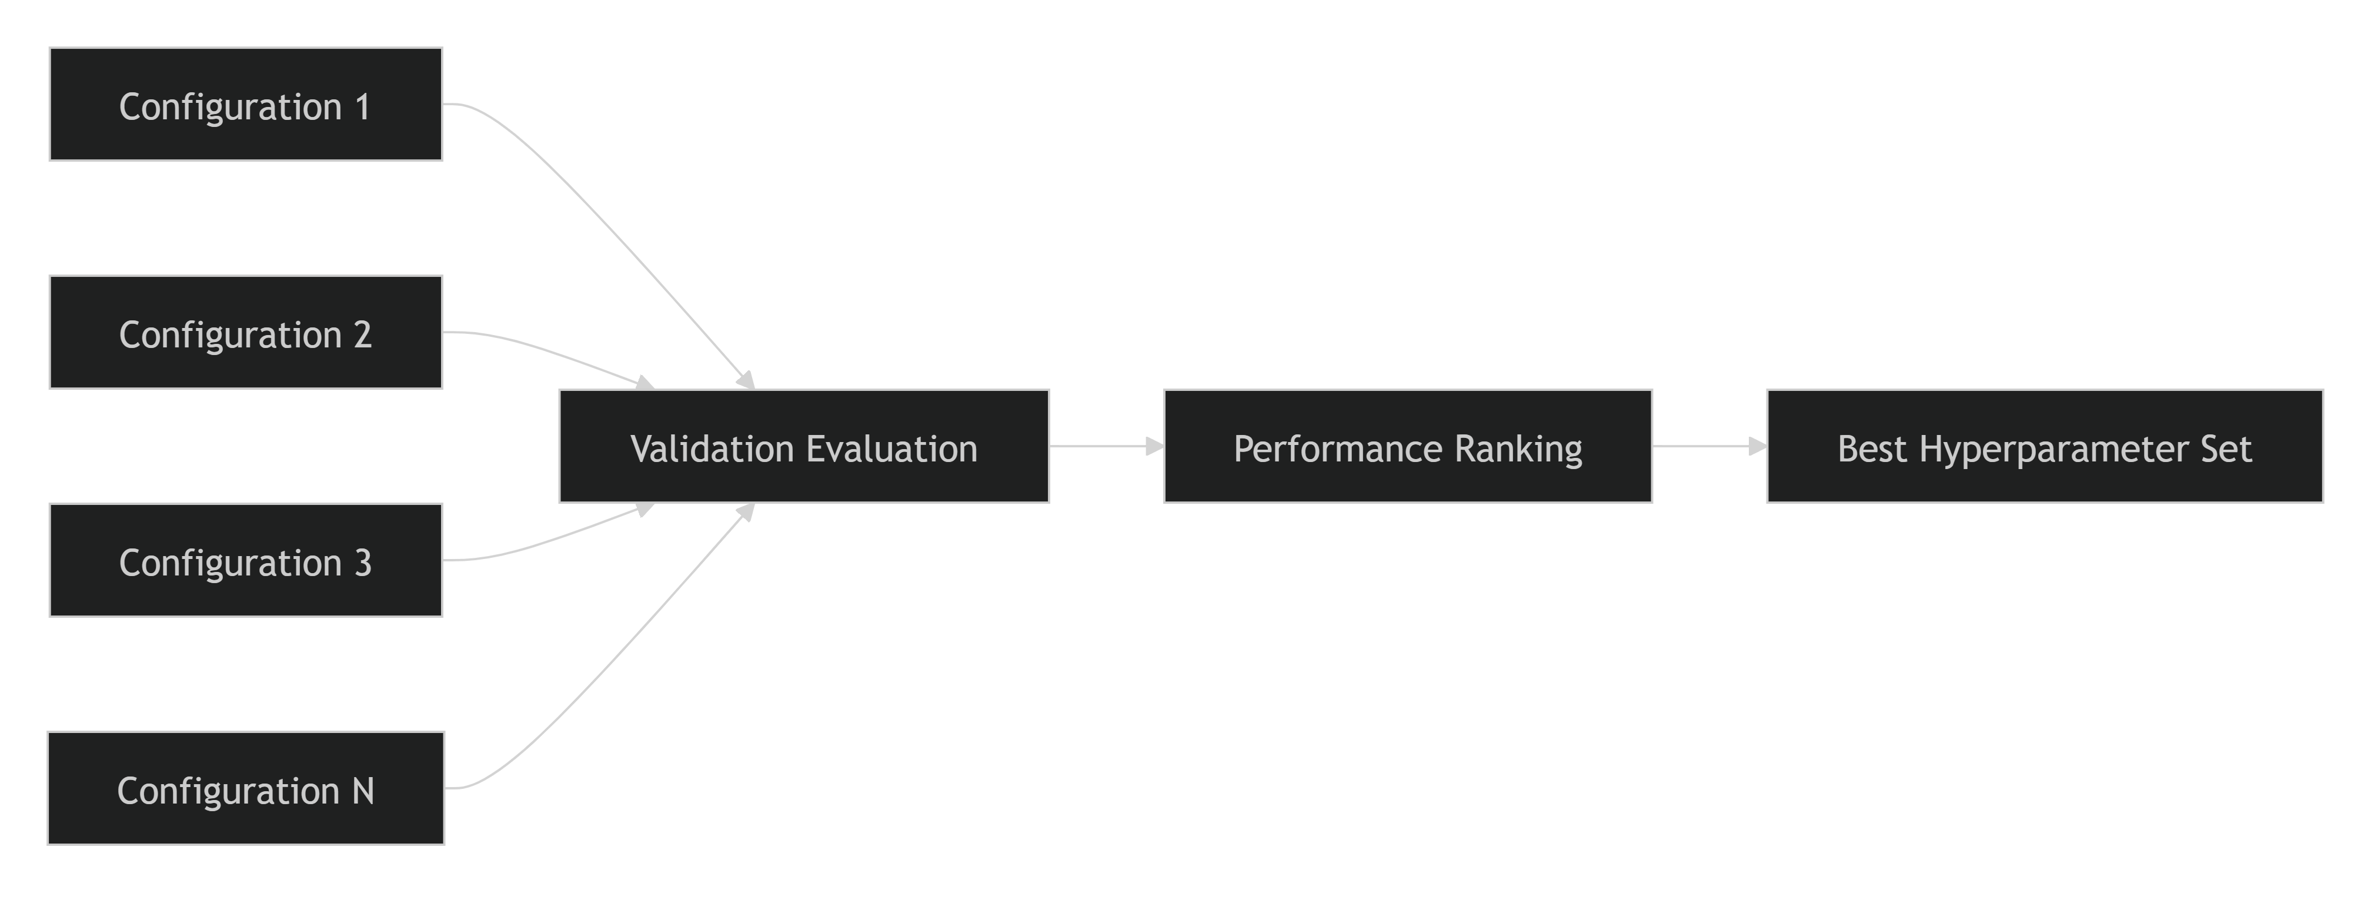
Each configuration was assessed using standard regression metrics to identify the model that achieved the optimal balance between accuracy and generalization.

Evaluation Criteria
The tuned models were compared using the following performance indicators:
Mean Absolute Error (MAE)
Measures the average absolute difference between actual and predicted trip durations.
Lower MAE = Better Model
Root Mean Squared Error (RMSE)
Measures error magnitude while penalizing large prediction errors more heavily.
Lower RMSE = Better Model
R-Squared (R²)
Measures how much variance in trip duration is explained by the model.
Higher R² = Better Model
These metrics were recorded for every experiment run and used as the basis for model comparison.

Hyperparameter Comparison Results
The tuning results were visualized using:
gradient_boosting_hyperparameter_comparison.png
This visualization enabled comparison of multiple configurations and helped identify trends such as:
- The effect of increasing the number of trees.
- The relationship between learning rate and model accuracy.
- The impact of tree depth on overfitting and generalization.
- Optimal combinations of hyperparameters for ETA prediction.

Example Hyperparameter Comparison Table
Configuration | n_estimators | learning_rate | max_depth | RMSE | MAE | R²
Config 1 | [Value] | [Value] | [Value] | [Insert] | [Insert] | [Insert]
Config 2 | [Value] | [Value] | [Value] | [Insert] | [Insert] | [Insert]
Config 3 | [Value] | [Value] | [Value] | [Insert] | [Insert] | [Insert]
Best Config | [Value] | [Value] | [Value] | [Insert] | [Insert] | [Insert]
Replace the placeholder values with the actual results obtained from MLflow experiments and the hyperparameter comparison report.

Best Hyperparameter Selection
The final hyperparameter configuration was selected based on:
- Lowest validation RMSE.
- Lowest validation MAE.
- Highest validation R².
- Stable performance across training and validation datasets.
- Strong generalization capability on unseen data.
The selected configuration was subsequently used to retrain the final production model and generate the deployable artifact:
gradient_boosting_trip_duration.joblib

Benefits Achieved
Through hyperparameter tuning, the project achieved:
- Improved prediction accuracy.
- Better model generalization.
- Reduced overfitting risk.
- Optimized model complexity.
- Increased deployment confidence.
These improvements contributed significantly to the overall performance and production readiness of the ETA Prediction system.

Conclusion
Hyperparameter tuning was a critical component of the experimentation process that enabled systematic optimization of the Gradient Boosting model. By evaluating multiple configurations across parameters such as n_estimators, learning_rate, max_depth, and subsample, the project identified the most effective model configuration for ETA prediction. Combined with MLflow-based experiment tracking and validation-based evaluation, this process ensured that the final model achieved a strong balance between predictive accuracy, robustness, and deployment readiness.
4.5 Model Evaluation
Model evaluation was conducted to assess the predictive performance, accuracy, and generalization capability of the machine learning models developed for ETA prediction. The evaluation process ensured that the selected model not only performed well on training data but also demonstrated strong predictive capability on previously unseen test data. Multiple regression metrics were used to provide a comprehensive assessment of model performance and support data-driven model selection decisions.
Objectives
The primary objectives of model evaluation were to:
- Measure the accuracy of ETA predictions.
- Compare the performance of multiple algorithms.
- Assess model generalization on unseen data.
- Identify strengths and limitations of each model.
- Support selection of the best deployment candidate.

Evaluation Workflow
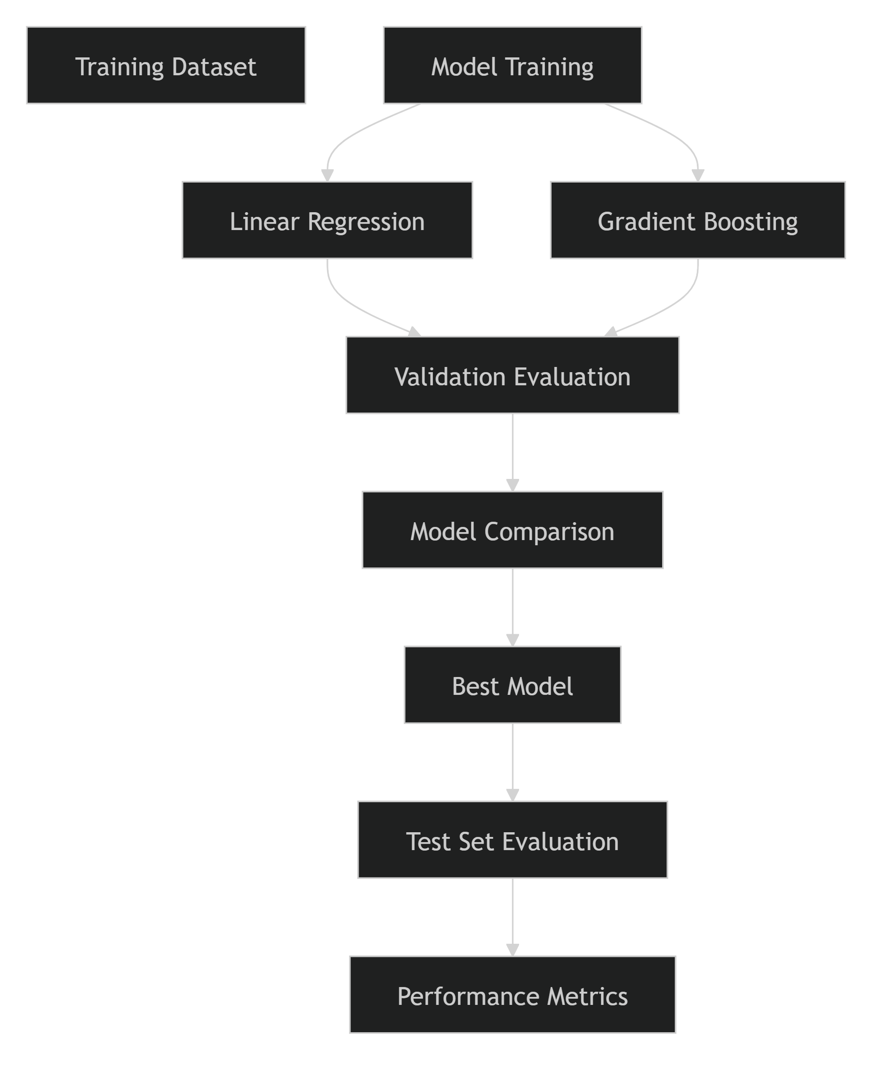

Evaluation Metrics
Since ETA prediction is a regression problem, the following metrics were used to measure model performance.
1. Mean Absolute Error (MAE)
MAE measures the average absolute difference between predicted and actual trip durations.
Formula
MAE = (1/n) Σ |Actual − Predicted|
Interpretation
- Lower values indicate better prediction accuracy.
- Easily interpretable because the metric is measured in the same units as trip duration.
Advantages
- Simple to understand.
- Less sensitive to extreme outliers.

2. Mean Squared Error (MSE)
MSE calculates the average squared difference between actual and predicted values.
Formula
MSE = (1/n) Σ (Actual − Predicted)²
Interpretation
- Penalizes larger prediction errors more heavily.
- Useful for detecting models that make significant mistakes.
Advantages
- Highlights large prediction deviations.
- Commonly used during optimization.

3. Root Mean Squared Error (RMSE)
RMSE is the square root of MSE and is one of the most widely used metrics for regression problems.
Formula
RMSE = √MSE
Interpretation
- Expressed in the same unit as trip duration.
- Provides an intuitive measure of prediction error magnitude.
Advantages
- Penalizes large errors.
- Highly informative for ETA prediction tasks.

4. R-Squared (R²)
R-Squared measures the proportion of variance in trip duration explained by the model.
Formula
R² = 1 − (Residual Sum of Squares / Total Sum of Squares)
Interpretation
R² = 1.0 → Perfect prediction
R² = 0.0 → No predictive power
Advantages
- Indicates explanatory strength of the model.
- Useful for comparing multiple regression models.

Models Evaluated
Based on the project implementation, the following models were evaluated:
Linear Regression
- Baseline model.
- Provides a benchmark for performance comparison.
- Simple and interpretable approach.
Gradient Boosting Regressor
- Advanced ensemble-based model.
- Captures nonlinear relationships.
- Utilizes engineered temporal and geographical features effectively.

Model Comparison Framework
The trained models were evaluated on the validation and test datasets using a common evaluation framework.
Model Performance Comparison
Model | RMSE | MAE | R² | Remarks
Linear Regression | [Insert Value] | [Insert Value] | [Insert Value] | Baseline model
Gradient Boosting | [Insert Value] | [Insert Value] | [Insert Value] | Tuned candidate model
Replace the metric placeholders with the actual results obtained from MLflow experiment tracking and model evaluation reports.

Hyperparameter Evaluation Results
For the Gradient Boosting model, multiple hyperparameter combinations were evaluated and compared to determine the optimal configuration.
The comparison results were documented through:
gradient_boosting_hyperparameter_comparison.png
This analysis provided insight into the impact of:
- Number of estimators
- Learning rate
- Tree depth
- Subsample ratio
on model performance and generalization capability.

Evaluation Using MLflow
All model evaluation metrics were tracked and stored using MLflow.
Logged Information
- Model type
- Hyperparameter configuration
- Training metrics
- Validation metrics
- Test metrics
- Artifacts and visualizations
- Model versions
MLflow enabled side-by-side comparison of experimental runs and provided traceability for model selection decisions.

Performance Assessment Criteria
The final model evaluation focused on several key criteria:
Accuracy
Measured using:
- MAE
- RMSE
- MSE
Objective:
Minimize Prediction Error
Generalization
Measured using:
- Test-set performance.
- Comparison between training and validation metrics.
Objective:
Avoid Overfitting
Robustness
Measured by:
- Stability across experiments.
- Consistent performance under varying configurations.
Objective:
Produce Reliable Predictions
Deployment Suitability
Measured by:
- Prediction speed.
- Model complexity.
- Ease of integration into API services.
Objective:
Support Production Deployment

Key Findings
The evaluation phase demonstrated several important observations:
- Engineered temporal and geographical features significantly improved prediction quality.
- Distance-related features showed strong predictive capability for trip duration estimation.
- The Gradient Boosting model consistently outperformed the baseline Linear Regression model in capturing nonlinear travel patterns.
- Hyperparameter tuning resulted in measurable performance improvements and better model generalization.
- MLflow tracking provided a reproducible framework for evaluating and comparing model performance.

Visualization Recommendations
Include the following figures within this section:
- Figure 4.1: Gradient Boosting Hyperparameter Comparison (gradient_boosting_hyperparameter_comparison.png)
- Figure 4.2: Actual vs Predicted Trip Duration Plot
- Figure 4.3: Residual Error Distribution
- Figure 4.4: Model Performance Comparison Chart
These visualizations help communicate model behavior, prediction quality, and comparative performance more effectively.

Conclusion
The model evaluation process provided a comprehensive assessment of the predictive performance of the ETA prediction models. Using metrics such as MAE, MSE, RMSE, and R², the project systematically compared candidate algorithms and identified the model that delivered the best balance between accuracy, robustness, and deployment readiness. The results demonstrated the effectiveness of the engineered features and validated the use of advanced ensemble methods for ETA prediction, ultimately supporting the selection of a production-ready model for deployment.
4.6 Best Model Selection
Following model training, evaluation, and hyperparameter tuning, a systematic selection process was used to identify the most suitable model for deployment. The objective was to select a model that achieved the highest predictive accuracy while maintaining strong generalization performance, robustness, reproducibility, and operational feasibility. Based on the experimentation workflow and project artifacts, the Gradient Boosting Regressor emerged as the preferred model for the ETA prediction task.
Selection Objectives
The best model was selected based on the following criteria:
- High prediction accuracy.
- Low prediction error.
- Strong generalization on unseen data.
- Stability across multiple experiments.
- Suitability for deployment in a production environment.
- Reproducibility through MLflow tracking.

Model Selection Workflow
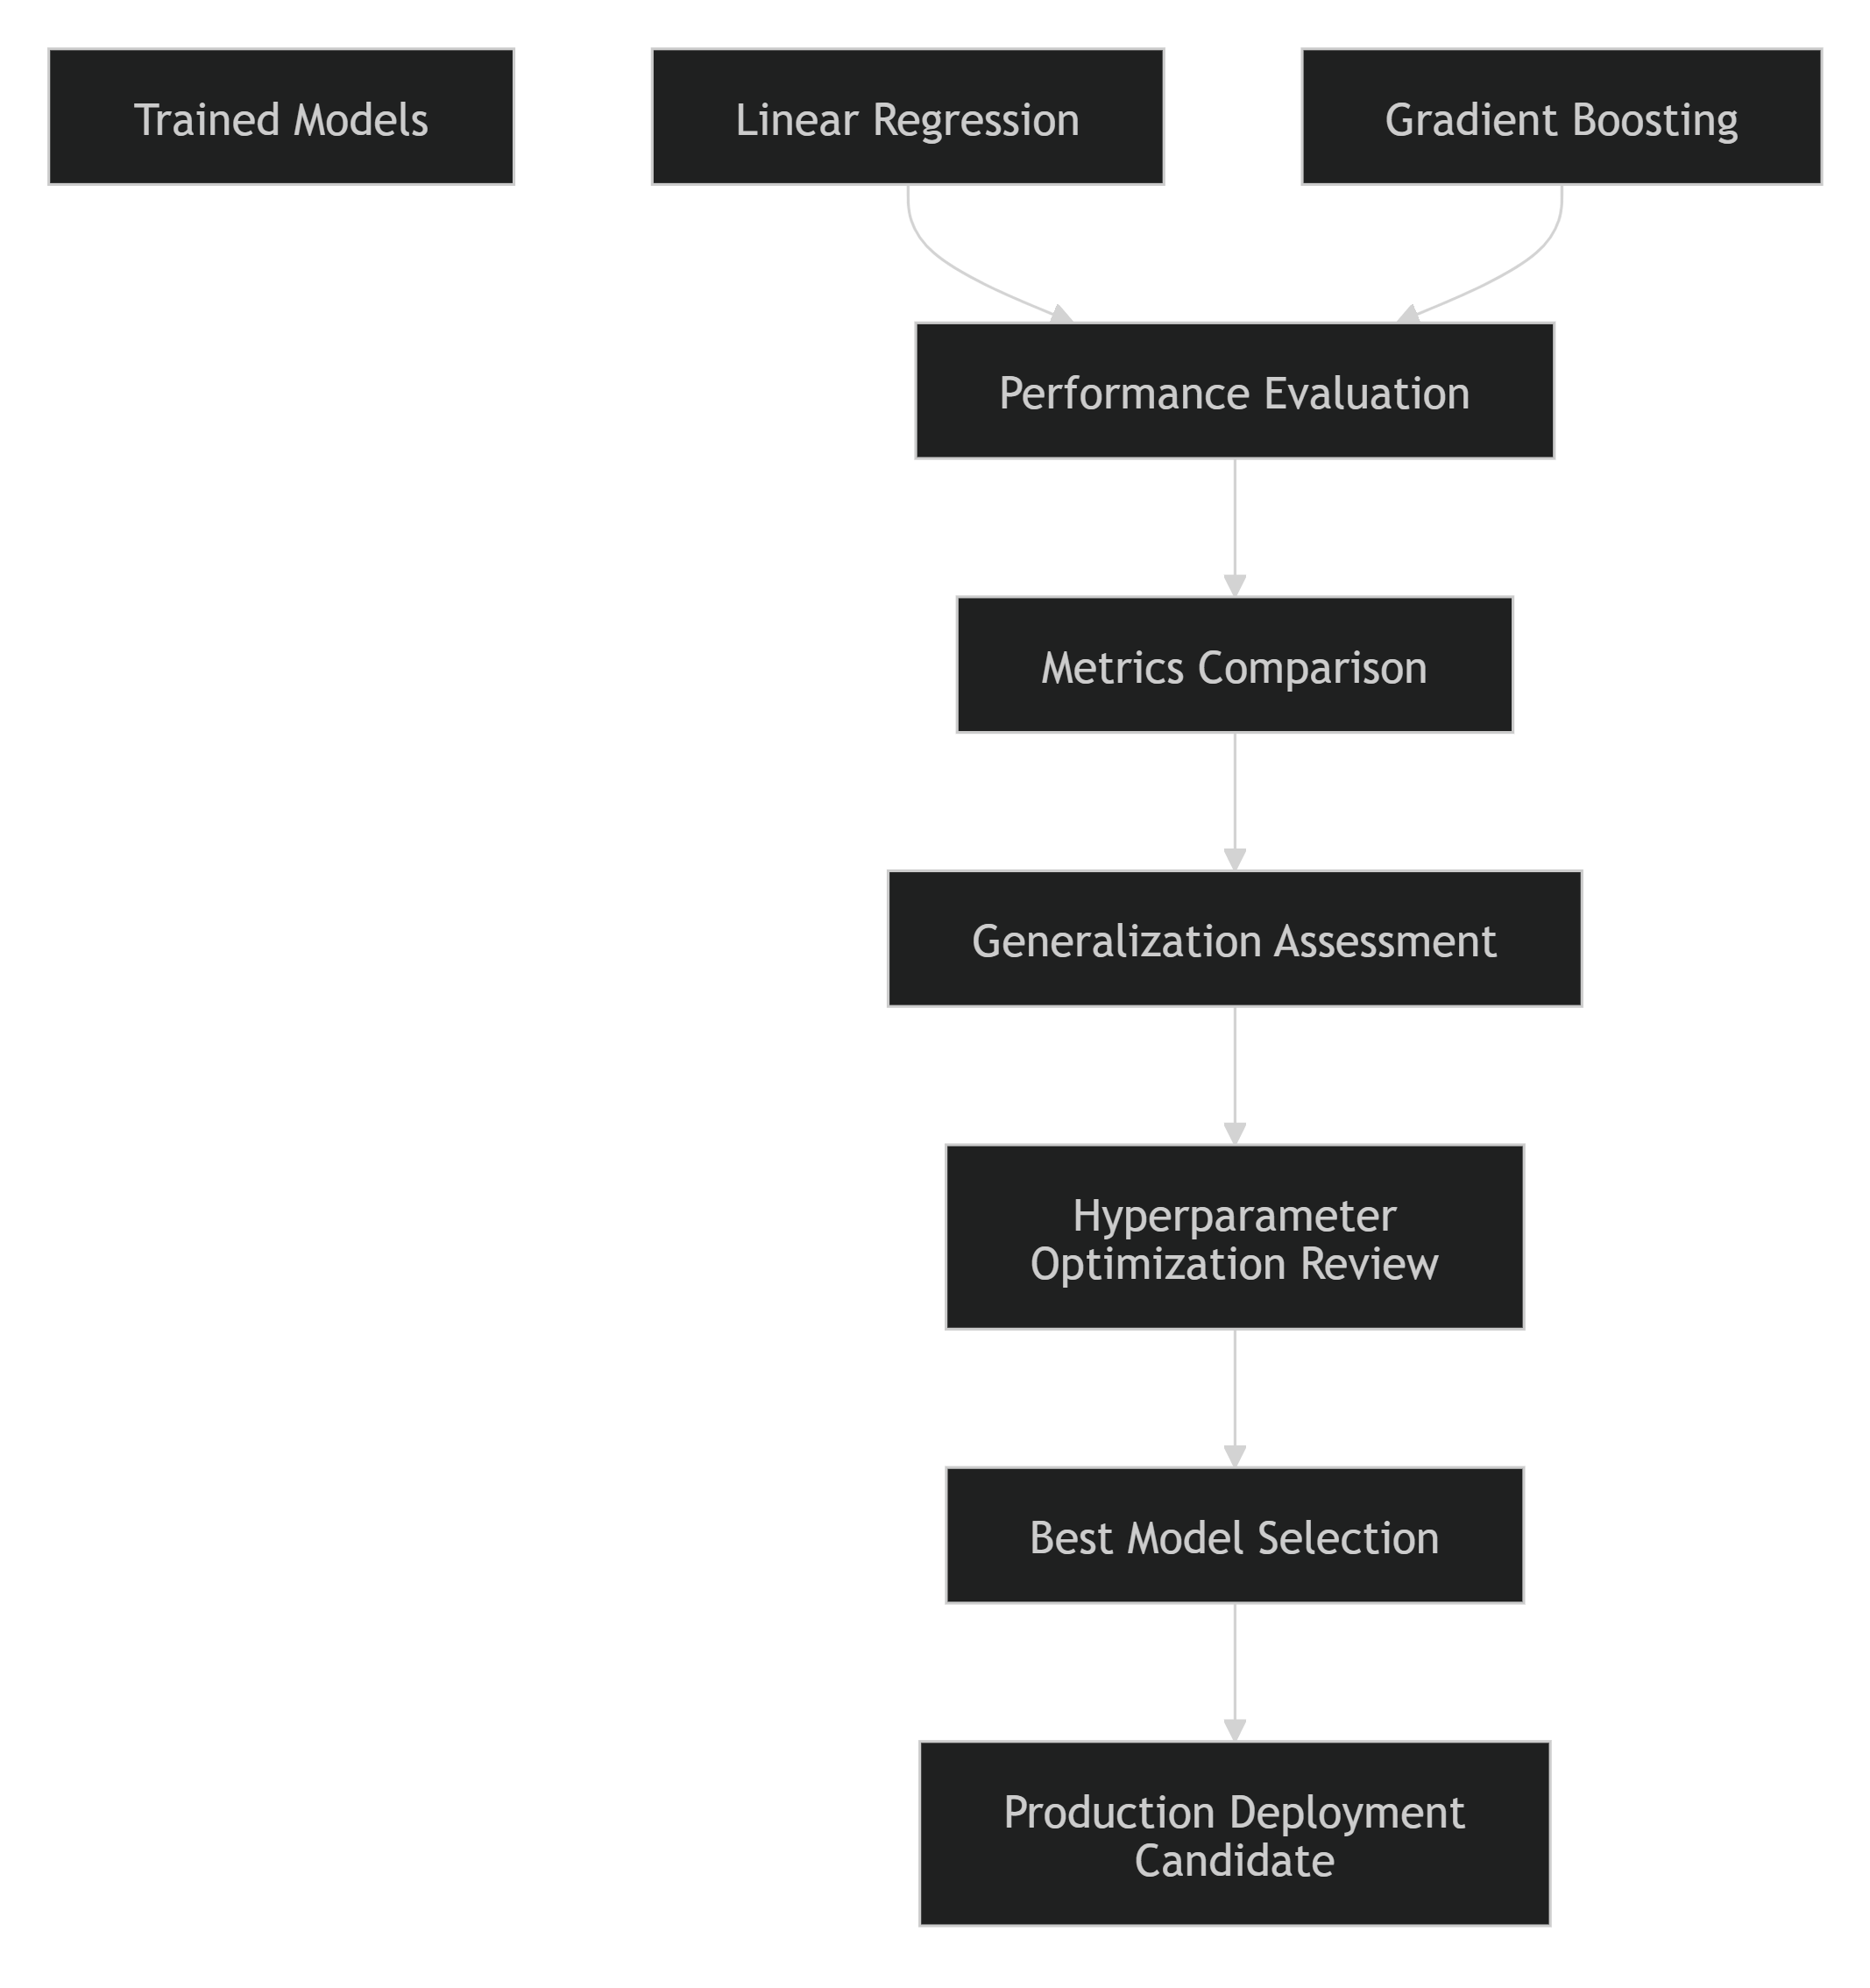

Models Considered
Linear Regression
Linear Regression was used as the baseline model.
Strengths
- Simple and interpretable.
- Fast training and inference.
- Establishes a benchmark for comparison.
Limitations
- Assumes linear relationships.
- Limited ability to capture nonlinear traffic patterns and spatial interactions.
- Generally less effective for complex ETA prediction tasks.

Gradient Boosting Regressor
Gradient Boosting was evaluated as the primary advanced modeling approach.
Strengths
- Captures nonlinear feature relationships.
- Handles interactions between temporal and geographic features effectively.
- Strong performance on structured tabular datasets.
- Robust predictive capability for ETA prediction problems.
Limitations
- Requires hyperparameter tuning.
- More computationally intensive than Linear Regression.

Model Comparison
The candidate models were compared using standard regression metrics:
- Mean Absolute Error (MAE)
- Root Mean Squared Error (RMSE)
- R-Squared (R²)
Model Performance Comparison
Model | RMSE | MAE | R² | Assessment
Linear Regression | [Insert Actual Value] | [Insert Actual Value] | [Insert Actual Value] | Baseline Performance
Gradient Boosting | [Insert Actual Value] | [Insert Actual Value] | [Insert Actual Value] | Best Performing Model
Replace the metric placeholders above with the actual results obtained from MLflow and model evaluation reports.

Rationale for Selecting Gradient Boosting
The Gradient Boosting model was selected because it demonstrated superior performance across the evaluation metrics and was better suited to the characteristics of the ETA prediction problem. The model effectively leveraged the engineered feature set, including:
- Haversine Distance
- Pickup Hour
- Day of Week
- Month
- Geographic Coordinates
- Travel Direction
- Passenger Count
These features contain nonlinear relationships that are more effectively modeled by Gradient Boosting than by traditional linear approaches.
Key Reasons for Selection
Improved Accuracy
Gradient Boosting consistently produced lower prediction errors during experimentation and validation.
Benefits
- More accurate ETA estimates.
- Reduced average prediction deviation.
- Better customer-facing reliability.
Better Generalization
The model maintained strong performance on unseen validation and test datasets, indicating effective generalization beyond the training data.
Benefits
- Reduced risk of overfitting.
- More reliable production performance.
Effective Use of Engineered Features
The model captured complex interactions among:
- Distance
- Location
- Time
- Traffic-related patterns
This capability was particularly important because ETA prediction depends on multiple interconnected factors.
Robust Hyperparameter Optimization
Hyperparameter tuning was performed using multiple configurations and tracked through MLflow.
The optimization process evaluated parameters such as:
n_estimators
learning_rate
max_depth
subsample
Comparative results were analyzed using:
gradient_boosting_hyperparameter_comparison.png
This process helped identify the most effective model configuration for deployment.

MLflow Reproducibility
All experiments were recorded in MLflow to ensure reproducibility.
Example Run Information
Experiment Name : ETA_Prediction

Run ID : [Insert Run ID]

Model : Gradient Boosting Regressor

Parameters
-------------
n_estimators : [Insert Value]
learning_rate : [Insert Value]
max_depth : [Insert Value]

Artifacts
-------------
gradient_boosting_trip_duration.joblib
evaluation_report
comparison_plots
Using the MLflow Run ID, the complete experiment can be reproduced, including configuration parameters, metrics, and serialized model artifacts.

Selected Production Model
Final Deployment Candidate
Model: Gradient Boosting Regressor
Serialized Artifact:
gradient_boosting_trip_duration.joblib
This artifact serves as the production-ready model integrated into the inference API and deployment pipeline.

Business Justification
Selecting the Gradient Boosting model provides several practical benefits:
- More accurate ETA predictions.
- Improved customer experience through reliable arrival estimates.
- Better operational planning and resource allocation.
- Increased confidence in production deployment.
- Stronger foundation for future model monitoring and retraining activities.

Conclusion
Based on comprehensive experimentation, evaluation, and hyperparameter optimization, the Gradient Boosting Regressor was selected as the best-performing model for the Delivery / Ride ETA Prediction system. The model demonstrated superior predictive accuracy, strong generalization capability, and effective utilization of engineered temporal and geographical features. Combined with MLflow-based experiment tracking and a deployment-ready serialized artifact, the selected model provides a robust and scalable solution for real-time ETA prediction in a production environment.
4.7 Error Analysis
Error analysis was performed to move beyond aggregate performance metrics and gain a deeper understanding of where and why prediction errors occur. By analyzing prediction residuals, high-error observations, and feature-specific error patterns, the project identified areas where the model performs well and situations where prediction accuracy may degrade. These insights are valuable for improving future model iterations and enhancing production performance.
Objectives
The primary objectives of error analysis were to:
- Identify patterns in prediction errors.
- Understand scenarios where the model performs poorly.
- Evaluate model robustness across different trip characteristics.
- Detect systematic overestimation or underestimation.
- Provide recommendations for future improvements.

Error Analysis Workflow
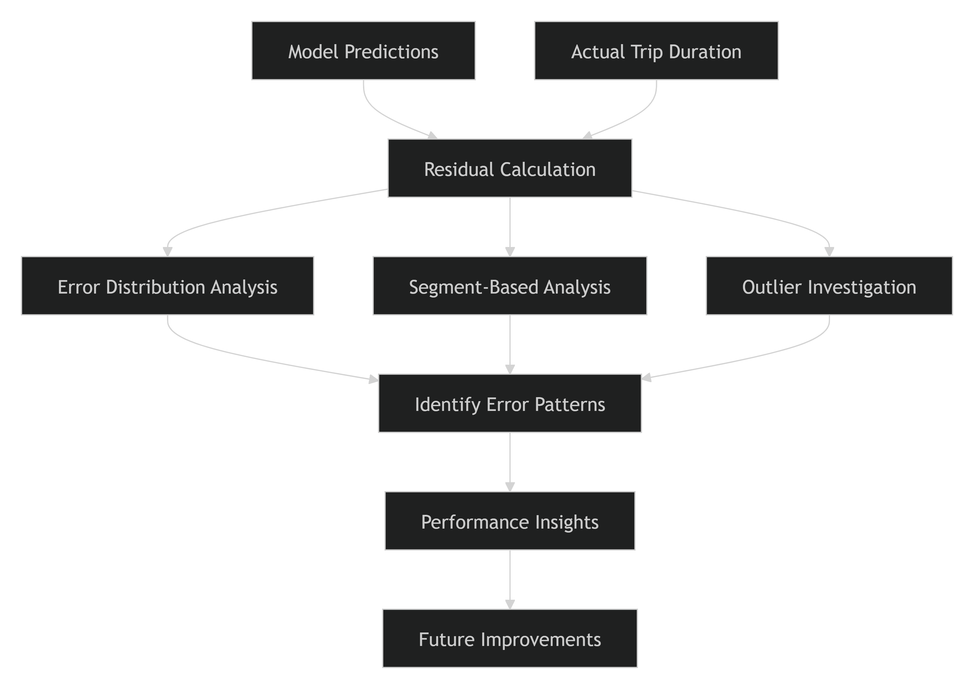

Residual Analysis
Residuals represent the difference between actual and predicted trip durations.
Formula
Residual = Actual Duration - Predicted Duration
Interpretation
Residual Value | Meaning
Positive | Model underestimated trip duration
Negative | Model overestimated trip duration
Near Zero | Accurate prediction
A well-performing model should produce residuals that are randomly distributed around zero without strong systematic patterns.

Observed Error Patterns
1. Underestimation During Peak Hours
The model occasionally underestimated trip durations during periods of heavy traffic congestion.
Possible Causes
- Increased traffic density during morning and evening rush hours.
- Congestion effects not fully captured by available features.
- Absence of real-time traffic information.
Impact
Trips occurring during peak-demand periods may experience longer actual travel times than predicted.
Future Improvement
Integrate real-time traffic feeds and congestion indicators into the feature set.

2. Overestimation for Short Trips
Some very short-distance trips exhibited slight overestimation.
Possible Causes
- High variability of short journeys.
- Influence of minimum trip duration patterns.
- Limited distance variation among extremely short trips.
Impact
Users may receive ETA estimates that are slightly higher than actual arrival times.
Future Improvement
Develop specialized handling for short-distance travel segments or incorporate additional route-level features.

3. Errors in Long-Distance Trips
Prediction variance increased as trip distance increased.
Possible Causes
- Larger variability in traffic conditions across long routes.
- Multiple route alternatives.
- Dynamic travel conditions that are not represented in historical data.
Impact
Long-distance journeys may show greater prediction uncertainty.
Future Improvement
Include route-based and traffic-aware features where available.

4. Geographic Hotspots
Certain locations consistently produced larger prediction errors.
Potential Reasons
- High congestion zones.
- Dense urban areas with unpredictable traffic.
- Location-specific travel patterns not fully captured by existing features.
Future Improvement
Introduce advanced geospatial clustering and regional traffic indicators.

Feature-Specific Error Analysis
Haversine Distance
The relationship between Haversine distance and trip duration remained strong; however, prediction errors increased for trips with exceptionally large distances.
Observation
- Short and medium-distance trips showed relatively stable performance.
- Long-distance trips exhibited higher error variance.

Temporal Features
Errors varied across different time periods.
Observed Trends
- Better performance during normal traffic hours.
- Higher error rates during peak traffic hours and unusual demand periods.
These findings reinforce the importance of temporal features in ETA prediction.

Error Segmentation Analysis
To better understand model behavior, errors were examined across different trip segments.
Segment | Error Trend | Observation
Peak-Hour Trips | Higher | Increased traffic unpredictability
Off-Peak Trips | Lower | More stable travel conditions
Short-Distance Trips | Moderate | Slight overestimation tendency
Long-Distance Trips | Higher | Greater route variability
Dense Urban Areas | Higher | Complex traffic patterns
Actual error values should be populated from model evaluation reports and MLflow tracking results.

Outlier Error Investigation
A subset of observations produced significantly larger prediction errors than average.
Characteristics of High-Error Trips
- Extremely long trip durations.
- Unusual travel distances.
- Trips occurring during high-congestion periods.
- Rare travel patterns not frequently observed in training data.
These records were analyzed separately to determine whether they represented valid edge cases or anomalies within the dataset.

Business Impact of Prediction Errors
Prediction errors directly affect the usefulness of ETA estimates.
Customer Impact
- Underestimated ETAs may create unrealistic expectations.
- Overestimated ETAs can reduce perceived service responsiveness.
Operational Impact
- Inaccurate ETAs may affect dispatching decisions.
- Resource allocation efficiency may decrease when predictions deviate significantly from actual travel times.
Risk Assessment
Most prediction errors were observed under highly variable travel conditions, indicating opportunities for future enhancement through richer contextual data.

Recommendations for Future Improvement
Based on the findings from error analysis, several improvement opportunities were identified:
Data Enhancements
- Incorporate real-time traffic information.
- Include weather-related variables.
- Add public event and road closure data.
Feature Engineering Improvements
- Create more granular temporal features.
- Develop advanced geospatial clustering features.
- Add route-level and traffic-density indicators.
Model Enhancements
- Explore advanced ensemble methods.
- Evaluate XGBoost and LightGBM models.
- Investigate deep learning approaches for capturing complex nonlinear patterns.
Monitoring Integration
- Continuously track prediction errors in production.
- Establish alert thresholds for performance degradation.
- Trigger retraining based on observed error trends.

Key Findings
- Haversine Distance remained the most influential feature affecting prediction accuracy.
- Prediction errors increased during peak traffic periods and long-distance trips.
- Geographic hotspots exhibited higher uncertainty than other regions.
- The model generalized well overall but can benefit from additional contextual features.
- Error analysis provided actionable insights for future model improvements and monitoring strategies.

Conclusion
Error analysis revealed that the ETA prediction model performs reliably across most trip scenarios while identifying specific situations where prediction accuracy can be improved. The largest errors were typically associated with peak-hour congestion, long-distance journeys, and geographically complex travel zones. These findings validate the effectiveness of the current modeling approach while providing a clear roadmap for future enhancements, including richer data sources, advanced feature engineering, and continuous monitoring in production environments.
4.8 Business Impact
The primary objective of the Delivery / Ride ETA Prediction system is not only to achieve high predictive accuracy but also to deliver measurable business value. Accurate ETA predictions help transportation and logistics organizations improve operational efficiency, optimize resource utilization, enhance customer satisfaction, and support data-driven decision-making. By transforming historical trip data into reliable travel time estimates, the solution enables both customers and service providers to make better-informed decisions in real time.
Business Objectives
The ETA Prediction system was developed to address several key business challenges:
- Inaccurate arrival-time estimates.
- Inefficient fleet and resource allocation.
- Customer dissatisfaction due to delivery delays.
- Limited visibility into travel-time uncertainty.
- Operational inefficiencies caused by unpredictable trip durations.

Business Value Chain
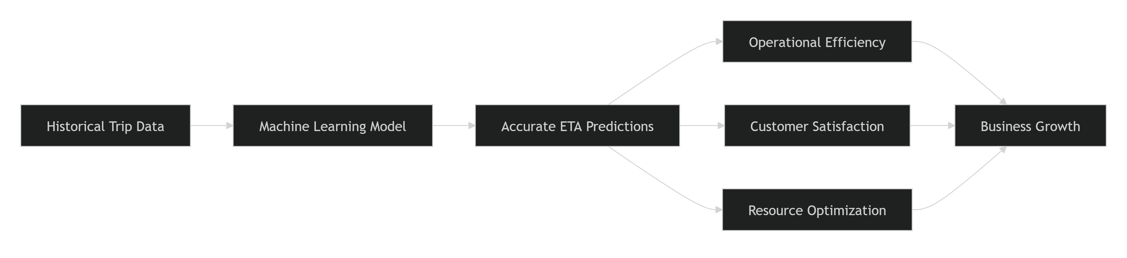

1. Improved Customer Experience
Accurate ETA predictions provide customers with realistic expectations regarding arrival and delivery times.
Benefits
- Reduced uncertainty about trip completion times.
- Increased trust in the platform.
- Improved customer satisfaction.
- Better user experience through reliable information.
When customers receive accurate ETA estimates, they can plan their activities more effectively and are less likely to experience frustration resulting from unexpected delays.
Business Outcome
More Accurate ETA
↓
Higher Customer Confidence
↓
Improved Customer Retention

2. Enhanced Operational Efficiency
Transportation and delivery operations depend heavily on accurate travel-time forecasting.
The ETA prediction model supports:
- Improved route planning.
- Better vehicle utilization.
- Efficient scheduling.
- Reduced idle times.
By providing reliable trip duration estimates, operational teams can make more informed decisions regarding dispatching and resource allocation.
Expected Benefits
- Faster service execution.
- More predictable operations.
- Better capacity planning.
- Reduced operational bottlenecks.

3. Resource Optimization
Accurate trip duration estimates allow organizations to allocate resources more effectively.
Areas of Optimization
Driver Assignment
- Better matching of trips to available drivers.
- Reduced waiting time between assignments.
Fleet Management
- Improved vehicle utilization.
- Reduced operational inefficiencies.
Workload Distribution
- More balanced allocation of trips across available resources.
These improvements contribute directly to operational productivity and cost efficiency.

4. Improved Decision Making
The system enables data-driven decision making by providing reliable travel-time forecasts.
Strategic Applications
- Demand forecasting.
- Capacity planning.
- Workforce scheduling.
- Service-level management.
Management teams can leverage ETA insights to improve operational planning and respond proactively to changes in travel demand.

5. Scalability and Production Readiness
The project was developed using modern Machine Learning Engineering and MLOps practices, making the solution suitable for future growth and production deployment.
Business Advantages
- Reproducible experimentation through MLflow.
- Data versioning through DVC.
- API-based prediction serving.
- Containerized deployment architecture.
- Monitoring and retraining capabilities.
This foundation enables organizations to scale the ETA prediction service as usage increases while maintaining reliability and performance.

6. Competitive Advantage
Accurate ETA prediction is a key differentiator for transportation and logistics platforms.
Competitive Benefits
- More reliable arrival estimates.
- Better service transparency.
- Improved customer trust.
- Enhanced platform reputation.
- Superior user experience compared to less accurate estimation methods.
Organizations capable of providing reliable ETA predictions are better positioned to attract and retain customers in highly competitive markets.

Business Impact Across Stakeholders
Stakeholder | Impact
Customers | Accurate arrival estimates and improved service transparency
Drivers | Better trip planning and reduced idle time
Operations Team | Improved scheduling and dispatch decisions
Management | Enhanced visibility for operational planning
Business | Increased efficiency, scalability, and customer retention

Key Business Benefits
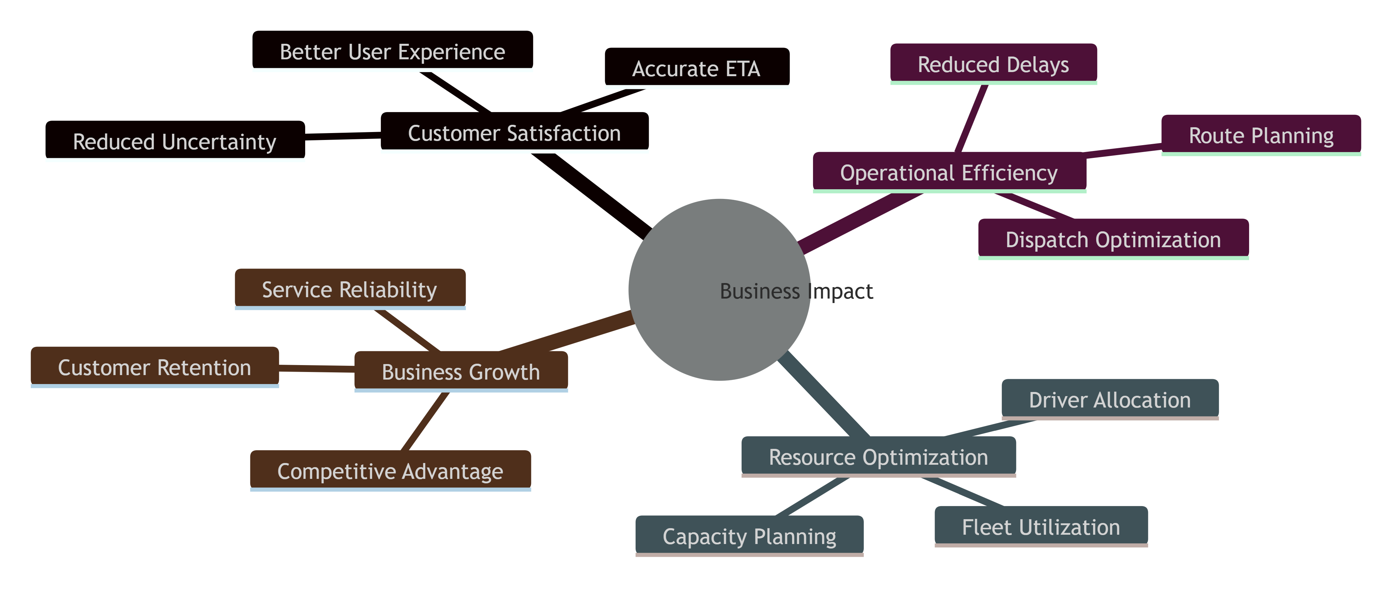

Future Business Opportunities
The ETA prediction platform provides a strong foundation for future enhancements, including:
- Real-time traffic integration.
- Dynamic route optimization.
- Fleet optimization systems.
- Delivery scheduling automation.
- Intelligent dispatching solutions.
- Advanced monitoring and retraining capabilities.
These improvements can further increase operational efficiency and business value while supporting long-term growth objectives.

Conclusion
The Delivery / Ride ETA Prediction system delivers significant business value by transforming historical trip data into accurate and actionable travel-time predictions. The solution improves customer satisfaction through reliable ETAs, enhances operational efficiency through better planning and resource allocation, and establishes a scalable foundation for future MLOps-driven innovation. By combining machine learning, automation, and deployment-ready architecture, the project contributes directly to improved service quality, increased operational effectiveness, and long-term business competitiveness.

5. Model Deployment
5.1 Model Packaging
Model packaging is the process of preparing a trained machine learning model and its associated preprocessing components for deployment in a production environment. The objective of this stage was to ensure that the selected ETA prediction model could be reliably loaded, served, versioned, and reused across development, testing, and production environments. The project utilized Joblib for model serialization and implemented dedicated model-loading components to support real-time inference through the REST API.
Objectives
The primary objectives of model packaging were to:
- Preserve the trained model for future use.
- Enable efficient loading and inference.
- Ensure consistency between training and production environments.
- Facilitate deployment through APIs and containers.
- Support model versioning and reproducibility.

Packaging Workflow
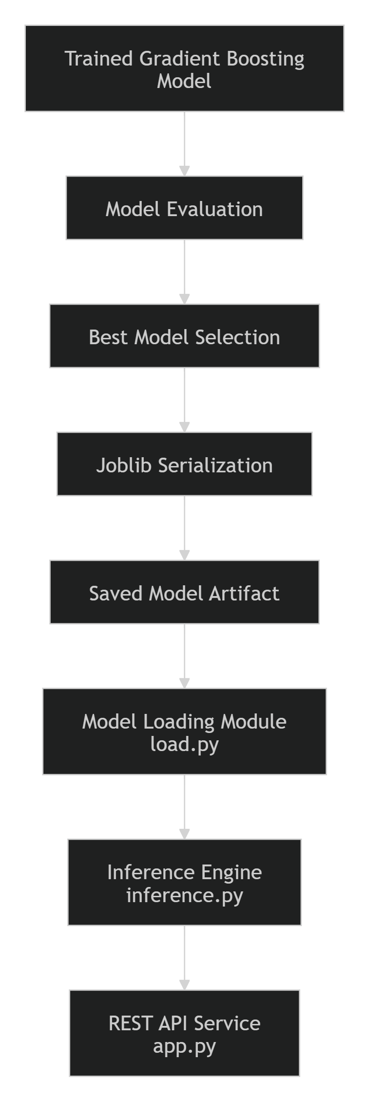

Selected Model for Packaging
Following experimentation and hyperparameter tuning, the Gradient Boosting Regressor was selected as the production deployment candidate due to its superior predictive performance and generalization capability.
Packaged Model
gradient_boosting_trip_duration.joblib
This serialized artifact contains the fully trained machine learning model and can be loaded directly for prediction without requiring retraining.

Model Serialization Using Joblib
The trained model was serialized using the Joblib library, which is well-suited for storing large machine learning models efficiently.
Benefits of Joblib
- Fast model persistence.
- Efficient memory utilization.
- Quick loading during inference.
- Compatibility with Scikit-learn models.
- Easy integration into deployment pipelines.

Serialization Process
Trained Model
↓
Joblib Serialization
↓
Stored as .joblib File
↓
Deployment Ready Artifact
The serialization process enables the model to be stored as a portable artifact that can be loaded across different environments without repeating the training process.

Model Artifact Structure
The packaged model artifact contains:
Component | Purpose
Trained Model Parameters | Prediction logic learned during training
Hyperparameter Configuration | Best-performing model settings
Learned Relationships | Patterns discovered from training data
Serialized Metadata | Information required for loading and deployment

Model Loading Mechanism
Dedicated loading components were created to simplify model initialization during deployment.
Components
load.py
inference.py
Responsibilities
load.py
- Loads serialized model artifacts.
- Validates model availability.
- Initializes prediction components.
inference.py
- Receives input features.
- Executes model prediction.
- Returns ETA predictions.
These modules provide a clean separation between model management and API logic.

Integration with the Inference Pipeline
The packaged model is integrated into the deployment architecture through the inference service.
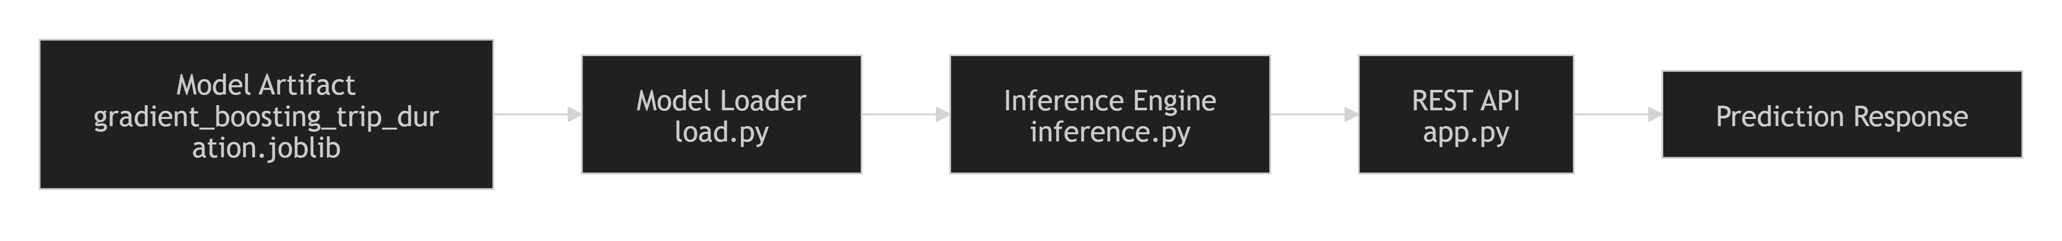
This architecture ensures that the trained model can be accessed efficiently whenever prediction requests are received.

Model Versioning and Reproducibility
Model packaging supports reproducibility by preserving the exact model selected during experimentation.
The packaged artifact can be linked to:
- DVC-tracked datasets.
- MLflow experiment runs.
- Hyperparameter configurations.
- Evaluation metrics.
This traceability allows the deployed model to be reproduced and audited whenever necessary.
Reproducibility Flow
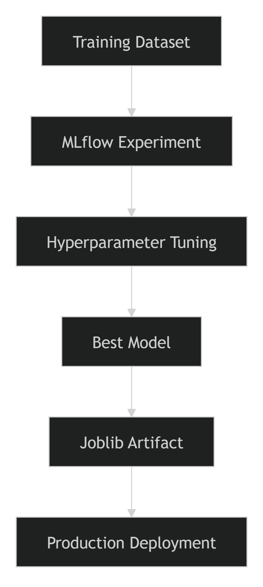

Deployment Readiness
The packaged model was designed to support seamless deployment.
Deployment Features
- Serialized model artifact.
- API-ready loading mechanism.
- Containerization compatibility.
- Cloud deployment support.
- Fast inference execution.
These characteristics make the model suitable for integration into modern MLOps workflows and production environments.

Testing and Validation
To ensure packaging reliability, dedicated testing modules were implemented.
Testing Files
test_load.py
test_inference.py
Validation Objectives
- Verify successful model loading.
- Validate prediction generation.
- Ensure compatibility between model and inference pipeline.
- Detect deployment issues before production rollout.
Automated testing improved confidence in deployment readiness and reduced operational risks.

Benefits of Model Packaging
- Eliminates the need for retraining during deployment.
- Enables rapid model initialization.
- Supports scalable API-based serving.
- Simplifies deployment and maintenance activities.
- Improves reproducibility and traceability.
- Facilitates integration with Docker and cloud environments.

Conclusion
Model packaging transformed the trained Gradient Boosting ETA Prediction Model into a deployment-ready artifact that can be efficiently loaded and served in production environments. Using Joblib serialization, dedicated loading modules, and an API-compatible inference pipeline, the project established a reliable mechanism for operationalizing machine learning predictions. This packaging strategy ensures reproducibility, scalability, and seamless integration with the broader MLOps architecture, providing a strong foundation for production deployment and future model updates.
5.2 REST API Development
To enable real-time ETA prediction and facilitate integration with external applications, a RESTful API was developed as part of the deployment architecture. The API serves as the interface between end users and the machine learning model, allowing prediction requests to be submitted and ETA predictions to be returned in a standardized and scalable manner. Dedicated components such as app.py, inference.py, load.py, and associated test scripts were implemented to support model inference, request handling, validation, and response generation.
Objectives
The REST API was developed to:
- Expose ETA prediction functionality through a standardized interface.
- Enable real-time model inference.
- Support integration with web, mobile, and enterprise applications.
- Validate incoming requests before prediction.
- Return consistent and structured responses.
- Support deployment in containerized and cloud environments.

API Architecture
The prediction service follows a layered architecture that separates request handling, model loading, inference execution, and response generation.
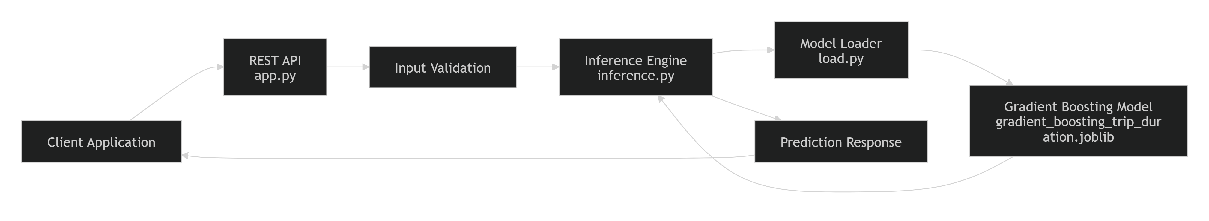

API Components
app.py
Acts as the primary API entry point.
Responsibilities
- Exposes API endpoints.
- Receives prediction requests.
- Performs request validation.
- Returns prediction responses.
- Handles exceptions and error messages.

load.py
Responsible for loading the serialized machine learning model.
Responsibilities
- Load Joblib artifacts.
- Verify model availability.
- Initialize model objects during startup.

inference.py
Executes prediction logic using the loaded model.
Responsibilities
- Receive validated features.
- Apply preprocessing if necessary.
- Generate ETA predictions.
- Return prediction results.

API Endpoint
ETA Prediction Endpoint
POST /predict
Purpose
Accepts trip information and returns the predicted trip duration (ETA).

Sample Request Payload
{
"passenger_count": 2,
"pickup_latitude": 40.7611,
"pickup_longitude": -73.9822,
"dropoff_latitude": 40.7419,
"dropoff_longitude": -73.9893,
"pickup_hour": 17,
"pickup_dayofweek": 2,
"pickup_month": 5
}
Request Parameters
Field | Description
passenger_count | Number of passengers
pickup_latitude | Pickup latitude
pickup_longitude | Pickup longitude
dropoff_latitude | Drop-off latitude
dropoff_longitude | Drop-off longitude
pickup_hour | Pickup hour
pickup_dayofweek | Day of week
pickup_month | Month of trip

Sample Successful Response
{
"status": "success",
"predicted_trip_duration": 845.32,
"unit": "seconds"
}
``
Response Fields
Field | Description
status | Request execution status
predicted_trip_duration | Predicted ETA
unit | Measurement unit

Input Validation
Robust validation mechanisms were implemented to ensure that only valid requests are processed.
Validation Rules
Passenger Count
Passenger Count > 0
Geographic Coordinates
Latitude ∈ [-90, 90]
Longitude ∈ [-180, 180]
Temporal Features
pickup_hour ∈ [0,23]
pickup_dayofweek ∈ [0,6]
pickup_month ∈ [1,12]
Required Fields
- All mandatory attributes must be present.
- Null values are rejected.
- Incorrect data types are rejected.

Error Handling
The API includes structured error handling to improve reliability and provide informative feedback to clients.
Invalid Input Example
Response
{
"status": "error",
"message": "Invalid latitude value."
}
HTTP Status Code
400 Bad Request

Missing Fields Example
{
"status": "error",
"message": "Required field missing: pickup_latitude"
}
HTTP Status Code
400 Bad Request

Internal Server Error Example
{
"status": "error",
"message": "Unexpected server error."
}
HTTP Status Code
500 Internal Server Error

API Request Lifecycle
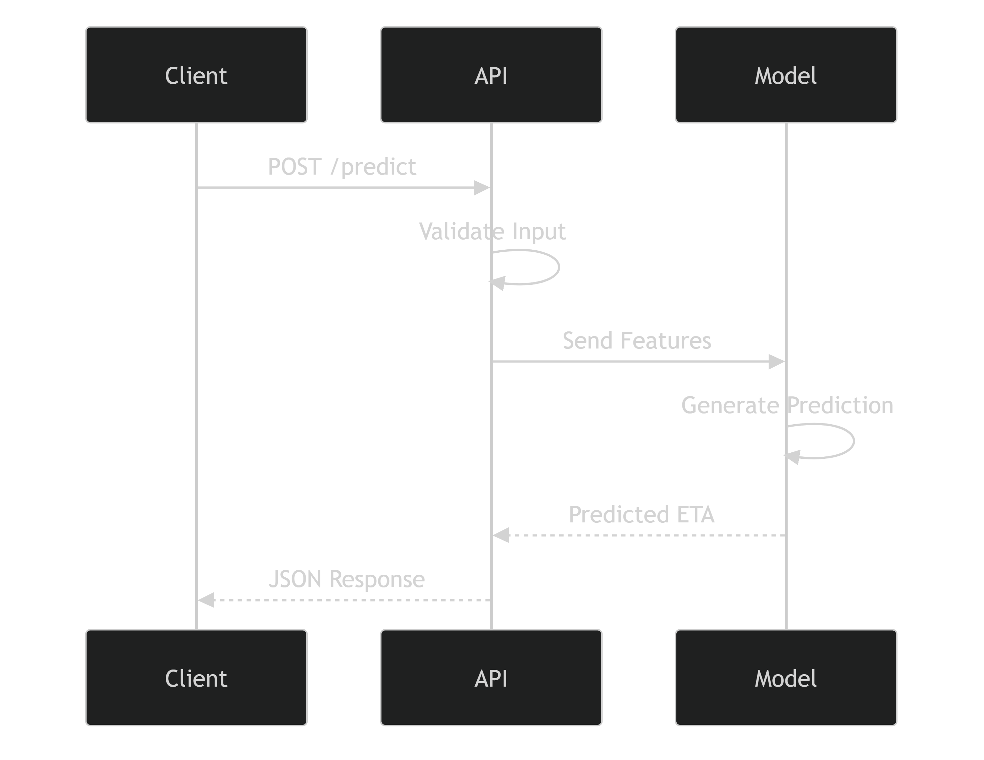

API Testing
Several testing components were implemented to verify API functionality and ensure production readiness.
Testing Files
test_api_app.py
test_inference.py
test_load.py
Test Coverage
- Endpoint availability.
- Request validation.
- Response format verification.
- Model loading validation.
- Inference execution testing.
- Error handling verification.

Performance and Scalability Considerations
The API design incorporates several deployment-oriented considerations.
Efficient Model Loading
- Model loaded once during service startup.
- Eliminates repeated loading overhead.
- Reduces prediction latency.
Stateless Architecture
- Each request processed independently.
- Supports horizontal scaling.
- Suitable for cloud environments.
Container Compatibility
- API can be deployed within Docker containers.
- Supports orchestration platforms and cloud-native deployment models.

Deployment Integration
The REST API serves as the operational interface between the packaged machine learning model and external consumers.
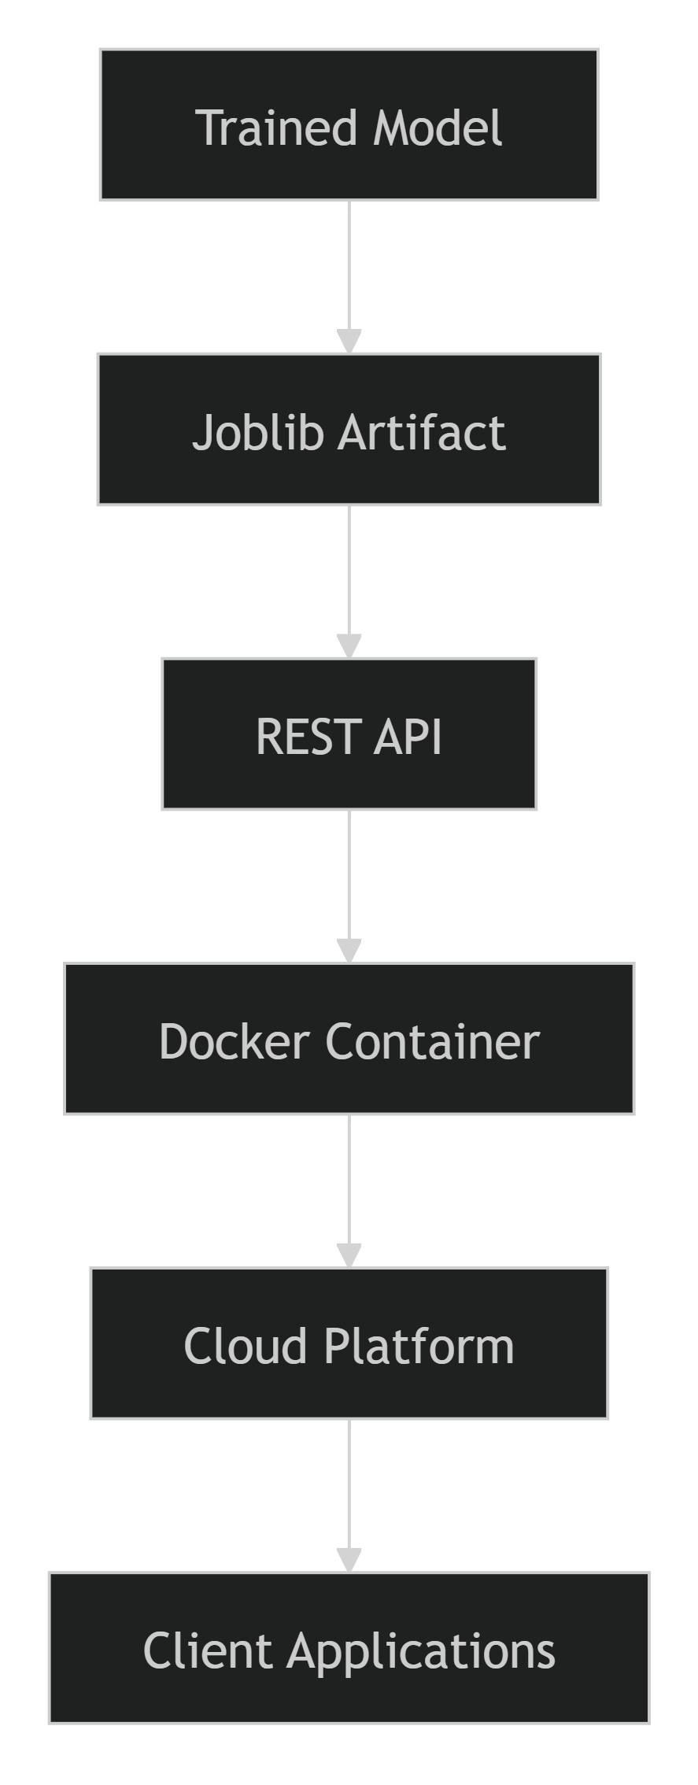

Benefits of the REST API
- Real-time ETA prediction.
- Easy integration with external systems.
- Standardized JSON-based communication.
- Scalable cloud deployment support.
- Improved maintainability through modular architecture.
- Deployment-ready inference framework.

Conclusion
The REST API serves as the production interface for the ETA Prediction system, enabling real-time access to machine learning predictions through standardized HTTP endpoints. Through dedicated components for model loading, inference, validation, and error handling, the API provides a reliable, scalable, and deployment-ready prediction service. Combined with automated testing, containerization support, and cloud deployment compatibility, the REST API forms a critical component of the project's end-to-end Machine Learning Engineering architecture.
5.3 Sample Request and Response Payloads
The ETA Prediction API accepts trip-related information as input and returns the predicted trip duration generated by the deployed Gradient Boosting model. The API follows a JSON-based request-response structure to ensure interoperability with web applications, mobile applications, and external services. The prediction service is exposed through a REST endpoint and processes validated input data before generating ETA estimates.
API Endpoint
POST /predict

Sample Request Payload
The client submits a JSON request containing the required trip features.
{
"passenger_count": 2,
"pickup_latitude": 40.7611,
"pickup_longitude": -73.9822,
"dropoff_latitude": 40.7419,
"dropoff_longitude": -73.9893,
"pickup_hour": 17,
"pickup_dayofweek": 2,
"pickup_month": 5,
"haversine_distance": 2.35
}
Request Field Description
Field | Description
passenger_count | Number of passengers traveling
pickup_latitude | Latitude of pickup location
pickup_longitude | Longitude of pickup location
dropoff_latitude | Latitude of destination
dropoff_longitude | Longitude of destination
pickup_hour | Hour at which trip begins
pickup_dayofweek | Day of the week (0-6)
pickup_month | Month of the year (1-12)
haversine_distance | Calculated distance between pickup and drop-off locations

Sample Successful Response
When the request is valid, the API returns the estimated trip duration.
{
"status": "success",
"predicted_trip_duration": 845.32,
"unit": "seconds",
"model": "Gradient Boosting Regressor"
}
Response Field Description
Field | Description
status | Indicates request execution status
predicted_trip_duration | Predicted ETA generated by the model
unit | Time unit of prediction
model | Model used to generate prediction

Example Response Interpretation
{
"status": "success",
"predicted_trip_duration": 845.32,
"unit": "seconds"
}
Interpretation:
845.32 seconds ≈ 14.09 minutes
This indicates that the model estimates the trip will take approximately 14 minutes to reach the destination based on the provided trip attributes.

Sample Invalid Request
{
"passenger_count": -1,
"pickup_latitude": 120.50,
"pickup_longitude": -73.98
}
The request contains invalid values:
- Passenger count cannot be negative.
- Latitude exceeds the valid range of -90 to +90.

Sample Validation Error Response
{
"status": "error",
"error_code": "INVALID_INPUT",
"message": "Latitude must be between -90 and 90."
}
HTTP Status Code
400 Bad Request

Sample Missing Field Response
{
"status": "error",
"error_code": "MISSING_FIELD",
"message": "Required field 'dropoff_latitude' is missing."
}
HTTP Status Code
400 Bad Request

Sample Server Error Response
{
"status": "error",
"error_code": "INTERNAL_SERVER_ERROR",
"message": "Model inference failed. Please
HTTP Status Code
500 Internal Server Error

Request–Response Flow
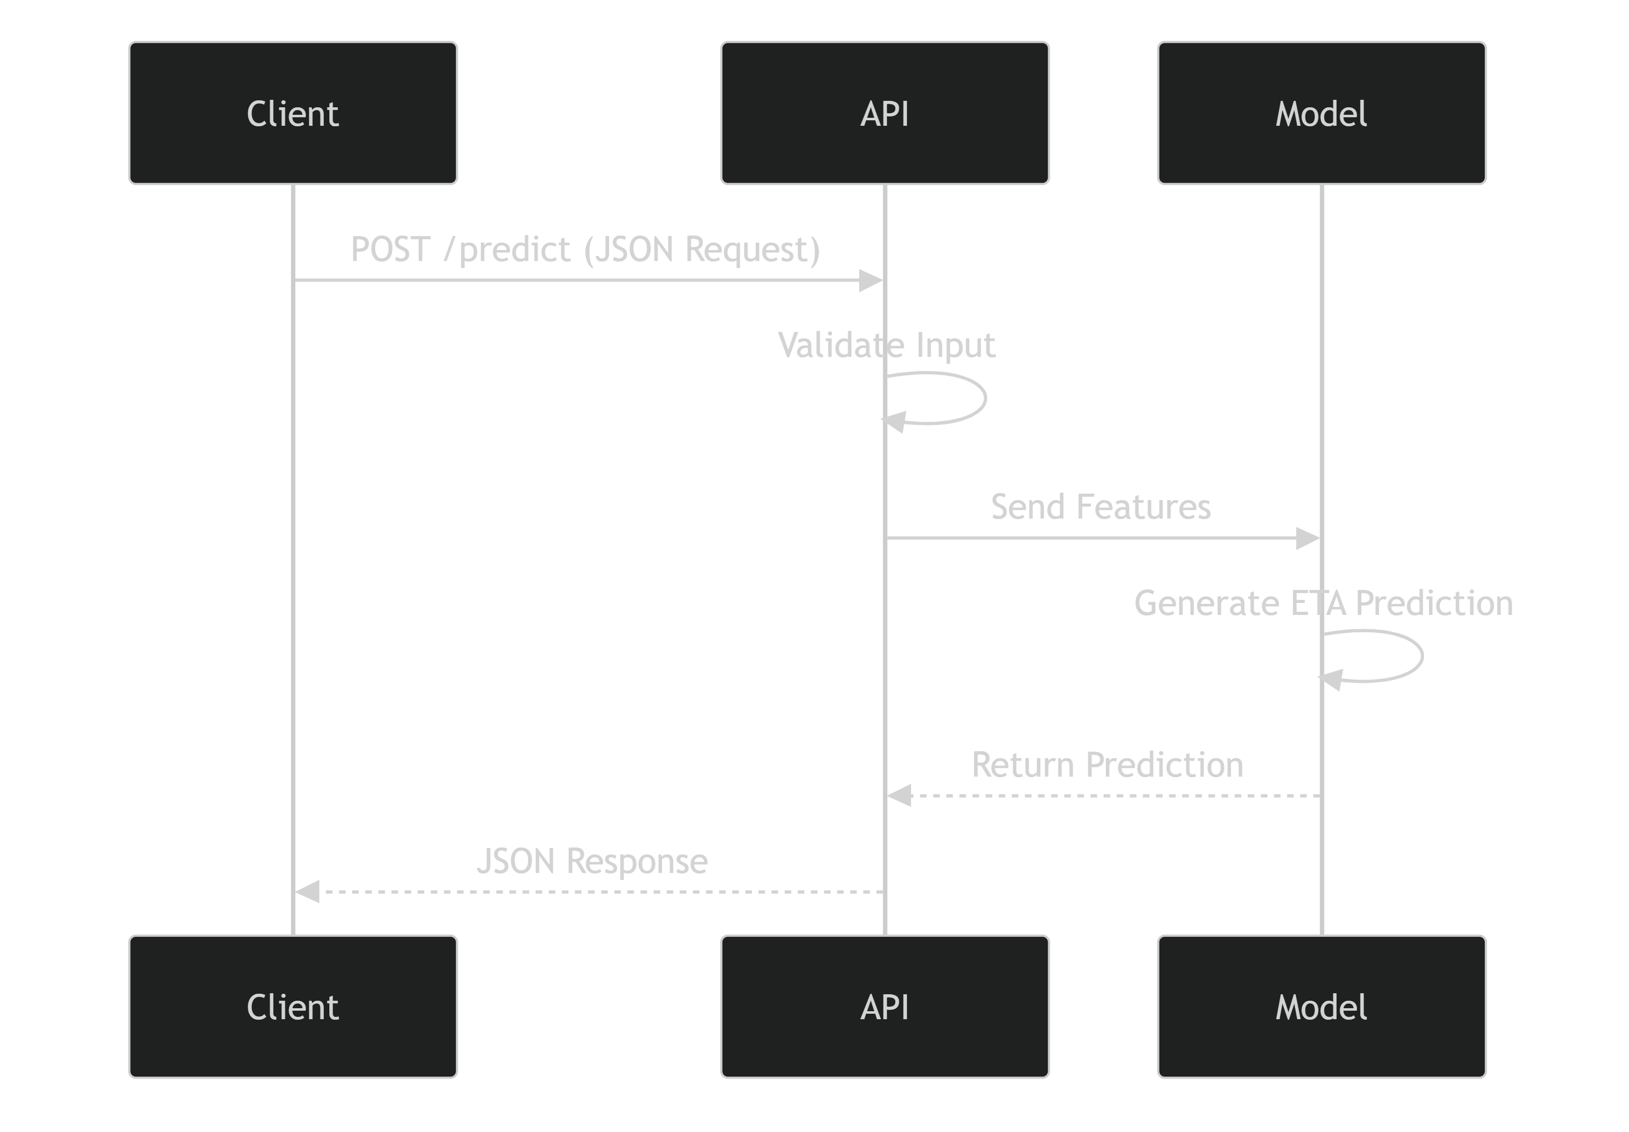

End-to-End Example
Request
{
"passenger_count": 1,
"pickup_latitude": 40.7549,
"pickup_longitude": -73.9840,
"dropoff_latitude": 40.7306,
"dropoff_longitude": -73.9866,
"pickup_hour": 18,
"pickup_dayofweek": 4,
"pickup_month": 8,
"haversine_distance": 3.12
}
Response
{
"status": "success",
"predicted_trip_duration": 1025.67,
"unit": "seconds",
"model": "Gradient Boosting Regressor"
}
This example demonstrates the complete interaction between a client application and the ETA Prediction API, showing how trip attributes are translated into a machine-learning-generated ETA estimate.
5.4 Validation and Error Handling
Validation and error handling are critical components of a production-grade REST API. They ensure that only valid requests are processed by the machine learning model and that users receive clear, consistent feedback when errors occur. In the ETA Prediction system, robust validation mechanisms were implemented to verify incoming request data before inference, while structured error-handling procedures were used to manage invalid inputs, prediction failures, and system-level exceptions. This approach improves API reliability, security, maintainability, and user experience.
Objectives
The validation and error-handling framework was designed to:
- Prevent invalid data from reaching the model.
- Improve prediction reliability.
- Provide meaningful feedback to API consumers.
- Reduce the risk of unexpected system failures.
- Ensure consistent API behavior across all requests.
- Support production-grade deployment standards.

Validation and Error Handling Workflow
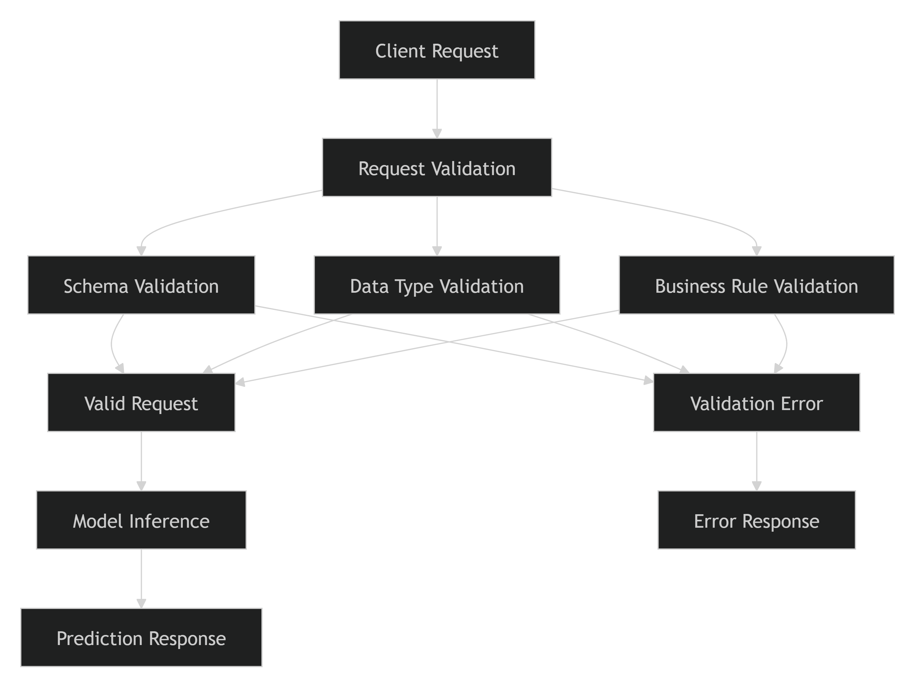

Input Validation
Every incoming API request undergoes validation before being submitted to the prediction engine.
Required Fields Validation
The API verifies that all mandatory fields are present.
Required Attributes
passenger_count
pickup_latitude
pickup_longitude
dropoff_latitude
dropoff_longitude
pickup_hour
pickup_dayofweek
pickup_month
If any required field is missing, the request is rejected.
Example Error Response
{
"status": "error",
"error_code": "MISSING_FIELD",
"message": "Required field 'pickup_latitude' is missing."
}
HTTP Status
400 Bad Request

Data Type Validation
Each field is checked to ensure it contains the expected data type.
Field | Expected Type
passenger_count | Integer
pickup_latitude | Float
pickup_longitude | Float
dropoff_latitude | Float
dropoff_longitude | Float
pickup_hour | Integer
pickup_dayofweek | Integer
pickup_month | Integer
Invalid data types are rejected before inference execution.
Example
Invalid Request
{
"passenger_count": "two",
"pickup_hour": "evening"
}
Response
{
"status": "error",
"error_code": "INVALID_DATATYPE",
"message": "pickup_hour must be an integer."
}

Business Rule Validation
In addition to data type validation, the API validates logical constraints on input values.
Passenger Count Validation
passenger_count > 0
Example:
{
"passenger_count": -1
}
Response:
{
"status": "error",
"error_code": "INVALID_PASSENGER_COUNT",
"message": "Passenger count must be greater than zero."
}

Coordinate Validation
Valid geographic coordinate ranges are enforced.
Latitude ∈ [-90, 90]
Longitude ∈ [-180, 180]
Example:
{
"pickup_latitude": 120.5
}
Response:
{
"status": "error",
"error_code": "INVALID_LATITUDE",
"message": "Latitude must be between -90 and 90."
}

Temporal Validation
Time-related features are validated against acceptable ranges.
pickup_hour : 0 - 23
pickup_dayofweek : 0 - 6
pickup_month : 1 - 12
Example:
{
"pickup_hour": 28
}
Response:
{
"status": "error",
"error_code": "INVALID_HOUR",
"message": "pickup_hour must be between 0 and 23."
}

Error Handling Architecture
The API includes centralized exception handling to manage both expected and unexpected failures.
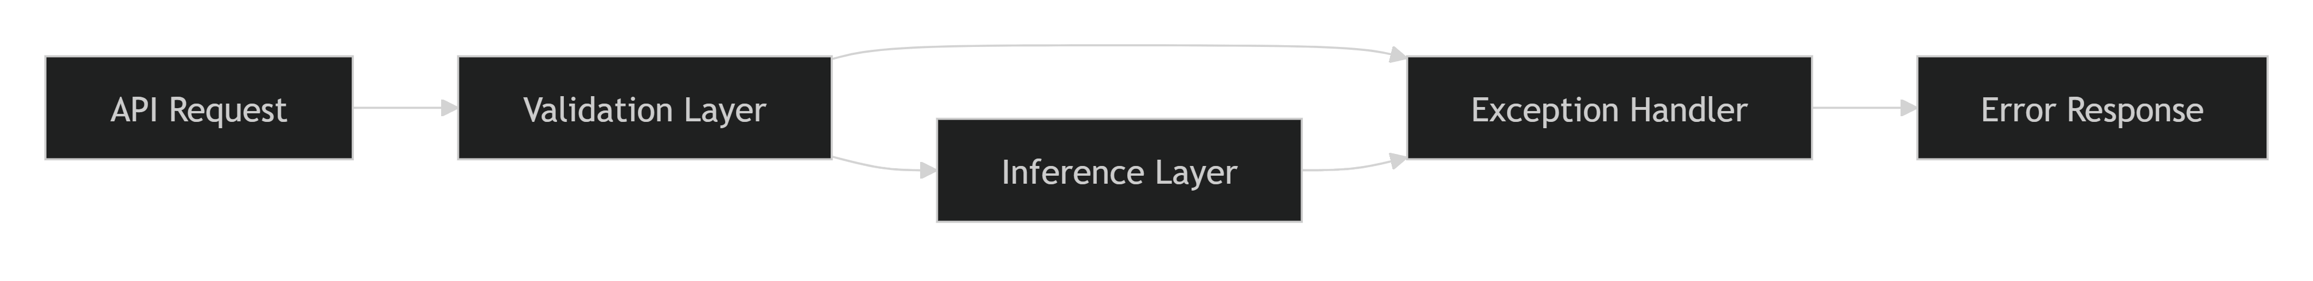

Validation Errors
Validation errors occur when client input does not meet API requirements.
Characteristics
- User-correctable.
- Client-side issue.
- No model execution required.
Status Code
400 Bad Request

Resource Not Found Errors
Returned when requested resources are unavailable.
Examples
- Model file missing.
- Unsupported endpoint requested.
Response:
{
"status": "error",
"error_code": "RESOURCE_NOT_FOUND",
"message": "Requested model artifact not found."
}
Status Code
404 Not Found

Model Inference Errors
These errors occur when prediction execution fails.
Possible Causes
- Corrupted model artifact.
- Incompatible feature data.
- Internal preprocessing issues.
Response:
{
"status": "error",
"error_code": "INFERENCE_ERROR",
"message": "Failed to generate prediction."
}
``
Status Code
500 Internal Server Error

Unexpected Server Errors
Unhandled exceptions are caught by a global exception handler.
Response:
{
"status": "error",
"error_code": "INTERNAL_SERVER_ERROR",
"message": "An unexpected server error occurred."
}
Status Code
500 Internal Server Error

API Response Standardization
All responses follow a consistent JSON structure.
Success Response
{
"status": "success",
"predicted_trip_duration": 845.32,
"unit": "seconds"
}
Error Response
{
"status": "error",
"error_code": "INVALID_INPUT",
"message": "Detailed error description."
}
This standardized format simplifies client-side integration and debugging.

Testing and Validation Coverage
Validation logic and error handling mechanisms were verified through automated testing.
Test Files
test_api_app.py
test_inference.py
test_load.py
Test Scenarios
- Missing fields.
- Invalid data types.
- Invalid coordinate values.
- Invalid temporal values.
- Model loading failure.
- Inference execution failure.
- Unexpected exception handling.

Benefits of Validation and Error Handling
Capability | Benefit
Input Validation | Prevents invalid predictions
Type Checking | Ensures data consistency
Business Rule Validation | Maintains domain correctness
Structured Error Responses | Improves user experience
Centralized Exception Handling | Enhances reliability
Automated Testing | Reduces production risks

Conclusion
The validation and error-handling framework ensures that the ETA Prediction API operates reliably and consistently in production environments. By enforcing schema validation, data-type checking, business-rule validation, and centralized exception handling, the system protects the machine learning model from invalid inputs and provides meaningful feedback to API consumers. This robust approach improves prediction quality, enhances user experience, and supports the long-term maintainability and scalability of the deployed ETA Prediction service.
5.5 Containerization Using Docker
To ensure consistent deployment across development, testing, and production environments, the ETA Prediction system was containerized using Docker. Containerization packages the machine learning model, API service, dependencies, and runtime environment into a single portable unit, eliminating environment-specific issues and simplifying deployment. By adopting Docker, the project achieves improved scalability, reproducibility, maintainability, and operational reliability.
Objectives
The primary objectives of containerization were to:
- Provide a consistent execution environment.
- Eliminate dependency conflicts.
- Simplify deployment across multiple platforms.
- Improve portability and scalability.
- Support cloud-native deployment strategies.
- Enable integration with CI/CD pipelines.

Why Docker?
Machine learning applications often depend on multiple libraries, runtime versions, and system configurations. Differences between local development and production environments can lead to deployment failures.
Docker addresses these challenges by:
- Packaging the application and dependencies together.
- Providing environment consistency.
- Supporting rapid deployment and scaling.
- Simplifying maintenance and updates.

Docker Architecture
The ETA Prediction service was containerized along with all required components.
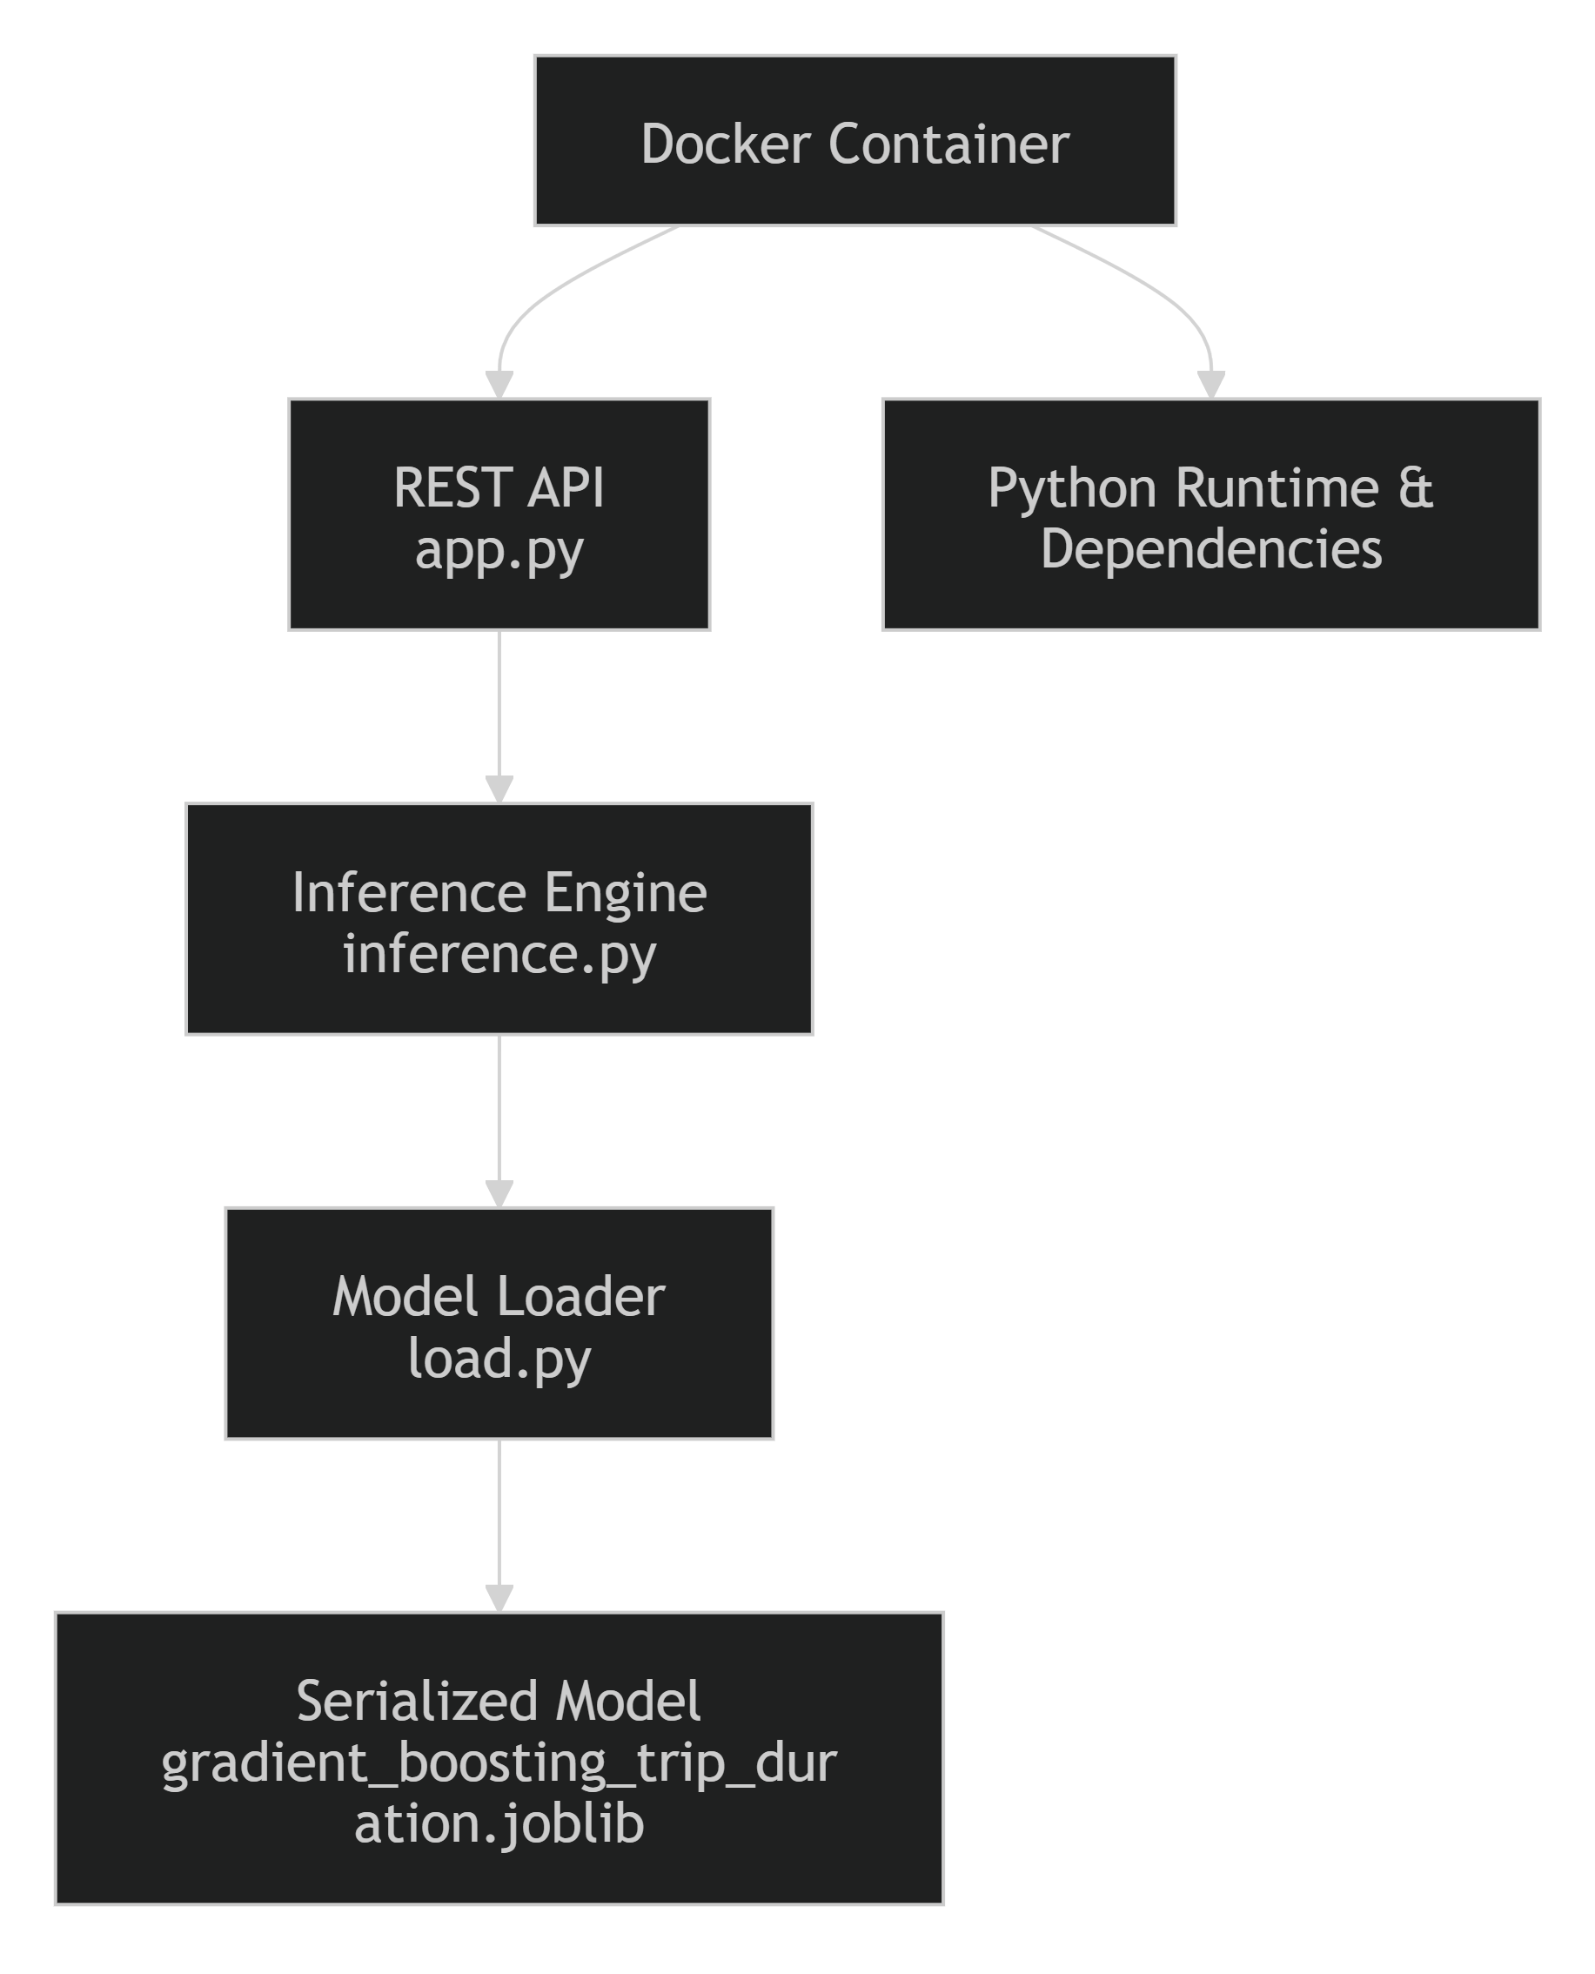

Container Components
The Docker container includes all components required for prediction serving.
Application Components
- REST API (app.py)
- Inference Engine (inference.py)
- Model Loading Module (load.py)
- Configuration Files (config.py)
Machine Learning Components
- Trained Gradient Boosting model
- Feature processing logic
- Validation mechanisms
Runtime Dependencies
- Python
- Scikit-learn
- Pandas
- NumPy
- Joblib
- Flask/FastAPI
- Other project dependencies

Docker Workflow

Docker Build Process
The deployment process begins by building a Docker image containing the application and required dependencies.
Build Command
docker build -t eta-prediction .
This command creates a Docker image that encapsulates:
- API service
- Machine learning model
- Required libraries
- Runtime environment

Running the Container
Once the image is created, a container instance can be launched.
Run Command
docker run -p 8000:8000 eta-prediction
This command:
- Starts the API service.
- Loads the trained model.
- Exposes prediction endpoints.
- Makes the application accessible through HTTP requests.

Deployment Flow
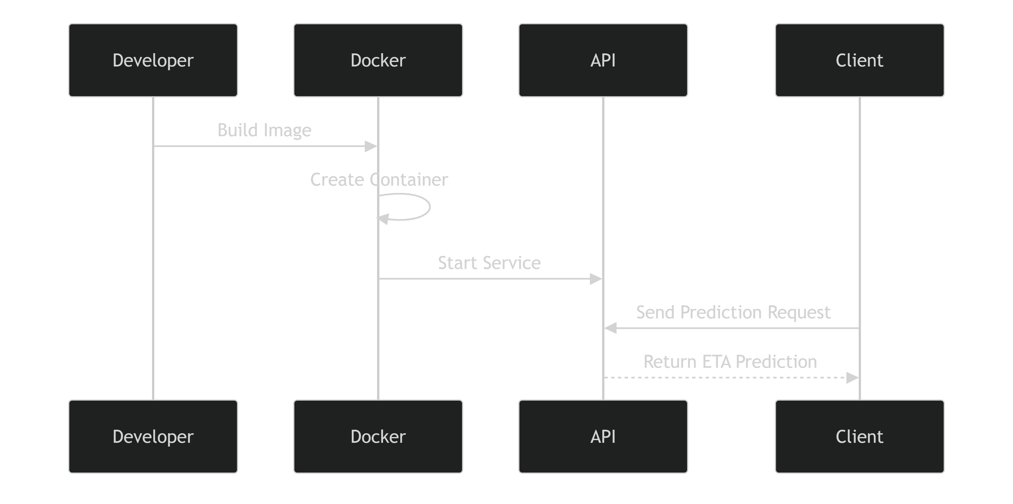

Benefits of Containerization
Environment Consistency
The same container image can run across:
- Developer workstations
- Testing environments
- Staging servers
- Production infrastructure
This eliminates the common issue of:
"It works on my machine."
`

Portability
The container can be deployed on:
- Local machines
- Virtual machines
- Kubernetes clusters
- Cloud platforms
including:
- Google Cloud Run
- Azure Container Apps
- AWS ECS / EKS

Scalability
Docker containers support horizontal scaling.
Benefits include:
- Multiple API instances.
- Load balancing support.
- High-availability deployments.
- Improved response times during peak traffic.

Faster Deployment
Containerized deployment provides:
- Simplified releases.
- Automated delivery pipelines.
- Reduced deployment risk.
- Faster rollback capability.

Integration with CI/CD
Docker serves as a key component in the future Continuous Integration and Continuous Deployment (CI/CD) workflow.
This pipeline enables automated testing, packaging, and deployment of updated model versions.

Security and Reliability Considerations
Several best practices were considered during containerization:
Security
- Restrict unnecessary system access.
- Store sensitive configuration outside the container.
- Use environment variables for secrets management.
Reliability
- Health checks for API availability.
- Centralized logging.
- Monitoring integration.
- Automated container restarts.
These measures improve operational stability and production readiness.

Deployment Readiness
The containerized architecture enables:
✅ Consistent execution environments
✅ Easy deployment and scaling
✅ Simplified maintenance
✅ Cloud-native deployment support
✅ MLOps integration
✅ Reproducible model serving
These characteristics align with modern Machine Learning Engineering and DevOps best practices.

Conclusion
Docker containerization provides a robust and portable deployment mechanism for the ETA Prediction system. By packaging the API, machine learning model, dependencies, and runtime environment into a single container image, the project achieves consistency, scalability, and deployment reliability. The Docker-based architecture simplifies operational management, supports cloud-native deployments, and establishes a strong foundation for future CI/CD automation and MLOps-driven production workflows.
5.6 Deployment Strategy
The deployment strategy was designed to transition the ETA Prediction system from a development environment to a scalable, reliable, and production-ready machine learning service. The strategy focuses on containerized deployment, API-based model serving, automated monitoring, model versioning, and future CI/CD integration. By leveraging modern MLOps practices, the solution ensures that ETA predictions can be delivered consistently while maintaining performance, scalability, and maintainability.
Objectives
The deployment strategy was developed to:
- Deploy the ETA prediction model in a production environment.
- Provide real-time prediction capabilities through a REST API.
- Ensure scalability and high availability.
- Support monitoring and model maintenance.
- Enable reproducible and automated deployments.
- Establish a foundation for continuous integration and continuous delivery (CI/CD).

Deployment Architecture
The deployment architecture follows a layered approach that separates model serving, application hosting, monitoring, and operational management.
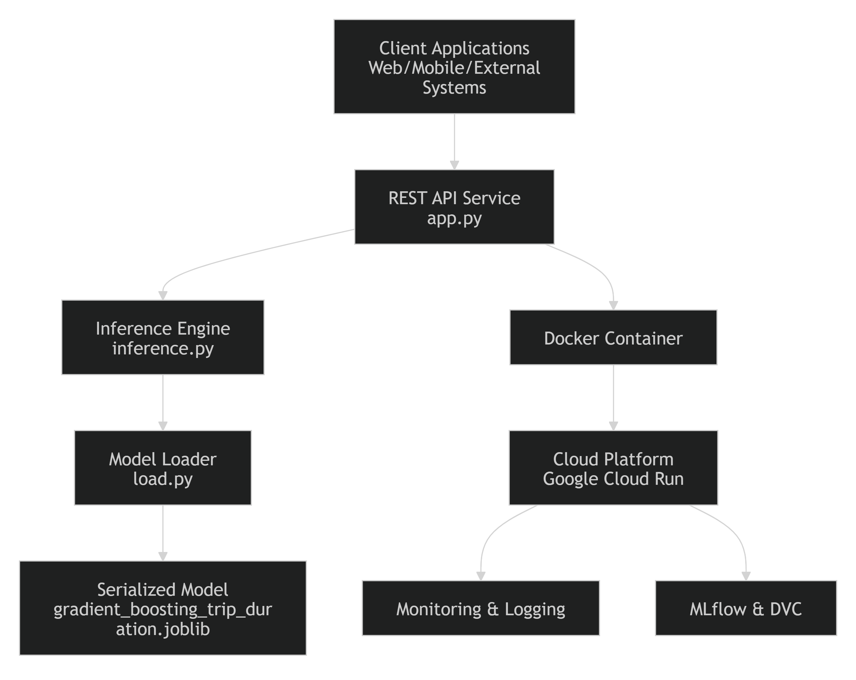

Deployment Workflow

Deployment Components
Machine Learning Model
The selected Gradient Boosting model is serialized and stored as:
gradient_boosting_trip_duration.joblib
This artifact serves as the production-ready prediction engine.

REST API Service
The API acts as the external interface for consuming ETA predictions.
Responsibilities
- Receive prediction requests.
- Validate input data.
- Invoke the trained model.
- Return ETA predictions.
- Handle errors and exceptions.

Docker Container
The complete application is packaged into a Docker container containing:
- API service
- Model artifact
- Dependencies
- Runtime environment
- Configuration files
Containerization ensures reproducibility and portability across environments.

Target Deployment Platform
Google Cloud Run (Recommended)
The project documentation identifies Google Cloud Run as a preferred deployment option.
Benefits
- Fully managed container deployment.
- Automatic scaling based on request volume.
- Reduced infrastructure management overhead.
- Pay-per-use pricing model.
- High availability and reliability.
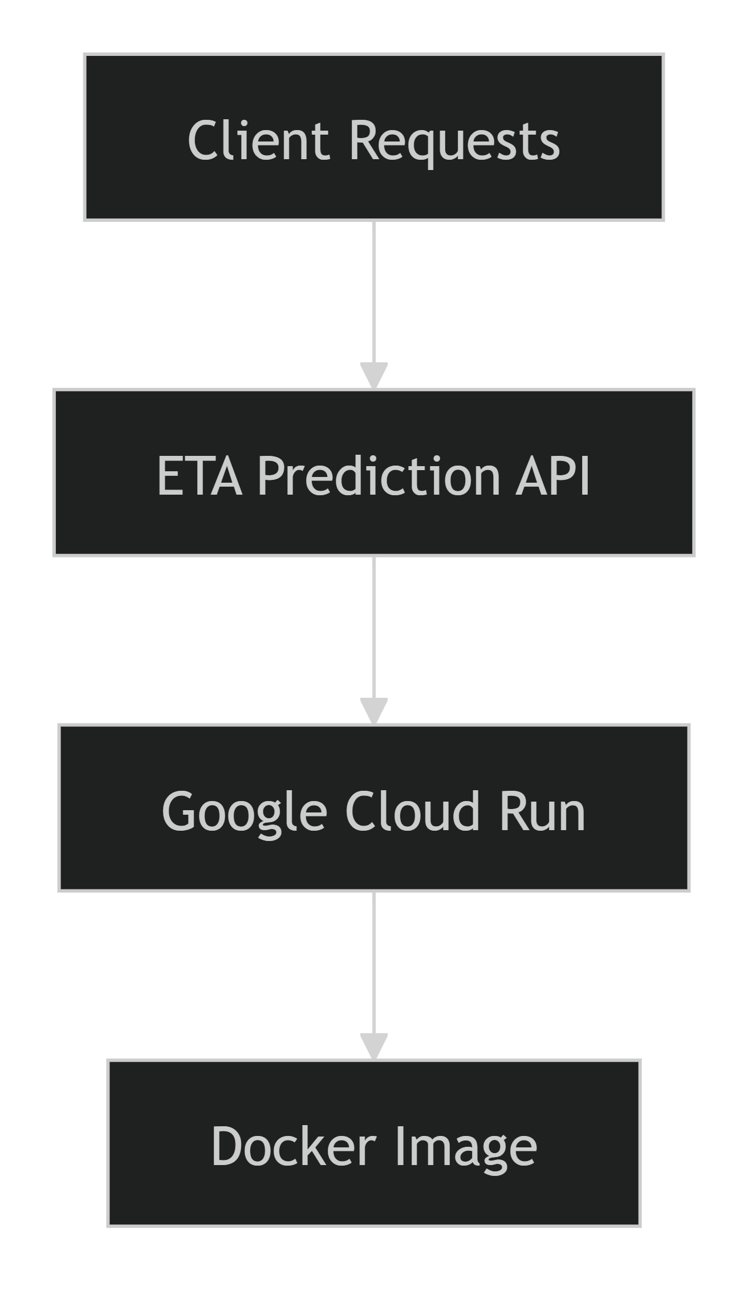

Scalability Strategy
To support increasing request volumes and future growth, the deployment strategy incorporates horizontal scalability.
Scaling Features
- Automatic container scaling.
- Stateless API architecture.
- Container-based deployment.
- Load-balancer compatibility.
- Cloud-native infrastructure support.
Benefits include:
- Reduced response latency.
- Improved availability.
- Efficient resource utilization.

Monitoring and Observability
Continuous monitoring is an essential part of the deployment strategy.
Monitored Components
Model Performance
- RMSE
- MAE
- Prediction accuracy trends
Data Quality
- Input feature distributions
- Data drift indicators
Service Health
- API latency
- Request throughput
- Error rates
- CPU and memory utilization
Prediction Logging
- Input requests
- Prediction outputs
- Operational metrics

Retraining Integration
The deployment strategy supports future model maintenance through automated retraining.
Retraining Triggers
Scheduled Retraining
Performance Degradation
Data Drift Detection
Business Requirement Changes
Retraining Workflow
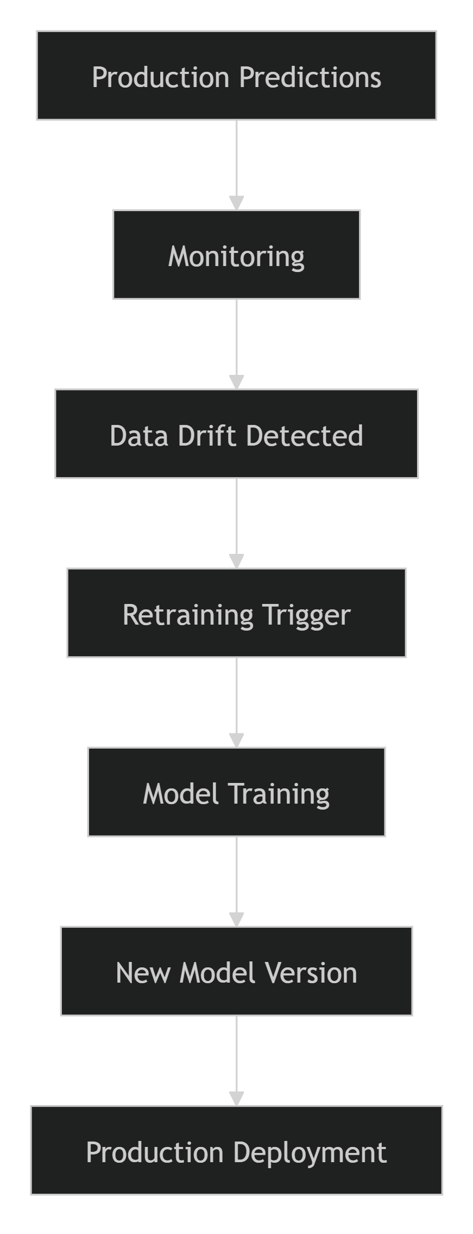

CI/CD Deployment Strategy
Future deployment automation will leverage CI/CD pipelines to streamline updates and reduce manual deployment effort.
Planned Pipeline
Benefits
- Faster releases.
- Reduced deployment risk.
- Automated quality checks.
- Consistent production updates.

Security Considerations
The deployment strategy incorporates several security best practices:
Application Security
- Input validation.
- Secure API endpoints.
- Exception handling.
- Rate-limiting capabilities.
Infrastructure Security
- Environment variable management.
- Restricted container permissions.
- Secure model artifact storage.
- Controlled deployment access.

Deployment Readiness Checklist
Component | Status
Trained Model Available | ✅
Model Serialization Completed | ✅
REST API Developed | ✅
API Testing Completed | ✅
Docker Containerization Planned | ✅
Monitoring Strategy Defined | ✅
Retraining Strategy Defined | ✅
Cloud Deployment Strategy Defined | ✅
CI/CD Roadmap Established | ✅

Expected Production Benefits
Technical Benefits
- Scalable prediction service.
- Fast model inference.
- Reproducible deployments.
- Simplified maintenance.
Business Benefits
- Reliable ETA predictions.
- Improved customer experience.
- Better operational planning.
- Enhanced service availability.
MLOps Benefits
- Continuous monitoring.
- Automated retraining readiness.
- Model version control.
- End-to-end traceability.

Conclusion
The deployment strategy provides a comprehensive roadmap for operationalizing the ETA Prediction system in a production environment. By combining Docker-based containerization, REST API model serving, Google Cloud Run deployment, continuous monitoring, and future CI/CD automation, the solution ensures scalability, reliability, and maintainability. This strategy aligns with modern Machine Learning Engineering and MLOps best practices, enabling the system to deliver accurate real-time ETA predictions while supporting long-term growth and continuous improvement.

6. Monitoring and Maintenance
6.1 Prediction Logging
Prediction logging is a critical component of the monitoring framework because it provides visibility into how the deployed model performs in real-world conditions. The objective of prediction logging is to systematically capture prediction requests, model outputs, and related metadata so that model behavior can be monitored, audited, evaluated, and improved over time. The collected logs serve as the foundation for performance monitoring, drift detection, troubleshooting, and future model retraining activities.
Objectives
The prediction logging framework was established to:
- Record all prediction requests processed by the API.
- Store model predictions for future analysis.
- Support model performance monitoring.
- Enable data drift and concept drift detection.
- Facilitate root-cause analysis of prediction issues.
- Create a reliable dataset for model retraining.

Prediction Logging Architecture
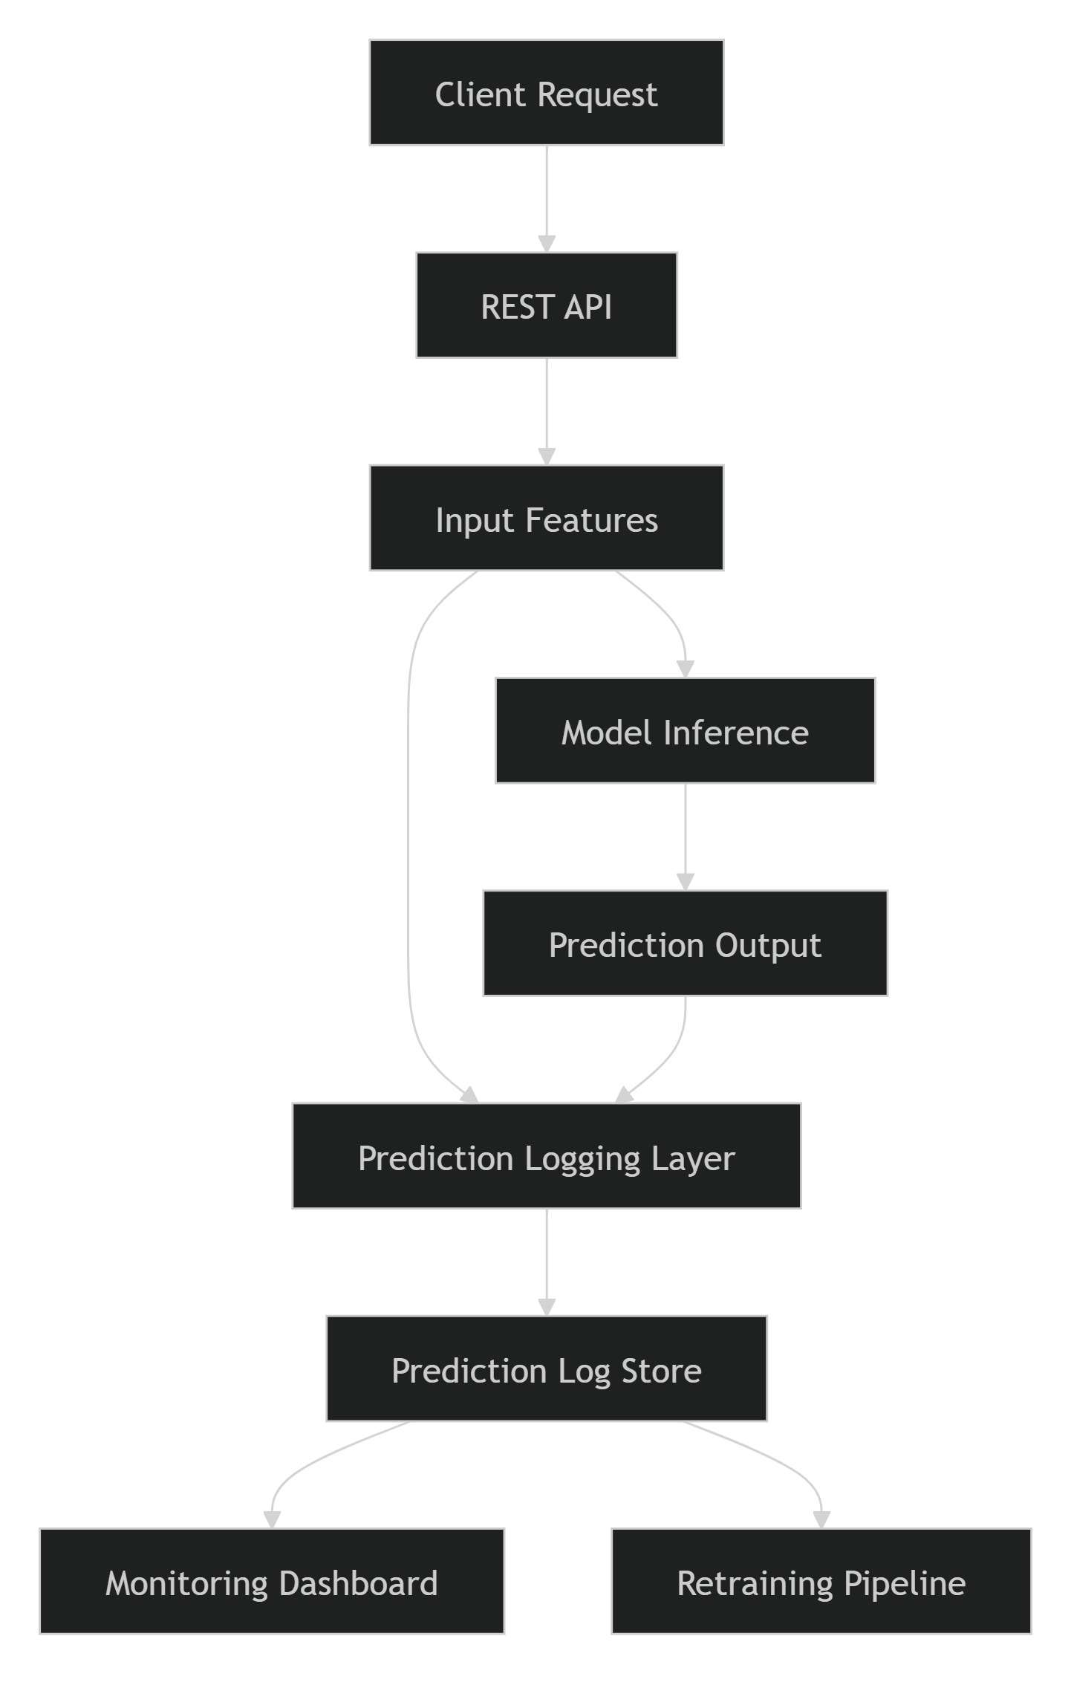

Information Logged
For every prediction generated by the ETA Prediction API, a structured log record is captured.
Input Data
The original features submitted by the user are stored.
Examples include:
- Passenger Count
- Pickup Coordinates
- Drop-off Coordinates
- Pickup Hour
- Day of Week
- Month
- Haversine Distance
Logging input features enables future analysis of data distribution changes and model behavior.

Prediction Results
The generated model output is recorded.
Example:
{
"predicted_trip_duration": 845.32
}
Prediction logging enables comparisons between predicted values and actual observed outcomes once they become available.

Metadata
Additional metadata is recorded for traceability and auditing purposes.
Examples:
- Request ID
- Prediction Timestamp
- API Version
- Model Version
- MLflow Run ID
- Response Time
This information helps identify which model version generated each prediction and supports reproducibility.

Example Prediction Log Record
{
"request_id": "REQ-20260829-001",
"timestamp": "2026-08-29T10:30:25Z",
"model_version": "GradientBoosting_v1",
"passenger_count": 2,
"pickup_hour": 17,
"pickup_dayofweek": 4,
"haversine_distance": 2.35,
"predicted_trip_duration": 845.32,
"prediction_latency_ms": 42
}

Prediction Logging Workflow
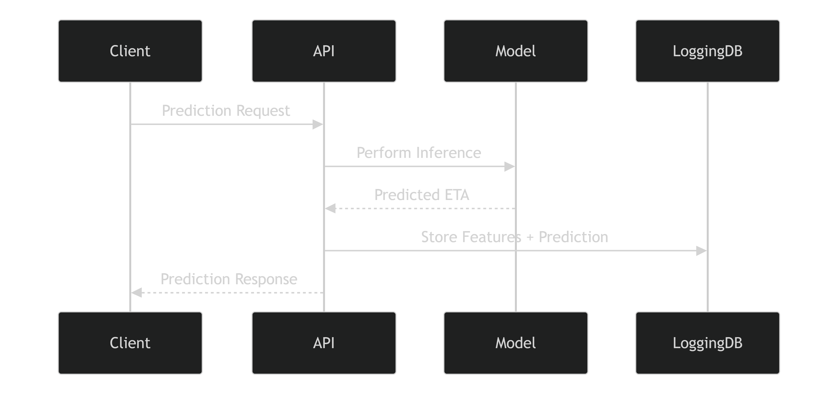

Storage Strategy
Prediction logs can be stored using one or more of the following approaches:
Database Storage
A relational database can store:
- Prediction inputs
- Prediction outputs
- Metadata
- Actual outcomes (when available)
Benefits:
- Easy querying
- Historical tracking
- Performance analysis

Data Lake Storage
Large-scale prediction logs can be archived within a centralized data lake.
Benefits:
- Long-term retention
- Retraining dataset generation
- Large-volume analytics

Centralized Logging Platform
Prediction events may also be streamed to:
- Cloud Logging
- ELK Stack
- Splunk
- Azure Monitor
Benefits:
- Real-time monitoring
- Operational visibility
- Centralized observability

Supporting Data Drift Detection
Prediction logging provides the baseline data required to identify shifts in feature distributions.
Examples of Monitored Features
- Pickup Hour
- Passenger Count
- Haversine Distance
- Geographic Coordinates
By comparing current feature distributions against training distributions, the system can identify data drift and trigger further investigation.
Drift Detection Flow
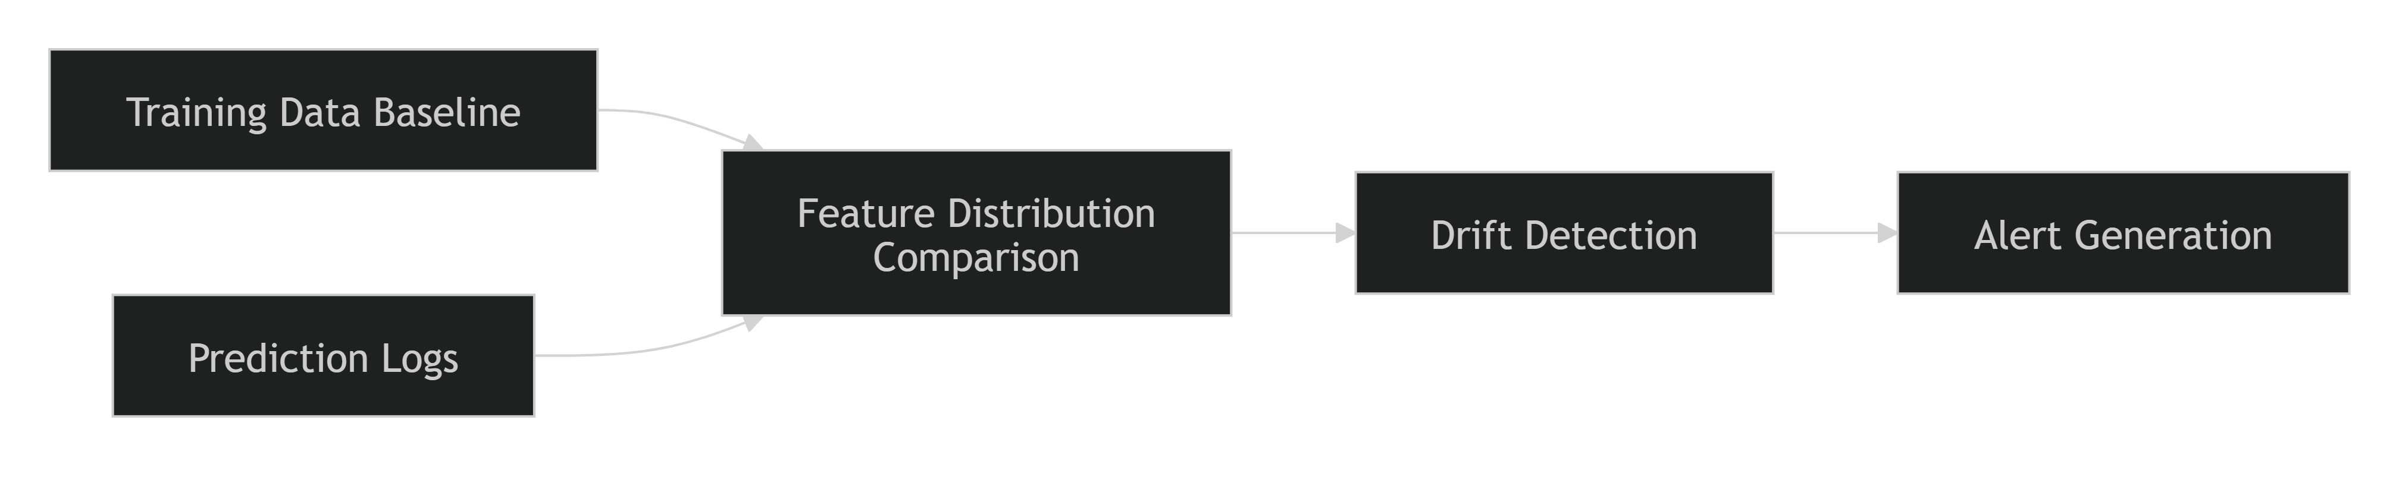

Supporting Performance Monitoring
As actual trip durations become available, prediction logs can be combined with observed outcomes to calculate model performance metrics in production.
Metrics Monitored
- Mean Absolute Error (MAE)
- Root Mean Squared Error (RMSE)
- R-Squared (R²)
This enables continuous assessment of prediction quality after deployment.

Supporting Automated Retraining
Prediction logs form the primary source of future training data.
Retraining Process
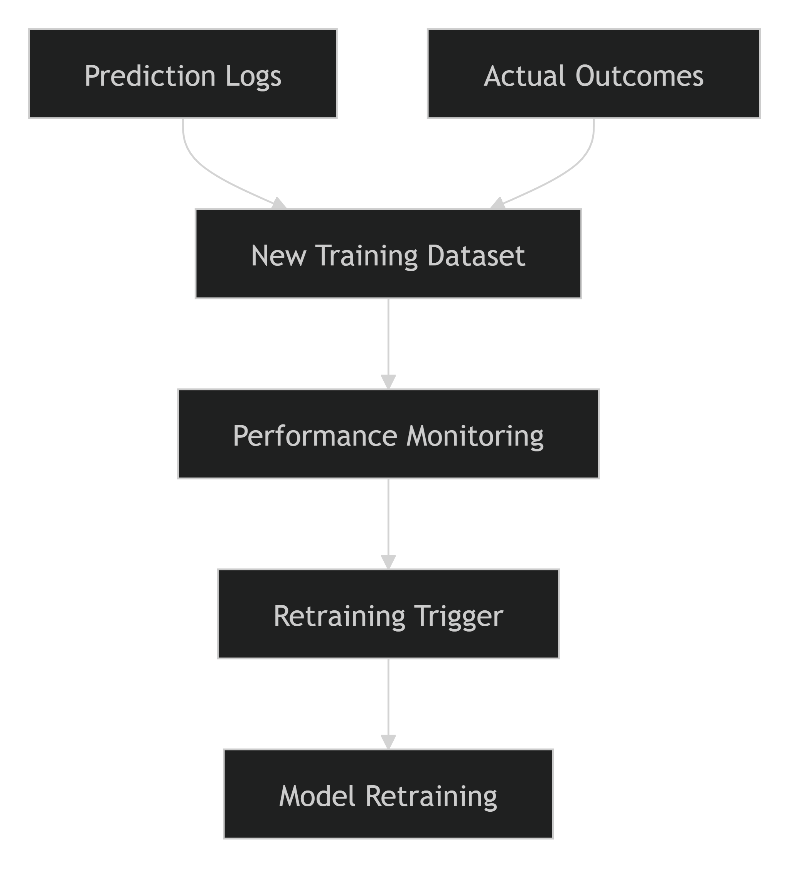
By continuously collecting production data, the organization can retrain models to adapt to changing traffic patterns and customer behavior.

Security and Compliance Considerations
Prediction logs should be managed according to organizational security policies.
Recommended practices include:
- Logging only required information.
- Encrypting stored sensitive data.
- Restricting access to operational logs.
- Implementing retention policies.
- Auditing prediction access and usage.
These controls help ensure that monitoring capabilities do not compromise security or privacy requirements.

Benefits of Prediction Logging
Capability | Business Benefit
Prediction Traceability | Easier debugging and auditing
Drift Detection | Early identification of data changes
Performance Monitoring | Continuous measurement of model quality
Retraining Dataset Creation | Supports model improvement
Root Cause Analysis | Faster issue resolution
Regulatory Auditing | Improved operational governance

Conclusion
Prediction logging serves as the foundation of the production monitoring framework for the ETA Prediction system. By capturing input features, model outputs, metadata, and performance information, the logging infrastructure enables continuous monitoring, drift detection, model evaluation, and automated retraining. This capability ensures that the deployed model remains accurate, reliable, and aligned with changing real-world conditions, supporting the long-term success of the machine learning solution.
6.2 Data Drift Detection
Data drift refers to changes in the statistical properties of input features over time compared to the data used during model training. In production environments, shifts in customer behavior, traffic patterns, seasonal trends, operational processes, or external factors can cause incoming data distributions to differ significantly from historical training data. If left undetected, data drift can reduce model accuracy and negatively impact ETA prediction reliability. Therefore, a comprehensive data drift detection strategy was incorporated into the monitoring framework to ensure the continued effectiveness of the deployed model.
Objectives
The primary objectives of data drift monitoring are to:
- Detect significant changes in production data distributions.
- Identify potential model performance degradation early.
- Trigger investigations and corrective actions.
- Support automated retraining decisions.
- Maintain prediction accuracy over time.
- Ensure long-term model reliability and business value.

Understanding Data Drift
Data drift occurs when the distribution of one or more input features changes between:
Training Data Distribution
↓
Production Data Distribution
Examples include:
- Changes in pickup locations.
- Seasonal fluctuations in ride demand.
- Changes in travel behavior.
- Unexpected traffic conditions.
- Changes in passenger patterns.
These variations may cause the model to encounter scenarios that were underrepresented during training.

Data Drift Detection Architecture
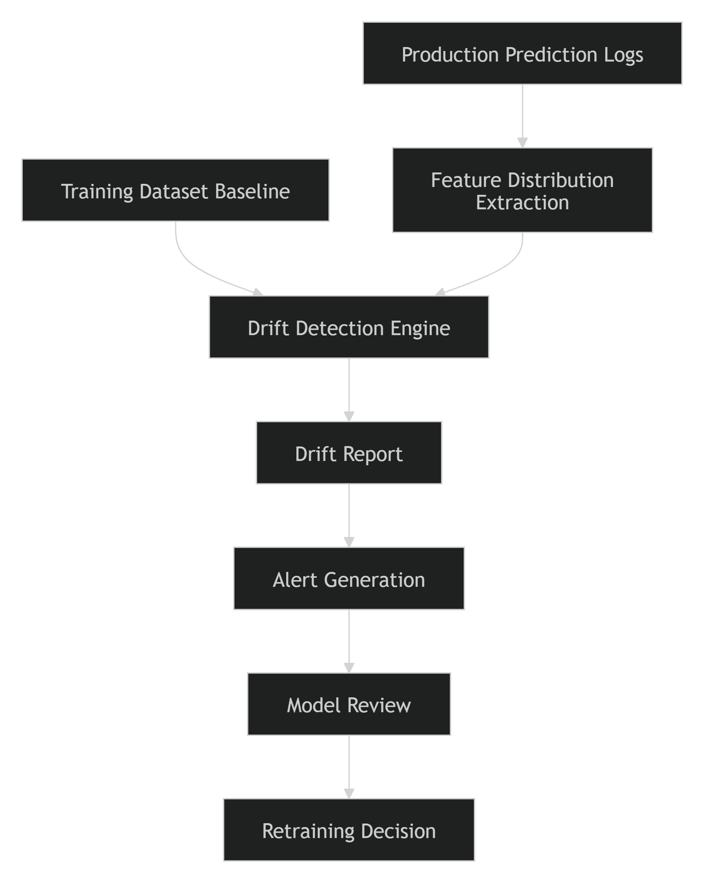

Features Monitored for Drift
The monitoring framework focuses on the most influential features used by the ETA prediction model.
Temporal Features
- Pickup Hour
- Pickup Day of Week
- Pickup Month
- Weekend Indicator
Changes in commuting behavior or seasonal travel patterns can affect these distributions.
Geographic Features
- Pickup Latitude
- Pickup Longitude
- Drop-off Latitude
- Drop-off Longitude
- Travel Direction
Changes in service areas or travel demand may introduce geographic drift.
Distance Features
- Haversine Distance
A shift toward longer or shorter trips can significantly affect model behavior.
Trip Features
- Passenger Count
Variations in passenger behavior may indicate changing business usage patterns.

Drift Detection Workflow
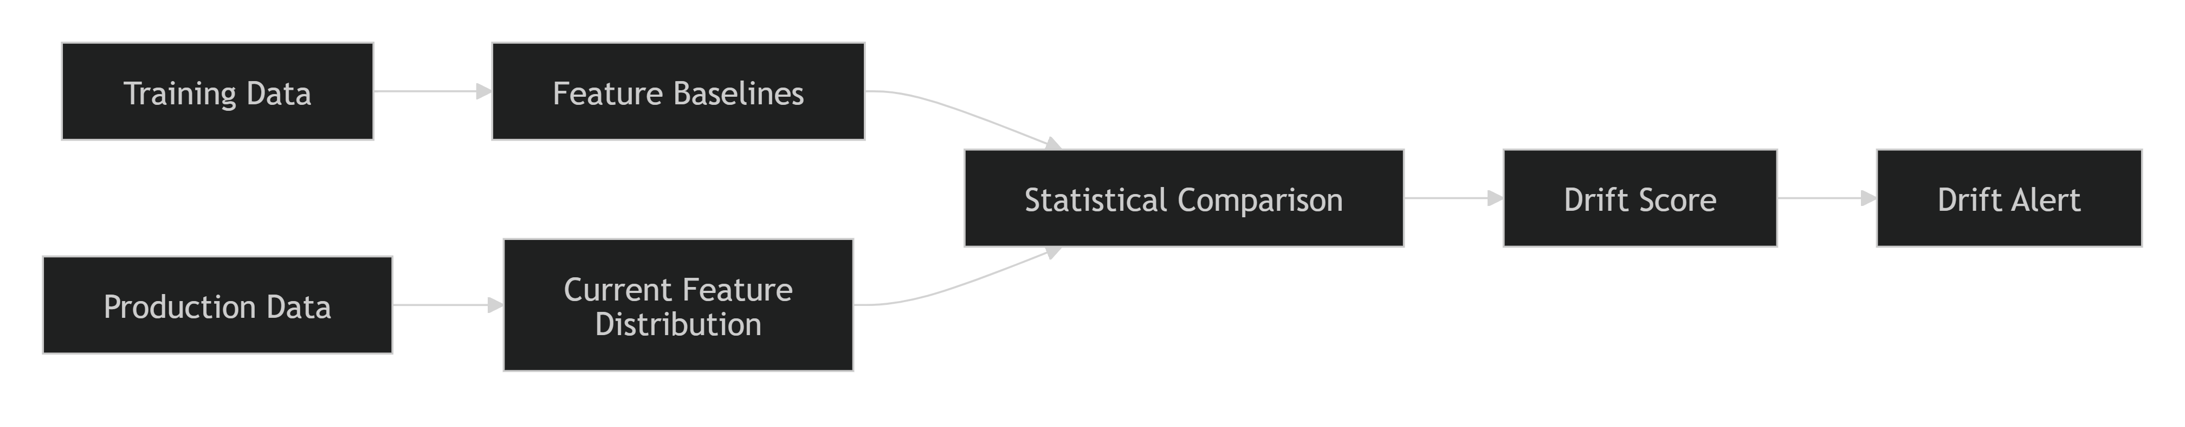

Statistical Drift Detection Methods
Several statistical techniques can be used to compare training and production feature distributions.
Kolmogorov-Smirnov (KS) Test
Used for numerical features.
Purpose
- Compares training and production distributions.
- Measures whether two samples originate from the same population.
Applicable Features
- Haversine Distance
- Passenger Count
- Geographic Coordinates

Jensen-Shannon Divergence
Measures the similarity between two probability distributions.
Purpose
- Quantifies the magnitude of distributional change.
- Provides intuitive drift scoring.

Population Stability Index (PSI)
Commonly used in production machine learning systems.
Purpose
- Quantifies feature distribution shifts.
- Generates drift severity indicators.
Example Interpretation
PSI Score | Interpretation
< 0.10 | No Significant Drift
0.10 – 0.25 | Moderate Drift
> 0.25 | Significant Drift

Drift Monitoring Dashboard
Feature drift metrics are visualized through monitoring dashboards.
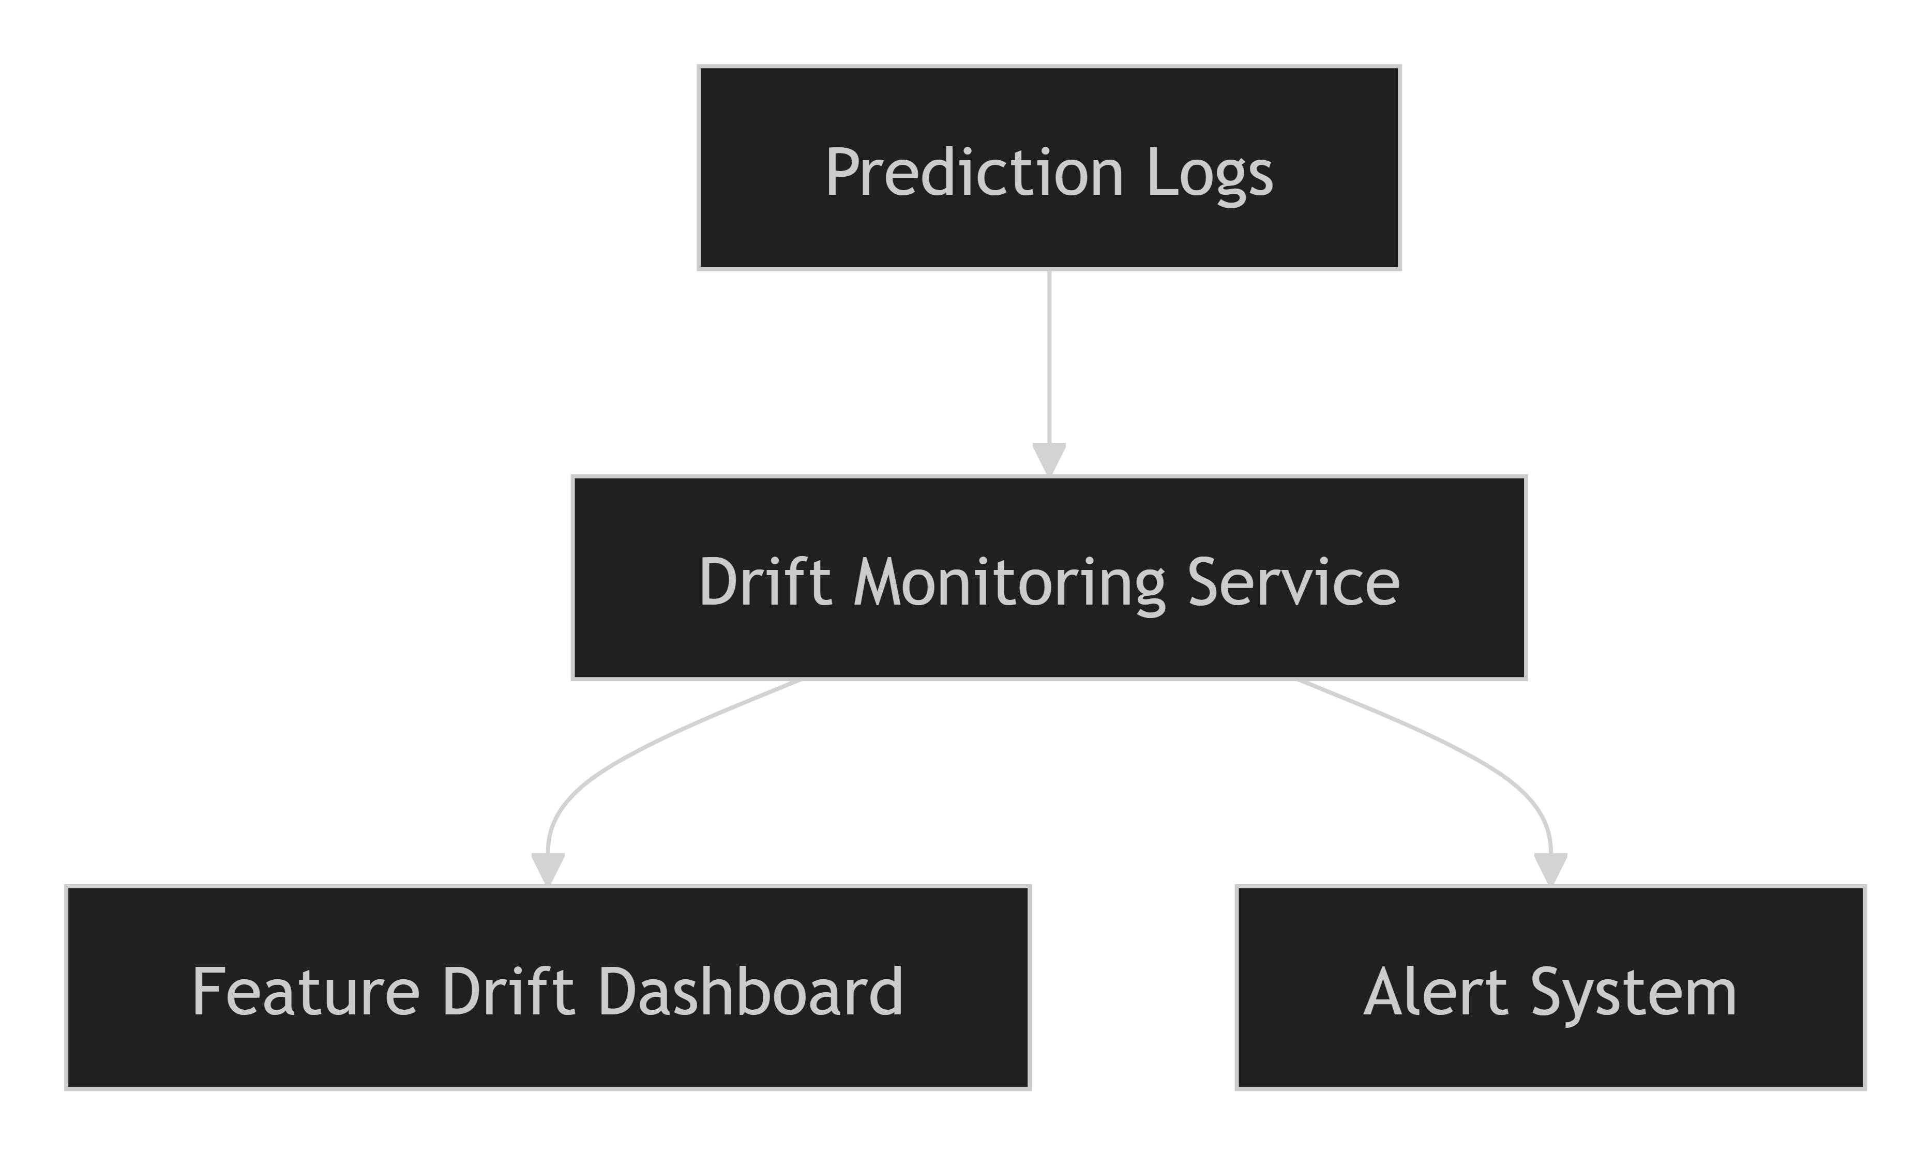
The dashboard tracks:
- Feature distributions
- Drift scores
- Historical trends
- Drift alerts
- Monitoring status

Drift Simulation Strategy
To validate the effectiveness of the monitoring framework, controlled drift scenarios can be simulated.
Scenario 1: Festival Surge
Increased ride demand
Higher passenger count
Longer trip durations
Expected Outcome:
- Shift in pickup-hour distribution.
- Increased drift score alerts.

Scenario 2: Holiday Traffic
Different travel patterns
Increased weekend trips
Congestion-related delays
Expected Outcome:
- Temporal feature drift detection.
- Performance monitoring alerts.

Scenario 3: Geographic Expansion
New service regions introduced
Different pickup and drop-off patterns
Expected Outcome:
- Geographic distribution drift.
- Coordinate distribution changes.

Scenario 4: Economic or Behavioral Changes
Reduced overall trip volume
Changes in customer travel habits
Expected Outcome:
- Passenger count and distance distribution shifts.
These simulated scenarios help verify that monitoring mechanisms can detect meaningful distribution changes before they affect production performance.

Alerting Strategy
Drift alerts are generated whenever predefined thresholds are exceeded.
Alert Levels
Level | Condition | Action
Informational | Minor Drift | Continue Monitoring
Warning | Moderate Drift | Review Feature Distributions
Critical | Significant Drift | Trigger Investigation & Retraining Review

Integration with Retraining
Data drift serves as one of the primary retraining triggers.
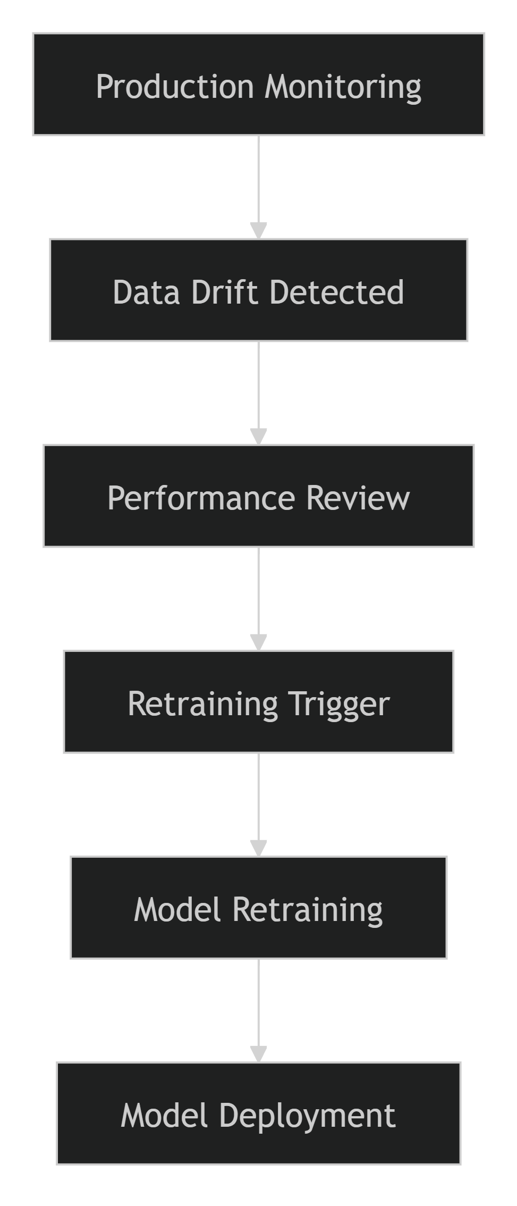
When significant drift persists over time, the retraining pipeline may be activated to incorporate fresh production data and restore model performance.

Benefits of Data Drift Monitoring
Capability | Benefit
Early Drift Detection | Prevents unexpected performance degradation
Continuous Visibility | Tracks changing data patterns
Automated Alerting | Enables proactive intervention
Retraining Support | Provides retraining triggers
Improved Reliability | Maintains prediction quality
Business Continuity | Reduces operational risks

Conclusion
Data drift detection is a critical component of the ETA Prediction monitoring framework. By continuously comparing production data against training baselines, the system can identify changes in feature distributions before they significantly impact model performance. Through statistical drift analysis, monitoring dashboards, alerting mechanisms, and retraining integration, the project establishes a proactive approach to maintaining model accuracy, reliability, and long-term production readiness.
6.3 Drift Simulation Strategy
While data drift detection mechanisms are designed to identify distribution changes in production data, it is equally important to verify that these monitoring systems can successfully detect drift when it occurs. To accomplish this, a drift simulation strategy was designed to create controlled variations in production-like datasets and evaluate the effectiveness of the monitoring framework. The objective of drift simulation is to validate detection mechanisms, alerting systems, and retraining workflows before actual data drift impacts model performance.
Objectives
The drift simulation strategy was established to:
- Validate the effectiveness of data drift detection mechanisms.
- Test monitoring dashboards and alerting systems.
- Evaluate model robustness under changing data conditions.
- Identify drift thresholds that require intervention.
- Verify automated retraining triggers.
- Improve overall production readiness of the ETA Prediction system.

Drift Simulation Framework
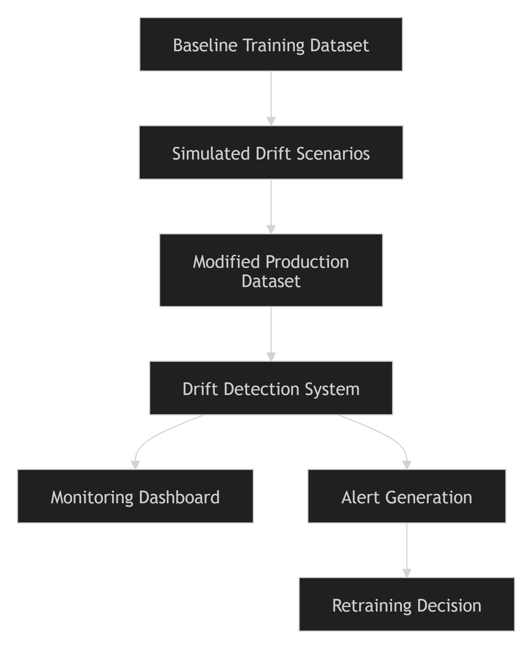

Why Drift Simulation?
Production environments are dynamic, and travel behavior may change because of:
- Seasonal demand fluctuations.
- Major public events.
- Holidays and celebrations.
- Urban expansion.
- Traffic congestion changes.
- Economic and behavioral shifts.
Since these events cannot always be predicted, simulated drift scenarios allow monitoring systems to be tested under controlled conditions before real-world drift occurs.

Simulated Drift Scenarios
Scenario 1: Festival Surge
A major city-wide festival can significantly alter travel behavior.
Simulated Changes
- Increased ride requests.
- Higher passenger counts.
- Longer travel times due to congestion.
- Increased demand during evening hours.
Features Affected
- passenger_count
- pickup_hour
- trip_duration
- pickup_location
Expected Outcome
- Temporal feature drift detected.
- Passenger-count distribution shifts identified.
- Monitoring dashboard generates alerts.

Scenario 2: Holiday Traffic Pattern
Holiday periods often create travel patterns very different from normal weekdays.
Simulated Changes
- Higher weekend travel frequency.
- Increased airport-related trips.
- Different peak travel windows.
- Reduced commuting activity.
Features Affected
- pickup_dayofweek
- pickup_hour
- haversine_distance
Expected Outcome
- Detection of shifts in temporal feature distributions.
- Alert generation if drift thresholds are exceeded.

Scenario 3: Geographic Expansion
The service expands into previously unserved districts or regions.
Simulated Changes
- New pickup locations.
- New drop-off zones.
- Different trip distances.
- Alternative travel routes.
Features Affected
- Pickup Latitude
- Pickup Longitude
- Drop-off Latitude
- Drop-off Longitude
- Haversine Distance
Expected Outcome
- Significant geographic distribution drift.
- Increased distance variability.
- Detection through location-based monitoring metrics.

Scenario 4: Traffic Congestion Shift
Infrastructure changes or road construction activities can modify travel patterns.
Simulated Changes
- Increased average travel duration.
- Longer trips during peak periods.
- Changes in travel direction frequencies.
Features Affected
- Travel Direction
- Haversine Distance
- Pickup Hour
Expected Outcome
- Gradual drift detection.
- Elevated model performance monitoring alerts.

Scenario 5: Economic and Behavioral Changes
Changes in economic conditions or customer preferences may alter service usage.
Simulated Changes
- Reduced ride volume.
- Shorter average trips.
- More shared rides.
Features Affected
- Passenger Count
- Haversine Distance
- Pickup Frequency
Expected Outcome
- Long-term feature distribution drift identification.
- Recommendations for retraining evaluation.

Drift Severity Levels
The monitoring framework classifies drift into several severity categories.
Drift Level | Description | Recommended Action
Low Drift | Minor distribution changes | Continue monitoring
Moderate Drift | Noticeable shift in feature distributions | Investigate affected features
High Drift | Significant change affecting model reliability | Review model performance and initiate retraining
Critical Drift | Severe deviation from training data | Trigger immediate retraining and deployment review

Drift Detection Validation Process
Each simulated scenario passes through the complete monitoring pipeline.
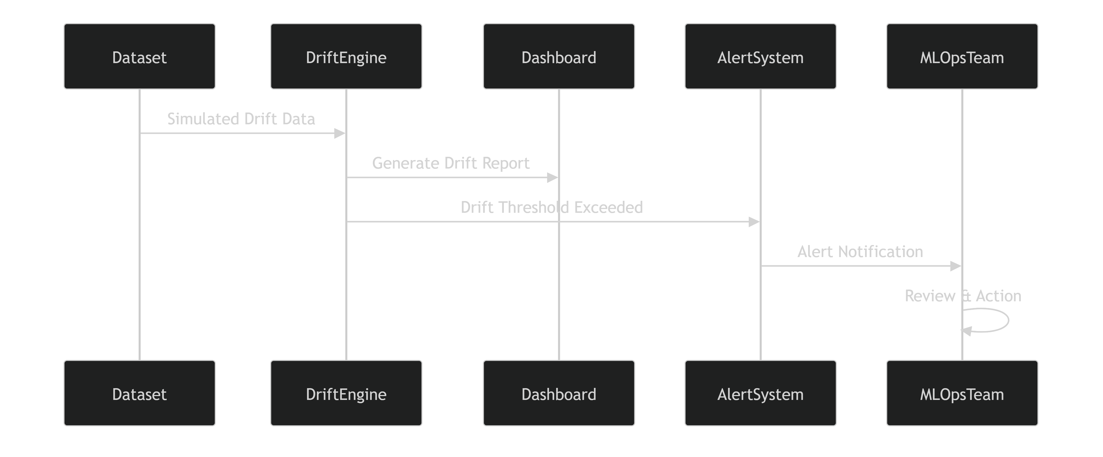

Retraining Validation
One objective of drift simulation is to validate retraining workflows.
Retraining Trigger Conditions
Persistent Drift Detection
+
Performance Degradation
=
Model Retraining Trigger
Workflow
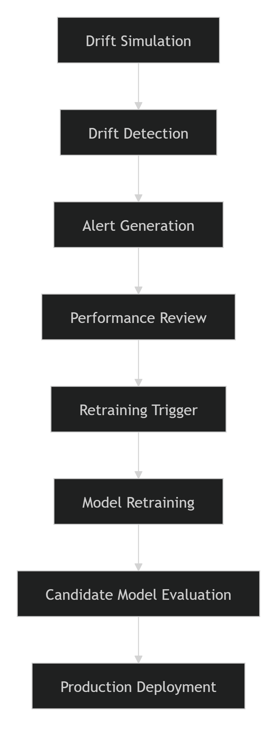

Monitoring Metrics Evaluated
The following indicators are monitored during drift simulations:
Feature Metrics
- Pickup Hour Distribution
- Passenger Count Distribution
- Haversine Distance Distribution
- Geographic Coordinate Distribution
Model Metrics
- MAE
- RMSE
- R²
Operational Metrics
- Prediction Latency
- Request Volume
- Error Rate
These measurements help assess whether drift impacts both data quality and model behavior.

Expected Outcomes
Successful drift simulation should demonstrate that:
✅ Distribution changes are detected correctly.
✅ Drift reports are generated automatically.
✅ Monitoring dashboards display drift indicators.
✅ Alert thresholds are triggered appropriately.
✅ Performance degradation is observable.
✅ Retraining workflows can be activated when necessary.
✅ The production monitoring framework functions as expected.

Benefits of Drift Simulation
Benefit | Impact
Monitoring Validation | Ensures drift detection works correctly
Alert Testing | Verifies notification processes
Retraining Readiness | Confirms retraining workflows function properly
Risk Reduction | Identifies monitoring gaps before production issues occur
Model Reliability | Supports long-term prediction quality
Production Confidence | Improves deployment readiness

Conclusion
The drift simulation strategy provides a proactive mechanism for validating the ETA Prediction monitoring framework before real-world drift occurs. By simulating scenarios such as festival surges, holiday traffic patterns, geographic expansion, congestion shifts, and behavioral changes, the project ensures that drift detection mechanisms, monitoring dashboards, alerting systems, and retraining workflows operate effectively. This approach strengthens the overall MLOps architecture and helps maintain long-term model accuracy, reliability, and business value in a dynamic production environment.
6.4 Model Performance Monitoring
Model Performance Monitoring is a critical component of the MLOps lifecycle that ensures the deployed ETA Prediction model continues to deliver accurate, reliable, and business-relevant predictions over time. While a model may perform well during development and testing, its predictive accuracy can gradually decline in production due to evolving traffic patterns, changing customer behavior, seasonal variations, and other real-world factors. Continuous monitoring enables the team to detect performance degradation early and take corrective actions before business impact occurs.
Objectives
The primary objectives of performance monitoring are to:
- Continuously evaluate the accuracy of production predictions.
- Detect model degradation at an early stage.
- Compare production performance against training-time benchmarks.
- Support proactive retraining decisions.
- Ensure consistent business value from the deployed model.
- Maintain trust in ETA predictions provided to customers and operational teams.

Performance Monitoring Architecture
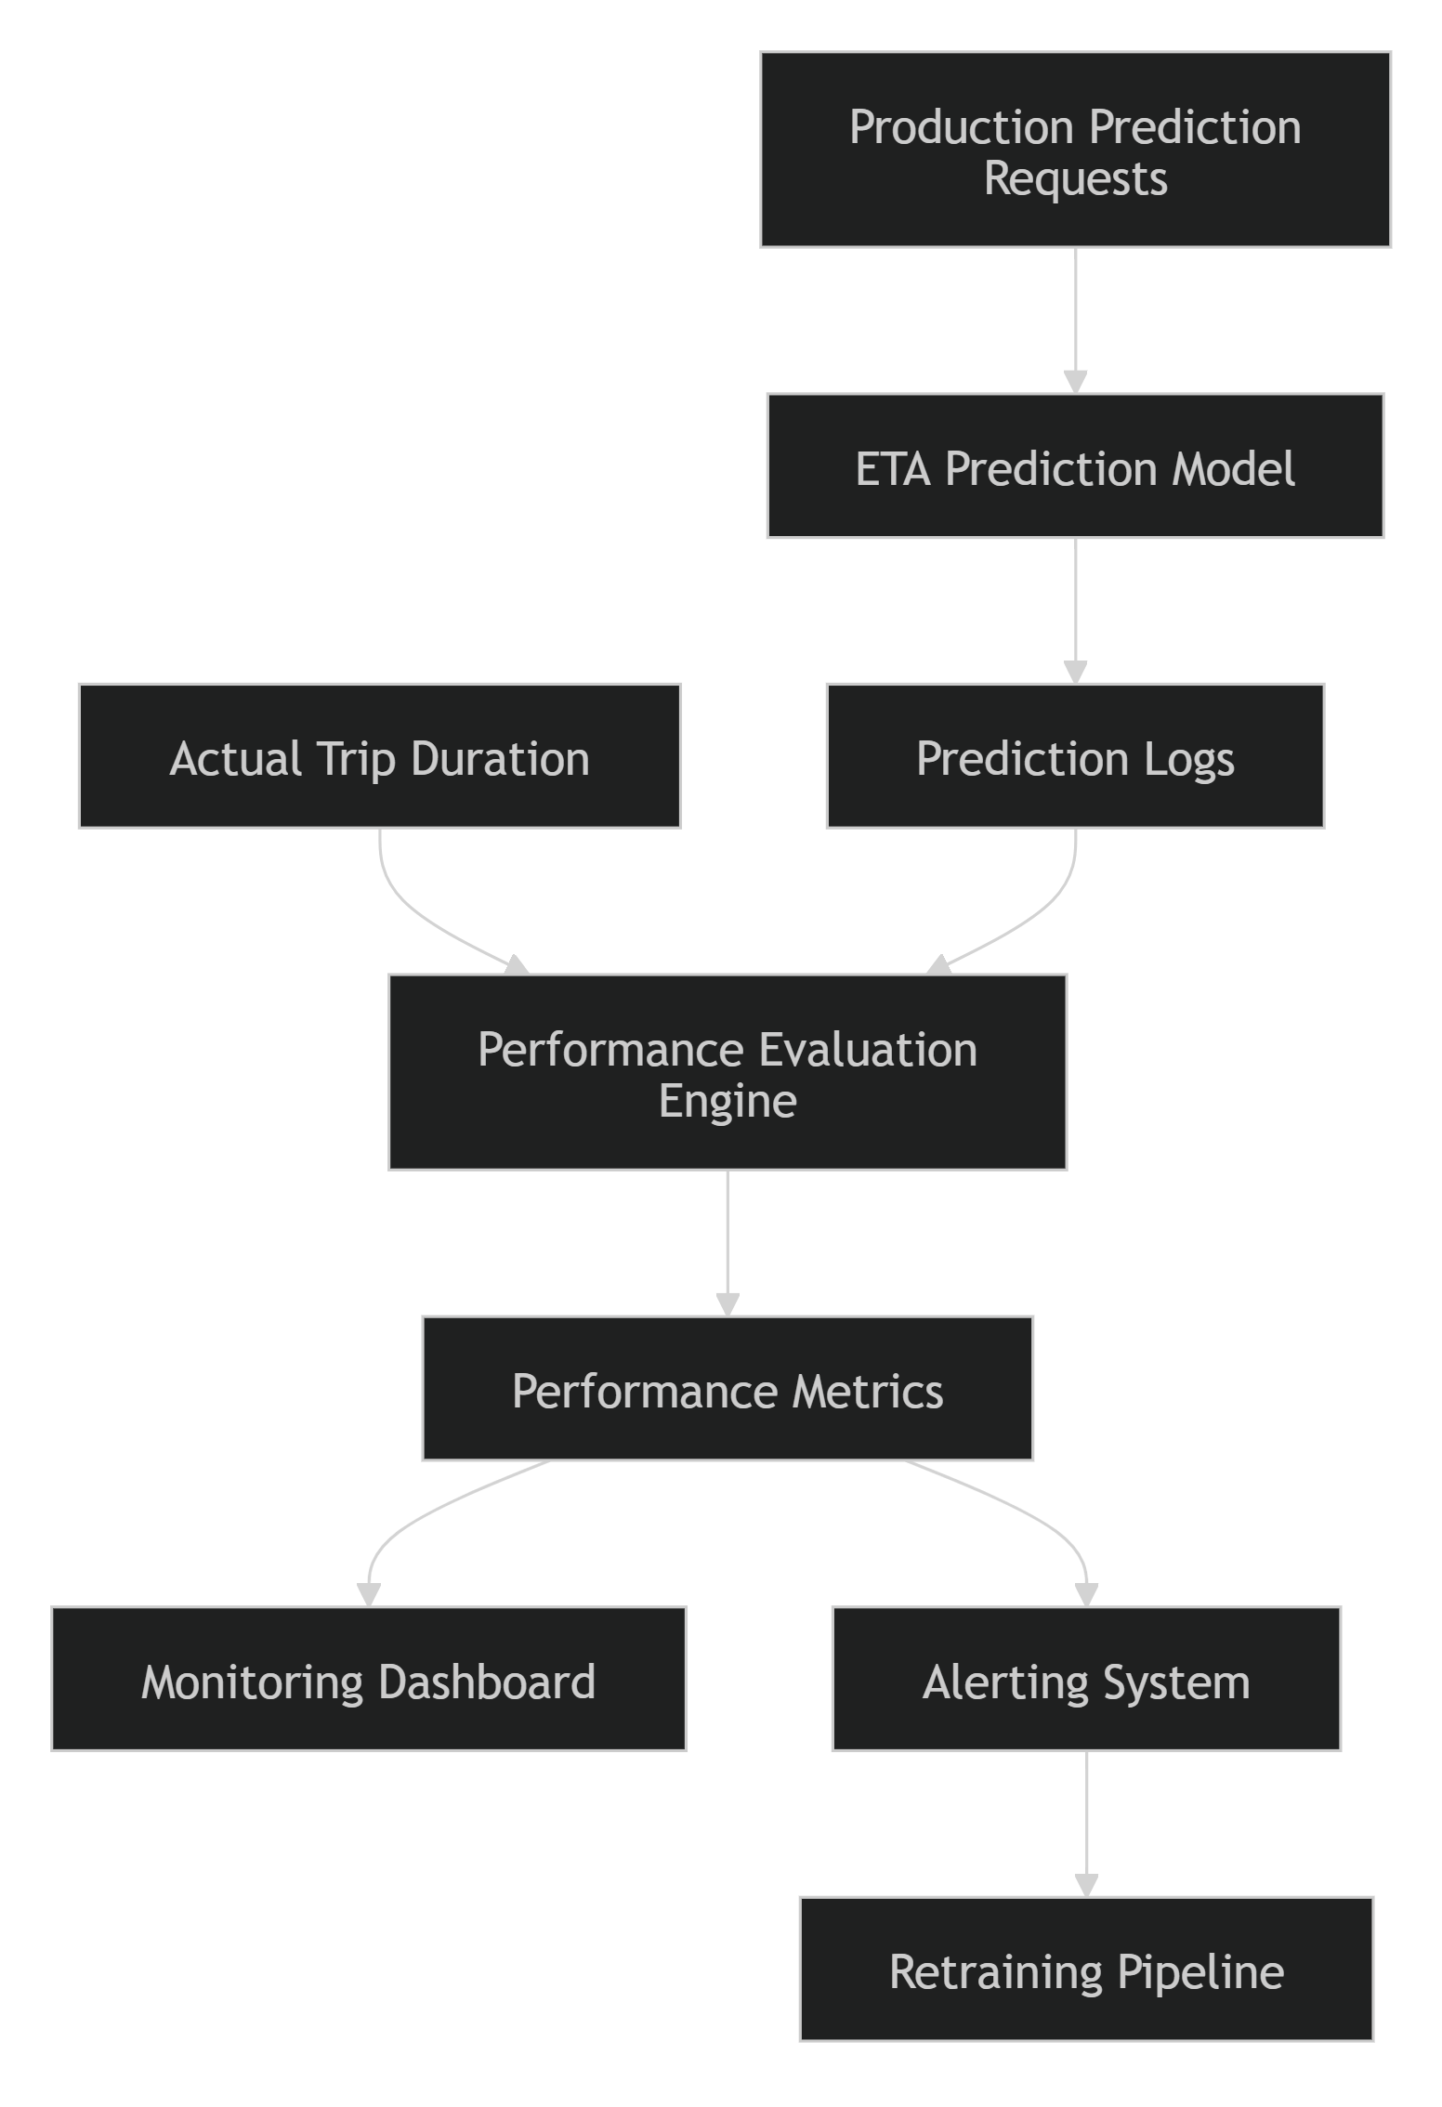

Production Performance Monitoring Workflow
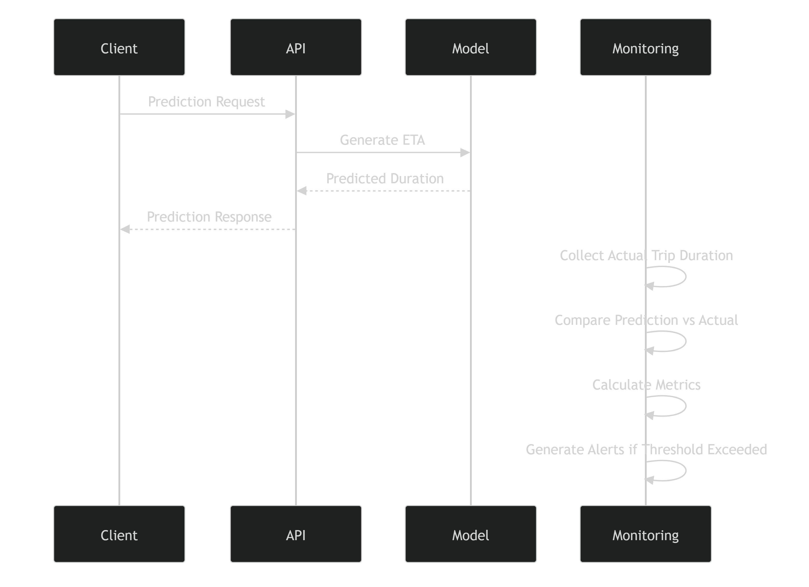

Performance Evaluation Metrics
The same evaluation metrics used during model development are monitored in production to measure ongoing model quality.
Mean Absolute Error (MAE)
Measures the average magnitude of prediction errors.
Formula
MAE = (1/n) Σ |Actual − Predicted|
Purpose
- Tracks average prediction deviation.
- Easy to interpret because values are expressed in trip-duration units.
Monitoring Goal
Lower MAE = Better Performance

Root Mean Squared Error (RMSE)
Measures the overall magnitude of prediction errors while penalizing larger mistakes.
Formula
RMSE = √(Σ(Actual − Predicted)² / n)
Purpose
- Sensitive to large prediction errors.
- Detects severe degradation in ETA accuracy.
Monitoring Goal
Lower RMSE = Better Performance

R-Squared (R²)
Measures how much variation in trip duration is explained by the model.
Purpose
- Evaluates the overall predictive capability of the model.
- Provides a high-level performance indicator.
Monitoring Goal
Higher R² = Better Performance

Prediction Latency
Measures the time required to generate a prediction.
Purpose
- Ensures the API remains responsive.
- Tracks inference performance.
Monitoring Goal
Low Prediction Latency

Performance Monitoring Dashboard
A centralized dashboard provides visibility into the health of the deployed model.
Dashboard Components
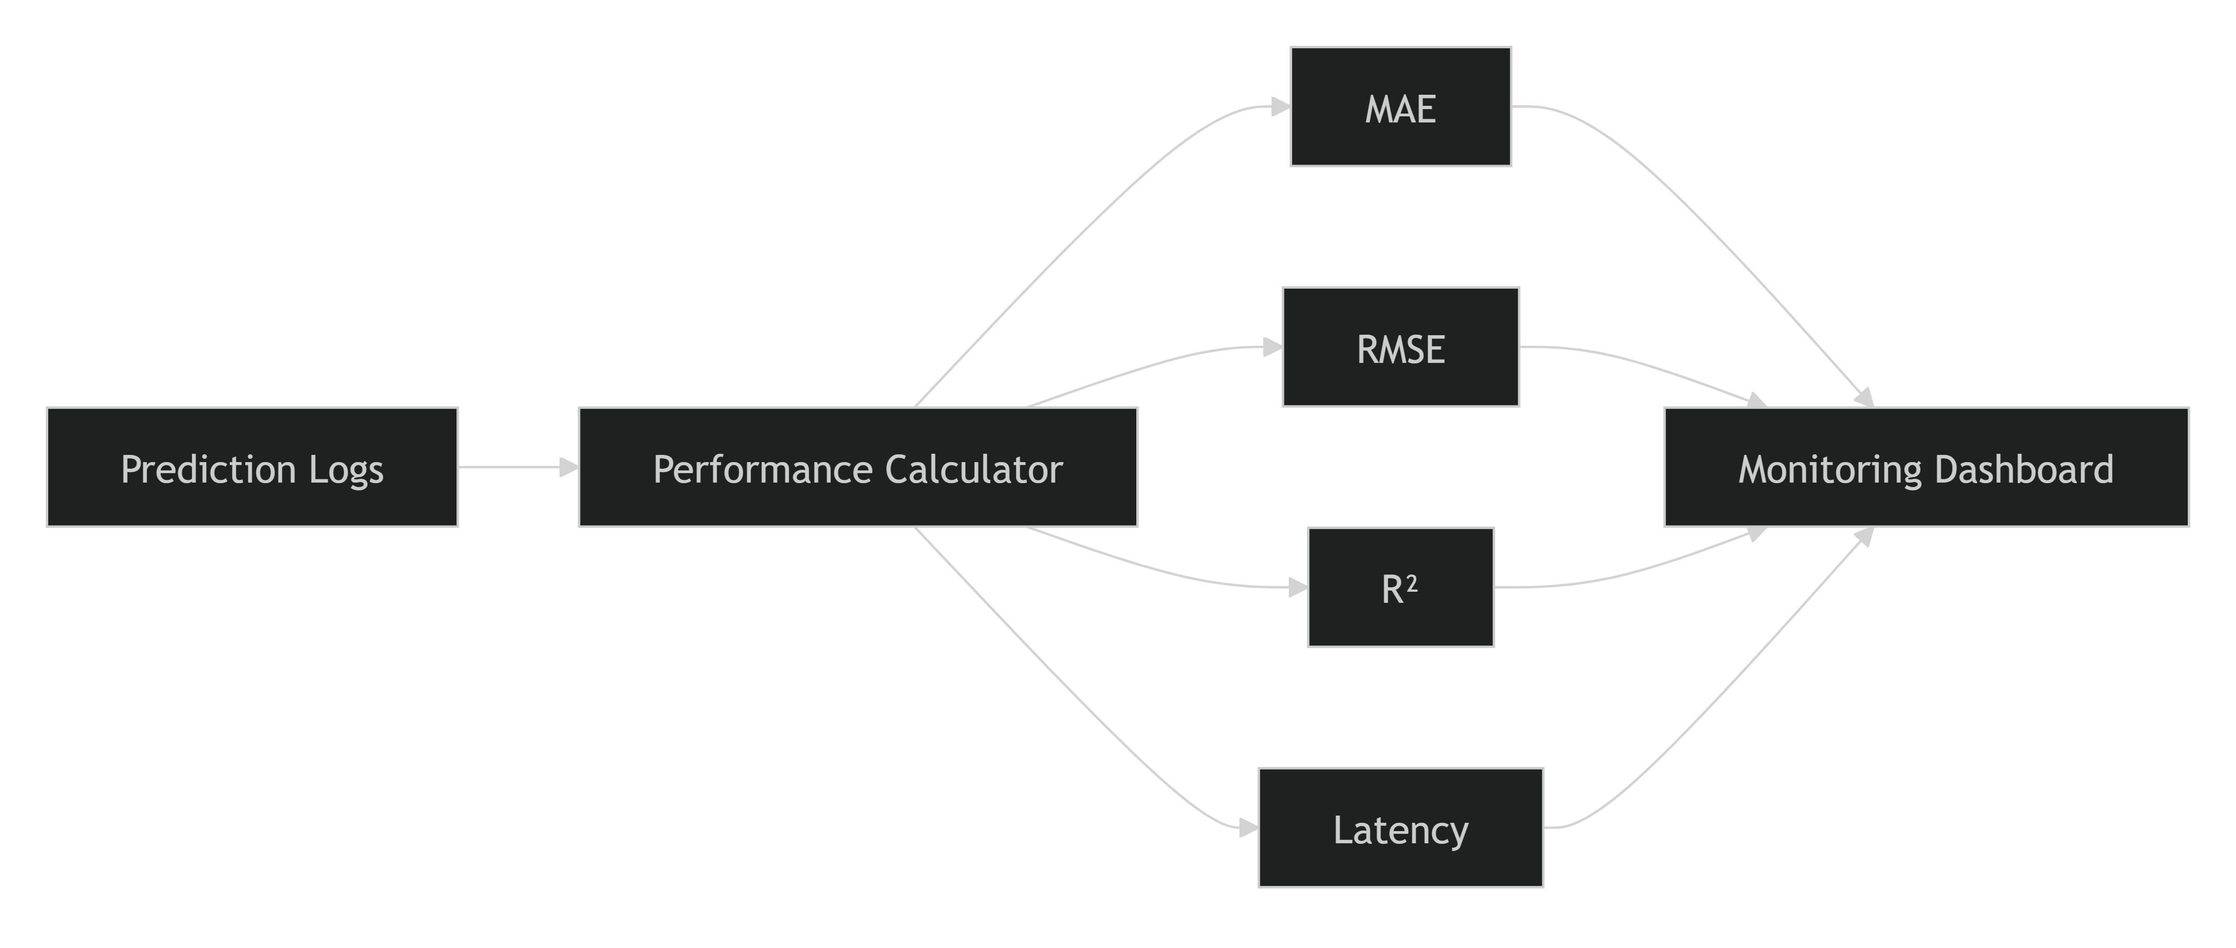

Performance Monitoring Frequency
Performance metrics are calculated using rolling monitoring windows.
Monitoring Window | Purpose
Hourly | Near real-time anomaly detection
Daily | Operational monitoring
Weekly | Trend analysis
Monthly | Model governance and reporting

Performance Degradation Detection
The system compares production metrics against baseline metrics established during model evaluation.
Example Monitoring Logic
Current RMSE > Baseline RMSE + Threshold
↓
Generate Warning Alert
Current MAE > Baseline MAE + Threshold
↓
Trigger Performance Investigation
Persistent Performance Degradation
↓
Initiate Retraining Review

Alert Threshold Framework
Example Thresholds
Metric | Threshold | Action
MAE Increase > 10% | Warning | Review recent predictions
RMSE Increase > 15% | Warning | Investigate error patterns
R² Drop > 10% | Critical | Evaluate model quality
Persistent Degradation | Critical | Consider retraining
Actual thresholds should be defined according to business requirements and production performance baselines.

Segment-Based Performance Monitoring
Performance is monitored across different operational segments to identify localized issues.
Monitored Segments
Temporal Segments
- Morning Trips
- Afternoon Trips
- Evening Trips
- Night Trips
Distance Segments
- Short Trips
- Medium Trips
- Long Trips
Geographic Segments
- Urban Zones
- Business Districts
- Residential Areas
Demand Segments
- Peak Hours
- Off-Peak Hours
- Holiday Periods
This segmented analysis helps identify specific situations where performance deteriorates.

Integration with Data Drift Detection
Performance monitoring works closely with drift monitoring.
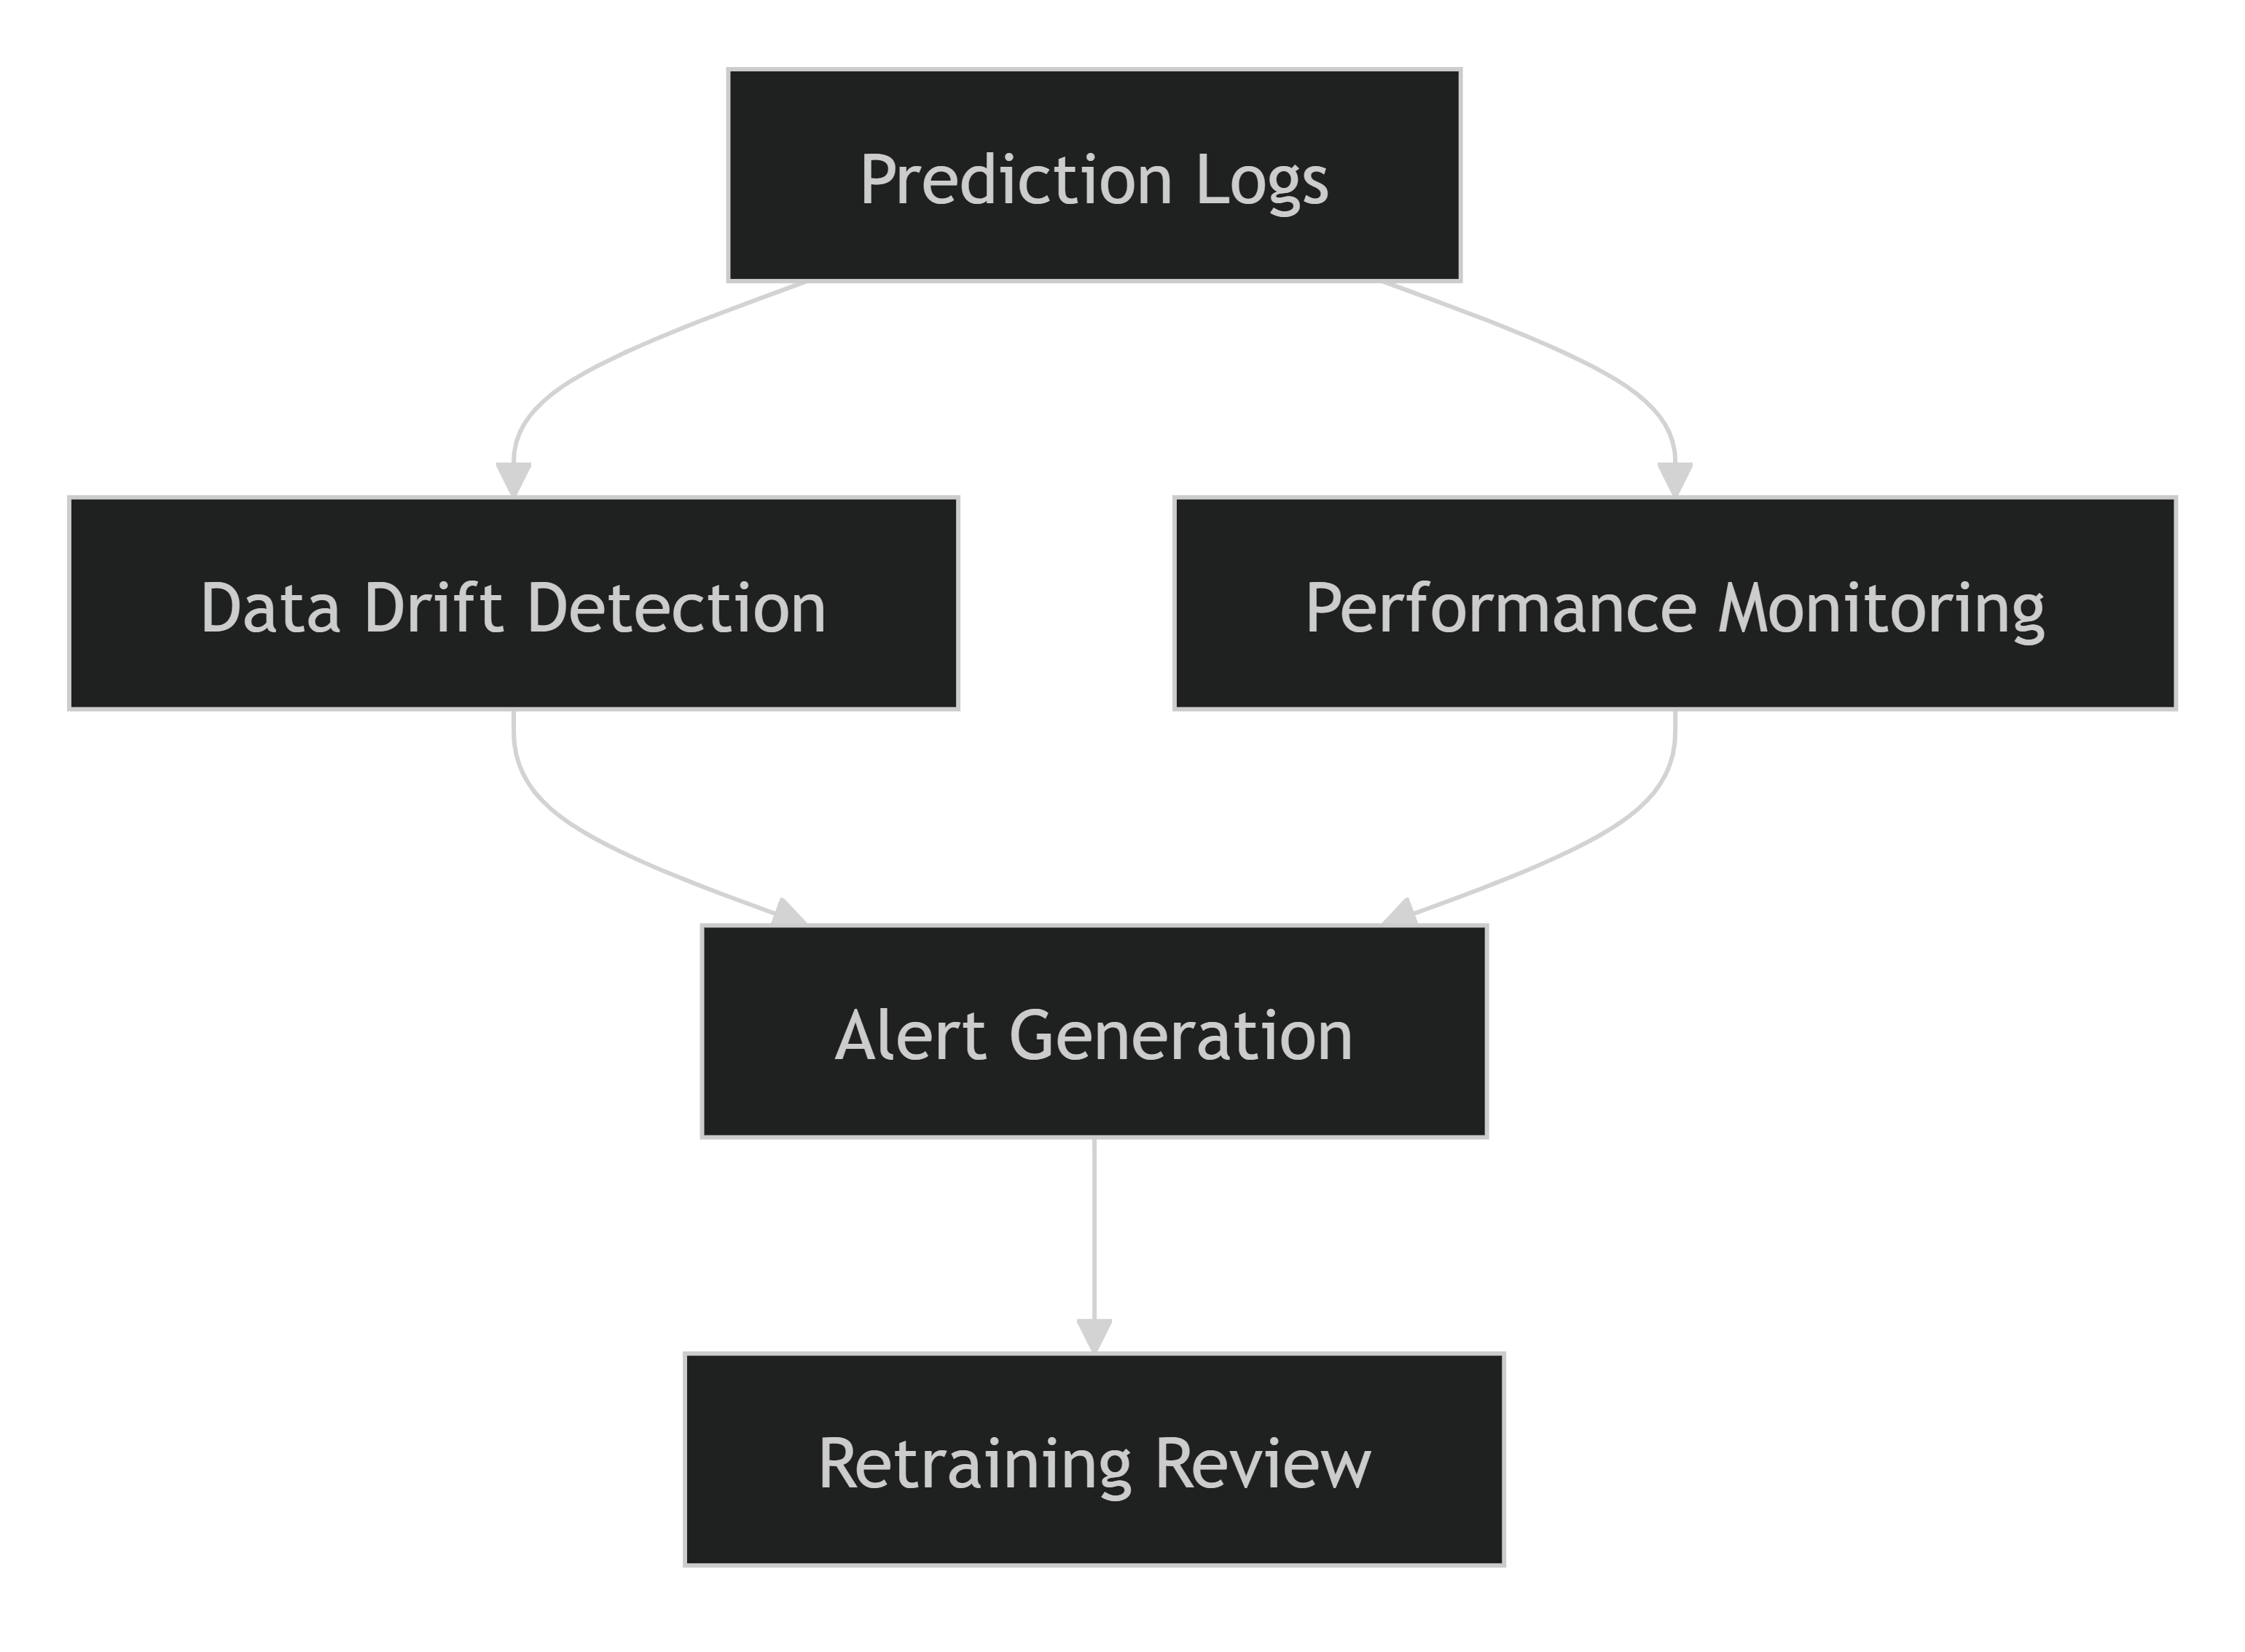
Example Scenario
Data Drift Detected
+
Increasing RMSE
+
Declining R²
=
High Probability of Model Degradation
This combined approach improves the accuracy of retraining decisions.

Retraining Triggers
Performance monitoring serves as a key input to the retraining strategy.
Trigger Conditions
- Sustained increase in MAE.
- Significant increase in RMSE.
- Declining R² scores.
- Consistent underperformance within specific trip segments.
- Performance degradation accompanied by feature drift.
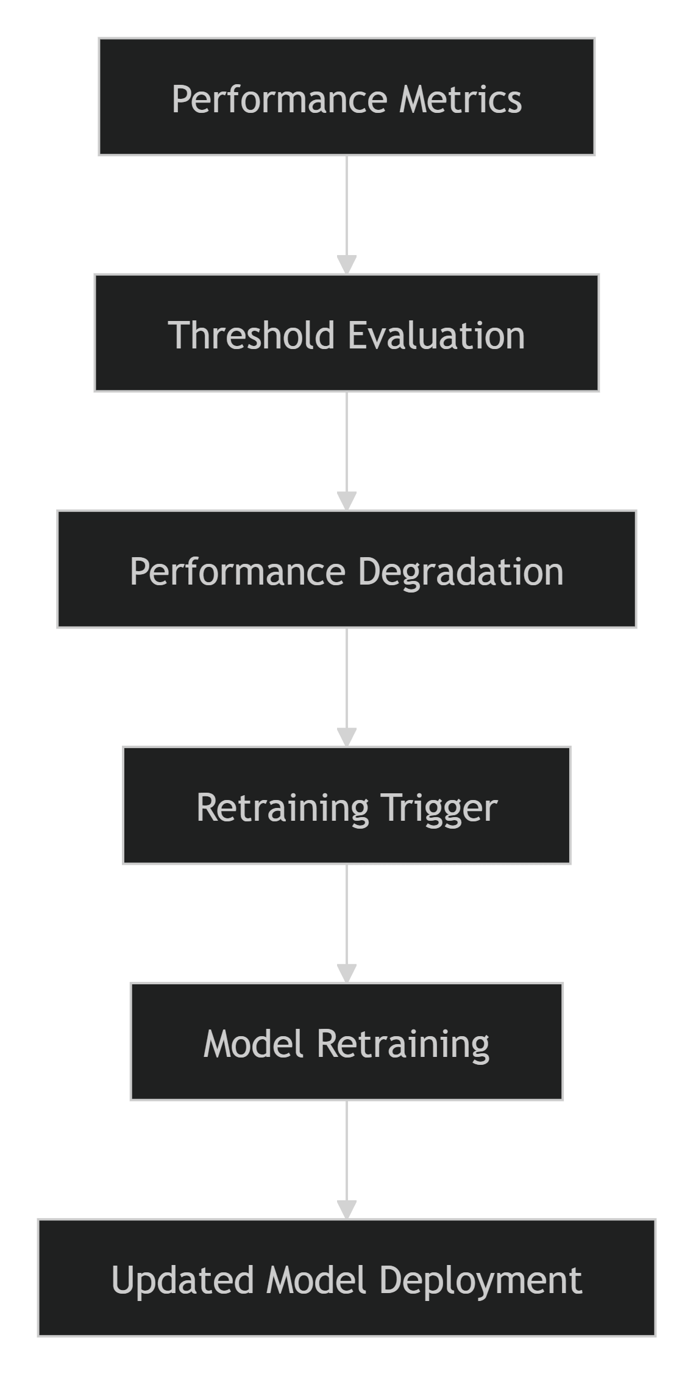

Benefits of Performance Monitoring
Capability | Benefit
Continuous Accuracy Tracking | Maintains model quality
Early Problem Detection | Reduces production risks
Performance Visibility | Supports operational decision-making
Segment-Based Analysis | Identifies localized issues
Retraining Support | Enables proactive model improvement
Business Reliability | Ensures consistent ETA predictions

Key Performance Indicators (KPIs)
The following KPIs are monitored to evaluate production success:
- Prediction Accuracy (MAE, RMSE, R²)
- Prediction Latency
- API Response Time
- Prediction Success Rate
- Error Rate
- Drift Score Trends
- Retraining Frequency
- Model Stability Over Time

Conclusion
Model Performance Monitoring ensures that the deployed ETA Prediction system maintains high levels of accuracy, reliability, and business effectiveness throughout its operational lifecycle. By continuously tracking metrics such as MAE, RMSE, R², and prediction latency, the monitoring framework provides early warning of model degradation and supports data-driven retraining decisions. Combined with prediction logging and data drift detection, performance monitoring forms a critical pillar of the project's MLOps strategy, helping preserve long-term model value and operational excellence.
6.5 Alerting Mechanisms
Alerting mechanisms play a critical role in the monitoring and maintenance framework by providing timely notifications when abnormal conditions are detected within the ETA Prediction system. The primary purpose of alerting is to ensure that data drift, model degradation, infrastructure issues, and operational failures are identified and addressed before they significantly impact prediction quality or business operations. By implementing automated alerts, the system supports proactive maintenance and rapid incident response.
Objectives
The alerting framework was designed to:
- Detect issues before they affect end users.
- Notify stakeholders of critical model and system events.
- Reduce system downtime and operational risks.
- Support proactive model maintenance.
- Enable rapid troubleshooting and incident response.
- Automate monitoring and governance activities.

Alerting Architecture
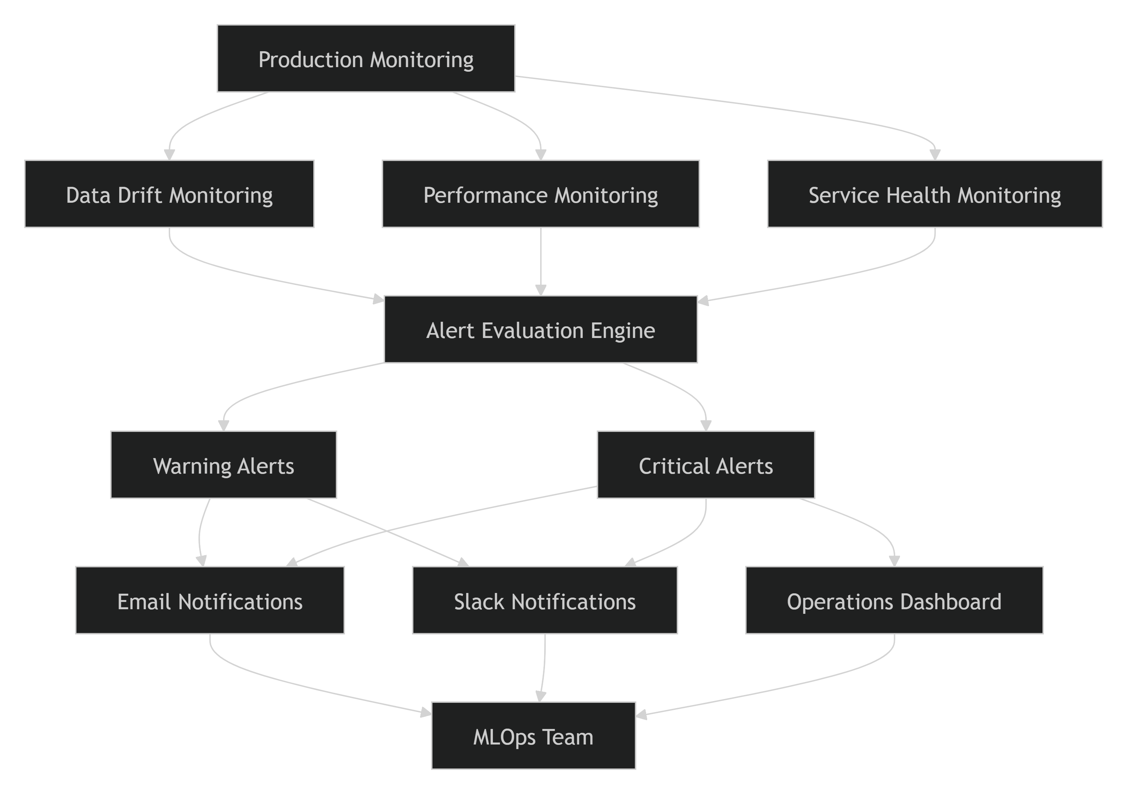

Categories of Alerts
1. Data Drift Alerts
Data drift alerts are generated when production data distributions significantly deviate from training data baselines.
Monitored Features
- Pickup Hour
- Passenger Count
- Haversine Distance
- Pickup Coordinates
- Drop-off Coordinates
Example Trigger
PSI > 0.25
Response Action
- Investigate affected features.
- Review prediction quality.
- Assess need for retraining.

2. Model Performance Alerts
These alerts are triggered when production model performance metrics deteriorate beyond acceptable thresholds.
Metrics Monitored
- MAE
- RMSE
- R²
Examples
RMSE Increase > 15%
R² Decrease > 10%
Response Action
- Conduct root-cause analysis.
- Verify data quality.
- Review recent prediction logs.
- Consider model retraining.

3. Service Health Alerts
Service monitoring ensures that the prediction API remains available and responsive.
Metrics Monitored
- API Response Time
- Request Throughput
- Error Rates
- CPU Utilization
- Memory Utilization
Example Triggers
API Latency > 2000 ms
HTTP 5xx Error Rate > 5%
CPU Utilization > 85%
Response Action
- Review infrastructure health.
- Scale service resources.
- Investigate API runtime issues.

Alert Severity Levels
Different alert levels help prioritize response efforts.
Severity Level | Description | Action Required
Information | Minor deviations detected | Monitor trends
Warning | Moderate issue identified | Investigate and assess impact
Critical | Significant risk to model or service | Immediate action required
Emergency | Severe production outage or model failure | Escalate to operations and MLOps teams

Alert Lifecycle

Notification Channels
Alerts are distributed through multiple communication channels to ensure rapid awareness.
Email Notifications
Used for:
- Daily summaries
- Warning alerts
- Performance reports
Example:
Subject:
Warning - RMSE Threshold Exceeded
Slack Notifications
Used for:
- Real-time operational alerts
- Critical incidents
- Monitoring events
Example:
[Critical Alert]
Data Drift Threshold Exceeded
Affected Feature: Haversine Distance
Monitoring Dashboards
Dashboards provide centralized visibility into:
- System health
- Drift status
- Performance trends
- Alert history

Alert Escalation Process
When an alert remains unresolved, escalation procedures are initiated.
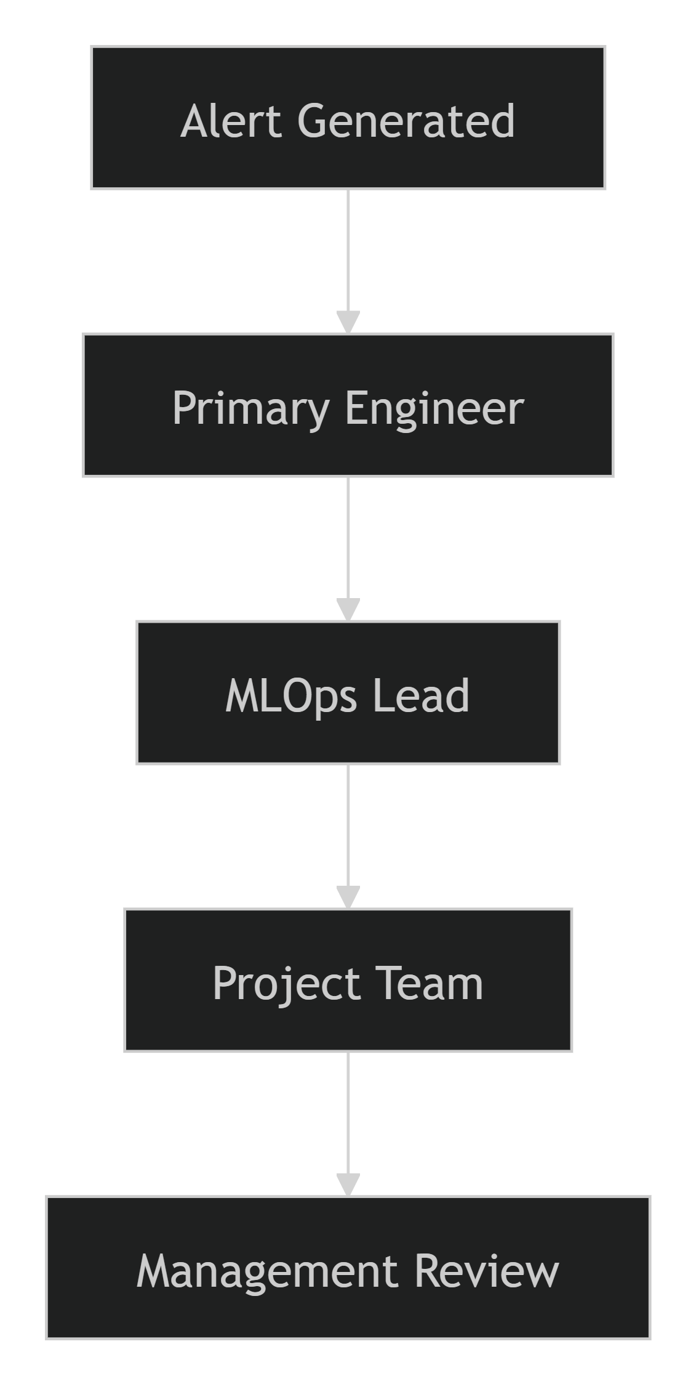
Escalation Rules
Condition | Escalation Level
Warning persists > 24 hours | MLOps Lead
Critical alert unresolved | Project Team
Service outage > defined SLA | Management Review

Integration with Retraining
Alerting serves as a key input into automated retraining decisions.
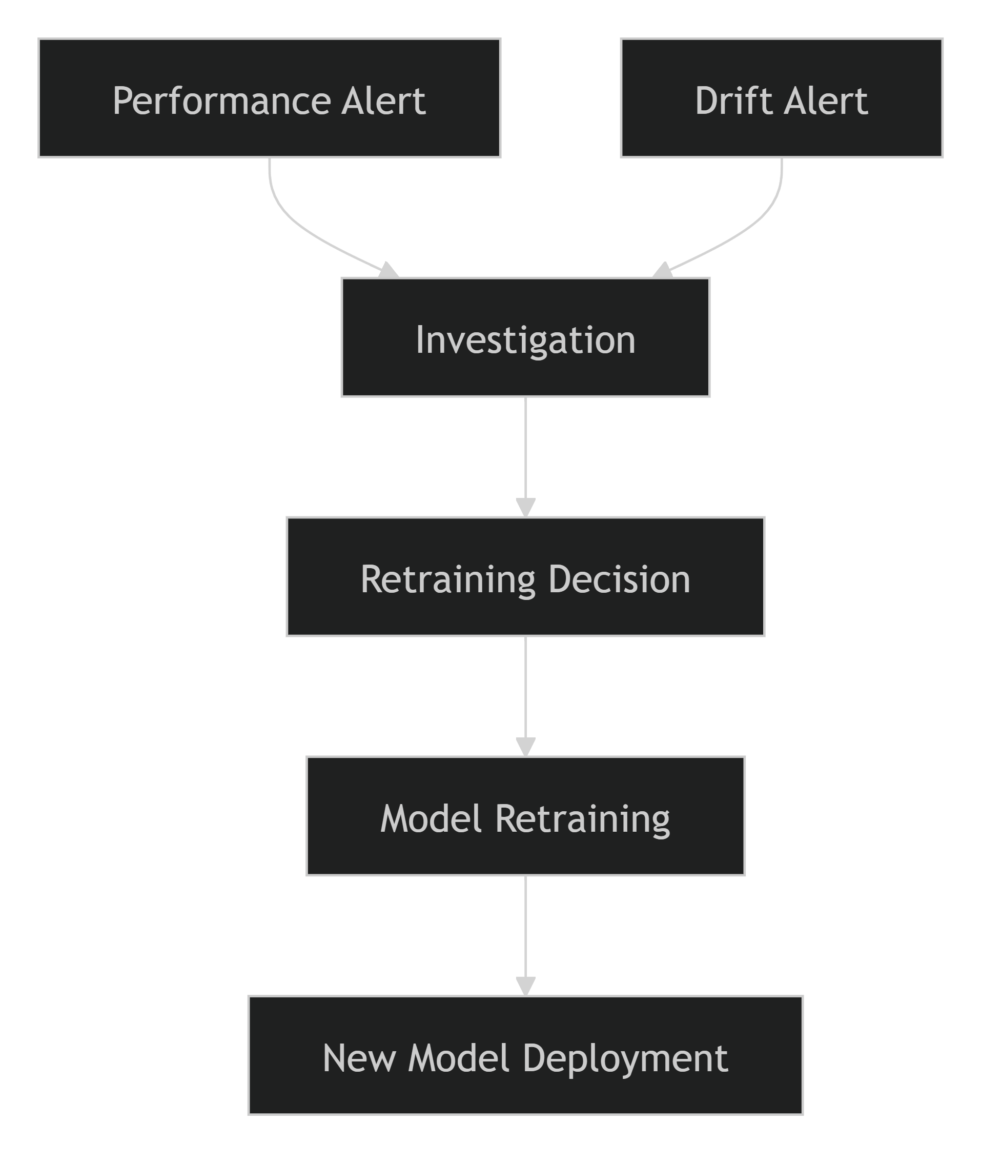
Example Retraining Condition
Significant Data Drift
+
Performance Degradation
+
Repeated Alerts
=
Retraining Trigger

Alert Logging and Audit Trail
All generated alerts are logged to maintain an operational history.
Logged Information
- Alert ID
- Timestamp
- Severity Level
- Affected Component
- Triggering Metric
- Resolution Status
- Assigned Owner
This audit trail supports compliance, troubleshooting, and retrospective analysis.

Key Performance Indicators for Alerting
The effectiveness of the alerting system can be measured using:
- Mean Time to Detect (MTTD)
- Mean Time to Acknowledge (MTTA)
- Mean Time to Resolve (MTTR)
- Number of Critical Alerts
- False Positive Alert Rate
- Retraining Trigger Frequency
These KPIs help assess the responsiveness and reliability of the monitoring framework.

Benefits of Alerting Mechanisms
Capability | Benefit
Automated Monitoring | Reduces manual oversight
Early Issue Detection | Prevents larger operational problems
Real-Time Notifications | Improves response speed
Escalation Management | Ensures accountability
Retraining Support | Facilitates continuous improvement
Auditability | Provides operational traceability

Conclusion
The alerting framework provides a proactive mechanism for maintaining the health, accuracy, and reliability of the ETA Prediction system. By continuously monitoring data drift, model performance, and service health metrics, the system can automatically notify stakeholders when predefined thresholds are exceeded. Through structured alert escalation, notification channels, and retraining integration, the alerting strategy strengthens the overall MLOps architecture and ensures that the deployed model continues to deliver reliable ETA predictions in production environments.
6.6 Retraining Strategy
Machine learning models deployed in production environments are susceptible to performance degradation over time due to changing traffic conditions, evolving customer behavior, seasonal variations, and shifts in data distributions. To ensure that the ETA Prediction system continues to deliver accurate and reliable predictions, a comprehensive retraining strategy was established. This strategy defines when retraining should occur, how new data should be collected and validated, and how updated models should be evaluated and deployed.
Objectives
The primary objectives of the retraining strategy are to:
- Maintain prediction accuracy over time.
- Adapt to changing traffic and travel patterns.
- Mitigate the effects of data drift and concept drift.
- Continuously improve model performance.
- Ensure production models remain aligned with real-world conditions.
- Support sustainable model lifecycle management.

Retraining Framework
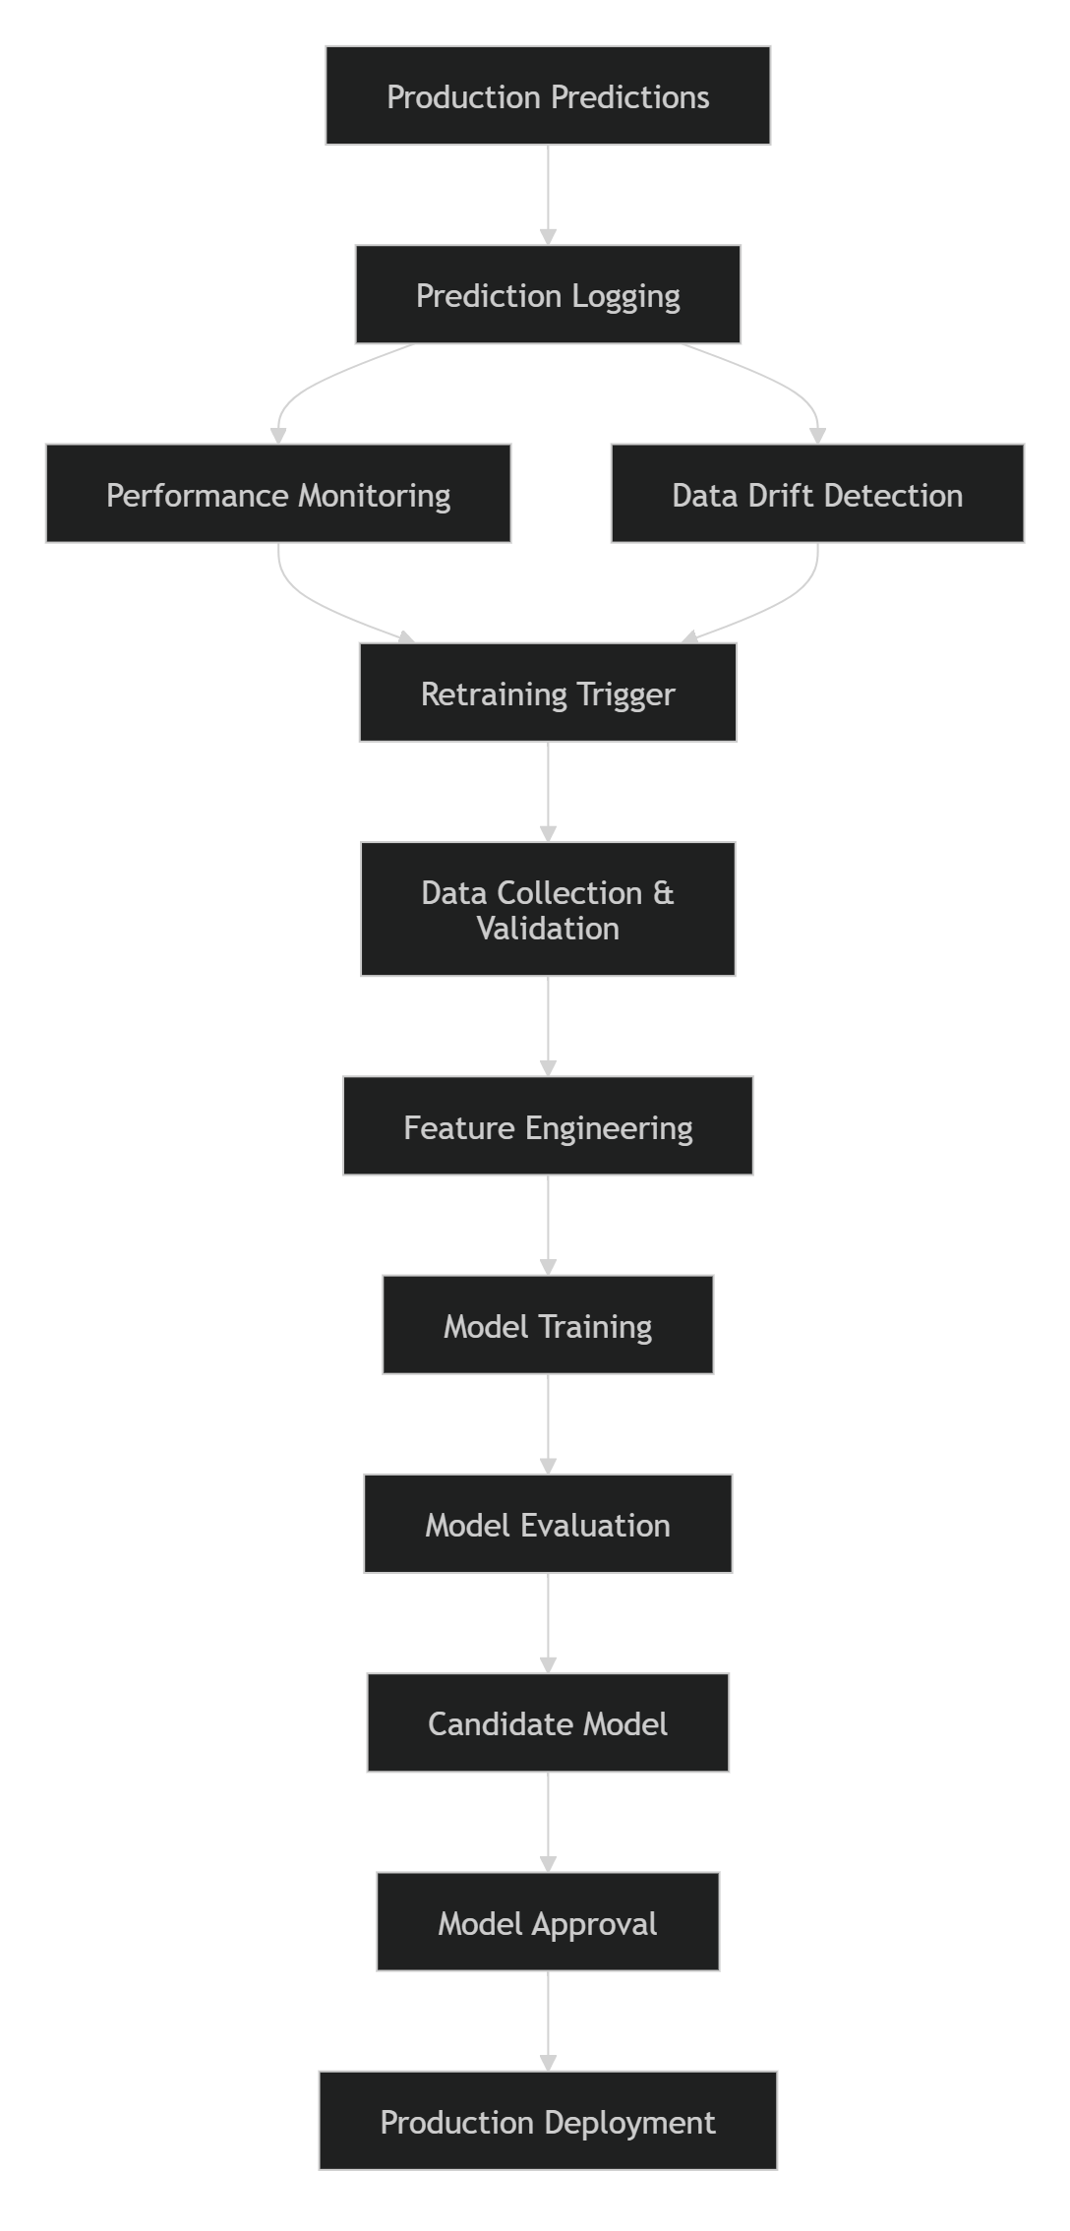

Retraining Triggers
The system supports both automated and manual retraining triggers.
1. Scheduled Retraining
Retraining can be performed at predefined intervals regardless of monitoring results.
Example Schedule
Frequency | Purpose
Monthly | Incorporate recent trip patterns
Quarterly | Address seasonal variations
Semi-Annual | Major model refresh
Scheduled retraining ensures the model regularly learns from newly collected data.

2. Performance-Based Retraining
Retraining may be triggered when production performance metrics degrade beyond predefined thresholds.
Monitored Metrics
- MAE
- RMSE
- R²
Example Trigger Conditions
MAE Increase > 10%
RMSE Increase > 15%
R² Decrease > 10%
When performance degradation persists, retraining is initiated to restore prediction quality.

3. Data Drift-Based Retraining
Significant drift in production feature distributions may indicate that the model is operating on data that differs substantially from the training dataset.
Monitored Features
- Pickup Hour
- Passenger Count
- Haversine Distance
- Geographic Coordinates
- Travel Direction
Trigger Example
PSI > 0.25
Persistent drift alerts prompt model review and retraining assessment.

4. Business Event-Based Retraining
Certain business changes may require immediate model updates.
Examples include:
- Expansion into new service areas.
- Major changes in transportation patterns.
- New customer segments.
- Significant operational policy changes.
These events may introduce new behaviors that are not represented in historical training data.

Retraining Workflow

Retraining Dataset Construction
The retraining dataset is generated from production prediction logs and actual outcomes.
Data Sources
Historical Training Data
Provides continuity with previous model versions.
Production Prediction Logs
Provide recent input feature distributions.
Actual Trip Durations
Allow evaluation of prediction quality and creation of new training labels.
Newly Collected Records
Capture evolving traffic and operational conditions.

Dataset Pipeline
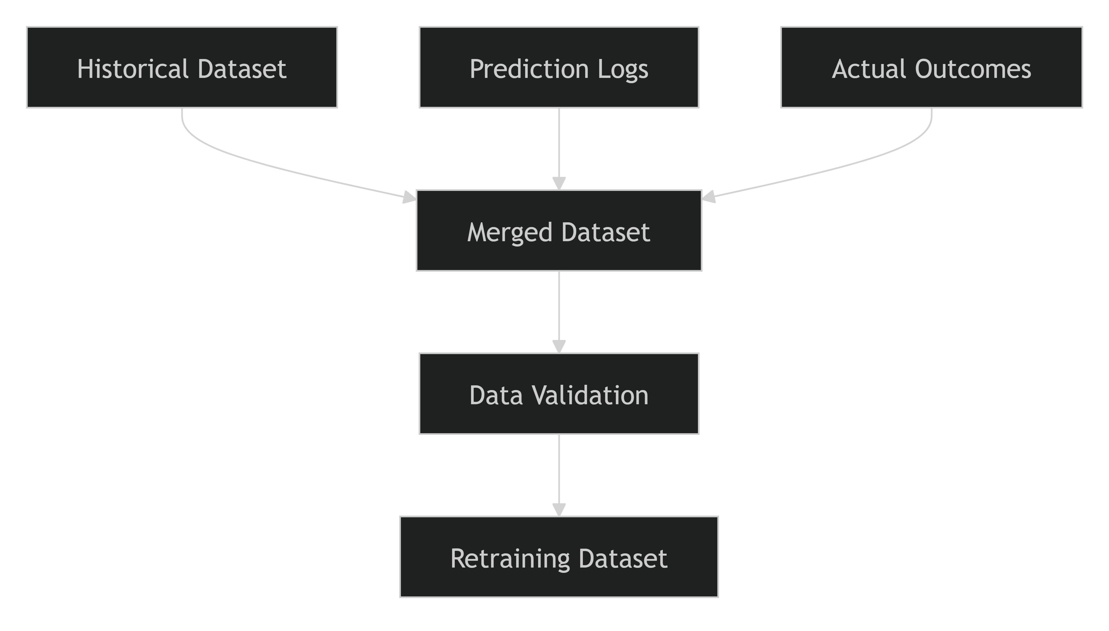

Validation Before Retraining
All retraining data undergoes the same validation process used during initial model development.
Validation Activities
- Schema validation
- Missing value checks
- Duplicate detection
- Timestamp validation
- Geographic coordinate validation
- Outlier analysis
This ensures that retraining data meets quality standards and does not introduce noise into the model.

Model Selection During Retraining
Retraining does not automatically replace the existing production model.
New candidate models must pass a complete evaluation process.
Evaluation Criteria
- Lower MAE
- Lower RMSE
- Higher R²
- Stable performance across validation sets
- Business acceptance criteria
Only models that outperform the current production model are considered for deployment.

Model Versioning
Each retrained model receives a unique version identifier.
Example
GradientBoosting_v1
GradientBoosting_v2
GradientBoosting_v3
Associated information includes:
- Training dataset version
- MLflow Run ID
- Hyperparameter configuration
- Evaluation metrics
- Deployment timestamp
This enables complete traceability and reproducibility.

Deployment and Rollback Strategy
After evaluation, the new model can be deployed using a controlled rollout process.
Deployment Options
A/B Testing
Compare current and new models with a subset of traffic.
Canary Deployment
Gradually route production requests to the new model.
Full Deployment
Promote the retrained model after validation.

Rollback Process
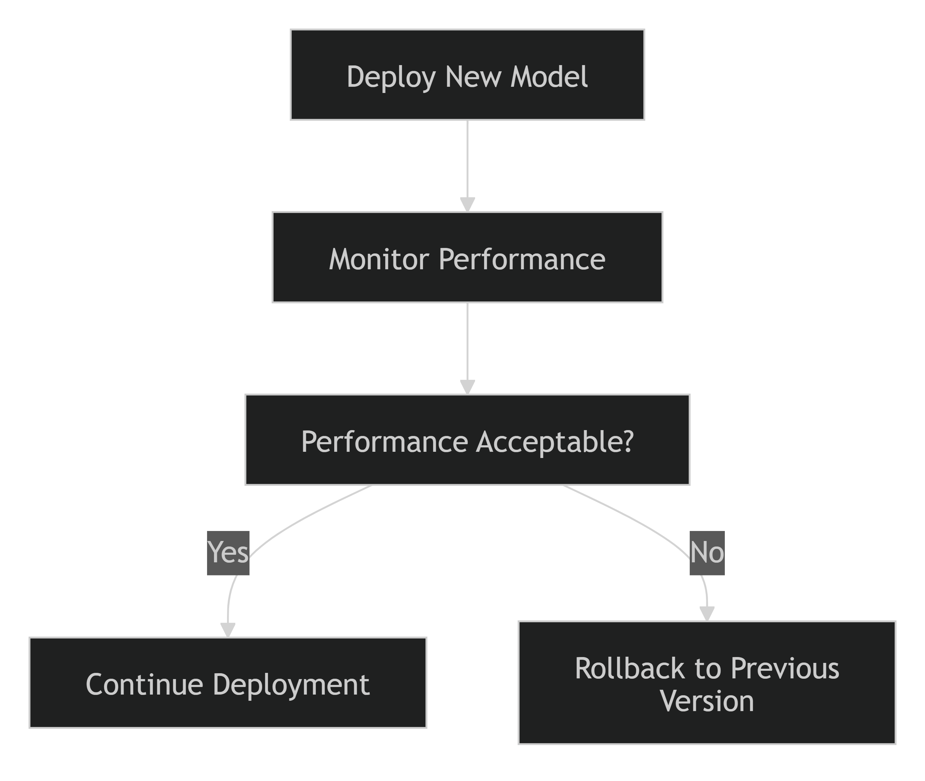
This minimizes operational risk and ensures service continuity.

MLflow Integration
MLflow supports retraining by tracking:
- Dataset versions
- Hyperparameters
- Training metrics
- Validation metrics
- Model artifacts
- Deployment candidates
This creates a complete audit trail for every retraining cycle.

Automation Roadmap
The long-term goal is to implement Continuous Training (CT) as part of the MLOps pipeline.
This capability will allow the system to adapt more rapidly to changing production conditions.

Benefits of the Retraining Strategy
Capability | Benefit
Scheduled Retraining | Maintains model freshness
Drift-Based Retraining | Adapts to changing data patterns
Performance-Based Retraining | Restores prediction accuracy
Model Versioning | Improves traceability
Controlled Deployment | Reduces production risk
Automated Monitoring Integration | Enables proactive model maintenance

Conclusion
The retraining strategy ensures that the ETA Prediction model remains accurate, reliable, and aligned with evolving real-world conditions throughout its operational lifecycle. By combining scheduled retraining, performance-based triggers, data drift detection, robust validation procedures, model versioning, and controlled deployment practices, the project establishes a comprehensive framework for continuous model improvement. This strategy strengthens the overall MLOps architecture and ensures sustainable long-term performance of the ETA Prediction system in production environments.

7. Version Control and Collaboration
7.1 Git Workflow
Effective version control is essential for managing code, coordinating team collaboration, tracking project changes, and ensuring reproducibility in Machine Learning Engineering projects. For the Delivery / Ride ETA Prediction project, Git was adopted as the primary version control system, while GitHub served as the centralized collaboration platform. The workflow was designed to support parallel development, controlled integration of changes, and maintenance of a stable codebase throughout the project lifecycle.
Objectives
The Git workflow was established to:
- Manage source code efficiently throughout the project lifecycle.
- Enable multiple team members to work simultaneously on different components.
- Maintain a complete history of project modifications.
- Support code quality through reviews and testing.
- Facilitate reproducibility and traceability.
- Minimize integration conflicts.

Branching Strategy
A feature-based branching model was adopted to allow independent development of project components while protecting the stability of the main codebase.
Branch Structure
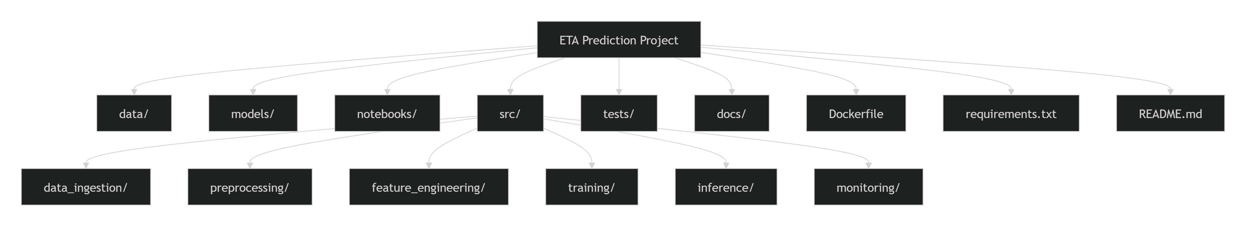
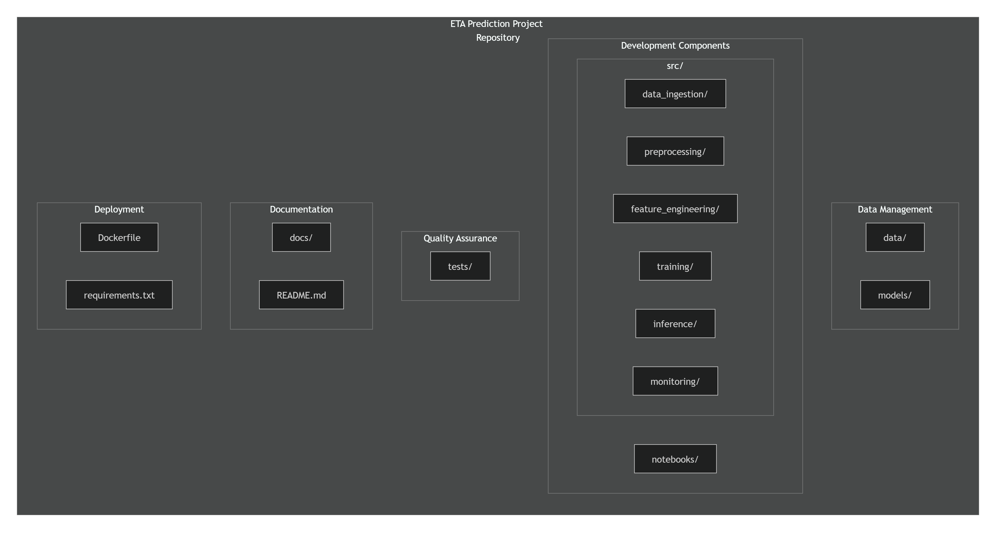
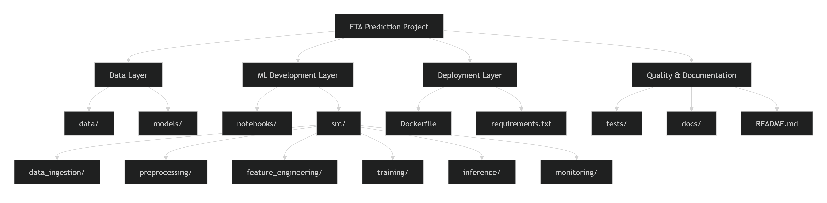
Main Branch (main)
The main branch represents the stable production-ready version of the project.
Characteristics
- Contains tested and approved code.
- Used for milestone releases.
- Protected from direct modifications.
Development Branch (develop)
The develop branch serves as the primary integration branch.
Characteristics
- Combines completed feature implementations.
- Used for integration testing.
- Acts as the staging environment before release.
Feature Branches
Each major project component was developed within a separate feature branch.
Examples:
feature-data-engineering
feature-model-development
feature-api-development
feature-monitoring
feature-documentation
``
This approach enabled team members to work independently without impacting ongoing development activities.

Git Workflow Process

Development Lifecycle
Step 1: Create a Feature Branch
Developers begin by creating a dedicated branch from the latest develop branch.
git checkout develop
git pull origin develop
git checkout -b feature-model-development
Step 2: Implement Changes
The assigned functionality is developed within the feature branch without affecting other project components.
Examples include:
- Data ingestion pipeline development
- Feature engineering enhancements
- Model training implementation
- API development
- Monitoring integration
Step 3: Commit Changes
Developers commit changes using clear and descriptive commit messages.
Example:
git commit -m "feat: implement gradient boosting training pipeline"
Step 4: Push Changes
Changes are pushed to the remote repository.
git push origin feature-model-development
Step 5: Create Pull Request
A Pull Request (PR) is created to merge the feature branch into the develop branch.
The PR includes:
- Feature description
- Testing results
- Implementation details
- Related documentation updates
Step 6: Code Review
Team members review the changes before approval.
Review criteria include:
- Code quality
- Functionality
- Testing coverage
- Documentation completeness
- Adherence to project standards
Step 7: Merge and Test
Approved branches are merged into develop, followed by integration testing to verify compatibility with existing components.

Commit Message Standards
To maintain a clean and understandable project history, commit messages followed a standardized convention.
Format
<type>: <description>
Examples
feat: add haversine distance feature

fix: correct model loading error

test: add API unit tests

docs: update deployment documentation

refactor: improve inference pipeline
Commit Types
Type | Purpose
feat | New functionality
fix | Bug fixes
docs | Documentation updates
test | Test implementation
refactor | Code restructuring
chore | Maintenance tasks

Pull Request Workflow
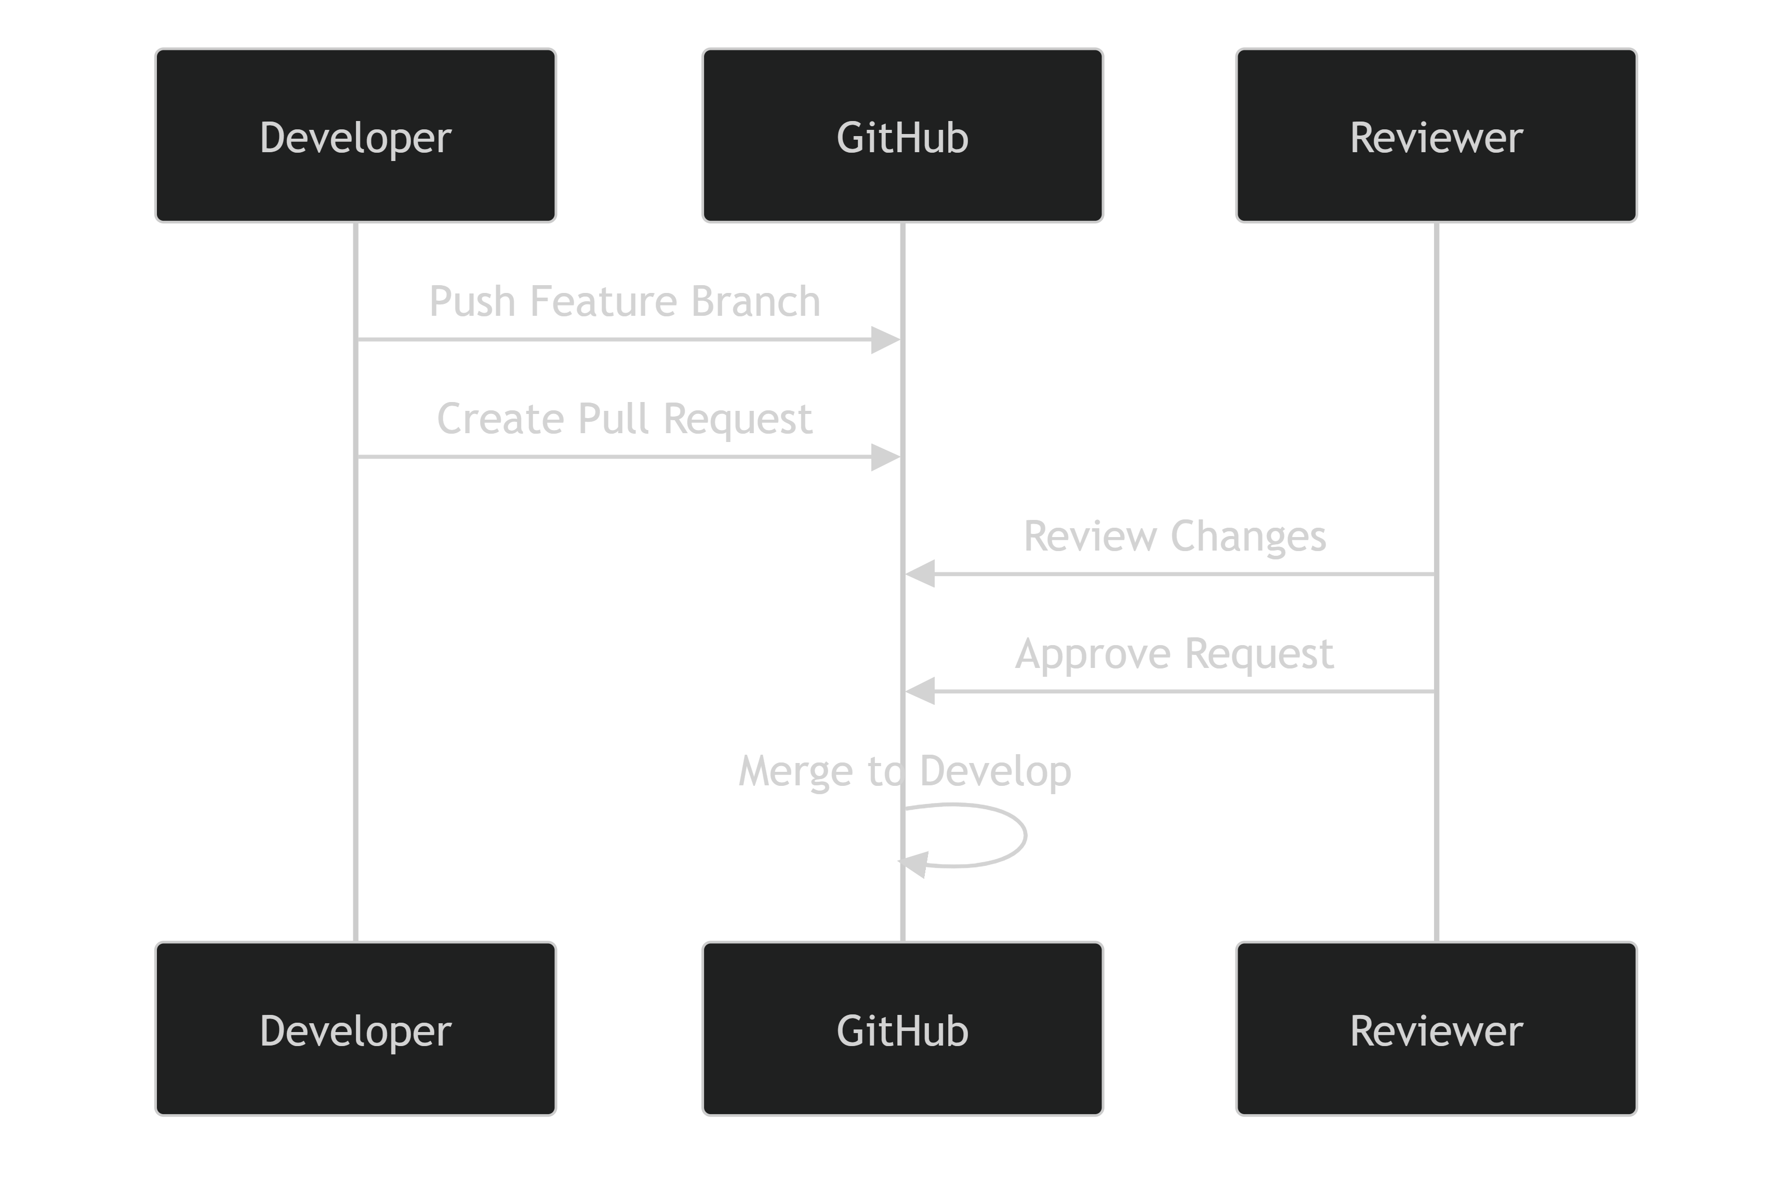
Pull Request Requirements
Before merging:
- Code must compile successfully.
- Unit tests must pass.
- Documentation must be updated.
- Review approval must be obtained.

Merge Conflict Resolution
Occasionally, parallel development activities resulted in merge conflicts.
Resolution Process
1. Pull latest changes
2. Resolve conflicting files locally
3. Run tests
4. Verify functionality
5. Commit resolved changes
6. Complete merge process
This process minimized integration risks and maintained project stability.

Integration with MLOps Components
The Git workflow was integrated with the broader MLOps ecosystem.
Tool | Purpose
Git | Source code version control
GitHub | Collaboration and repository hosting
DVC | Dataset version control
MLflow | Experiment tracking
Docker | Deployment packaging
Pytest | Automated testing
This integration ensured reproducibility across data, experiments, code, and deployment environments.

Team Collaboration Model
The Git workflow aligned with the team's role distribution:
Team Member | Primary Responsibility
BHALLAMUDI VENKATA SRINIVAS KIRAN | Data Engineering, Feature Engineering, Documentation
GM CHANDRA KISHORE | Model Development, Experimentation, MLflow Tracking
CHETAN RAGHAV | API Development, Deployment, Monitoring, MLOps
Each member worked primarily within dedicated feature branches and collaborated through pull requests and code reviews.

Release Management Workflow
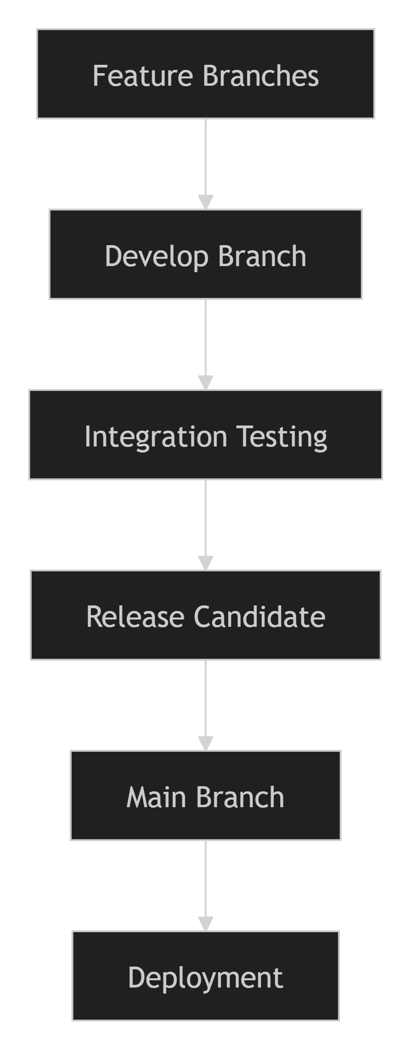
This workflow ensured that only validated and well-tested code was promoted to production.

Benefits of the Git Workflow
- Supports parallel team development.
- Maintains a complete project history.
- Simplifies collaboration and code review.
- Improves code quality and maintainability.
- Enables controlled releases.
- Enhances reproducibility and traceability.
- Reduces deployment and integration risks.
Conclusion
The Git workflow provided a structured framework for collaborative software development throughout the ETA Prediction project. Through feature-based branching, pull-request reviews, controlled integrations, and alignment with DVC and MLflow, the team was able to maintain high code quality, reproducibility, and project stability while enabling efficient parallel development across data engineering, machine learning, and MLOps activities.
7.2 Data Version Control (DVC) Workflow
Managing datasets and machine learning artifacts is as important as managing source code. Traditional version control systems such as Git are highly effective for source code; however, they are not well suited for large datasets and model artifacts. To address this challenge, the project adopted Data Version Control (DVC) to track datasets, maintain reproducibility, manage model artifacts, and ensure consistency across development and deployment environments. DVC enabled the team to version control data in a manner similar to source code while maintaining traceability throughout the Machine Learning lifecycle.
Objectives
The DVC workflow was implemented to:
- Version control raw and processed datasets.
- Track machine learning artifacts.
- Ensure dataset reproducibility.
- Facilitate collaboration among team members.
- Maintain data lineage throughout the ML pipeline.
- Support model retraining and experiment reproducibility.

Why DVC?
Machine Learning projects continuously evolve as data changes, features are engineered, and models are retrained. Managing these assets manually can lead to:
- Dataset inconsistencies.
- Loss of reproducibility.
- Difficulty reproducing experiments.
- Challenges in collaboration.
DVC solves these issues by:
- Tracking dataset versions.
- Managing large files outside Git.
- Linking data versions with code versions.
- Supporting reproducible ML pipelines.

DVC Architecture
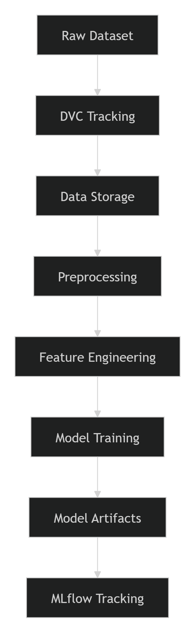

DVC Workflow
The project follows a structured workflow for managing data versions and machine learning artifacts.

Data Lifecycle Management
Stage 1: Raw Data Versioning
Raw datasets are ingested and stored in a dedicated data directory.
data/raw/
DVC tracks all dataset versions while Git stores the corresponding metadata files.
Example:
dvc add data/raw
This command creates a .dvc file that records dataset information while keeping the large data files outside Git.

Stage 2: Commit Dataset Metadata
After tracking the dataset, the corresponding metadata is committed to Git.
git add data/raw.dvc
git commit -m "Track raw dataset with DVC"
This establishes a relationship between the dataset version and the project code version.

Stage 3: Push Data to Remote Storage
The actual dataset is stored in remote storage rather than the Git repository.
Example:
dvc push
Potential storage backends include:
- Local storage
- Google Cloud Storage
- AWS S3
- Azure Blob Storage
This approach keeps the Git repository lightweight while supporting collaborative data access.

Stage 4: Retrieve Data
Team members can retrieve the exact dataset version associated with a project release.
dvc pull
This command downloads the required dataset version from remote storage.
Benefits:
- Reproducible experiments.
- Consistent development environments.
- Simplified onboarding for new contributors.

DVC Pipeline Stages
The ETA Prediction project utilizes DVC throughout the machine learning lifecycle.
Data Pipeline
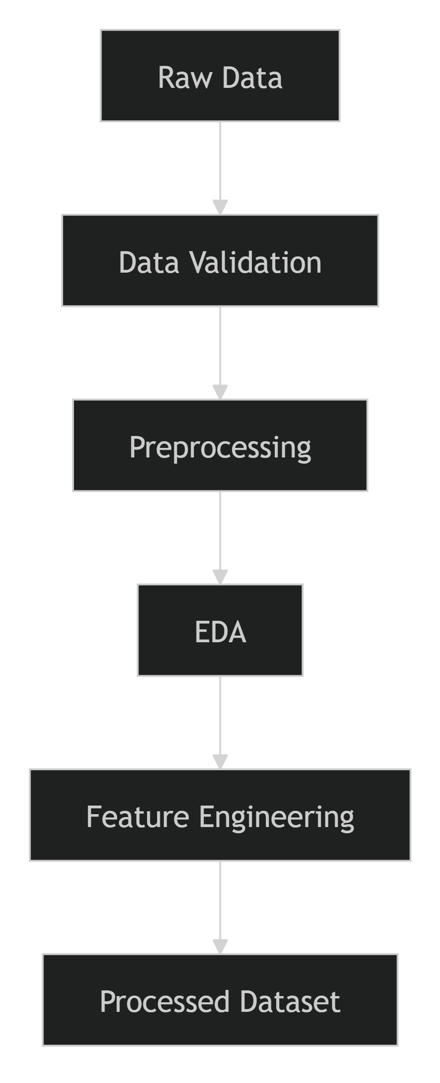

Model Pipeline
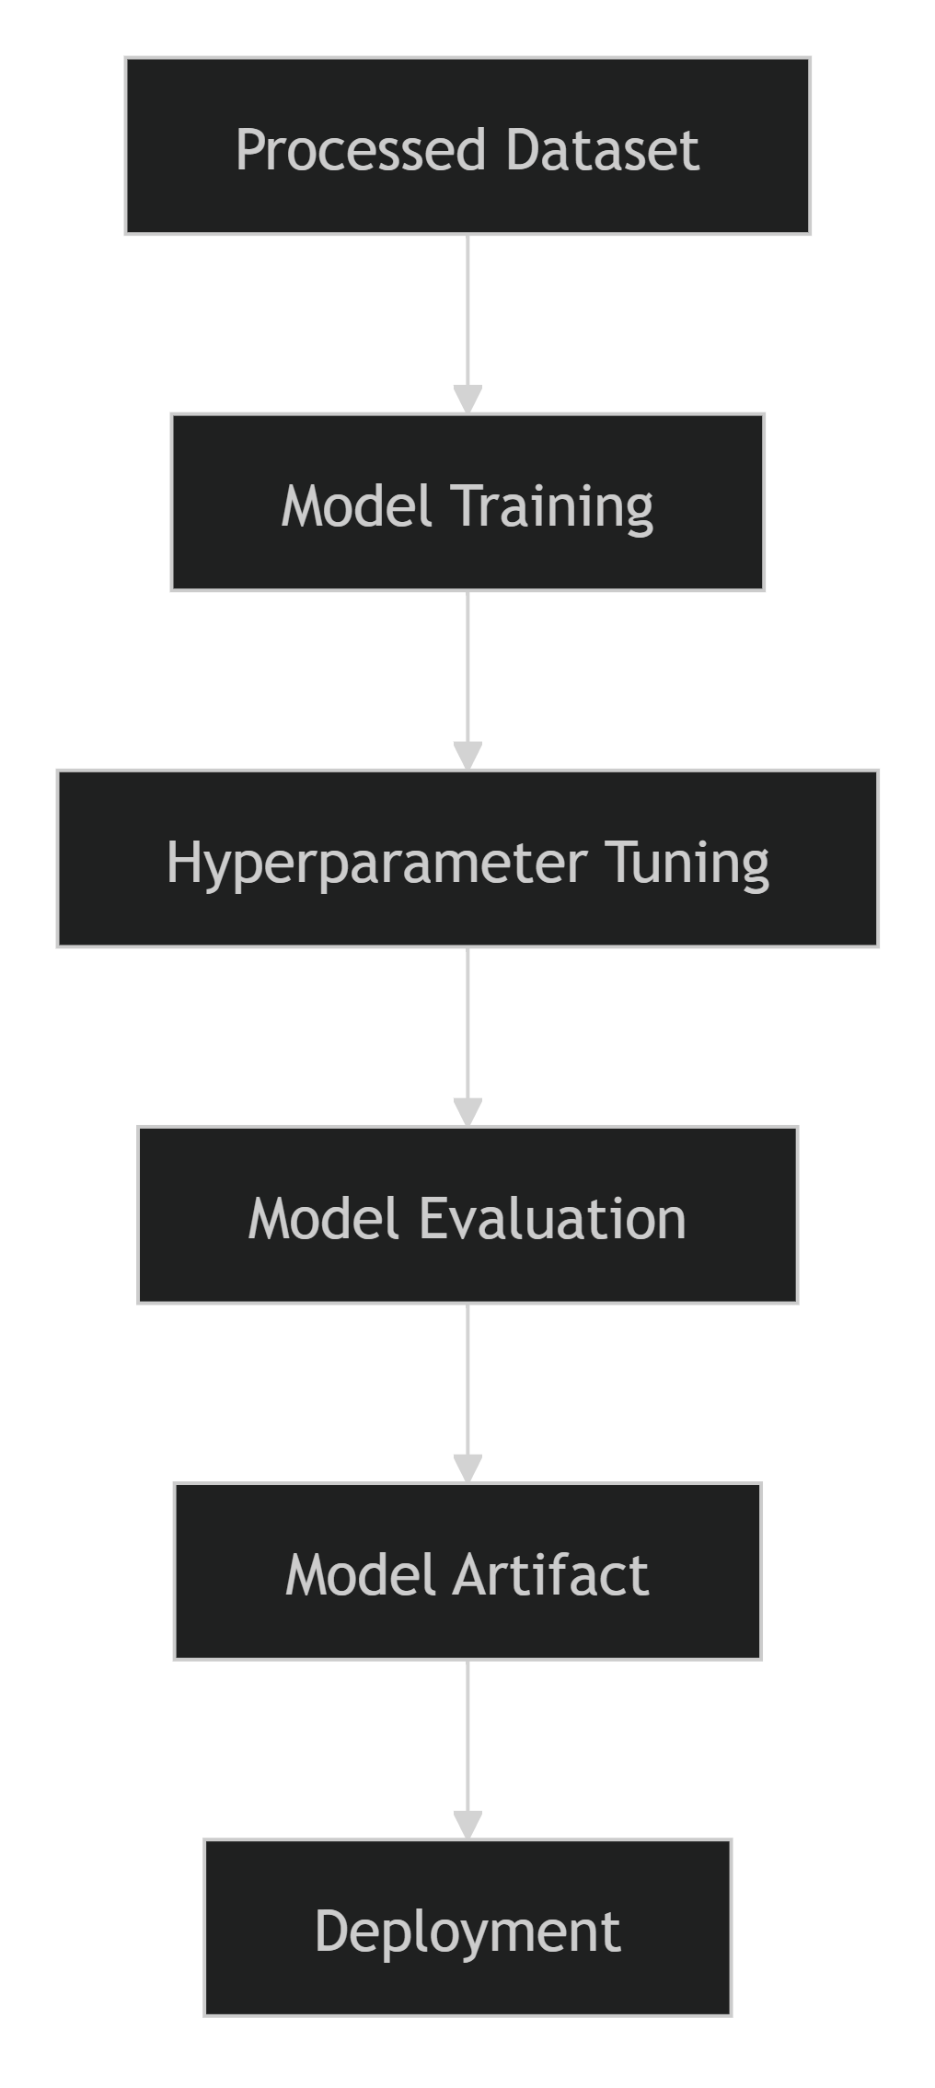

DVC Components in the Project
Several project files indicate DVC integration:
Data Acquisition
ExtractData_Using_DVC.py
stage_raw.py
pre-EDA-dvc.py
Validation and Testing
test_stage_raw.py
These scripts support data ingestion, staging, and retrieval through the DVC workflow.

Data Lineage and Reproducibility
One of the major benefits of DVC is complete data lineage.
This enables the team to answer questions such as:
- Which dataset produced a specific model?
- Which code version trained the model?
- Which feature set was used during experimentation?
This level of traceability is essential for enterprise-grade MLOps systems.

Integration with MLflow
DVC and MLflow complement one another within the project.
Tool | Responsibility
Git | Source code versioning
DVC | Dataset and artifact versioning
MLflow | Experiment tracking and model metadata
Integrated Workflow
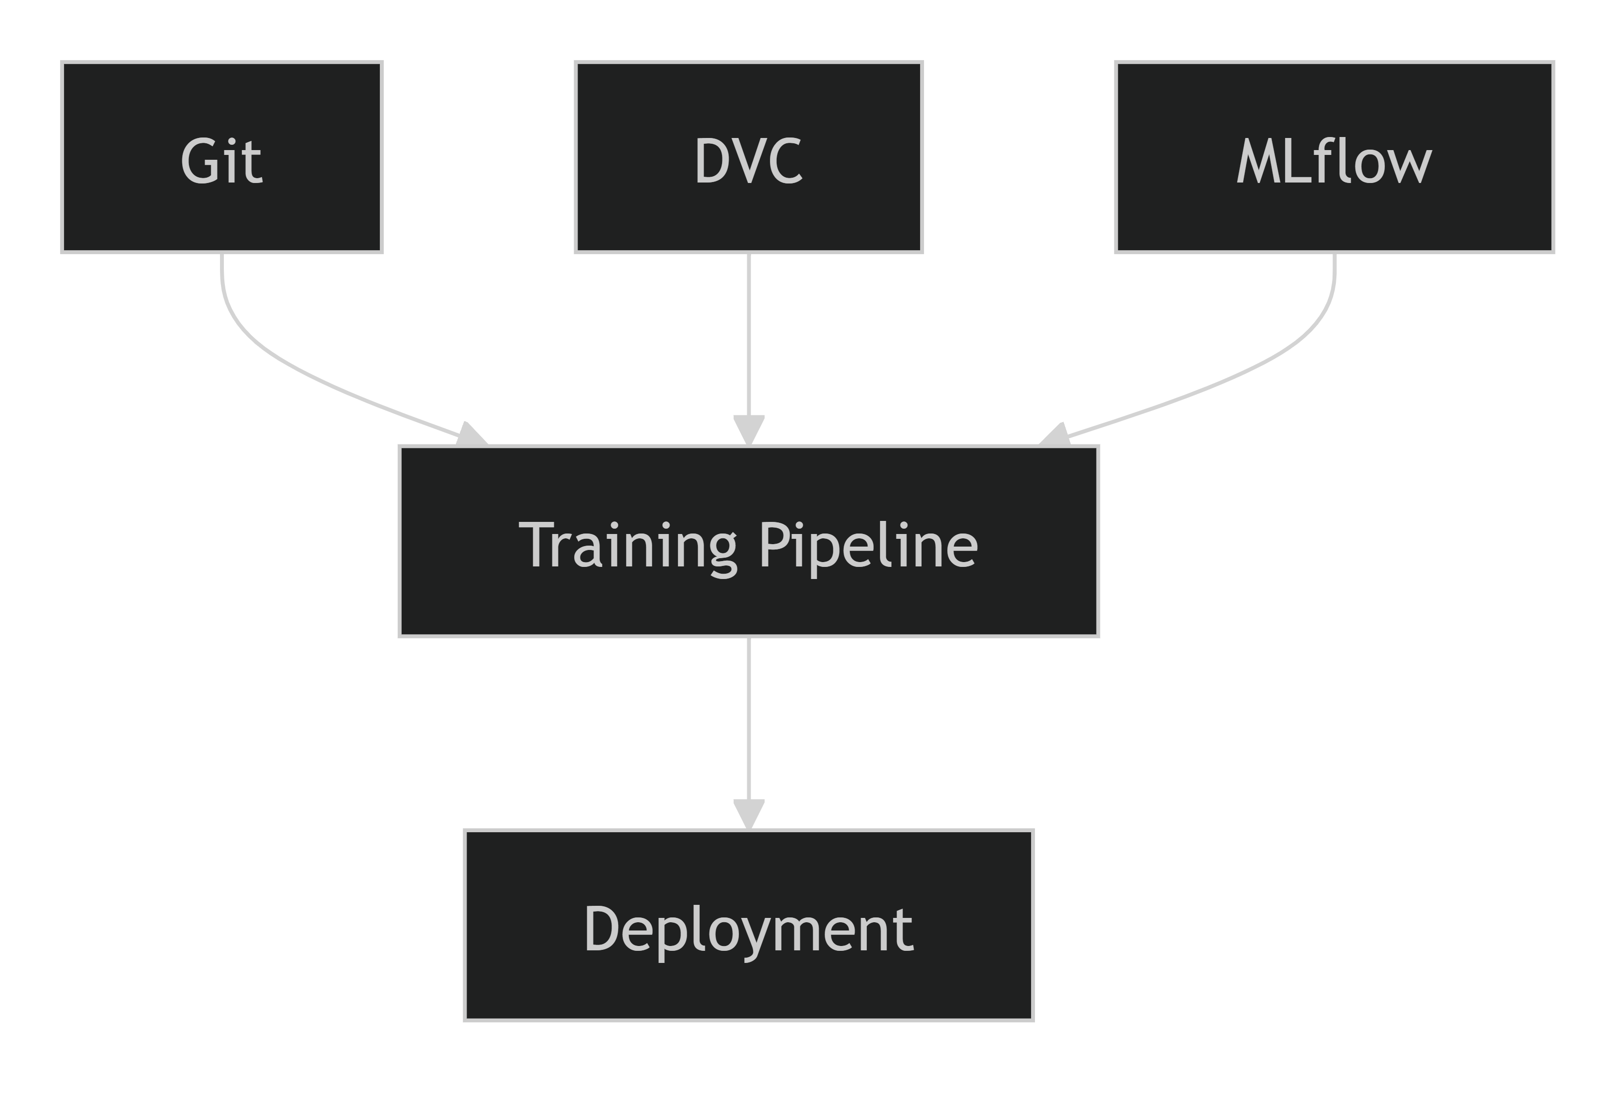
This integrated approach provides full reproducibility across code, data, experiments, and deployment artifacts.

Benefits of Using DVC
Capability | Benefit
Dataset Versioning | Tracks data evolution
Data Reproducibility | Recreates historical experiments
Collaboration Support | Enables team-wide consistency
Large File Management | Keeps Git repository lightweight
Data Lineage | Improves traceability
Retraining Support | Simplifies future model updates

Example DVC Command Workflow
# Track dataset
dvc add data/raw

# Commit metadata
git add data/raw.dvc
git commit -m "Track raw dataset"

# Upload data to remote storage
dvc push

# Retrieve dataset
dvc pull

# Execute pipeline
dvc repro

Conclusion
DVC played a crucial role in the ETA Prediction project by providing robust dataset versioning, reproducibility, and data lineage management capabilities. By version-controlling raw data, processed datasets, and machine learning artifacts, the project ensured consistency across development, experimentation, and deployment environments. Combined with Git and MLflow, the DVC workflow established a comprehensive MLOps foundation that supports collaboration, reproducibility, and long-term maintainability of the machine learning system.
7.3 Collaboration Process
Effective collaboration was essential for successfully delivering the Delivery / Ride ETA Prediction project. Since the project encompassed multiple domains including data engineering, machine learning, MLOps, deployment, and documentation, a structured collaboration process was established to ensure smooth coordination, clear ownership, knowledge sharing, and timely delivery of project milestones. The team leveraged Git, GitHub, DVC, MLflow, code reviews, and regular communication to maintain consistency and transparency throughout the project lifecycle.
Objectives
The collaboration process was designed to:
- Enable efficient teamwork across project components.
- Clearly define roles and responsibilities.
- Reduce development bottlenecks.
- Ensure consistency in code, data, and documentation.
- Facilitate knowledge sharing among team members.
- Improve project quality through reviews and collaborative decision-making.

Team Structure
The project team was organized based on specialized responsibilities within the Machine Learning Engineering lifecycle.
Team Member | Role | Key Responsibilities
BHALLAMUDI VENKATA SRINIVAS KIRAN | Data & Features Lead, Documentation Lead | Data acquisition, preprocessing, feature engineering, EDA, documentation, reporting
GM CHANDRA KISHORE | Modeling & Core ML Lead | Model development, experimentation, hyperparameter tuning, model evaluation, MLflow tracking
CHETAN RAGHAV | MLOps & Deployment Lead | API development, Docker containerization, deployment architecture, monitoring and maintenance

Collaboration Workflow

Project Collaboration Lifecycle
1. Planning and Requirement Analysis
At the beginning of each milestone, team members collaboratively reviewed:
- Project objectives
- Assignment requirements
- Deliverables
- Technical architecture
- Development roadmap
This ensured that all members shared a common understanding of project goals.

2. Task Allocation
Work was divided according to areas of expertise.
Data Engineering Activities
- Data acquisition
- Data validation
- Data preprocessing
- Feature engineering
- Exploratory Data Analysis
Machine Learning Activities
- Model training
- Hyperparameter tuning
- Experiment tracking
- Model evaluation
MLOps Activities
- Model packaging
- API development
- Docker deployment
- Monitoring design
- Retraining framework
Documentation Activities
- Technical documentation
- Architecture diagrams
- Reports and presentations
This specialization improved development efficiency and accountability.

3. Parallel Development
Individual tasks were developed independently within dedicated Git branches.
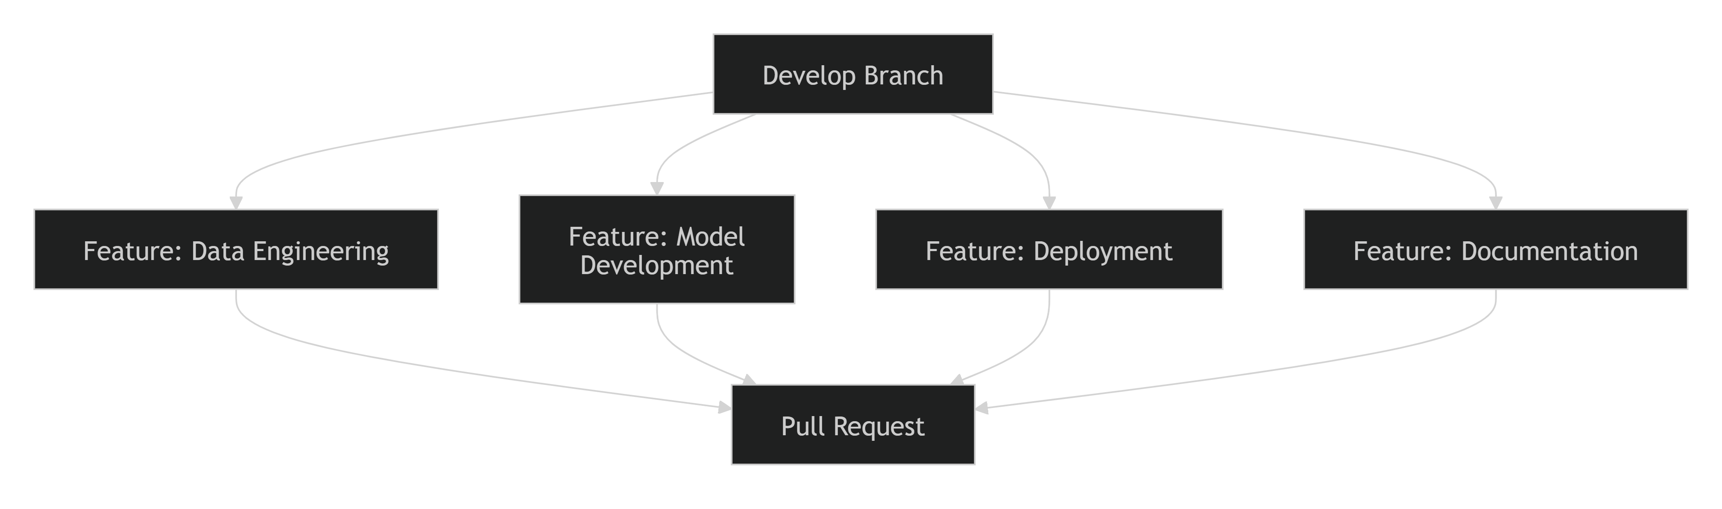
This approach enabled simultaneous development while minimizing conflicts.

Collaboration Through GitHub
GitHub served as the central collaboration platform.
Activities Managed Through GitHub
- Repository management
- Branch management
- Pull requests
- Code reviews
- Issue tracking
- Documentation updates
Pull Request Process
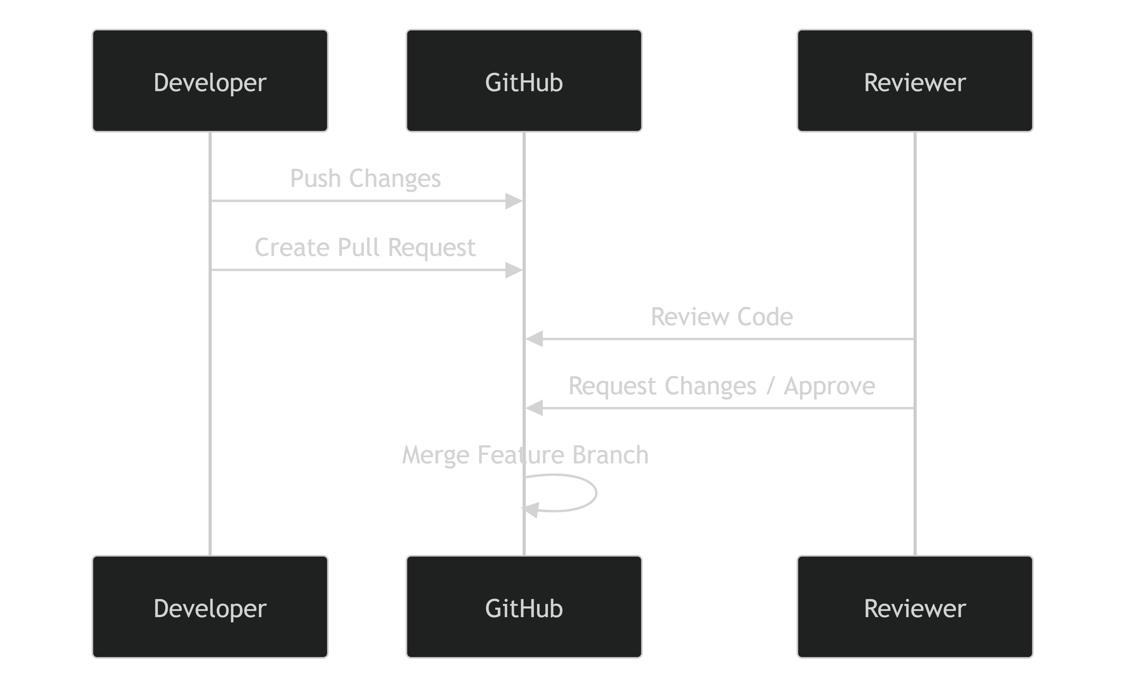
This workflow ensured that all significant changes underwent review before integration.

Data Collaboration Using DVC
Since machine learning projects require management of large datasets, DVC was used alongside Git.
Benefits
- Shared dataset versions.
- Reproducible experiments.
- Data lineage tracking.
- Consistent development environments.

This allowed all team members to work on identical versions of the data.

Experiment Collaboration Using MLflow
MLflow enabled collaborative experiment tracking and model comparison.
Shared Information
- Hyperparameters
- Metrics
- Training runs
- Model artifacts
- Evaluation results
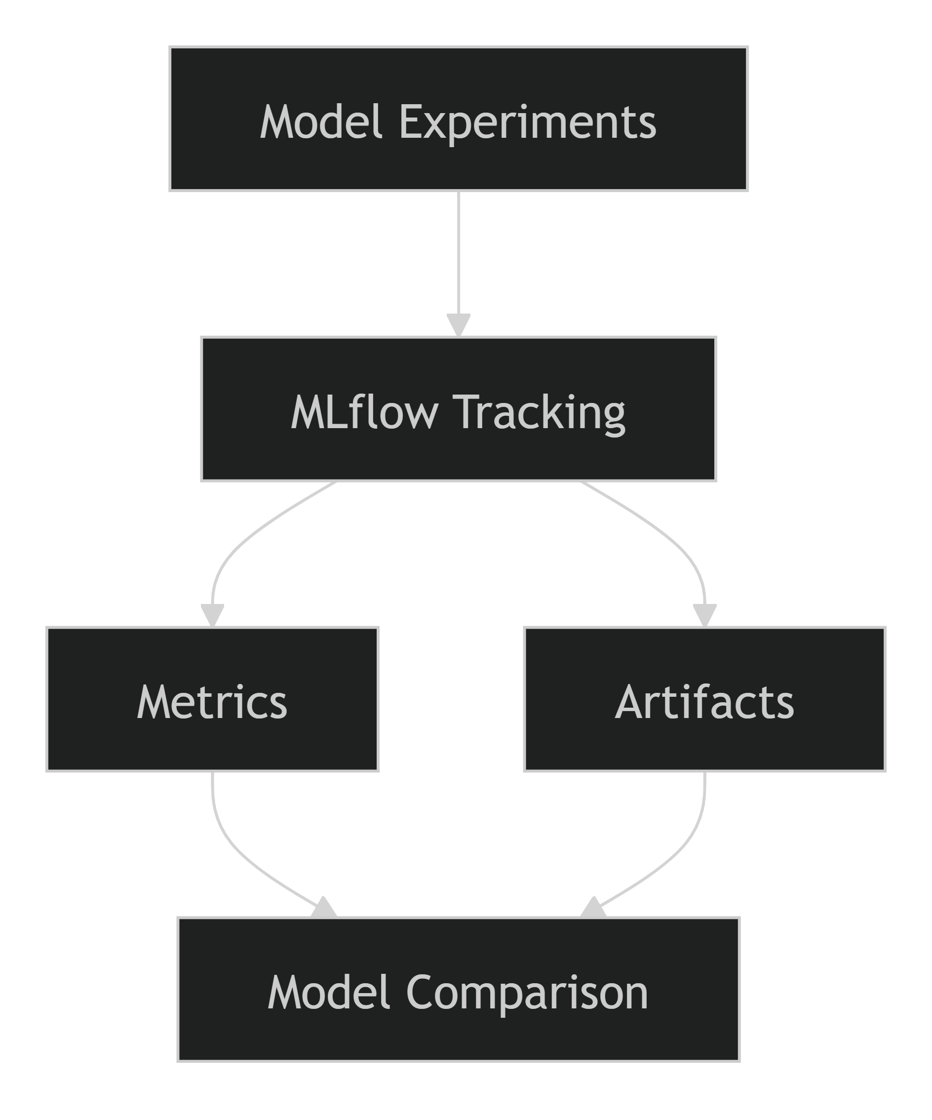
This ensured transparency and reproducibility in model development.

Communication and Coordination
Regular communication was maintained throughout the project lifecycle.
Coordination Activities
- Progress updates
- Technical discussions
- Design reviews
- Issue resolution
- Integration planning
Discussion Topics
- Data quality findings
- Feature engineering decisions
- Model performance analysis
- Deployment architecture
- Monitoring strategy
Frequent collaboration reduced project risks and improved solution quality.

Knowledge Sharing
Team members actively shared knowledge across domains.
Examples
- Data engineering findings informed feature engineering decisions.
- Model evaluation results guided deployment planning.
- Monitoring requirements influenced API design.
- Documentation consolidated project-wide learnings.
This collaborative approach improved the overall quality of the final solution.

Integration and Testing
After feature completion, all components were integrated and tested collectively.
Validation Activities
- Data pipeline validation
- Feature engineering validation
- Model evaluation
- API testing
- Deployment testing
- Monitoring workflow verification
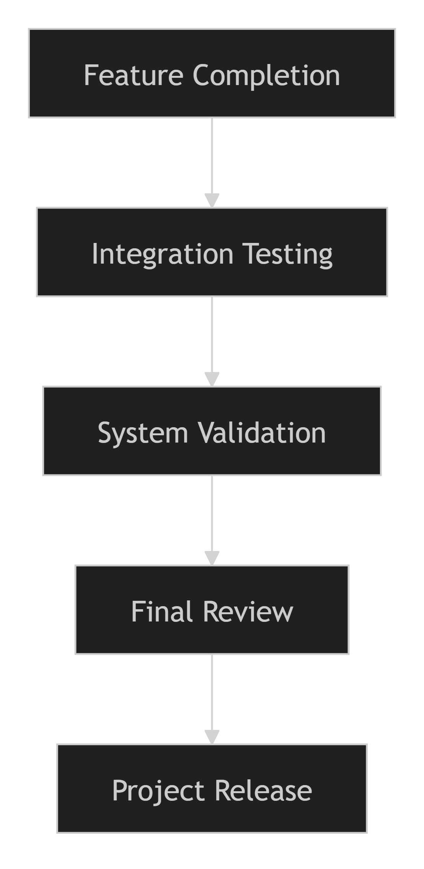

Collaboration Best Practices Followed
- Clear ownership of deliverables.
- Frequent synchronization of code and data.
- Pull-request-based code reviews.
- Shared documentation standards.
- Experiment reproducibility through MLflow.
- Data reproducibility through DVC.
- Continuous communication and feedback.

Benefits of the Collaboration Process
Practice | Benefit
Role-Based Ownership | Clear accountability
GitHub Workflow | Efficient collaboration
Pull Request Reviews | Improved code quality
DVC Integration | Consistent datasets
MLflow Tracking | Reproducible experiments
Regular Communication | Faster issue resolution
Shared Documentation | Improved knowledge transfer

Conclusion
The collaboration process combined structured task ownership, GitHub-based development workflows, DVC-enabled data sharing, MLflow experiment tracking, and continuous communication to support efficient team coordination throughout the project. This collaborative approach enabled parallel development across data engineering, machine learning, deployment, and documentation activities while maintaining code quality, reproducibility, and project consistency. As a result, the team successfully delivered a scalable, production-oriented ETA Prediction system aligned with Machine Learning Engineering and MLOps best practices.

8. Conclusion and Future Work
8.1 Project Summary
The Delivery / Ride ETA Prediction System was developed as an end-to-end Machine Learning Engineering (MLE) and MLOps solution to accurately predict trip durations and Estimated Time of Arrival (ETA) using historical transportation data. The project addressed the challenge of providing reliable ETA estimates by leveraging data-driven machine learning techniques, robust feature engineering, experiment tracking, deployment automation, and production monitoring practices.
The project followed a complete machine learning lifecycle, beginning with data acquisition, validation, and preprocessing. Historical trip datasets containing temporal and geographical information were collected, version-controlled using DVC, and subjected to comprehensive quality checks to ensure consistency and reliability. Exploratory Data Analysis (EDA) was conducted to identify key patterns, trends, and relationships affecting trip duration, providing valuable insights for feature engineering and model development.
A rich set of temporal and location-based features was engineered from the raw dataset. Features such as pickup hour, day of week, month, Haversine distance, travel direction, and geographic coordinates enabled the models to capture complex traffic and travel patterns. Feature transformation and analysis further improved data quality and predictive capability.
Multiple machine learning models were evaluated, including a baseline Linear Regression model and an advanced Gradient Boosting Regressor. Experiments were systematically tracked using MLflow, enabling reproducibility and comparative evaluation of model configurations. Through hyperparameter tuning and rigorous performance evaluation, the Gradient Boosting model was identified as the best-performing candidate due to its ability to capture non-linear relationships and deliver superior predictive accuracy.
To operationalize the solution, the selected model was serialized and packaged as a deployable artifact. A REST API was developed to support real-time ETA predictions, enabling seamless integration with external applications. Docker containerization was incorporated to ensure deployment portability and consistency across environments, while a cloud-ready deployment strategy was defined to support scalability and future production rollout.
A comprehensive MLOps framework was also established to support long-term model maintenance. The monitoring architecture includes prediction logging, data drift detection, drift simulation, performance monitoring, alerting mechanisms, and retraining strategies. These capabilities ensure that the deployed model can adapt to changing data patterns and maintain reliable performance in production.
The project additionally adopted industry-standard collaboration and version-control practices through Git, GitHub, DVC, and MLflow. These tools enabled efficient teamwork, reproducibility, traceability, and structured development throughout the project lifecycle.
Key Achievements
- Successfully developed an end-to-end ETA prediction pipeline.
- Implemented robust data acquisition, validation, and preprocessing workflows.
- Engineered meaningful temporal and geographical features.
- Evaluated and optimized multiple machine learning models.
- Integrated MLflow for experiment tracking and reproducibility.
- Selected and deployed a high-performing Gradient Boosting model.
- Developed a production-ready REST API for real-time predictions.
- Implemented Docker-based containerization for deployment portability.
- Designed a comprehensive monitoring and maintenance framework.
- Established Git, DVC, and collaborative workflows aligned with MLOps best practices.
Overall Outcome
The project successfully demonstrates the integration of Data Engineering, Machine Learning, Software Engineering, and MLOps principles into a unified solution for ETA prediction. The resulting system is scalable, reproducible, deployment-ready, and capable of delivering accurate travel time estimates that can improve customer satisfaction, enhance operational efficiency, and support data-driven decision-making in transportation and logistics environments.
The developed architecture also provides a strong foundation for future enhancements such as real-time traffic integration, advanced ensemble modeling, automated retraining pipelines, CI/CD automation, and fully cloud-native deployment. As a result, the project not only meets its immediate objectives but also establishes a sustainable framework for continuous improvement and long-term operational success.
8.2 Limitations
While the Delivery / Ride ETA Prediction system successfully demonstrates a complete end-to-end Machine Learning Engineering and MLOps solution, several limitations were identified during development and evaluation. These limitations highlight areas where prediction accuracy, scalability, and real-world applicability can be further enhanced in future iterations of the project.
1. Dependence on Historical Data
The model is trained primarily on historical trip records and learns patterns from past travel behavior.
Limitation:
- Predictions are based on historical trends and may not fully reflect sudden changes in traffic conditions or travel patterns.
- Unforeseen events that were not present in the training data may reduce prediction accuracy.
Impact:
- Prediction quality may decrease when real-world conditions differ significantly from historical observations.

2. Absence of Real-Time Traffic Data
The current implementation does not incorporate live traffic information.
Limitation:
- Road congestion, accidents, construction activities, and temporary traffic disruptions are not considered during prediction.
Impact:
- ETA estimates may be less accurate during unexpected traffic conditions, especially in highly congested urban environments.

3. Limited External Contextual Features
The model primarily utilizes temporal and geographic features derived from trip records.
Missing Factors Include:
- Weather conditions
- Public events
- Road closures
- Traffic incidents
- Special holiday schedules
Impact:
- Certain travel-time variations cannot be fully explained using the available feature set.

4. Geographic Generalization Constraints
The model was developed and evaluated using a specific transportation dataset.
Limitation:
- Travel patterns learned from one geographic region may not directly generalize to other cities or transportation networks.
Impact:
- Additional training and validation may be required before deploying the model to new operational regions.

5. Static Feature Engineering Approach
The engineered features are generated using predefined transformation rules.
Limitation:
- The current feature set may not capture all complex spatial and temporal interactions influencing trip duration.
Impact:
- Some predictive information may remain unexploited, limiting overall model performance.

6. Prediction Uncertainty Not Explicitly Modeled
The deployed model currently provides a single ETA estimate.
Limitation:
- Confidence intervals or uncertainty estimates are not provided with predictions.
Impact:
- Users receive a point estimate without visibility into the potential range of prediction variability.

7. Limited Production Validation
Although the solution is deployment-ready and includes monitoring and retraining frameworks, large-scale production validation has not yet been completed.
Limitation:
- The model has primarily been evaluated using historical datasets and controlled experimentation environments.
Impact:
- Additional testing is required to assess performance under real-world production workloads and traffic conditions.

8. Drift Detection Depends on Monitoring Data Availability
The effectiveness of drift detection relies on the availability of sufficient production data and actual trip outcomes.
Limitation:
- Drift monitoring and retraining decisions become less reliable when outcome data is delayed or unavailable.
Impact:
- Detection of emerging performance issues may be delayed.

9. Computational Cost of Retraining
As data volume grows over time, retraining activities may become more resource-intensive.
Limitation:
- Larger datasets require additional storage, processing power, and training time.
Impact:
- Retraining cycles may require infrastructure optimization and automation for long-term scalability.

10. Limited Model Diversity
The experimentation phase primarily focused on Linear Regression and Gradient Boosting approaches.
Limitation:
- Other advanced algorithms such as XGBoost, LightGBM, CatBoost, or Deep Learning architectures were not extensively explored.
Impact:
- Potential performance improvements from alternative modeling techniques may not have been fully realized.

Summary of Key Limitations
Limitation Area | Potential Impact
Historical Data Dependency | Reduced adaptability to sudden changes
No Real-Time Traffic Data | Lower accuracy during unexpected congestion
Missing External Factors | Incomplete contextual understanding
Geographic Constraints | Limited direct transferability to new regions
Static Feature Set | May miss complex travel patterns
No Prediction Uncertainty | Limited confidence information for users
Limited Production Validation | Additional real-world testing required
Drift Monitoring Dependency | Delayed detection under sparse feedback
Retraining Cost | Increased infrastructure requirements
Limited Model Exploration | Potential performance gains not fully explored
Conclusion
Despite these limitations, the ETA Prediction system provides a strong foundation for accurate trip-duration estimation and demonstrates successful implementation of modern Machine Learning Engineering and MLOps practices. Most identified limitations can be addressed through future enhancements such as real-time traffic integration, richer contextual features, advanced modeling techniques, automated retraining pipelines, and large-scale production validation. These improvements offer a clear roadmap for evolving the solution into a more robust, scalable, and enterprise-ready prediction platform.
8.3 Future Enhancements
While the current ETA Prediction system successfully delivers accurate trip-duration predictions through a robust Machine Learning Engineering and MLOps framework, several opportunities exist to further improve prediction accuracy, scalability, automation, and business value. Future enhancements will focus on enriching the feature set, adopting advanced machine learning techniques, strengthening MLOps automation, and expanding deployment capabilities.
1. Integration of Real-Time Traffic Data
One of the most impactful improvements would be the incorporation of live traffic information into the prediction pipeline.
Potential Data Sources
- Google Maps Traffic API
- HERE Maps Traffic Services
- TomTom Traffic APIs
- Municipal traffic monitoring systems
Benefits
- Improved ETA accuracy during congestion.
- Better handling of accidents and road closures.
- More realistic travel-time estimates.
- Enhanced responsiveness to dynamic traffic conditions.
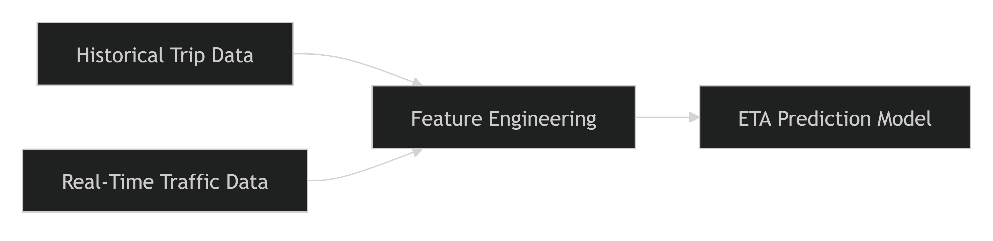

2. Weather Data Integration
Weather conditions significantly influence traffic flow and travel time.
Additional Features
- Temperature
- Rainfall
- Visibility
- Wind conditions
- Storm alerts
Expected Benefits
- Better prediction during adverse weather conditions.
- Improved robustness across seasons.
- Enhanced model generalization.

3. Advanced Machine Learning Models
Future work may include evaluating more sophisticated machine learning algorithms.
Candidate Models
- XGBoost
- LightGBM
- CatBoost
- Random Forests
- Deep Neural Networks
- LSTM-based Time Series Models
Advantages
- Better handling of complex nonlinear patterns.
- Improved predictive performance.
- Enhanced feature interaction modeling.
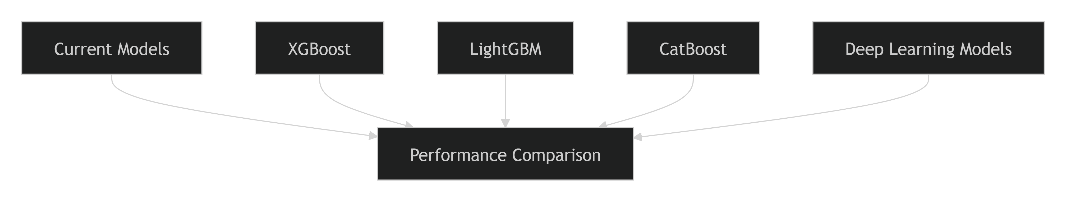

4. Route-Based Feature Engineering
The current implementation primarily utilizes straight-line (Haversine) distance.
Future Enhancements
- Actual route distance
- Road network information
- Estimated travel routes
- Number of intersections
- Traffic signal density
Benefits
- More realistic travel-time estimation.
- Better modeling of urban transportation networks.
- Reduced prediction error for complex routes.

5. Geospatial Intelligence Enhancements
Advanced geospatial analytics can strengthen the location-based feature set.
Potential Features
- Regional traffic zones
- Pickup and drop-off hotspots
- Spatial clustering using DBSCAN or K-Means
- Region-specific demand patterns
Benefits
- Better location awareness.
- Improved predictions in high-density urban areas.
- Enhanced understanding of traffic hotspots.

6. Automated Retraining Pipeline
The current framework defines retraining procedures, but future versions can fully automate the process.
Continuous Training Workflow
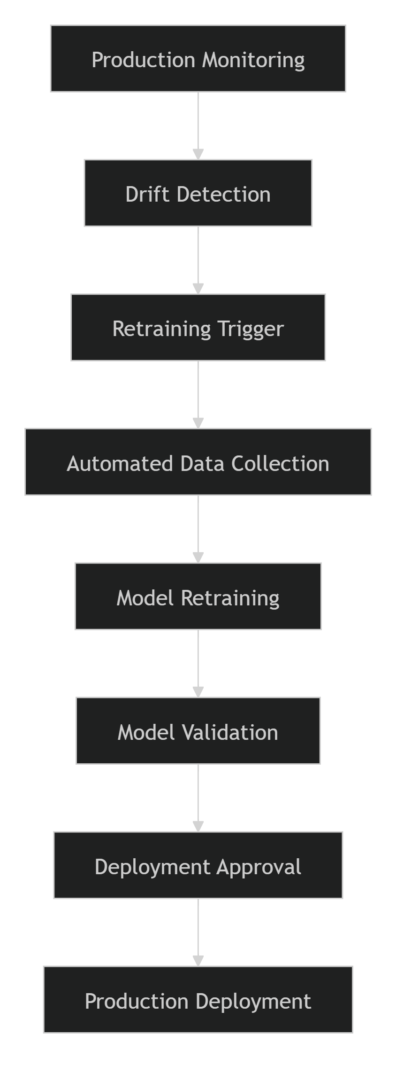
Benefits
- Reduced manual intervention.
- Faster adaptation to changing conditions.
- Improved operational efficiency.

7. CI/CD for MLOps
Future iterations can implement a complete Continuous Integration and Continuous Deployment (CI/CD) pipeline.
Enhancements
- Automated testing
- Automated model packaging
- Automated deployment
- Model promotion workflows
Benefits
- Faster releases.
- Reduced deployment risk.
- Improved reproducibility.

8. Real-Time Monitoring Dashboard
A dedicated monitoring dashboard can provide operational visibility into system performance.
Dashboard Metrics
- API latency
- Prediction volumes
- Drift scores
- MAE and RMSE trends
- Resource utilization
Technologies
- Grafana
- Prometheus
- Evidently AI
Benefits
- Improved observability.
- Faster incident response.
- Better operational governance.

9. Cloud-Native Scaling
Future deployments can leverage fully managed cloud-native infrastructure.
Potential Platforms
- Google Cloud Run
- Google Kubernetes Engine (GKE)
- Azure Kubernetes Service (AKS)
- Amazon EKS
Advantages
- Auto-scaling
- High availability
- Reduced infrastructure management
- Better cost optimization

10. Prediction Confidence Intervals
The current model generates a single ETA value.
Enhancement
Provide uncertainty estimates alongside predictions.
Example Response
{
"predicted_eta": 845,
"confidence_interval": {
"lower_bound": 790,
"upper_bound": 910
}
}
Benefits
- Better decision-making.
- Improved transparency.
- Enhanced user trust.

11. Mobile and Web Application Integration
The deployed API can be integrated with user-facing applications.
Applications
- Ride-hailing platforms
- Delivery management systems
- Fleet management applications
- Customer tracking portals
Business Benefits
- Real-time ETA visibility.
- Improved customer experience.
- Enhanced operational coordination.

12. Enterprise MLOps Expansion
Future work can extend the platform into a full enterprise-grade MLOps solution.
Enhancements
- Model registry
- Automated governance
- Approval workflows
- Feature store integration
- Centralized metadata management
Expected Outcomes
- Better lifecycle management.
- Improved compliance.
- Enhanced scalability.

Future Roadmap
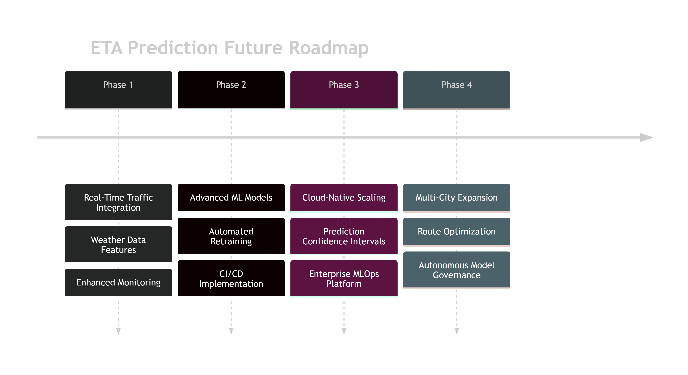

Conclusion
The current ETA Prediction system establishes a strong foundation for accurate trip-duration prediction and production-ready MLOps practices. Future enhancements will focus on incorporating real-time contextual data, advanced machine learning algorithms, automated retraining workflows, enhanced monitoring capabilities, and cloud-native scalability. These improvements have the potential to significantly increase prediction accuracy, operational efficiency, system reliability, and business value, ultimately evolving the solution into a fully autonomous and enterprise-ready intelligent transportation platform.

9. References
9.1 Academic References
The following academic references provided the theoretical foundation for machine learning, gradient boosting algorithms, experiment tracking, MLOps practices, feature engineering, model evaluation, and transportation-related prediction systems used throughout this project.
Machine Learning and Predictive Modeling
- Géron, A. (2022). Hands-On Machine Learning with Scikit-Learn, Keras, and TensorFlow (3rd ed.). O'Reilly Media.
- Bishop, C. M. (2006). Pattern Recognition and Machine Learning. Springer.
- Hastie, T., Tibshirani, R., & Friedman, J. (2009). The Elements of Statistical Learning: Data Mining, Inference, and Prediction (2nd ed.). Springer.
- James, G., Witten, D., Hastie, T., & Tibshirani, R. (2021). An Introduction to Statistical Learning with Applications in R (2nd ed.). Springer.

Gradient Boosting and Ensemble Learning
- Friedman, J. H. (2001). "Greedy Function Approximation: A Gradient Boosting Machine." The Annals of Statistics, 29(5), 1189-1232.
- Chen, T., & Guestrin, C. (2016). "XGBoost: A Scalable Tree Boosting System." Proceedings of the 22nd ACM SIGKDD International Conference on Knowledge Discovery and Data Mining, 785-794.
- Ke, G., Meng, Q., Finley, T., Wang, T., Chen, W., Ma, W., Ye, Q., & Liu, T. Y. (2017). "LightGBM: A Highly Efficient Gradient Boosting Decision Tree." Advances in Neural Information Processing Systems (NeurIPS).

Feature Engineering and Data Preparation
- Kuhn, M., & Johnson, K. (2019). Feature Engineering and Selection: A Practical Approach for Predictive Models. Chapman and Hall/CRC.
- Zhao, Y. (2022). Feature Engineering Bookcamp: Better Features for Better Machine Learning. Manning Publications.

MLOps and Machine Learning Engineering
- Treveil, M., Omont, N., Stengelin, C., et al. (2020). Introducing MLOps: How to Scale Machine Learning in the Enterprise. O'Reilly Media.
- Burkov, A. (2020). Machine Learning Engineering. True Positive Inc.
- Huyen, C. (2022). Designing Machine Learning Systems: An Iterative Process for Production-Ready Applications. O'Reilly Media.
- Dattatraya, A., Kale, A., & Bhadoria, R. (2023). MLOps Engineering at Scale. Packt Publishing.

Experiment Tracking and Model Management
- Zaharia, M., Chen, A., Davidson, A., et al. (2018). "Accelerating the Machine Learning Lifecycle with MLflow." IEEE Data Engineering Bulletin, 41(4), 39-45.
- MLflow Contributors. (2024). MLflow Documentation and Model Lifecycle Management. Databricks Inc.

Data Version Control and Reproducibility
- Kuprieiev, R., Petrov, D., & DVC Contributors. (2024). Data Version Control (DVC): Documentation and Best Practices. Iterative Inc.
- Sculley, D., Holt, G., Golovin, D., et al. (2015). "Hidden Technical Debt in Machine Learning Systems." Advances in Neural Information Processing Systems (NeurIPS), 2503-2511.

Transportation Analytics and ETA Prediction
- Moreira-Matias, L., Gama, J., Ferreira, M., Mendes-Moreira, J., & Damas, L. (2013). "Predicting Taxi-Passenger Demand Using Streaming Data." IEEE Transactions on Intelligent Transportation Systems, 14(3), 1393-1402.
- Ke, J., Zheng, H., Yang, H., & Chen, X. (2017). "Short-Term Forecasting of Passenger Demand Under On-Demand Ride Services: A Spatio-Temporal Deep Learning Approach." Transportation Research Part C, 85, 591-608.
- Wang, D., Zhang, J., Cao, W., Li, J., & Zheng, Y. (2018). "When Will You Arrive? Estimating Travel Time Based on Deep Neural Networks." Proceedings of AAAI Conference on Artificial Intelligence, 2500-2507.

Monitoring, Drift Detection, and Model Maintenance
- Gama, J., Žliobaitė, I., Bifet, A., Pechenizkiy, M., & Bouchachia, A. (2014). "A Survey on Concept Drift Adaptation." ACM Computing Surveys, 46(4), 1-37.
- Webb, G. I., Hyde, R., Cao, H., Nguyen, H. L., & Petitjean, F. (2016). "Characterizing Concept Drift." Data Mining and Knowledge Discovery, 30(4), 964-994.
- Evidently AI Team. (2024). Monitoring Machine Learning Models in Production: Drift Detection and Performance Monitoring. Evidently AI Documentation.

Software Engineering and DevOps
- Humble, J., & Farley, D. (2010). Continuous Delivery: Reliable Software Releases Through Build, Test, and Deployment Automation. Addison-Wesley.
- Kim, G., Humble, J., Debois, P., & Willis, J. (2021). The DevOps Handbook (2nd ed.). IT Revolution Press.
- Fowler, M. (2018). Refactoring: Improving the Design of Existing Code (2nd ed.). Addison-Wesley.

Citation Format
This project follows the APA (7th Edition) referencing style for academic citations and bibliography management. All external concepts, methodologies, algorithms, frameworks, and architectural practices discussed throughout this report are referenced using these academic and industry-standard sources.
9.2 Technology Documentation
The implementation of the ETA Prediction system relies on a collection of open-source technologies, frameworks, libraries, and cloud-native tools. The following official documentation resources were referenced throughout the project for development, experimentation, deployment, monitoring, and maintenance activities.

Programming Language
Python
Python served as the primary programming language for data processing, machine learning development, API implementation, and automation tasks.
Documentation
- Python Software Foundation. Python Documentation. Available at: https://docs.python.org/
Project Usage
- Data processing
- Machine learning workflows
- API development
- Automation scripts

Data Processing and Analysis
Pandas
Pandas was used for data manipulation, preprocessing, cleaning, and exploratory data analysis.
Documentation
- Pandas Documentation: https://pandas.pydata.org/docs/
Project Usage
- Data loading
- Data transformation
- Missing value handling
- Statistical analysis

NumPy
NumPy was utilized for numerical computations and mathematical operations.
Documentation
- NumPy Documentation: https://numpy.org/doc/
Project Usage
- Numerical processing
- Array manipulation
- Feature calculations

Matplotlib
Matplotlib was used to generate visualizations during EDA and model evaluation.
Documentation
- Matplotlib Documentation: https://matplotlib.org/stable/
Project Usage
- Distribution plots
- Correlation visualizations
- Model evaluation charts

Seaborn
Seaborn was employed for advanced statistical visualization.
Documentation
- Seaborn Documentation: https://seaborn.pydata.org/
Project Usage
- Heatmaps
- Boxplots
- Distribution analysis
- Feature relationship visualization

Machine Learning Framework
Scikit-Learn
Scikit-Learn served as the primary machine learning framework.
Documentation
- Scikit-Learn Documentation: https://scikit-learn.org/stable/
Project Usage
- Linear Regression
- Gradient Boosting Regressor
- Model evaluation
- Train-test splitting
- Hyperparameter tuning

Joblib
Joblib was used for model serialization and persistence.
Documentation
- Joblib Documentation: https://joblib.readthedocs.io/
Project Usage
- Saving trained models
- Loading models during inference
- Model deployment

Experiment Tracking
MLflow
MLflow was used to track experiments, log metrics, manage artifacts, and support reproducibility.
Documentation
- MLflow Documentation: https://mlflow.org/docs/latest/
Project Usage
- Experiment tracking
- Hyperparameter logging
- Model artifact management
- Run comparison
- Model reproducibility

Data Version Control
DVC (Data Version Control)
DVC was adopted to manage datasets and machine learning artifacts throughout the project lifecycle.
Documentation
- DVC Documentation: https://dvc.org/doc
Project Usage
- Dataset versioning
- Data lineage
- Reproducible pipelines
- Remote data storage

API Development
Flask
Flask was used to expose machine learning predictions through RESTful endpoints.
Documentation
- Flask Documentation: https://flask.palletsprojects.com/
Project Usage
- REST API implementation
- Request processing
- Response generation
- API deployment

FastAPI (Future Enhancement / Alternative)
FastAPI was evaluated as a high-performance API framework for future deployment enhancements.
Documentation
- FastAPI Documentation: https://fastapi.tiangolo.com/
Potential Usage
- High-performance inference APIs
- Automatic API documentation
- Asynchronous request handling

Containerization and Deployment
Docker
Docker was used to package the application and its dependencies into portable containers.
Documentation
- Docker Documentation: https://docs.docker.com/
Project Usage
- Application containerization
- Deployment portability
- Environment consistency

Version Control and Collaboration
Git
Git served as the primary version control system.
Documentation
- Git Documentation: https://git-scm.com/doc
Project Usage
- Source code management
- Branching workflows
- Release management

GitHub
GitHub was used as the collaborative development platform.
Documentation
- GitHub Documentation: https://docs.github.com/
Project Usage
- Repository hosting
- Pull requests
- Code reviews
- Team collaboration

Testing Frameworks
Pytest
Pytest was utilized for unit and integration testing.
Documentation
- Pytest Documentation: https://docs.pytest.org/
Project Usage
- API testing
- Data validation testing
- Model testing
- Integration testing

Monitoring and Observability
Evidently AI
Evidently AI was investigated as a monitoring solution for data drift and model performance analysis.
Documentation
- Evidently Documentation: https://docs.evidentlyai.com/
Potential Usage
- Data drift detection
- Model monitoring
- Performance tracking

Prometheus
Prometheus can be integrated for operational monitoring and metrics collection.
Documentation
- Prometheus Documentation: https://prometheus.io/docs/
Potential Usage
- Infrastructure monitoring
- Application metrics
- API performance tracking

Grafana
Grafana can be used for dashboard creation and visualization.
Documentation
- Grafana Documentation: https://grafana.com/docs/
Potential Usage
- Real-time monitoring dashboards
- Drift tracking visualizations
- Operational reporting

Cloud Deployment Platforms
Google Cloud Run
Recommended platform for containerized deployment.
Documentation
- Google Cloud Run Documentation: https://cloud.google.com/run/docs
Potential Usage
- Managed deployment
- Auto-scaling
- Serverless API hosting

Kubernetes (Future Enhancement)
Container orchestration platform for large-scale deployments.
Documentation
- Kubernetes Documentation: https://kubernetes.io/docs/
Potential Usage
- High-availability deployments
- Container orchestration
- Enterprise-scale ML services

Development Environment
Visual Studio Code
Primary development environment used during implementation.
Documentation
- VS Code Documentation: https://code.visualstudio.com/docs
Project Usage
- Code development
- Debugging
- Git integration
- Extension ecosystem

Technology Documentation Summary
Technology Category | Tools & Frameworks
Programming Language | Python
Data Processing | Pandas, NumPy
Visualization | Matplotlib, Seaborn
Machine Learning | Scikit-Learn
Model Serialization | Joblib
Experiment Tracking | MLflow
Data Versioning | DVC
API Development | Flask, FastAPI
Containerization | Docker
Version Control | Git, GitHub
Testing | Pytest
Monitoring | Evidently AI, Prometheus, Grafana
Cloud Deployment | Google Cloud Run, Kubernetes
Development Tools | Visual Studio Code
Conclusion
The ETA Prediction solution leverages a comprehensive modern technology stack spanning data engineering, machine learning, MLOps, deployment, monitoring, and collaboration. The official documentation resources listed in this section provided implementation guidance, best practices, and technical references throughout the project lifecycle, ensuring the development of a scalable, reproducible, and production-ready machine learning system.

10. Appendices
Appendix A: High-Level System Architecture Diagram
The following architecture diagram illustrates the end-to-end flow of the ETA Prediction system, covering data ingestion, feature engineering, model development, experiment tracking, deployment, monitoring, and retraining.
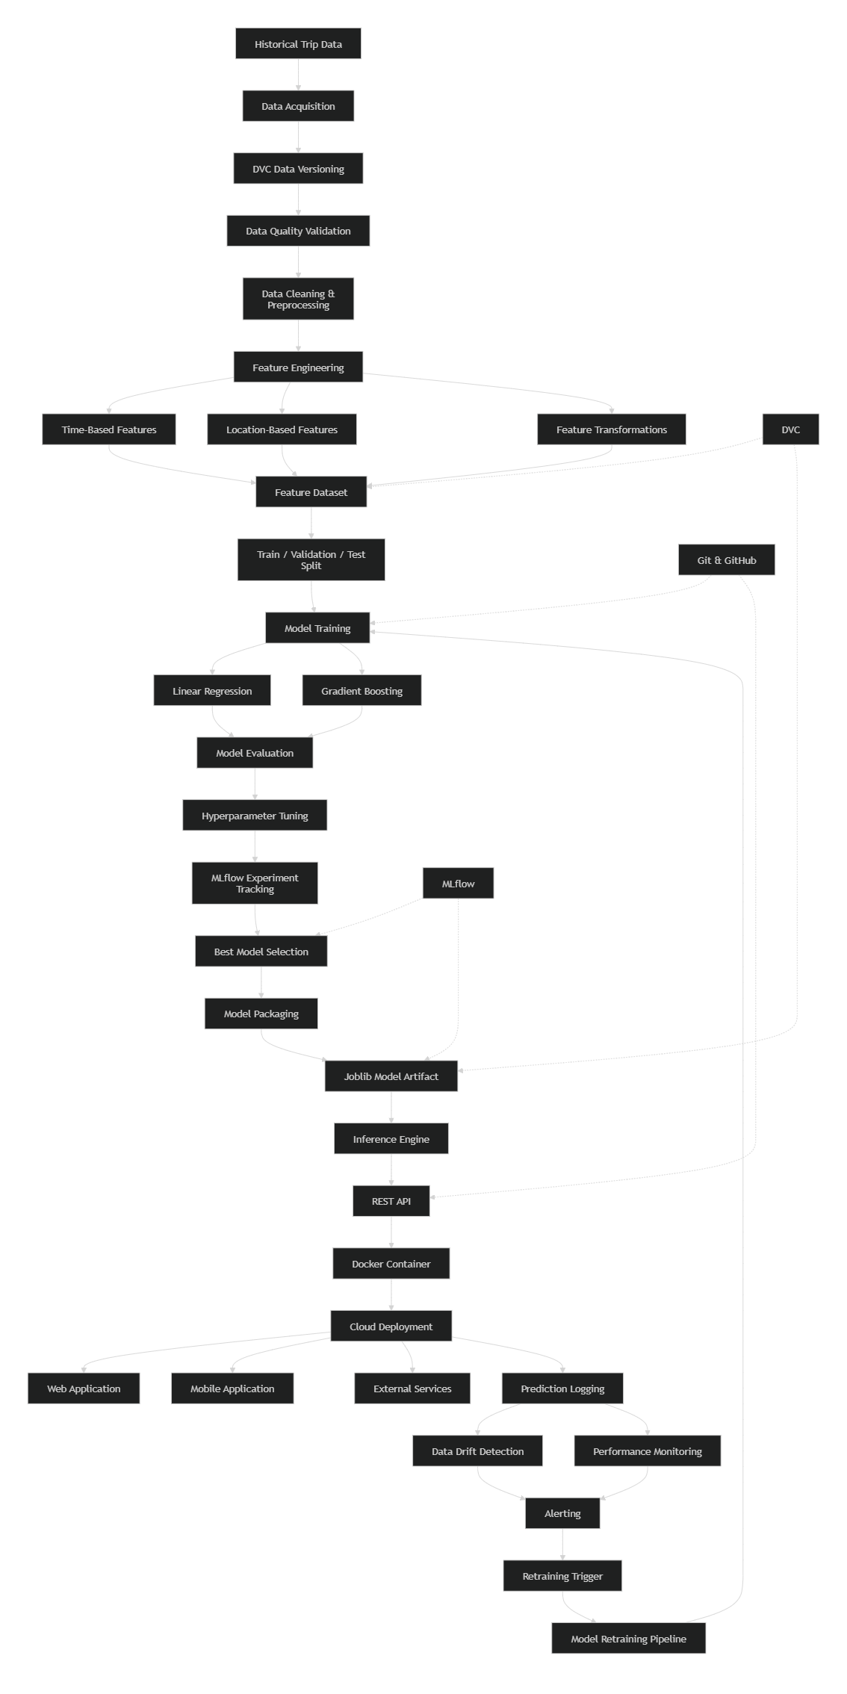
Architecture Components
Data Layer
- Historical trip data acquisition
- Data validation and preprocessing
- Dataset versioning using DVC
Feature Engineering Layer
- Time-based feature generation
- Location-based feature extraction
- Feature transformation and preparation
Model Development Layer
- Model training and experimentation
- Hyperparameter optimization
- MLflow experiment tracking
- Best-model selection
Deployment Layer
- Model serialization using Joblib
- REST API-based inference service
- Docker containerization
- Cloud deployment platform
Monitoring & Maintenance Layer
- Prediction logging
- Data drift detection
- Performance monitoring
- Alert generation
- Automated retraining workflow
Collaboration & MLOps Layer
- Git/GitHub for source code versioning
- DVC for dataset versioning
- MLflow for experiment tracking and model lifecycle management
This architecture demonstrates the complete Machine Learning Engineering and MLOps workflow implemented for the ETA Prediction solution, from raw data ingestion to continuous monitoring and retraining in production.
Appendix B: Exploratory Data Analysis (EDA) Figures
The Exploratory Data Analysis (EDA) phase generated several visualizations to understand data quality, travel behavior, temporal patterns, spatial distributions, and feature relationships. These figures provided critical insights that guided data preprocessing, feature engineering, and model selection decisions.

Figure B.1: Passenger Count Distribution
File: passenger_count_distribution.png
Purpose: Visualizes the distribution of passenger counts across all trips.
Key Observations:
- Most trips involved one or two passengers.
- Single-passenger journeys represented the largest proportion of trips.
- Higher passenger counts occurred relatively infrequently.
- A small number of extreme passenger counts were identified as potential anomalies.
Business Insight: The passenger count feature provides contextual information about trip characteristics and can contribute to travel-time prediction.

Figure B.2: Pickup Distribution by Hour, Day of Week, and Month
File: pickup_distribution_by_hourofday_dayofweek_month.png
Purpose: Examines temporal patterns in trip demand.
Key Observations:
- Significant peaks occur during morning and evening commuting hours.
- Weekday travel patterns differ from weekend patterns.
- Seasonal variations are evident across different months.
Business Insight: Travel demand varies considerably over time, validating the inclusion of time-based features such as pickup hour, day of week, and month.

Figure B.3: Pickup and Drop-off Location Distribution
File: pickup_dropoff_locations.html
Purpose: Visualizes the geographic distribution of trip origins and destinations.
Key Observations:
- High-density pickup and drop-off clusters are concentrated in major urban zones.
- Certain geographic regions serve as significant transportation hubs.
- Strong spatial patterns exist within the dataset.
Business Insight: Location information is a major determinant of trip duration and ETA prediction accuracy.

Figure B.4: Haversine Distance Distribution
File: haversine_distance_distributions.png
Purpose: Analyzes the distribution of trip distances calculated using the Haversine formula.
Key Observations:
- Most trips are relatively short-distance journeys.
- Long-distance trips occur less frequently.
- The distribution exhibits moderate right skewness.
Business Insight: Distance is one of the strongest predictors of trip duration and therefore a critical engineered feature.

Figure B.5: Haversine Distance vs Trip Duration
File: haversine_distance_v_trip_duration.png
Purpose: Investigates the relationship between distance traveled and trip duration.
Key Observations:
- Strong positive correlation exists between distance and travel time.
- Longer trips generally correspond to longer durations.
- Variability indicates the influence of traffic and temporal factors.
Business Insight: The analysis confirms Haversine Distance as a high-impact feature for ETA prediction.

Figure B.6: Engineered Feature Distributions
File: engineered_feature_distributions.png
Purpose: Examines statistical properties of engineered numerical features.
Features Evaluated:
- Pickup Hour
- Day of Week
- Month
- Haversine Distance
- Travel Direction
Key Observations:
- Features exhibit meaningful variation across observations.
- Distribution analysis helped identify skewness and potential outliers.
Business Insight: Understanding feature distributions improves preprocessing decisions and model performance.

Figure B.7: Engineered Feature Correlation Matrix
File: engineered_feature_correlation.png
Purpose: Visualizes correlations among engineered features and the target variable.
Key Observations:
- Haversine Distance shows a strong positive correlation with trip duration.
- Temporal features demonstrate meaningful relationships with travel time.
- Feature interactions provide valuable predictive information.
Business Insight: Correlation analysis supported feature selection and validated the importance of engineered attributes.

Figure B.8: Engineered Feature Boxplots
File: engineered_feature_boxplots.png
Purpose: Identifies feature spread, variability, and outliers.
Key Observations:
- Most engineered features exhibit reasonable distributions.
- Outliers are visible in distance and duration-related attributes.
- Boxplots supported anomaly detection and data cleaning activities.
Business Insight: Outlier analysis improves model robustness and prediction reliability.

Figure B.9: Engineered Categorical Feature Distributions
File: engineered_categorical_distributions.png
Purpose: Visualizes distributions of categorical and derived temporal features.
Features Evaluated:
- Time of Day
- Weekend Indicator
- Day of Week Categories
Key Observations:
- Distinct demand patterns exist across different time categories.
- Weekday and weekend travel behavior differs significantly.
- Peak demand periods can be clearly identified.
Business Insight: Categorical temporal features provide meaningful behavioral information that improves ETA prediction accuracy.

EDA Summary
The EDA phase revealed several important patterns:
- Haversine Distance is the most influential feature affecting trip duration.
- Trip demand varies significantly by hour, day, and month.
- Geographic location strongly influences travel time.
- Temporal and spatial features demonstrate meaningful relationships with the target variable.
- Outlier detection and data quality assessment were critical preprocessing activities.
- Engineered features significantly enhanced the predictive capability of machine learning models.
EDA Figure Mapping
Figure No. | Visualization | Purpose
B.1 | Passenger Count Distribution | Rider behavior analysis
B.2 | Pickup Distribution by Time | Temporal trend analysis
B.3 | Pickup & Drop-off Locations | Spatial distribution analysis
B.4 | Haversine Distance Distribution | Distance analysis
B.5 | Distance vs Trip Duration | Feature relationship analysis
B.6 | Engineered Feature Distributions | Feature quality assessment
B.7 | Correlation Matrix | Relationship analysis
B.8 | Feature Boxplots | Outlier identification
B.9 | Categorical Distributions | Temporal behavior analysis
These EDA visualizations collectively provided the analytical foundation for data preprocessing, feature engineering, model development, and business insights throughout the ETA Prediction project.
Appendix C: API Specification
This appendix provides the technical specification for the ETA Prediction REST API. The API enables external applications, web portals, mobile applications, and monitoring systems to request Estimated Time of Arrival (ETA) predictions from the deployed machine learning model.

C.1 API Overview
Service Name
ETA Prediction API
Purpose
Provide real-time trip-duration predictions based on temporal and geographical trip information.
Protocol
HTTP/HTTPS
Data Format
JSON
Architecture Style
RESTful API
Model Used
Gradient Boosting Regressor
``

C.2 Base URL
Development Environment
http://localhost:8000
Production Environment
https://api.eta-prediction.com
Replace the production URL with the actual deployment endpoint.

C.3 API Endpoints
Method | Endpoint | Description
GET | /health | Service health check
POST | /predict | Generate ETA prediction
GET | /model-info | Retrieve model information
GET | /metrics | Monitoring and service metrics

C.4 Health Check Endpoint
Endpoint
GET /health
Description
Used to verify API availability and readiness.
Sample Request
GET /health
Sample Response
{
"status": "healthy",
"service": "ETA Prediction API",
"version": "1.0.0"
}
HTTP Status
200 OK

C.5 Prediction Endpoint
Endpoint
POST /predict
Description
Generates ETA predictions based on trip information.
Request Headers
Content-Type: application/json
Accept: application/json

Request Schema
{
"passenger_count": 2,
"pickup_latitude": 40.7611,
"pickup_longitude": -73.9822,
"dropoff_latitude": 40.7419,
"dropoff_longitude": -73.9893,
"pickup_hour": 17,
"pickup_dayofweek": 2,
"pickup_month": 5,
"haversine_distance": 2.35
}

Request Parameters
Parameter | Type | Required | Description
passenger_count | Integer | Yes | Number of passengers
pickup_latitude | Float | Yes | Pickup latitude
pickup_longitude | Float | Yes | Pickup longitude
dropoff_latitude | Float | Yes | Destination latitude
dropoff_longitude | Float | Yes | Destination longitude
pickup_hour | Integer | Yes | Hour of pickup (0-23)
pickup_dayofweek | Integer | Yes | Day of week (0-6)
pickup_month | Integer | Yes | Month (1-12)
haversine_distance | Float | Yes | Geographical distance between pickup and drop-off

C.6 Successful Prediction Response
Response
{
"status": "success",
"prediction_id": "PRED-001245",
"predicted_trip_duration": 845.32,
"unit": "seconds",
"model_name": "Gradient Boosting Regressor",
"model_version": "v1.0"
}
Response Fields
Field | Description
status | Request result
prediction_id | Unique prediction identifier
predicted_trip_duration | ETA prediction
unit | Time unit
model_name | Model used for prediction
model_version | Model version number
HTTP Status
200 OK

C.7 Example Prediction
Request
{
"passenger_count": 1,
"pickup_latitude": 40.7549,
"pickup_longitude": -73.9840,
"dropoff_latitude": 40.7306,
"dropoff_longitude": -73.9866,
"pickup_hour": 18,
"pickup_dayofweek": 4,
"pickup_month": 8,
"haversine_distance": 3.12
}
``
Response
{
"status": "success",
"prediction_id": "PRED-10021",
"predicted_trip_duration": 1025.67,
"unit": "seconds"
}
`
Interpretation
1025.67 seconds ≈ 17.1 minutes

C.8 Validation Rules
The API validates all incoming requests before inference.
Passenger Count
passenger_count > 0
Hour Validation
pickup_hour ∈ [0,23]
Day of Week Validation
pickup_dayofweek ∈ [0,6]
Month Validation
pickup_month ∈ [1,12]
Coordinate Validation
Latitude ∈ [-90,90]
Longitude ∈ [-180,180]

C.9 Error Responses
Missing Required Field
Response
{
"status": "error",
"error_code": "MISSING_FIELD",
"message": "Required field 'pickup_latitude' is missing."
}
Status Code
400 Bad Request

Invalid Input
Response
{
"status": "error",
"error_code": "INVALID_INPUT",
"message": "Latitude must be between -90 and 90."
}
Status Code
400 Bad Request

Invalid Data Type
Response
{
"status": "error",
"error_code": "INVALID_DATATYPE",
"message": "pickup_hour must be an integer."
}
Status Code
400 Bad Request

Inference Failure
Response
{
"status": "error",
"error_code": "INFERENCE_ERROR",
"message": "Unable to generate ETA prediction."
}
Status Code
500 Internal Server Error

Internal Server Error
Response
{
"status": "error",
"error_code": "INTERNAL_SERVER_ERROR",
"message": "Unexpected server error occurred."
}
Status Code
500 Internal Server Error

C.10 Model Information Endpoint
Endpoint
GET /model-info
Sample Response
{
"model_name": "Gradient Boosting Regressor",
"model_version": "v1.0",
"framework": "Scikit-Learn",
"artifact": "gradient_boosting_trip_duration.joblib",
"deployment_date": "2026-08-29"
}
``

C.11 Monitoring Metrics Endpoint
Endpoint
GET /metrics
Purpose
Expose health and performance metrics for monitoring systems such as Prometheus and Grafana.
Sample Response
{
"prediction_count": 15230,
"average_latency_ms": 42,
"error_rate": 0.01,
"model_version": "v1.0"
}

C.12 API Request Lifecycle
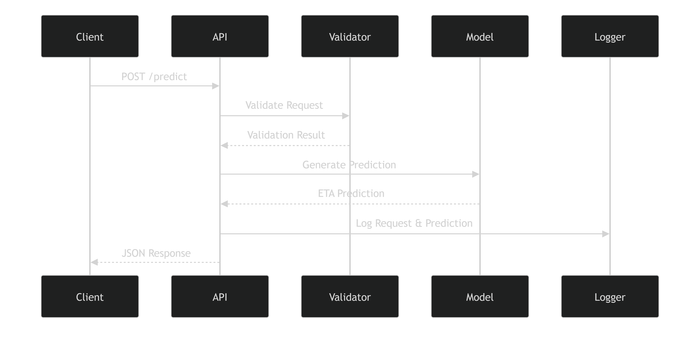

C.13 API Security Considerations
Input Validation
- Request payload validation
- Data type validation
- Business rule validation
Secure Communication
- HTTPS enabled communication
- TLS encryption
Rate Limiting
- Prevent API abuse
- Protect service availability
Logging and Auditing
- Prediction request tracking
- Error monitoring
- Access auditing

C.14 API Specification Summary
Component | Description
Protocol | HTTP/HTTPS
Data Format | JSON
Main Endpoint | POST /predict
Model | Gradient Boosting Regressor
Serialization | Joblib
Validation | Schema, datatype, and business-rule validation
Monitoring | Metrics and logging endpoints
Deployment | Docker and Cloud Run compatible
Security | HTTPS, validation, logging, rate limiting
Conclusion
The ETA Prediction API provides a scalable, production-ready interface for real-time travel-time prediction. Through standardized REST endpoints, robust validation mechanisms, structured error handling, monitoring support, and secure communication practices, the API serves as the operational gateway between client applications and the deployed machine learning model. Its architecture supports seamless integration, efficient inference, and future expansion within a complete MLOps ecosystem.
Appendix D: Deployment Checklist
The Deployment Checklist provides a structured set of activities to verify that the ETA Prediction system is ready for deployment into a production environment. The checklist covers data readiness, model readiness, infrastructure preparation, API validation, monitoring configuration, security requirements, and operational readiness activities. Completing these checks helps minimize deployment risks and ensures a stable, scalable, and reliable production release.

D.1 Pre-Deployment Checklist
Project Readiness
Item | Status
Project documentation completed | ☐
Architecture reviewed and approved | ☐
Source code merged into main branch | ☐
Release candidate created | ☐
Final project review completed | ☐

Data Readiness
Item | Status
Raw dataset validated | ☐
Data quality checks completed | ☐
Missing values handled | ☐
Duplicate records removed | ☐
Feature engineering pipeline validated | ☐
Dataset version stored using DVC | ☐
Production dataset approved | ☐

Model Readiness
Item | Status
Model training completed | ☐
Hyperparameter tuning completed | ☐
Model evaluation approved | ☐
Performance metrics documented | ☐
MLflow experiments recorded | ☐
Best model selected | ☐
Model serialized successfully | ☐
Model artifact available (.joblib) | ☐
Model Information
Model Name:

Model Version:

MLflow Run ID:
____________________________

D.2 API Deployment Checklist
API Validation
Item | Status
REST API developed | ☐
Input validation implemented | ☐
Error handling implemented | ☐
API unit tests passed | ☐
API integration tests passed | ☐
Health-check endpoint verified | ☐
API documentation completed | ☐
Endpoint Verification
Endpoint | Verified
GET /health | ☐
POST /predict | ☐
GET /model-info | ☐
GET /metrics | ☐

D.3 Docker Readiness Checklist
Containerization
Item | Status
Dockerfile created | ☐
Docker image build successful | ☐
Container starts successfully | ☐
Environment variables configured | ☐
Required dependencies installed | ☐
Model artifact packaged correctly | ☐
API accessible within container | ☐
Build Verification
docker build -t eta-prediction .
docker run -p 8000:8000 eta-prediction
Verification Item | Status
Image built successfully | ☐
Container started | ☐
API responding correctly | ☐

D.4 Cloud Deployment Checklist
Infrastructure Readiness
Item | Status
Cloud project configured | ☐
Deployment environment created | ☐
Container registry configured | ☐
Networking configured | ☐
SSL/TLS enabled | ☐
DNS configured | ☐
Autoscaling policies configured | ☐

Deployment Platform Validation
Component | Status
Google Cloud Run / Target Platform Configured | ☐
Container Registry Connected | ☐
Deployment Successful | ☐
Public Endpoint Accessible | ☐
HTTPS Enabled | ☐

D.5 Security Checklist
Application Security
Item | Status
Input validation enabled | ☐
Sensitive data removed from logs | ☐
Error messages sanitized | ☐
API rate limiting configured | ☐
Secure headers enabled | ☐
Infrastructure Security
Item | Status
Secrets stored securely | ☐
Environment variables configured securely | ☐
Access controls implemented | ☐
Backup strategy documented | ☐
Audit logging enabled | ☐

D.6 Monitoring and Maintenance Checklist
Prediction Logging
Item | Status
Prediction logging enabled | ☐
Log storage configured | ☐
Request tracking verified | ☐
Model version logging enabled | ☐
Data Drift Detection
Item | Status
Drift monitoring configured | ☐
Drift thresholds defined | ☐
Drift dashboard available | ☐
Drift simulation completed | ☐
Performance Monitoring
Item | Status
MAE monitoring configured | ☐
RMSE monitoring configured | ☐
R² monitoring configured | ☐
API latency monitoring configured | ☐
Resource utilization monitoring configured | ☐
Alerting
Item | Status
Email notifications configured | ☐
Alert thresholds defined | ☐
Escalation workflow documented | ☐
Alert testing completed | ☐

D.7 Retraining Readiness Checklist
Retraining Preparation
Item | Status
Retraining strategy documented | ☐
Production prediction logs available | ☐
Automated data collection configured | ☐
Model versioning process defined | ☐
Retraining triggers defined | ☐

MLOps Validation
Item | Status
Git repository updated | ☐
DVC pipeline verified | ☐
MLflow tracking operational | ☐
Model registry process defined | ☐
Rollback strategy validated | ☐

D.8 Production Readiness Assessment
Go-Live Approval Matrix
Area | Status
Data Pipeline | ☐ Approved
Feature Engineering | ☐ Approved
Model Performance | ☐ Approved
API Validation | ☐ Approved
Docker Deployment | ☐ Approved
Cloud Infrastructure | ☐ Approved
Monitoring Setup | ☐ Approved
Security Review | ☐ Approved
Retraining Framework | ☐ Approved

D.9 Final Go-Live Approval
Deployment Information
Deployment Date:

Model Version:

MLflow Run ID:

DVC Dataset Version:

Deployment Environment:
_________________________________

Approval Sign-Off
Role | Name | Signature | Date
Data & Features Lead | __________________ | __________ | __________
Modeling & Core ML Lead | __________________ | __________ | __________
MLOps & Deployment Lead | __________________ | __________ | __________
Project Reviewer | __________________ | __________ | __________

Deployment Decision
☐ Approved for Production Deployment

☐ Approved with Conditions

☐ Requires Additional Validation

☐ Deployment Rejected
Deployment Checklist Summary
The ETA Prediction system may be considered production-ready when:
- ✅ Data validation is complete.
- ✅ Model performance meets acceptance criteria.
- ✅ API functionality is verified.
- ✅ Docker deployment is successful.
- ✅ Monitoring and alerting are operational.
- ✅ Security requirements are satisfied.
- ✅ Retraining and rollback procedures are documented.
- ✅ All stakeholder approvals have been obtained.
This checklist serves as the final verification artifact before production deployment and helps ensure that the ETA Prediction solution is deployed in a reliable, secure, and maintainable manner.

